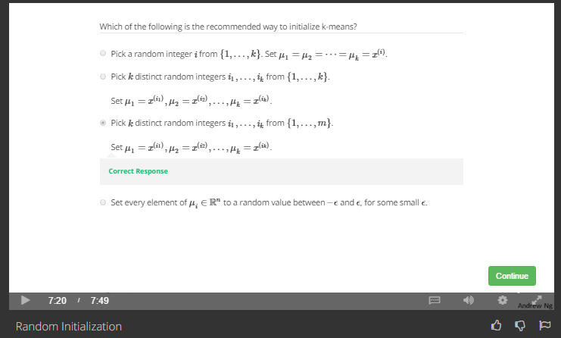

Select k cluster centers from m training dataset.