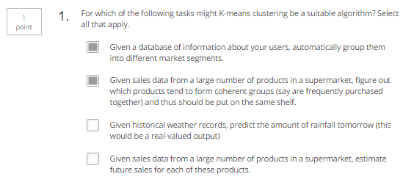

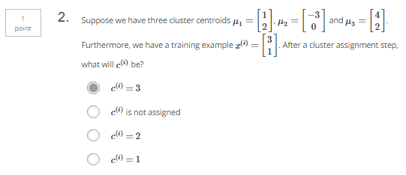

Answer:

||x-u1||=2^2+1^2=5

||x-u2||=6^2+1^2=37

||x-u3||=1^2+1^2=2

X belongs to cluster-3

