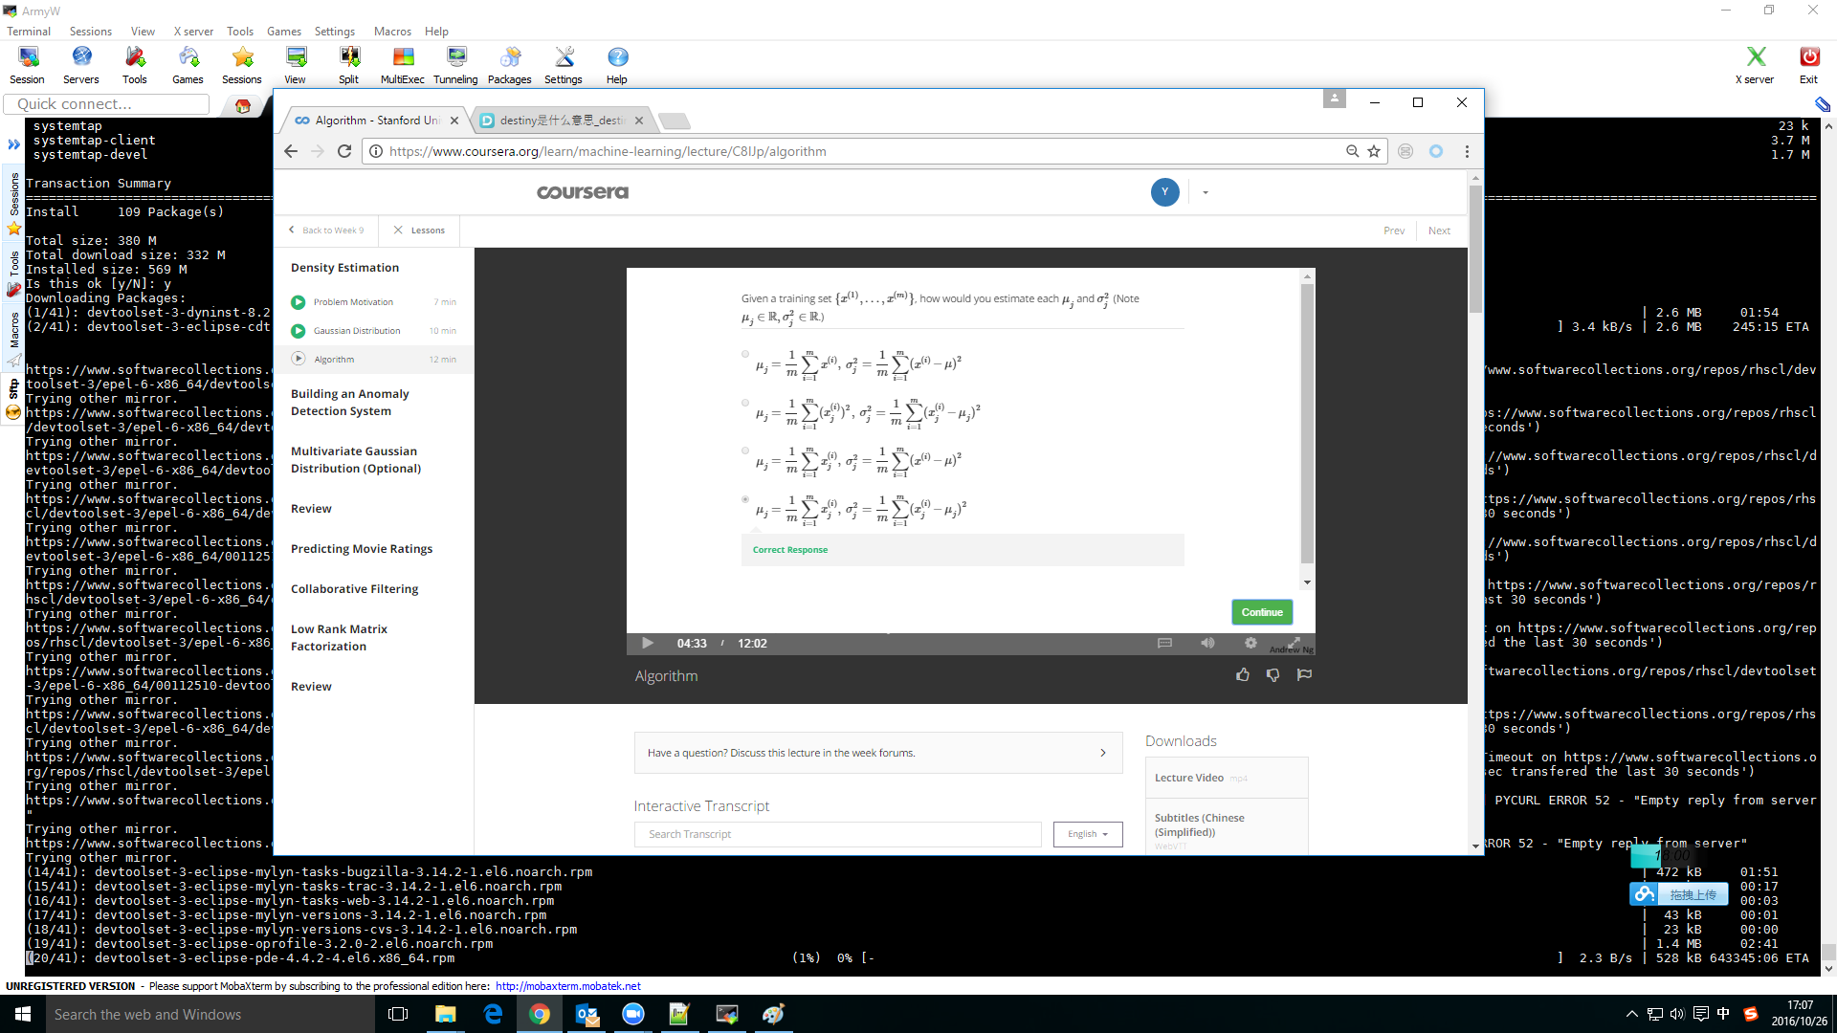

n: Feature count

m: training dataset count