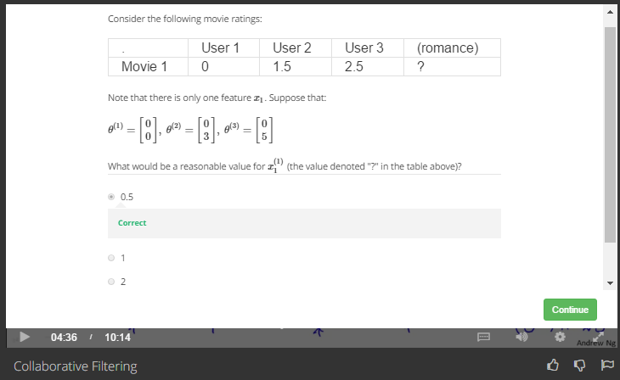

Answer

0 = θ(1)T \* [1, x]

1.5 = θ(2)T \* [1, x]

2.5 = θ(3)T \* [1, x]

So

x=0.5

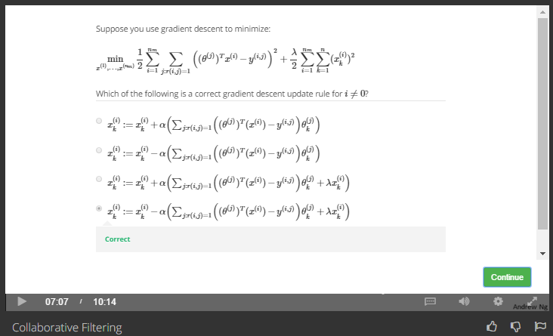

Answer

The basic gradient descent rule.