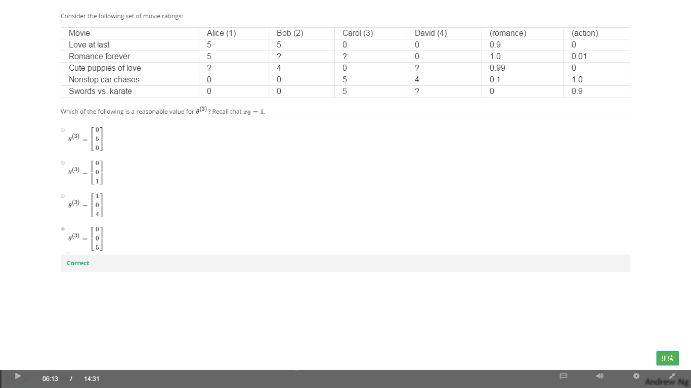

**Answer:**

x1 = [1, 0.9, 0]T

x2 = [1, 1, 0.01]T

x3 = [1, 0.99, 0]T

x4 = [1, 0.1, 1.0]T

x5 = [1, 0, 0.9]T

[Ɵ1, Ɵ2, Ɵ3] * x1 = 0

[Ɵ1, Ɵ2, Ɵ3] * x3 = 0

[Ɵ1, Ɵ2, Ɵ3] * x4 = 5

[Ɵ1, Ɵ2, Ɵ3] * x5 = 5