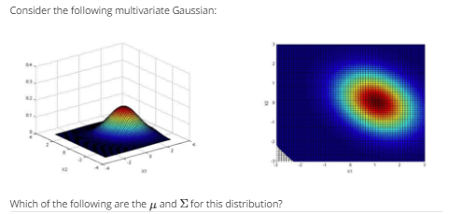

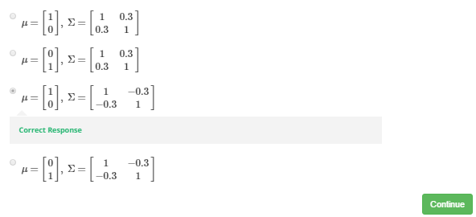

Answer:

u1, u2 is the center: [1, 0]

And the direction indicate sigma[1,2] and sigma[2,1] is negative

