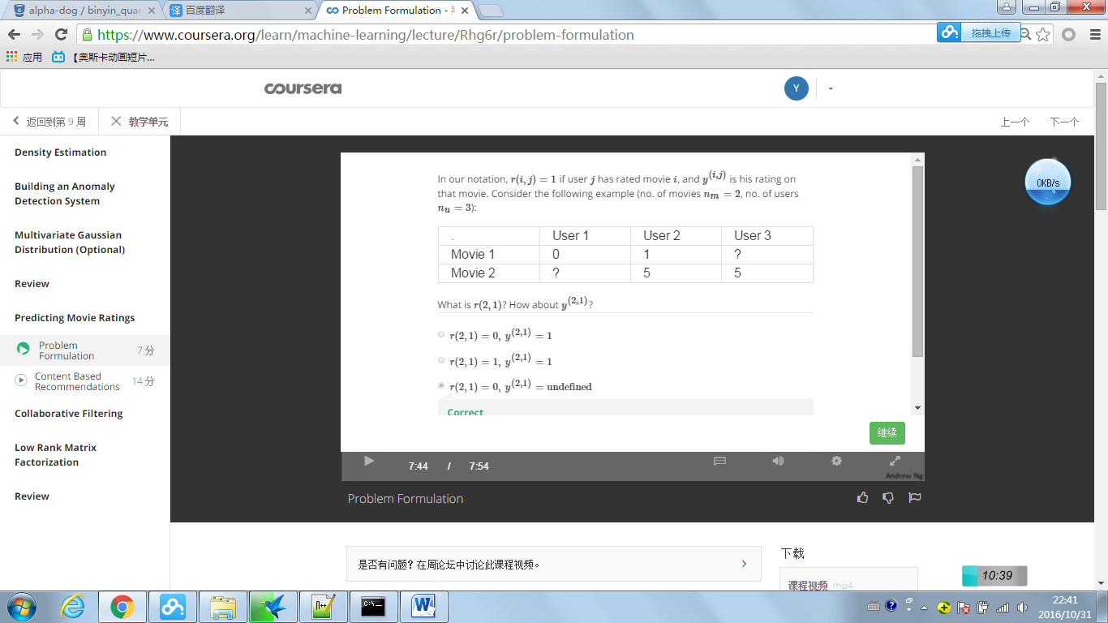

Answer

r(2,1) means if user 1 has movie 2: not (0)

y(2,1) is the score of usr1 for movie 2

