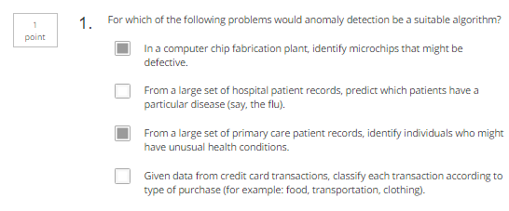

Answer: B and D are typically classification problems

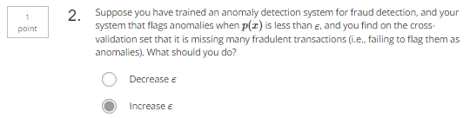

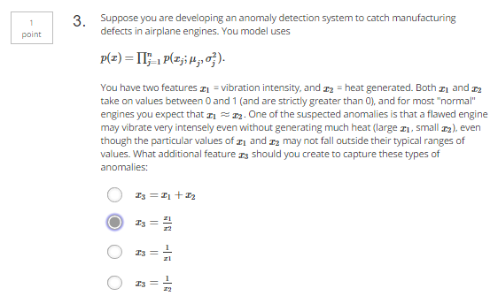

Answer: design feature that will jump out the typically normal value (0~1)

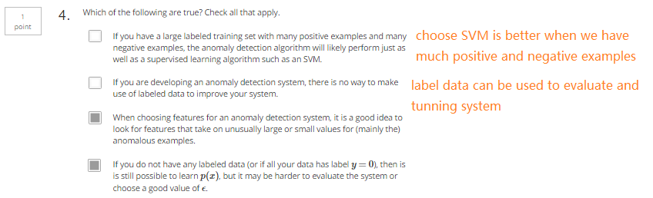

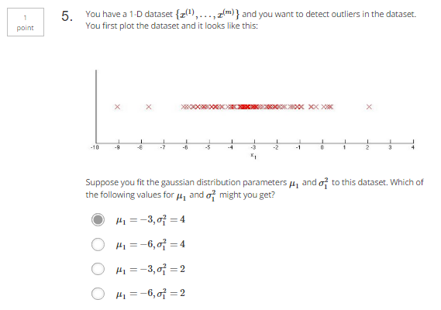

Answer:

u is the center

P(x)=0 when x=3\*Sigma