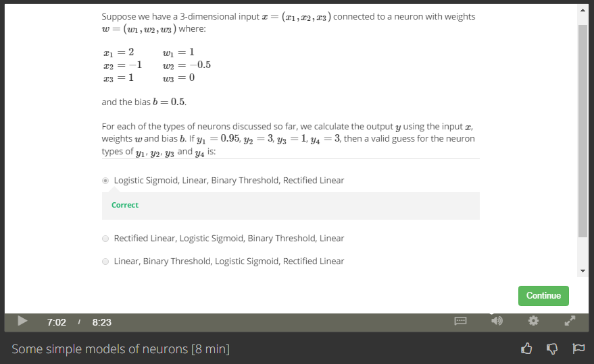

Answer:

X1\*w1+ X2\*w2 + X3\*w3 + b = 3

So

Y1=0.95, sigmoid

Y2=Y4=3, linear

Y3=1, binary

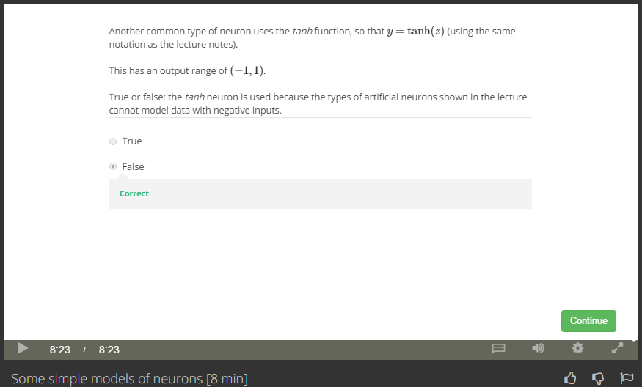

Answer: NN can model data with negative inputs.