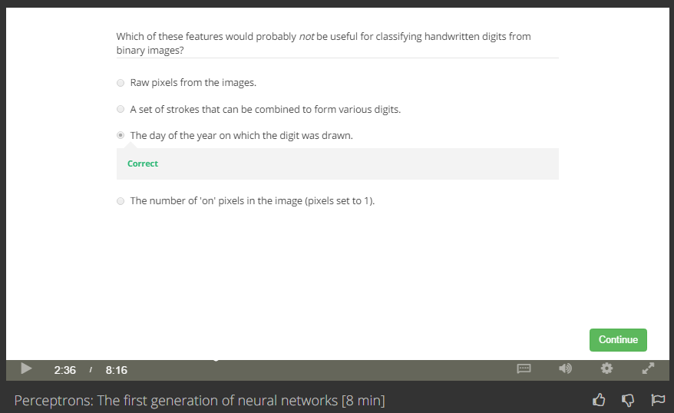

We should choose the features that can represent digit.

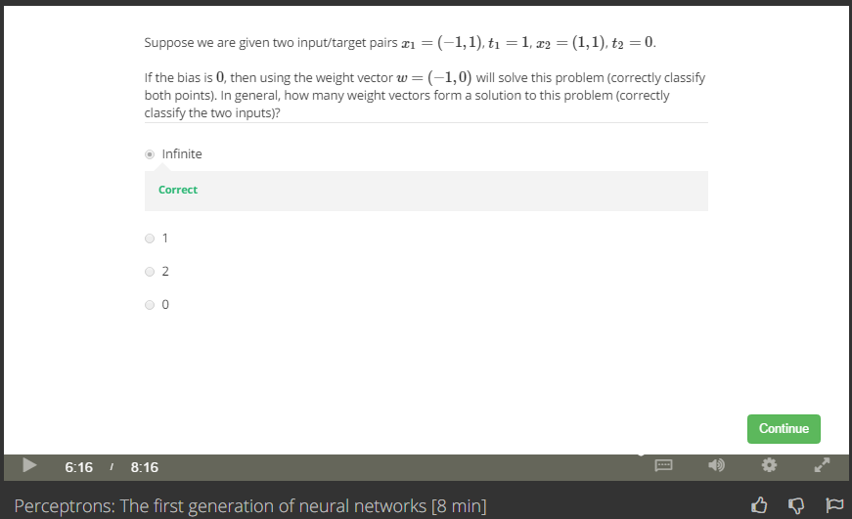

We can find infinite w for those {x1, x2} classification.

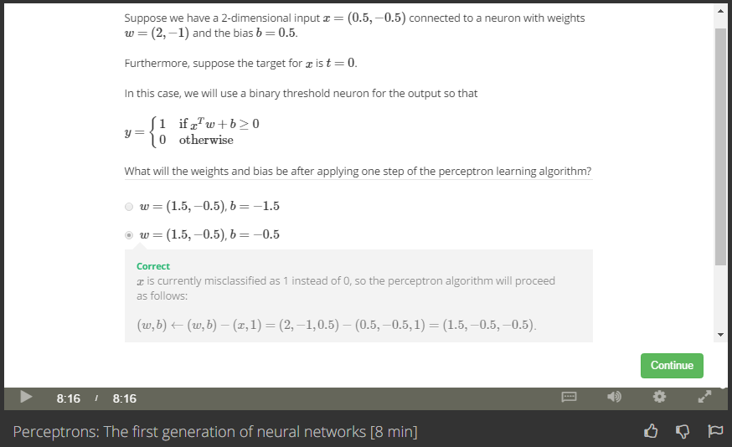

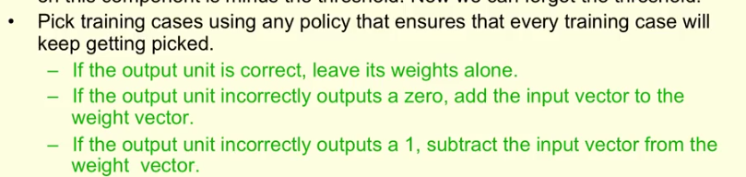

Xw+b=2, output 1, but t=0.

Output incorrectly outputs 1, sub

w = w-x = (2,-1)-(0.5,-0.5) = (1.5, -0.5)

b = b-1=0.5-1=-0.5