Text in paragraph 1
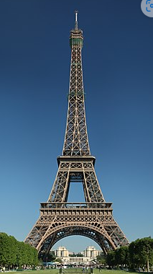
Figure 1 : Eiffel Tower
Text in paragraph 2
DJIMO
Text in paragraph with bold and italic text 3
Tableau 1 Exemple de tableau
Head 1 | Head 2 | Head 3
Row 2, Column 1
 | Row 3, Column 2
 |  | Row 5, Column 3

Heading 1
Text1 in paragraph1Heading1

Heading 2
Tata

Heading 2
Tata

