Text in paragraph 1

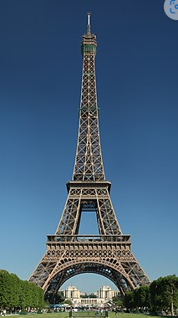

Figure 1 : Eiffel Tower

Text in paragraph 2

DJIMO

Text in paragraph with **bold** and italic *te­xt* 3

Tableau 1 Exemple de tableau

|  |  |  |
| --- | --- | --- |
| Head 1 | Head 2 | Head 3 |
| Row 2, Column 1 |  |  |
|  | Row 3, Column 2 |  |
|  |  |  |
|  |  | Row 5, Column 3 |

# Heading 1

Text1 in paragraph1Heading1

## Heading 2

Tata

## Heading 2

Tata