1. https://www.datasciencecentral.com/automated-grading-systems-how-ai-is-revolutionizing-exam-evaluation/
2. https://www.edsurge.com/news/2023-06-14-can-ai-help-teachers-with-grading
3. https://www.princetonreview.com/ai-education/how-ai-is-reshaping-grading#:~:text=Artificial%20intelligence%20(AI)%20technology%20is,systems%20can%20decipher%20written%20responses.
4. <https://medium.com/@smartpaper/top-6-examples-of-artificial-intelligence-in-education-the-future-of-grading-9a95c7ba1ff8>
5. https://scholar.google.ru/scholar?hl=en&as_sdt=0%2C5&as_vis=1&q=ai+education+grading+supervised+semi-supervised+unsupervised+learning&btnG=

I think the contents of the site of the first URL are all useful data for the AI project.

I will extract the most important part from the contents into 2nd page.

I think the 4 titles from the picture should be the partial topics of the AI project, not supervised and unsupervised learning.

The descriptions of the titles show the necessities of them.

The papers for this project are in the 5th URL.

The following is my opinion about the structure of the project.

The main Topic: AI automated grading and assessment system

Partial topics:

1. Natural Language Processing(NLP)
2. Adaptive Learning
3. Pattern Recognition
4. Feedback Generation

In these partial topics

Let them think about several machine learning techniques including supervised learning, unsupervised learning and semi-supervised learning for each partial topic.

**How AI is Transforming Exam Evaluation?**

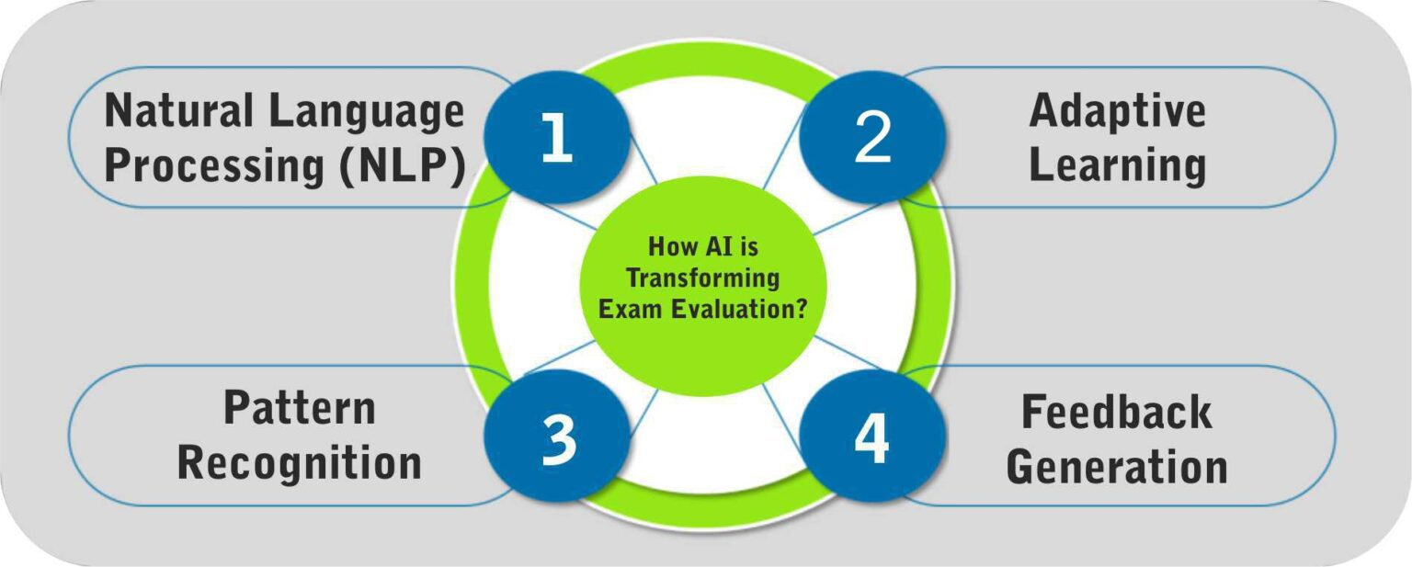

Artificial Intelligence plays a vital role in revolutionizing exam evaluation through automated grading systems. Here are some ways in which AI technology is transforming this field:

**Natural Language Processing (NLP):**

[NLP](https://www.datasciencecentral.com/magic-bullet-intelligent-process-automation-nlp-edition/) algorithms enable automated grading systems to analyze and understand written responses. By employing machine learning techniques, AI can assess the quality, coherence, and relevance of the student’s answers, providing valuable insights into their understanding of the subject matter.

**Pattern Recognition:**

AI-powered systems can recognize patterns in student responses and identify common errors or misconceptions. This allows educators to pinpoint areas where students may be struggling and tailor their teaching strategies accordingly.

**Adaptive Learning:**

AI-based grading systems, empowered by the knowledge and techniques acquired through an [artificial intelligence course](https://www.mygreatlearning.com/artificial-intelligence/courses), can adapt and improve over time. By analyzing vast amounts of student data, these systems can identify areas of weakness and develop personalized feedback and recommendations for individual learners. This personalized approach enhances the learning experience and helps students progress at their own pace.

**Feedback Generation:**

[AI algorithms](https://www.datasciencecentral.com/5-algorithms-to-train-a-neural-network/) can generate detailed feedback for students, highlighting their strengths and improvement areas. This feedback not only guides students but also saves educators’ time by automating the process of generating individualized feedback.