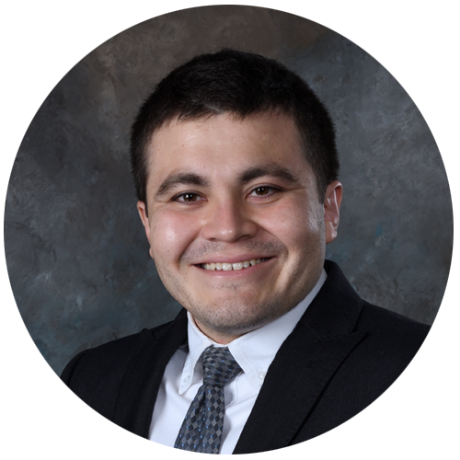

Leonardo Rodriguez
Remote Full Stack Mobile & Web Developer

Contact Info
Email: leo@fullstackleo.net
Mobile Phone: +1 512 312 8481
Location: Eagle Pass, Texas, USA

Cover Letter
I was born in Piedras Negras, Coahuila, Mexico, the same place where nachos (classic chips and queso) were invented. Since I was a little kid, I was pushed to work hard and make money by my entire family. Like any toddler that is raised with a destined discipline, my repetitions of marketing, sales, finance, and delivering hard work were in the thousands by the time I was 18 years old.

My jobs from 1st to 12th grade included: car detailing, landscaping, residential cleaning, commercial cleaning, amateur photography, photo/video post production, and mariachi mother’s day serenatas. As a population, we are mostly raised this way on the US-Mexican border. Working adult jobs as children is a way of life for at least half of us neighboring the Rio Grande River.

You can imagine my culture shock when I left the border and moved to Austin, TX for college. I started working for Office Depot while attending the Art Institute of Austin, both full time. I was getting to know all sorts of adults ranging from 18-22 who had never worked in their life and even worse, didn’t know how to cook, clean, or wash clothes! What was even crazier, was the fact that these young adults lacking all sorts of work and life experiences were amazed that I lived a life of service which they thought of as torture and inhumane.

What does this have to do with a cover letter?!

I’m just trying to depict the vast amount of general work and labor experience someone from my area and culture acquires while growing up. The seemingly endless repetitions of work and more work have built me to become the ultimate professional I am today. Add my 15 years of technical career with a proven track record of success on top of that and you’ll see why I can work harder and more efficiently than most US job candidates. Someone like me can work under pressure and stress with a smile on their face while maintaining professionalism and hospitality.

You can verify me by contacting my previous workplaces. All of their contact info is on my resume.

Lucky for you, I am actively looking for a new full time job.

Let’s partner up and execute your tech and business goals. You’re gonna LOVE it!

Portfolios
• Full Stack Dev: https://fullstackleo.net
• Web Dev, Design, Writing: https://idealeo.net
• GitHub: https://github.com/fullstackleo777

Skills
🌐 Deployment: Linux (Ubuntu, CentOS, RHEL), AWS, GCP, Windows Azure, Docker, Podman, CI/CD

🗄️ Database: MySQL, NoSQL, SQLite, MariaDB, PostgreSQL, Database Visualizers
🧠 Back End: Linux, Bash Scripting, Cron Jobs, SSH, Node.js, PHP, Python, REST API, OAuth
👁️ Front End: XML, HTML, CSS/SCSS/SASS, Javascript, Organic SEO, Frameworks (Vue.js, Svelte, React.js)
❤️ Open Source Software: Server (Apache, NGINX, Lighttpd, ffmpeg), Productivity (OpenOffice, LibreOffice)
🖼️ Creative Software: Adobe (Photoshop, Illustrator, InDesign, Premiere Pro), Open Source (Inkscape, Gimp)
🔐 Server Security: Firewalled, SSL/TLS, Fail2Ban, SSH Keys, Argon2, IP White/Blacklisting
🔑 DNS Security: DNSSEC, DDOS Protection, Secure Cache, DNS Proxy, DNS Firewall
🖱️ Content Management Systems: HubSpot, Wordpress, Wix, Squarespace, Drupal
💰 eCommerce Platforms: WP WooCommerce, Magento CE, Shopify, Thirty Bees, Wix, Squarespace
🛠️ Dev Tooling: GIT (GitHub, GitLab, GiTea), VSCodium, VSCode, Vim, Nano, DIFF, Chrome DevTools
👨‍💼 Project Management: Agile, Scrum, Lean, BPM

Hire me to execute your tech and business goals!

