N O X T I L L
10 FREE TOOLS
  - Complete Full-Stack Developer & Product Specification
Frontend • Backend • UX • Algorithms • API Contracts • Data Model • Security • Testing
PRODUCT SCOPE
PUBLIC UTILITIES | DELIVERY SCOPE
FT-01 Discount Calculator | Precision discount and tax calculations
FT-02 Profit Margin Calculator | Cost, contribution, margin and markup
FT-03 Break-Even Calculator | Financial break-even and scenario charts
FT-04 Invoice Generator | Document composition, export and canonical invoice boundary
FT-05 QR Code Generator | Safe static QR and print exports
FT-06 Google Review Link & QR Generator | Owner-supplied official review links and share kits
FT-07 WhatsApp Link Generator | International click-to-chat URL composition
FT-08 UTM Campaign Link Builder | Campaign URLs without broken query/fragment
FT-09 Email Signature Generator | Secure, compatible HTML signatures
FT-10 Missed Call Revenue Calculator | Assumption-driven recovery opportunity model

Version 1.0 • 11 October 2026 • Internal product / engineering specification
Status: implementation blueprint, not evidence that code has been written or that third-party services are connected.

Executive implementation contract
This specification defines ten public, free Noxtill utility pages. They are utility experiences—not ten additional top-level Noxtill Business OS modules. Each tool must operate independently for anonymous users, and any advanced save-to-workspace flow must delegate to the corresponding canonical Noxtill module with authorization and explicit confirmation.
The main deliverable is working software: validated input, deterministic business logic, accessible frontend, downloadable/copyable output, robust failure handling, privacy-safe analytics, test coverage and secure integrations. It must not be implemented as static demonstration cards or as a mandatory lead-capture wall.
NO ACCIDENTAL SCOPE INFLATION
- No “ten-day” or other schedule promises are included in this specification.
- The default public action is genuinely free, with no trial requirement and no card requirement.
- Never invent business data, transactions, tax certification, verified Google review link, WhatsApp message delivery or ROI realization.
- One object, one owner: documents/invoices/CRM/customer/contact/marketing campaigns remain with existing Noxtill canonical services.
- A front-end preview is not a confirmed external operation; call response or actual persisted state must confirm completion.

Document navigation
SECTION | WHAT DEVELOPER WILL FIND
01 Global platform contract | Architecture, privacy, technology stack, SEO, security, API consistency, shared UI
02 10 tool chapters | Each contains fields, screens, workflows, algorithms, backend, API contracts, failure cases, QA and wireframe
03 Cross-tool integrations | Canonical module ownership, explicit-save contracts and event boundaries
04 Implementation checklist | Frontend/backend quality gates, test layers, release acceptance
05 Research & references | Official source citations R1–R12 and assumptions requiring jurisdiction review

Product positioning and visual identity
Match the approved Noxtill visual identity: deep forest green, emerald and mint accents, white/pale green surfaces, generous whitespace, strong typography, restrained borders and responsive layouts. Avoid unrelated purple/blue startup styling, ornamental parallax and generic decorative human images. Public tool data should be plausible but explicitly labeled demo/example where applicable.
Each utility should be reachable through the footer Free Tools link, a discoverable public route, keyboard navigation and a task-specific SEO landing page. The underlying calculator is usable without registration; sign-up is a separate optional step when a result can genuinely be saved.
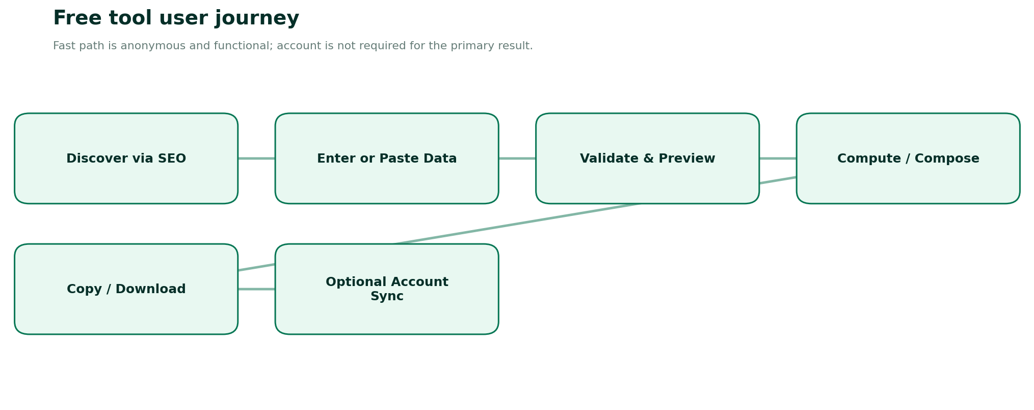
Figure 1. Shared anonymous-first journey for all ten tools.

01 — Shared architecture and engineering policies

1.1 Noxtill integration and source-of-truth rule
Use one tool shell and shared components, but a dedicated domain calculation/composition package per utility. Public inputs are untrusted. Anonymous pages are accessible without a tenant; authenticated workspace variants may resolve tenant context only from trusted session middleware. Do not allow tenant_id or staff_id passed by clients to select arbitrary business accounts.
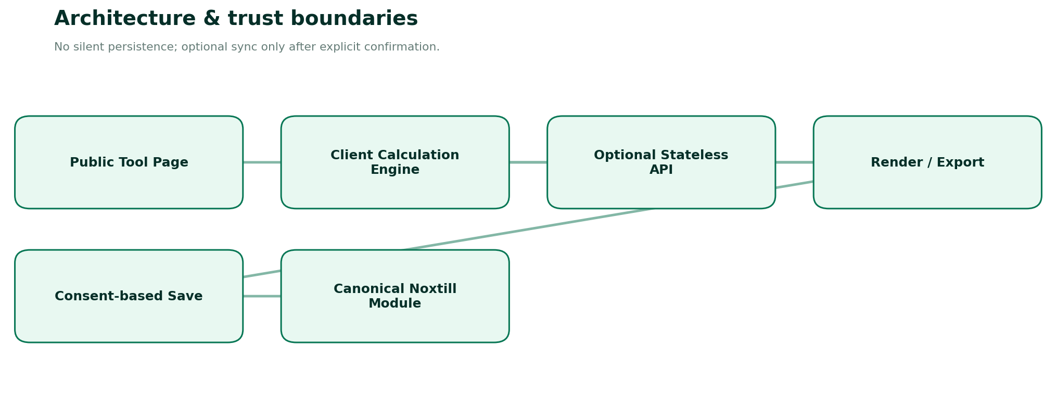
Figure 2. Browser-first computation, optional verified backend, explicit canonical save.
BUSINESS OBJECT | CANONICAL OWNER / RULE
Products, costs, SKUs | Products & Services; finance records only via approved Finance & Accounting flows.
Invoices, quotes, orders | Orders; actual payment collection and status in Payments & Billing.
Customers/recipients | Customers (CRM); public invoice generator may hold ephemeral entered recipient data, not canonical CRM record.
Marketing campaigns | Marketing & Campaigns and Advertising; UTM variants reference campaigns only through explicit sync.
Reviews and public reputation | Reviews & Reputation; listing connections are owned by Business Listings / Integrations.
Staff and brand identity | Staff and Settings; managed signatures use existing authorized staff identity.
Calls and missed-call events | AI Phone Receptionist; free estimator may only reference permissioned aggregates.
Media and files | Documents, Contracts & eSign / existing media owner; no duplicate asset libraries.
Automations / delivery | Automations & Workflows / Unified Inbox; generating a link or PDF does not imply it was sent.

1.2 Suggested technology architecture
LAYER | PREFERRED IMPLEMENTATION | RATIONALE / RULE
Website UI | Next.js / React / TypeScript; Tailwind or current Noxtill UI tokens | SSR/SEO for explanation, client hydration for live interaction.
Form validation | Zod schemas + typed form adapters | One validated schema; explicit localized field errors.
Money mathematics | decimal.js, big.js or equivalent decimal package | Use decimal strings and shared calculation tests.
QR encoding | Audited browser QR library with SVG/PNG export | No paid external QR API needed for static QR.
PDF output | Client-print or server-side audited PDF renderer | Avoid fake issued-invoice state; accessible text and font support.
Backend | Current Node/TypeScript API / service boundary | Do not add a new stack without codebase audit.
Persistence | Existing PostgreSQL/Supabase under tenant RLS / app policies | Save only explicit authorized objects; audit actual mutations.
Exports | Ephemeral memory / short-lived download URL, no cache by default for PII | Prevent sensitive documents from ending up in CDN/public buckets.
Observability | Existing Noxtill structured logs, error traces and anonymized metrics | Capture tool and error category, not raw names/phones/messages.
Testing | Vitest/Jest + Playwright + axe + contract tests | Golden math vectors; export smoke tests; real browser accessibility.

1.3 Shared frontend page composition
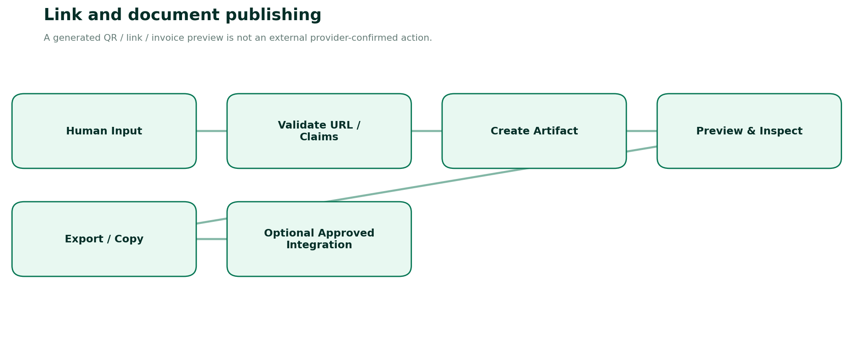
Figure 3. All generated links/documents remain visibly separate from actual external sending.
- Hero: H1 exact tool name, single-sentence value proposition, brief truthful result description, small Noxtill brand label.
- Workspace: Desktop form left and live output right; on mobile form first, result tab/panel below.
- Presets: Task-specific sample values labelled Example; no false user activity or scores.
- Validation: Inline issue summary, associated labels, input hints, preserved user entries and focus management.
- Results: Accessible result region with line-by-line explanation, copy/export buttons and explicit currency/units.
- Assumptions: Collapsible How calculated panel and user-controlled options; show estimates as estimates.
- Guidance: Useful genuine FAQ/help instructions sourced from official docs, not fabricated marketing claims.
- Footer: Navigation, privacy notes and a restrained sign-up invitation only after functional free output.

1.4 UI states and interaction contract
STATE | REQUIRED BEHAVIOUR
untouched | Guide/example; no invented output.
dirty-valid | Recalculate client-side or debounce costly output; never send raw PII as analytics.
dirty-invalid | Focus field; concise corrective error; previous preview explicitly stale or hidden.
generating | Visible progress when export/render is genuinely asynchronous; cancel if supported.
success | Results and enabled copy/download; download is confirmed only after browser artifact is created.
empty | Clear next step; accessible empty state, no fake zeros unless mathematically valid.
external-redirect | User must explicitly click; no automatic Google/WhatsApp navigation.
permission-denied | Authenticated save blocked with honest instructions; anonymous calculator still accessible.
offline | Local deterministic tools work; server-based PDF falls back to print where possible.
retry | Idempotent when writing canonical data; exports may safely recompute.

1.5 API conventions and errors
POST /api/public/tools/{slug}/calculate [optional]
Content-Type: application/json
Request: {"version":"1","input":{...},"locale":"en-US"}
Response: {"ok":true,"result":{...},"warnings":[],"formulaVersion":"v1"}
Error: {"ok":false,"code":"VALIDATION_ERROR","fields":{"price":"Must be >= 0"},"requestId":"..."}
Use strict input DTO schemas, typed result DTOs, bounded input arrays, origin controls, minimal CORS, suitable API rate limits, timeout and error observability. On authenticated saves use explicit confirmation, scoped authorization, stable idempotency keys, optimistic concurrency where appropriate and canonical-module ownership. Public APIs should not expose bulk export of other users’ tool submissions.

1.6 Privacy, trust and security guardrails
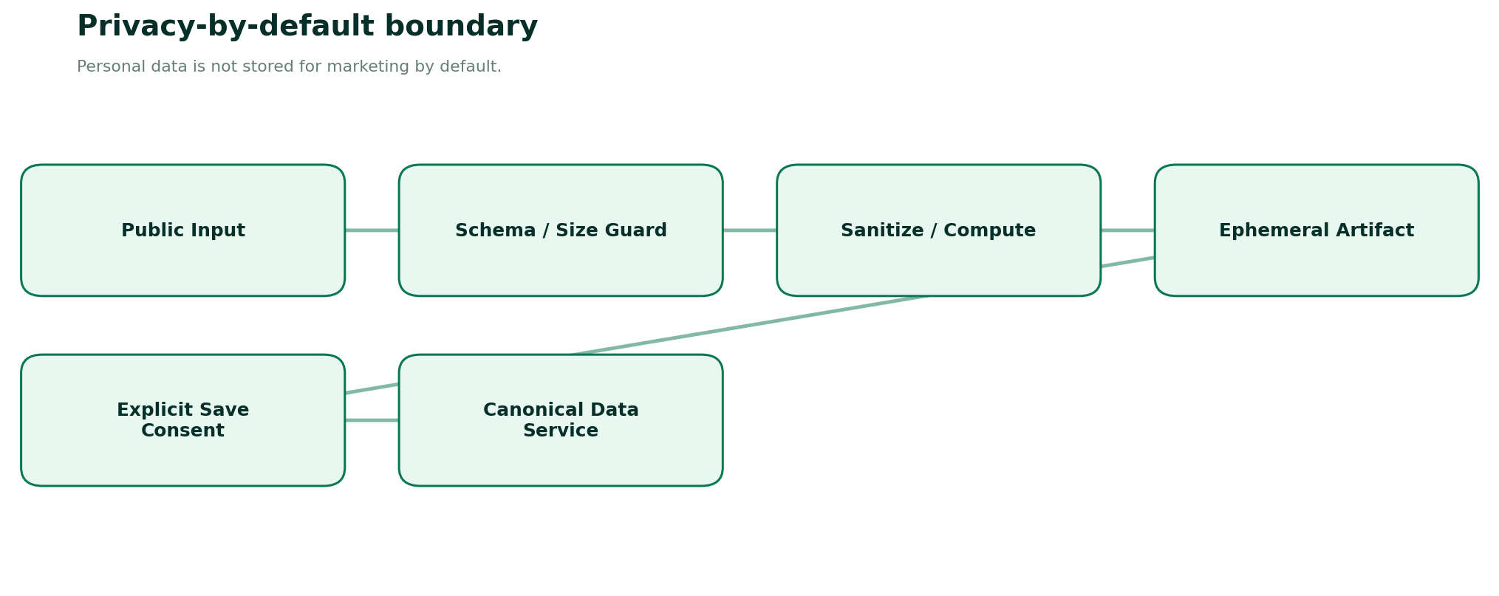
Figure 4. Public input should not become stored personal business data without consent.
- No anonymous-result autosave to a database. Use in-memory client state by default; if persisted drafts are offered, explain local storage separately and provide clear deletion.
- No data to third-party AI APIs by default: deterministic utilities do not need AI inference. Optional AI copywriting would require explicit, separately scoped consent and disclosure.
- Validate URL schemes; do not permit SSRF (user-provided URL fetch), JavaScript/data URIs for web links, open redirects or HTML injection.
- Invoice buyer contact, WhatsApp numbers, email signatures and personal details must be excluded from analytics events and exception logs.
- Use Content Security Policy, escaping/sanitization, rate limits and anti-abuse resources as appropriate to anonymous endpoints [R9].
- QR exports and PDFs must not contain script, unsafe SVG references or external tracking images.
- When integrations are connected, authorization checks apply to every operation at resource and tenant boundary, not just page routes.
- Data retention, cookie choices, tax/document rules and legal policies require country-specific review; do not claim universal compliance.

1.7 Accessibility, internationalization and SEO
Target WCAG 2.2 AA across desktop/mobile interactions. Every form input has a visible label, description, consistent error association, clear tab order, non-color status, escape/back keyboard operation, minimum tap targets and screen-reader summary. Use aria-live=polite sparingly for recalculation summaries, not on every keystroke [R8].
- Locale-aware display through Intl.NumberFormat and date APIs, but use canonical decimal strings for computation and ISO date/time where applicable.
- No assumption all currencies have two decimals; currency code always visible in financial tool reports and copied summary.
- Each public route has unique title/meta description, indexable explanatory content, one canonical, breadcrumbs and meaningful FAQ. Avoid mass-generated duplicate doorways.
- Structured data should describe real functionality and follow Google guidance; no guarantee of rich results [R10]. FAQ rich results are generally limited for ordinary commercial websites [R12].
- Language switching localizes interface text while preserving formulas/values; changing locale must not change numerical amount or drop user data.
- Copy/download interactions include fallback, actionable error and no dark patterns requiring newsletter signup.

1.8 Reusable controls and packages
SHARED COMPONENT / PACKAGE | REQUIRED OUTPUT
ToolPageLayout | Metadata, title, related tools, responsive slots, page skeleton, keyboard navigation.
DecimalMoneyInput | Locale display, parse canonical string, reject ambiguity; controlled decimal precision.
PercentageInput | Validated 0..100 domain; min/max hint; clear labels.
CountryPhoneInput | E.164 normalization, no account existence probing.
SafeUrlInput | Scheme validation, relative/absolute awareness, fragment and query preview.
QRCodePreviewExport | SVG/PNG/PDF export, 4-module quiet zone, scan reliability guard.
ResultBreakdown | Formula, inputs, units, assumptions, precision, copy summary.
DocumentPrintPreview | A4/Letter preview, accessible PDF generation, safe HTML escaping.
CopyExportMenu | Clipboard permissions fallback; download type/name MIME correct.
ConsentSaveGate | Explicit opt-in, canonical owner, auditable result, auth and permission checks.
ToolEventSchema | Anonymous aggregate event names only, no raw contents, proof only for actual success.

1.9 Common quality gates
For every tool: (1) tool works without sign-in; (2) input invalidity never produces a fabricated success; (3) preview matches exported asset byte-for-byte in its semantic content; (4) actual external/provider actions are labeled accurately; (5) all persistent saves are permission checked; (6) keyboard/mobile/screen readers work; (7) meaningful golden vectors, fuzz/property tests and injection tests pass; (8) zero unnecessary paid API dependencies for deterministic tools.

FT-01 — Discount Calculator
PUBLIC ROUTE: /FREE-TOOLS/DISCOUNT-CALCULATOR / MONEY + PROMOTION MATHEMATICS
Product promise. Calculate discounts, net prices, item totals, taxes, stacked reductions and savings without ambiguous rounding.
Target audience. Retailers, sales staff, ecommerce sellers, buyers comparing offers.
Data ownership. Stateless public calculator; authorized optional product/pricing handoff belongs to Products & Services / Orders / Marketing, never public utility tables.
How it works — Roman Urdu: Yeh calculator selling price aur discount ka exact breakdown deta hai. Kisi POS discount ko automatically apply nahi karega jab tak merchant authorized approval na de.
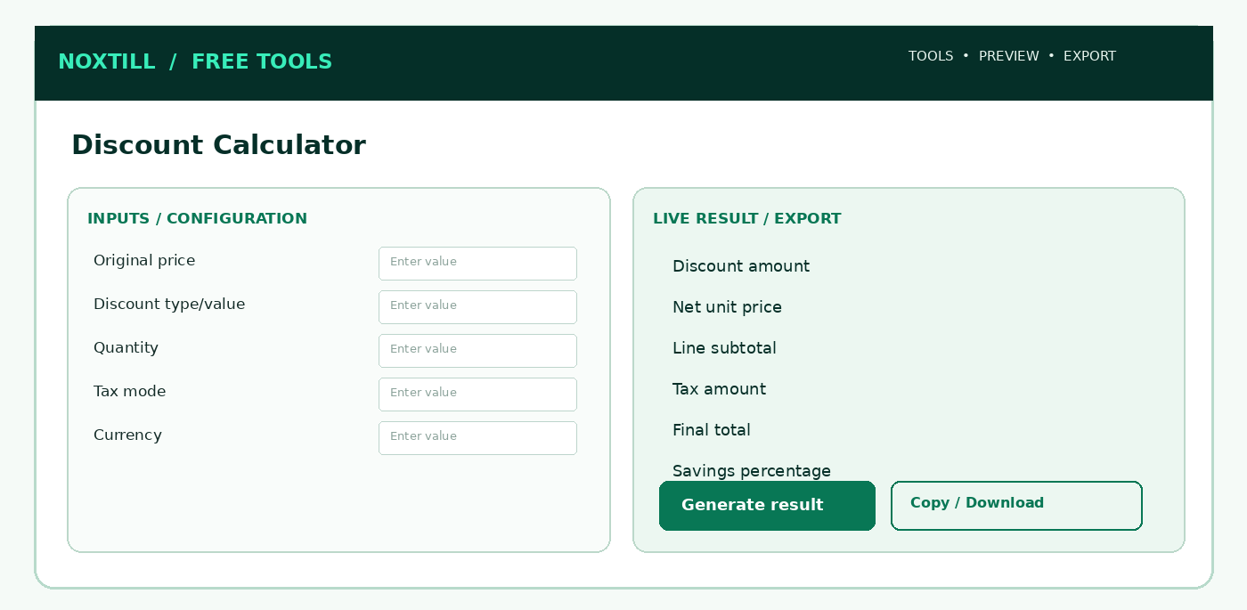
Figure 5. Proposed responsive desktop workbench structure for Discount Calculator; this is a functional wireframe, not a production screenshot.

1.1 Screens, sections and frontend interaction
Use one indexable public utility route with client-side interactive panels, drawers and modals rather than creating unnecessary Noxtill top-level navigation modules. The following are screen AREAS or subviews, not extra canonical sidebar modules:
1. Calculator tab: price, quantity, discount model and optional tax.
2. Detailed steps drawer: show ordered stacking effects and net/tax distinction.
3. Batch mode: bounded multi-line products with no server-side persistence.
4. Results/export tab: summary, copy, optional authorized pricing draft.

1.2 Step-by-step user workflow
1. Choose one discount mode: percentage, fixed amount, or sequential discount chain.
2. Enter original unit price and quantity; pick currency and locale.
3. If a tax option is enabled, explicitly select inclusive or exclusive pricing and supply user-entered tax rate.
4. Update live preview with transparent order of operations and breakdown.
5. Generate copyable receipt-style summary; reset should restore safe defaults.
6. Optional signed-in user explicitly applies validated proposal in the canonical catalog/campaign system.
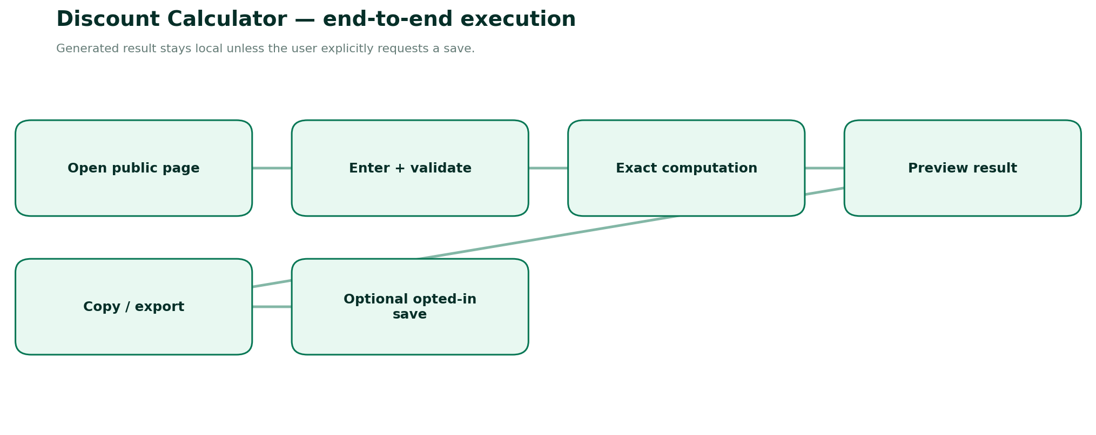
Figure 6. End-to-end execution and explicit persistence boundary for Discount Calculator.

1.3 Detailed form specification and validation dictionary
FIELD / CONTROL | TYPE | RULES, FEEDBACK AND SECURITY
originalUnitPrice | decimal string | Required; ≥0, max configurable; reject exponent/NaN; 2+ currency-aware precision.
quantity | integer | Required; 1..100000; no fractional quantity unless explicit unit quantity mode.
currency | ISO 4217 | Required; default USD; minor unit rules per currency.
discountMode | enum | percent | fixed_per_unit | fixed_line | sequential.
discountPercent | decimal | 0..100; percentage in percent points, not fraction.
fixedAmount | decimal | 0..original eligible amount; clamp? never silently—display validation.
sequentialSteps | array | Each ordered step has type and amount; per-step calculated on remaining eligible base.
couponLabel | string | Optional descriptive only; never claims to validate an external merchant coupon.
taxMode | enum | none | exclusive | inclusive; never infer tax treatment.
taxRatePercent | decimal | 0..100 with jurisdiction note; user supplies rate.
roundingPolicy | enum | Use explicit standard: decimal half-up at line totals, currency minor units; disclose.
resultBreakdown | read-only | Original total; each discount; taxable base; tax; final total; savings.

1.4 Calculation / composition rules
1. gross = unitPrice × quantity; percentageDiscount = gross × percent / 100; fixed_line_discount = fixedAmount; fixed_unit_discount = fixedAmount × quantity.
2. Sequential discounts operate on the remaining base in entered order; 20% then 10% ≠ 30% (it is 28%).
3. For exclusive tax: tax = rounded(discountedSubtotal × taxRate/100); final = discountedSubtotal + tax.
4. For inclusive tax: includedTax = discountedSubtotal - discountedSubtotal/(1 + taxRate/100); total stays discountedSubtotal.
5. Use arbitrary-precision decimal math; guard percent=100, zeros, and currencies without minor units. State line-vs-document rounding model.
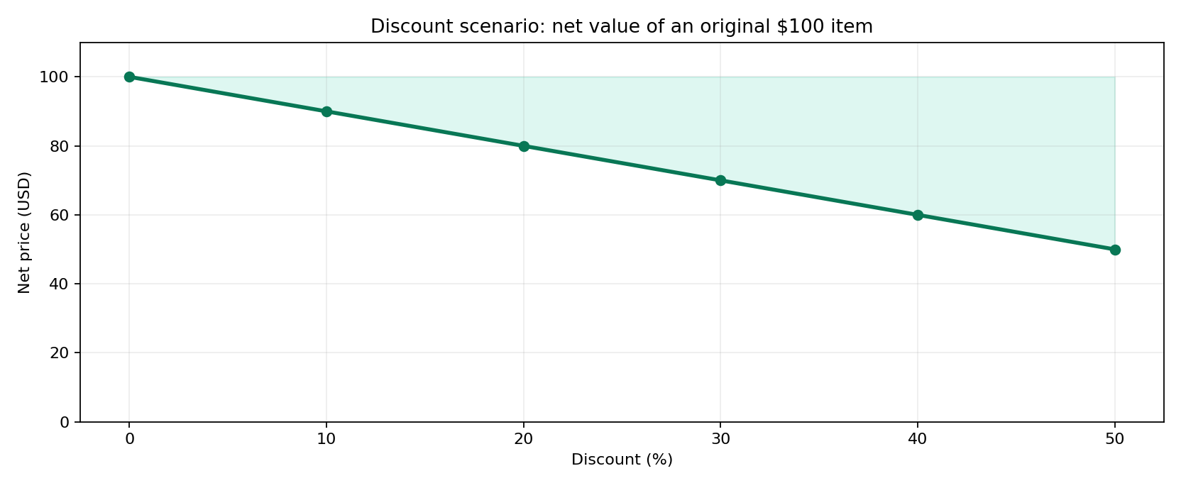
Reference graph. Savings comparison for the discount tool (illustrative inputs).

1.5 Frontend build detail — React/Next.js
- Form composition: Create FT-01ClientPage as a publicly accessible feature entry. Use React Hook Form or existing Noxtill form pattern with Zod; type each field as in §1.3.
- Calculation lifecycle: Only run on validated canonical inputs. Debounce outputs that are expensive; for lightweight math compute immediately. Keep last valid result visibly stale if invalid edits occur.
- Result area: Show primary metrics from Discount amount, Net unit price, Line subtotal, Tax amount with exact units/assumptions, copy/export, and a human-readable computation explanation.
- Responsive behavior: ≥1024 px use two-column inputs/results; tablet stack/resize; mobile single column with sticky result-action (not an overlay hiding fields).
- Accessibility: Use fieldset/legend for mode groups, aria-describedby for hints/errors, keyboard focus restoration for modals, clear contrast, aria-live for final result only.
- Loading/failure: Render/print may take time; show real loading progress, cancel if supported; disable duplicate download. Preserve inputs and provide safe retry.
- Anonymous & authenticated: No login gating on primary function. Optional Save to Noxtill is a separate user click, opens a permission/consent confirmation and uses canonical API.
- Security: Treat every pasted/typed field as untrusted text; URL validation, escaping, length caps and no unsanitized HTML. Do not send raw inputs as marketing analytics.

1.6 Backend services, API contracts and source-of-truth
- Shared pure calculation package implements Decimal.js or equivalent; same version used on client preview and server verification.
- Optional POST compute endpoint verifies schema, returns formula version and calculation trace; local mode remains functional with no backend.
- Never accept browser-provided totals for durable Noxtill prices; recalculate server-side on authorized save.
- Enforce rate limits, request size caps, country/currency settings and immutable audit when offer is actually applied.
METHOD | ENDPOINT | SERVICE BEHAVIOUR
POST | /api/public/tools/discount/calculate | Optional deterministic server recomputation
POST | /api/private/tools/discount/apply-proposal | Authorized; creates draft in canonical campaign/pricing workflow

Request DTO illustration. Names and versioning are proposed—reconcile with the existing Noxtill API conventions before implementation:
{
"tool": "discount-calculator",
"version": "v1",
"input": {
"originalUnitPrice": "100.00",
"quantity": 2,
"currency": "USD",
"discountMode": "percent",
"discountPercent": "20",
"taxMode": "none"
}
}
Calculation/render contract sketch (typed pseudocode, not drop-in production code):
function discount(input) {
const gross = D(input.originalUnitPrice).times(input.quantity);
let remaining = gross;
for (const step of expandOrderedDiscounts(input)) {
const amount = step.type === 'percent'
? remaining.times(D(step.value).div(100)) : D(step.amount);
assert(amount.gte(0) && amount.lte(remaining));
remaining = remaining.minus(amount);
}
const net = currencyRound(remaining, input.currency);
const tax = computeTaxWithExplicitMode(net, input.taxMode);
return { gross, discounts: gross.minus(net), net, tax, total: net.plus(tax) };
}

1.7 Database and persistence policy
None anonymously. Signed-in draft promotion references only canonical products/campaigns; actor, tenant, approval and math version audited.
CONCEPT / RESOURCE | OWNERSHIP AND RETENTION POLICY
Anonymous runs | Ephemeral browser state; no row in shared Noxtill CRM/marketing table.
Optional result artifact | Generate short-lived download in memory; if cloud export is unavoidable, use expiring private storage and secure deletion.
Authenticated saves | Stateless public calculator; authorized optional product/pricing handoff belongs to Products & Services / Orders / Marketing, never public utility tables.
Audit and idempotency | Only actual canonical business writes generate activity/audit events, permission checks and idempotency; copy/download is not a business transaction.
Analytics | Event name, tool slug, status/error group, duration and coarse locale; never raw contacts, prices linked to identity, document contents or UTM private values.

1.8 Edge cases, alerts and error-state design
- Percentage above 100 or negative price: inline field error; result remains last valid state with stale warning.
- Fixed reduction exceeds eligible amount: reject, do not silently create negative totals.
- Changing currency must never convert a numeric price implicitly; request explicit reset/conversion.
- Tax-inclusive and tax-exclusive modes must not be mixed in one value.
Additional all-tool negative paths: locale changed mid-edit; browser clipboard denied; mobile narrow viewport; offline state; malformed JSON/overlong payload; double-click on export; stale last-valid preview; authenticated session expiration during optional save; provider integration not configured; cross-tenant resource ID attempts. These must have deterministic user-facing outcomes and logged request IDs where a server is involved.

1.9 Noxtill integration boundaries and events
Canonical mapping: Stateless public calculator; authorized optional product/pricing handoff belongs to Products & Services / Orders / Marketing, never public utility tables.
Recommended events: tool.opened (anonymous aggregate), tool.input_validated (no value payload), tool.result_generated (outcome only), tool.export_completed (file type only), tool.save_requested (authenticated), tool.save_confirmed (only after canonical service success), tool.save_failed (reason code only). Do not send phone/email/URLs/invoice parties in generic tracking events. Integrations execute only when the user elects to save/import/apply.

1.10 Verification vectors and acceptance criteria
1. 100 × 2 with 20% discount → discount 40, net 160 before tax.
2. 100 with 20% then 10% → 72 final, 28% effective discount.
3. 100 net after 10% tax-exclusive → 110; with zero discount.
4. A 100%-off discount yields zero due; no negative taxes.
5. Decimal .005 half-up behavior verified for chosen currency policy.
6. RTL locale, keyboard-only, narrow screens and screen-reader updated output.
DEFINITION OF DONE
A user can complete the stated tool task anonymously, input validation and all listed edge cases work, calculations/encoded output round-trip correctly, mobile/keyboard/screen-reader paths pass, export is semantically consistent with on-screen result, and any authenticated mutation is verified by the canonical owner. The tool may only advertise capabilities actually implemented and passing acceptance tests.
OFFICIAL REFERENCES
R8, R9 — see the full source register and implementation caveats at the end of this document.

FT-02 — Profit Margin Calculator
PUBLIC ROUTE: /FREE-TOOLS/PROFIT-MARGIN-CALCULATOR / UNIT ECONOMICS AND PROFITABILITY
Product promise. Explain gross margin, markup, break-even contribution and target selling price without confusing revenue with profit.
Target audience. Sellers, freelancers, store owners, service operators evaluating pricing and cost structure.
Data ownership. Public sandbox; any persistent unit-cost record belongs to Products & Services / Finance & Accounting / Profit & Analytics.
How it works — Roman Urdu: Profit Margin mein percent ka denominator selling price hota hai, jabke markup ka denominator cost hai. Dono ko mix karna pricing ka serious error hai.
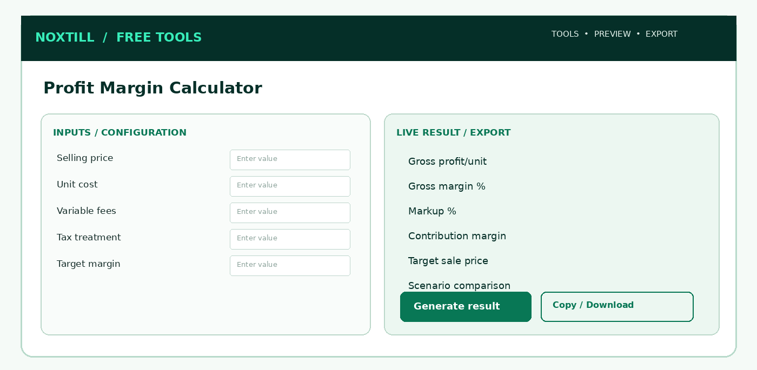
Figure 7. Proposed responsive desktop workbench structure for Profit Margin Calculator; this is a functional wireframe, not a production screenshot.

2.1 Screens, sections and frontend interaction
Use one indexable public utility route with client-side interactive panels, drawers and modals rather than creating unnecessary Noxtill top-level navigation modules. The following are screen AREAS or subviews, not extra canonical sidebar modules:
1. Margin calculator: price and all variable direct costs in visible rows.
2. Target price mode: reverse compute with non-solvable state.
3. Scenario comparison: up to three side-by-side cases.
4. Formula glossary: net price, contribution, gross margin vs markup.

2.2 Step-by-step user workflow
1. Choose sales-cost basis: before-tax sales price by default; explain exclusions.
2. Enter direct unit cost, optional packaging, shipping, variable platform/payment fees and returns allowance.
3. Compute profit and margin, show markup separately; show tooltips with denominator definitions.
4. Use target margin mode to reverse-calculate price; surface infeasible 100% cases.
5. Compare up to three editable scenarios side-by-side and show sensitivity chart.
6. Copy/export assumptions and result; optional authorized link to product cost record.
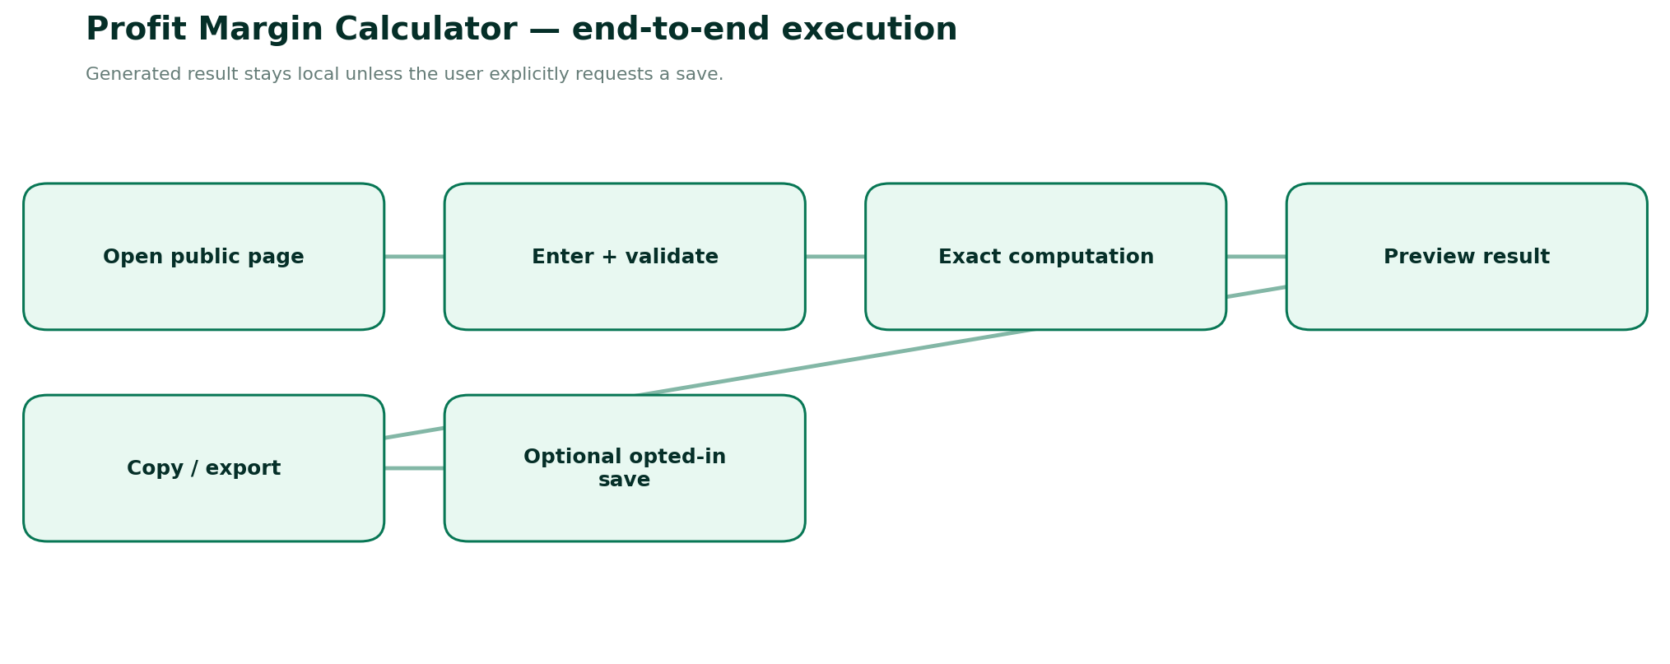
Figure 8. End-to-end execution and explicit persistence boundary for Profit Margin Calculator.

2.3 Detailed form specification and validation dictionary
FIELD / CONTROL | TYPE | RULES, FEEDBACK AND SECURITY
salePrice | decimal string | Currency amount excluding sales tax by default.
costOfGoods | decimal string | Direct unit cost; no speculative default.
packaging | decimal string | Optional unit-level cost ≥0.
shippingSubsidy | decimal string | Optional seller-borne unit shipping cost ≥0.
paymentFeeFixed | decimal string | Optional fixed fee per unit/order; warn about allocation basis.
paymentFeePercent | decimal string | Percent of sales price, 0..100; not compounded with flat fee.
returnAllowancePercent | decimal string | Expected return/loss assumption; modeling only, not guaranteed.
targetGrossMargin | decimal string | 0..<100%; cannot solve 100% positive costs.
scenarioName | string | Comparison label, no PII required.
currency | ISO 4217 | Display code and grouping; avoid currency conversion.
negativeMarginWarning | derived | Reveal losses and zero denominator.
marginVsMarkup | derived | Show values as distinct metrics and formulas.

2.4 Calculation / composition rules
1. Direct cost C = COGS + packaging + seller shipping + allocable fixed fees + modeled allowances.
2. Profit P = net sale price S − C − percentFee × S. Margin = P / S × 100 if S>0; markup = P / C ×100 if C>0.
3. For a target margin m with percentage variable fee r: target S = C / (1 − m − r); invalid if denominator ≤0.
4. If fee or return assumption depends on sale price, document exact modeling choice and solve algebraically rather than iteration without convergence guards.
5. An illustrated unit sale at S=100, C=60 yields 40% margin and 66.67% markup, before any other fees.

2.5 Frontend build detail — React/Next.js
- Form composition: Create FT-02ClientPage as a publicly accessible feature entry. Use React Hook Form or existing Noxtill form pattern with Zod; type each field as in §2.3.
- Calculation lifecycle: Only run on validated canonical inputs. Debounce outputs that are expensive; for lightweight math compute immediately. Keep last valid result visibly stale if invalid edits occur.
- Result area: Show primary metrics from Gross profit/unit, Gross margin %, Markup %, Contribution margin with exact units/assumptions, copy/export, and a human-readable computation explanation.
- Responsive behavior: ≥1024 px use two-column inputs/results; tablet stack/resize; mobile single column with sticky result-action (not an overlay hiding fields).
- Accessibility: Use fieldset/legend for mode groups, aria-describedby for hints/errors, keyboard focus restoration for modals, clear contrast, aria-live for final result only.
- Loading/failure: Render/print may take time; show real loading progress, cancel if supported; disable duplicate download. Preserve inputs and provide safe retry.
- Anonymous & authenticated: No login gating on primary function. Optional Save to Noxtill is a separate user click, opens a permission/consent confirmation and uses canonical API.
- Security: Treat every pasted/typed field as untrusted text; URL validation, escaping, length caps and no unsanitized HTML. Do not send raw inputs as marketing analytics.

2.6 Backend services, API contracts and source-of-truth
- Pure stateless Decimal engine; return contribution layers, formula model version and warnings.
- No data linkage to real Profit module without user confirmation, authentication and validated product mapping.
- Explicitly distinguish unit gross margin, contribution margin and operating/net margin; tool does not know business overhead by default.
- Optional CSV input sandbox can process up to bounded rows locally; file never uploaded unless explicit permission.
METHOD | ENDPOINT | SERVICE BEHAVIOUR
POST | /api/public/tools/margin/calculate | Optional formula validation and scenario results
POST | /api/private/tools/margin/save-scenario | Opt-in save to authorized analytical scenario service

Request DTO illustration. Names and versioning are proposed—reconcile with the existing Noxtill API conventions before implementation:
{
"tool": "profit-margin-calculator",
"version": "v1",
"input": {
"salePrice": "100.00",
"costOfGoods": "60.00",
"paymentFeePercent": "0",
"targetGrossMargin": "40",
"currency": "USD"
}
}
Calculation/render contract sketch (typed pseudocode, not drop-in production code):
const sale = D(input.salePrice);
const feeRate = D(input.paymentFeePercent).div(100);
const direct = sumDirectCosts(input);
const contribution = sale.minus(direct).minus(sale.times(feeRate));
const marginPct = sale.gt(0) ? contribution.div(sale).times(100) : null;
const markupPct = direct.gt(0) ? contribution.div(direct).times(100) : null;
const targetPrice = (D(1).minus(targetMargin).minus(feeRate)).gt(0)
? direct.div(D(1).minus(targetMargin).minus(feeRate)) : null;

2.7 Database and persistence policy
Anonymous runs ephemeral; signed-in optional scenario stores assumptions separately from approved ledger and products.
CONCEPT / RESOURCE | OWNERSHIP AND RETENTION POLICY
Anonymous runs | Ephemeral browser state; no row in shared Noxtill CRM/marketing table.
Optional result artifact | Generate short-lived download in memory; if cloud export is unavoidable, use expiring private storage and secure deletion.
Authenticated saves | Public sandbox; any persistent unit-cost record belongs to Products & Services / Finance & Accounting / Profit & Analytics.
Audit and idempotency | Only actual canonical business writes generate activity/audit events, permission checks and idempotency; copy/download is not a business transaction.
Analytics | Event name, tool slug, status/error group, duration and coarse locale; never raw contacts, prices linked to identity, document contents or UTM private values.

2.8 Edge cases, alerts and error-state design
- Zero selling price: margin undefined; show “Not defined,” never Infinity.
- Zero cost: markup undefined; margin can still be 100% at positive sale.
- Target margin plus fees ≥100%: reject target calculation.
- Negative costs and invalid percentages produce specific field errors.
Additional all-tool negative paths: locale changed mid-edit; browser clipboard denied; mobile narrow viewport; offline state; malformed JSON/overlong payload; double-click on export; stale last-valid preview; authenticated session expiration during optional save; provider integration not configured; cross-tenant resource ID attempts. These must have deterministic user-facing outcomes and logged request IDs where a server is involved.

2.9 Noxtill integration boundaries and events
Canonical mapping: Public sandbox; any persistent unit-cost record belongs to Products & Services / Finance & Accounting / Profit & Analytics.
Recommended events: tool.opened (anonymous aggregate), tool.input_validated (no value payload), tool.result_generated (outcome only), tool.export_completed (file type only), tool.save_requested (authenticated), tool.save_confirmed (only after canonical service success), tool.save_failed (reason code only). Do not send phone/email/URLs/invoice parties in generic tracking events. Integrations execute only when the user elects to save/import/apply.

2.10 Verification vectors and acceptance criteria
1. S=100 C=60 yields 40% margin and 66.67% markup.
2. C=60 target margin 40% yields selling price 100.
3. C=60, target margin 40%, sales-based fee 10% yields selling price 120.
4. Loss S=40 C=60 yields margin −50%, not +33%.
5. S=0 correctly signals undefined denominator.
6. Chart/table agree to same decimal version in all locales.
DEFINITION OF DONE
A user can complete the stated tool task anonymously, input validation and all listed edge cases work, calculations/encoded output round-trip correctly, mobile/keyboard/screen-reader paths pass, export is semantically consistent with on-screen result, and any authenticated mutation is verified by the canonical owner. The tool may only advertise capabilities actually implemented and passing acceptance tests.
OFFICIAL REFERENCES
R8, R9 — see the full source register and implementation caveats at the end of this document.

FT-03 — Break-Even Calculator
PUBLIC ROUTE: /FREE-TOOLS/BREAK-EVEN-CALCULATOR / CONTRIBUTION ECONOMICS AND SCENARIOS
Product promise. Find units or revenue needed to cover costs, visualize contribution, and reveal cases where break-even is impossible.
Target audience. Small-business founders, consultants, owners planning services, subscriptions or product lines.
Data ownership. Standalone sandbox assumptions; Profit & Analytics owns persistent operational performance.
How it works — Roman Urdu: Rent jaise fixed costs aur har sale ke saath badhne wali variable cost alag rakhein. Chart tabhi crossing show kare jab per-unit contribution positive ho.
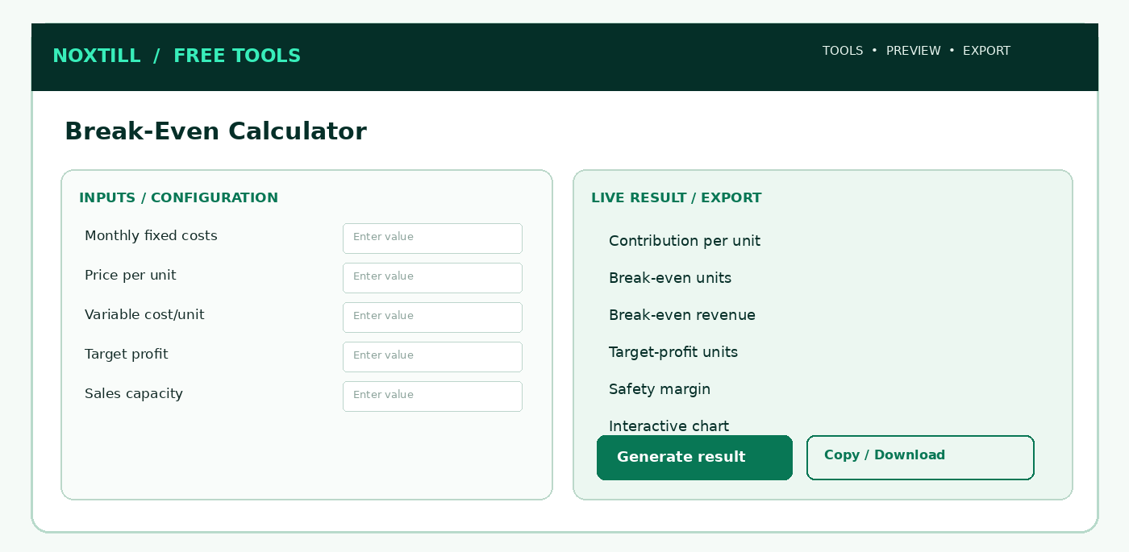
Figure 9. Proposed responsive desktop workbench structure for Break-Even Calculator; this is a functional wireframe, not a production screenshot.

3.1 Screens, sections and frontend interaction
Use one indexable public utility route with client-side interactive panels, drawers and modals rather than creating unnecessary Noxtill top-level navigation modules. The following are screen AREAS or subviews, not extra canonical sidebar modules:
1. Inputs panel: fixed and variable costs, sales period, target.
2. Interactive break-even chart: cost/revenue with labelled intersection.
3. Scenario sensitivity: manual changes to price/cost/capacity.
4. Export panel: assumptions, whole-unit threshold and methodology.

3.2 Step-by-step user workflow
1. Pick unit of analysis (item, service, customer, booking) and period (monthly by default).
2. Enter fixed costs, price and variable costs; include helper fields and transparent sum.
3. Calculate contribution per unit and mathematical break-even quantity.
4. Round up break-even units for indivisible units, retaining theoretical calculation for explanation.
5. Draw revenue/fixed+variable cost lines and highlight intersection; support target profit slider.
6. Compare scenarios and download table/PNG chart; optionally save authorized analysis.
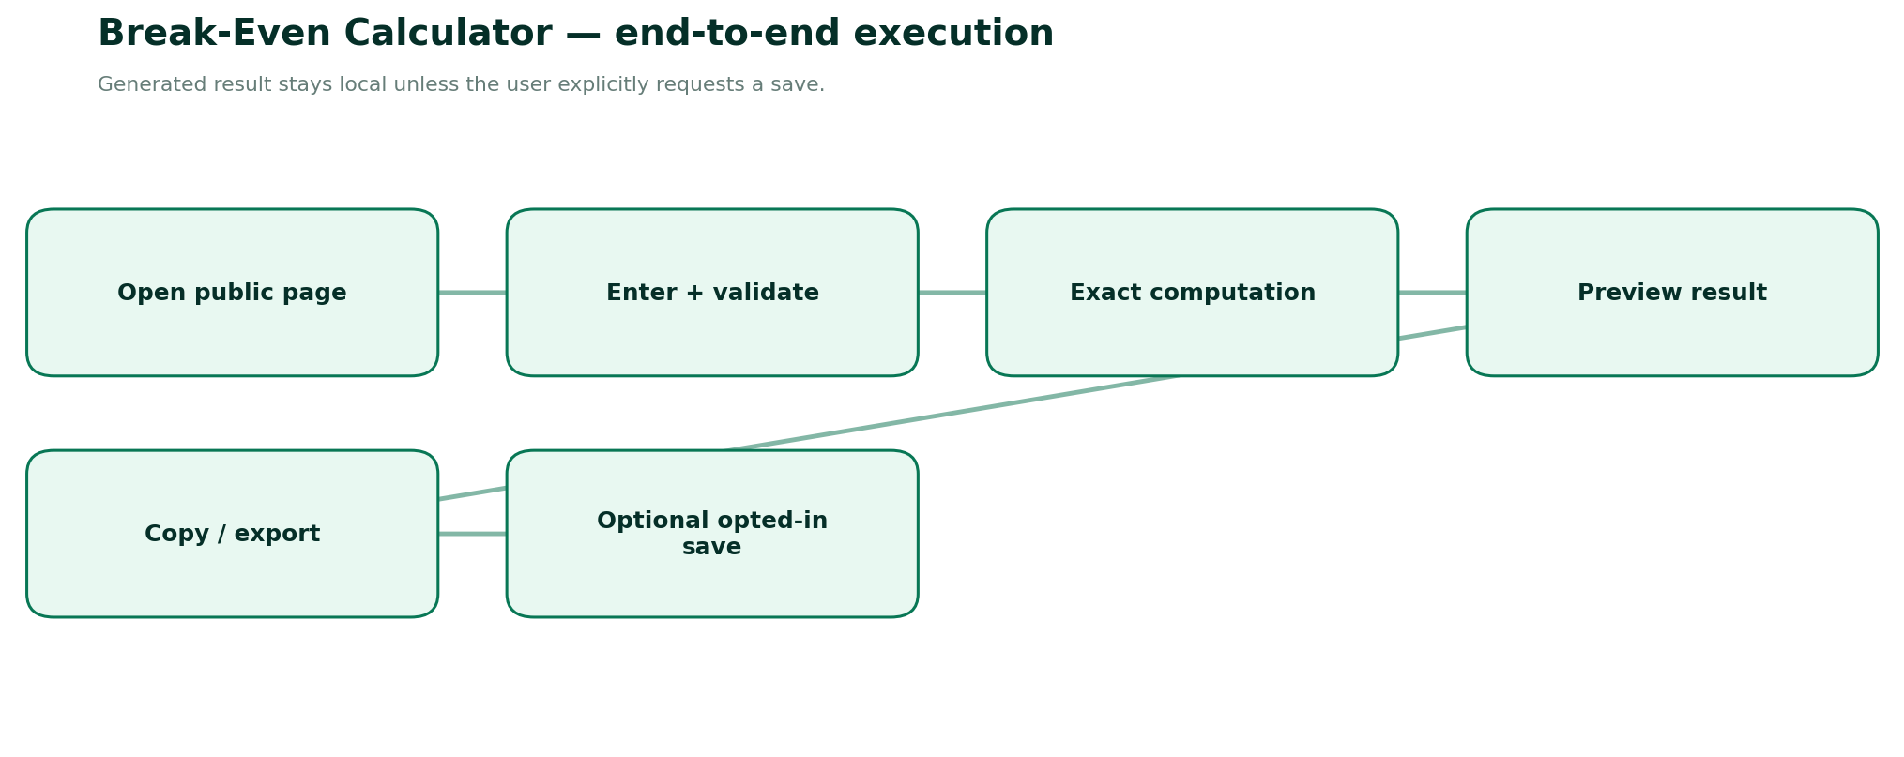
Figure 10. End-to-end execution and explicit persistence boundary for Break-Even Calculator.

3.3 Detailed form specification and validation dictionary
FIELD / CONTROL | TYPE | RULES, FEEDBACK AND SECURITY
period | enum | month | week | year with explicit unit consistency; no automatic reclassification of costs.
unitLabel | string | Item/service/customer, max 48 characters.
fixedCosts | decimal | Nonnegative: rent, base payroll, insurance and other fixed costs.
sellingPricePerUnit | decimal | Positive price excluding applicable collected taxes.
variableCostPerUnit | decimal | Nonnegative; including variable fees if relevant.
targetProfit | decimal | Nonnegative desired operating contribution above fixed costs.
expectedSalesUnits | integer | Optional, used for safety margin.
capacityCeiling | integer | Optional; flag infeasible operating capacity.
rounding | derived | Ceil for discrete break-even units.
profitProjection | derived | Contribution × units − fixed costs.
sensitivity | array | 2-3 alternative scenarios, each separately validated.
visualizationData | array | Bounded points, zero + break-even + capacity labels.

3.4 Calculation / composition rules
1. Contribution C = unit selling price P − unit variable cost V.
2. Break-even quantity Q* = fixedCosts / C if C>0. Required whole units = ceil(Q*).
3. Break-even revenue in continuous model = fixedCosts /(C/P), if P>0 and C>0. Revenue at whole-unit threshold = ceil(Q*) × P.
4. Target profit units = ceil((fixedCosts + targetProfit) / C).
5. Safety margin units = forecastUnits − wholeUnitBreakEven; as % of forecast = marginUnits / forecastUnits, forecast>0.
6. No break-even with C≤0 when fixed costs>0; at fixedCosts=0 and C>0, zero units mathematically covers fixed costs.
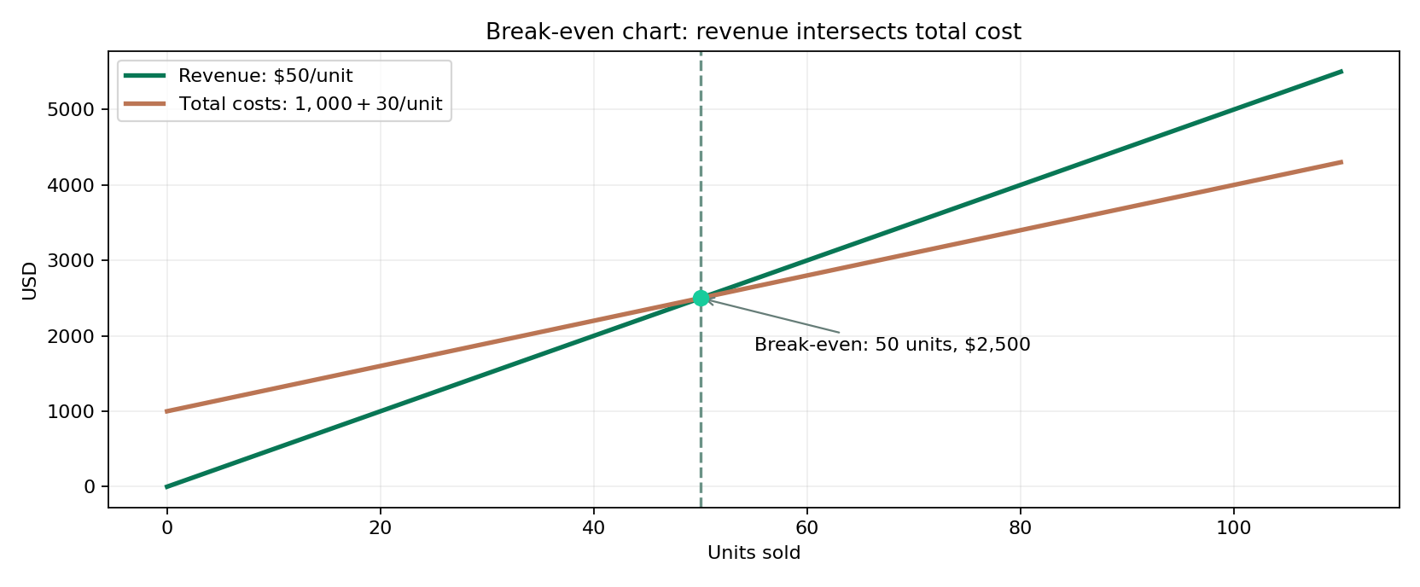
Reference graph. Revenue versus total cost and the mathematical break-even crossing.

3.5 Frontend build detail — React/Next.js
- Form composition: Create FT-03ClientPage as a publicly accessible feature entry. Use React Hook Form or existing Noxtill form pattern with Zod; type each field as in §3.3.
- Calculation lifecycle: Only run on validated canonical inputs. Debounce outputs that are expensive; for lightweight math compute immediately. Keep last valid result visibly stale if invalid edits occur.
- Result area: Show primary metrics from Contribution per unit, Break-even units, Break-even revenue, Target-profit units with exact units/assumptions, copy/export, and a human-readable computation explanation.
- Responsive behavior: ≥1024 px use two-column inputs/results; tablet stack/resize; mobile single column with sticky result-action (not an overlay hiding fields).
- Accessibility: Use fieldset/legend for mode groups, aria-describedby for hints/errors, keyboard focus restoration for modals, clear contrast, aria-live for final result only.
- Loading/failure: Render/print may take time; show real loading progress, cancel if supported; disable duplicate download. Preserve inputs and provide safe retry.
- Anonymous & authenticated: No login gating on primary function. Optional Save to Noxtill is a separate user click, opens a permission/consent confirmation and uses canonical API.
- Security: Treat every pasted/typed field as untrusted text; URL validation, escaping, length caps and no unsanitized HTML. Do not send raw inputs as marketing analytics.

3.6 Backend services, API contracts and source-of-truth
- Deterministic scenario service with versioned assumptions; calculation can be fully local.
- Chart points generated over valid bounded range; do not plot fake “intersection” when no BE.
- PDF/CSV export includes assumptions, period and not-financial-advice label.
- Conditional persistence only through authorized scenario/inventory forecast owner, not accounting ledger.
METHOD | ENDPOINT | SERVICE BEHAVIOUR
POST | /api/public/tools/break-even/calculate | Optional verified calculation and chart series
POST | /api/private/tools/break-even/save-scenario | Explicit save to analysis scenario

Request DTO illustration. Names and versioning are proposed—reconcile with the existing Noxtill API conventions before implementation:
{
"tool": "break-even-calculator",
"version": "v1",
"input": {
"fixedCosts": "1000",
"sellingPricePerUnit": "50",
"variableCostPerUnit": "30",
"targetProfit": "400",
"period": "month",
"currency": "USD"
}
}
Calculation/render contract sketch (typed pseudocode, not drop-in production code):
const contribution = D(input.sellingPricePerUnit).minus(input.variableCostPerUnit);
if (contribution.lte(0)) return { possible: false, reason: 'NON_POSITIVE_CONTRIBUTION' };
const exactQty = D(input.fixedCosts).div(contribution);
const wholeUnits = exactQty.ceil();
const revenueAtThreshold = wholeUnits.times(D(input.sellingPricePerUnit));
return { exactQty, wholeUnits, revenueAtThreshold,
profitAtThreshold: wholeUnits.times(contribution).minus(input.fixedCosts) };

3.7 Database and persistence policy
None anonymously; opt-in named scenario with tenant ID, selected period and formula version.
CONCEPT / RESOURCE | OWNERSHIP AND RETENTION POLICY
Anonymous runs | Ephemeral browser state; no row in shared Noxtill CRM/marketing table.
Optional result artifact | Generate short-lived download in memory; if cloud export is unavoidable, use expiring private storage and secure deletion.
Authenticated saves | Standalone sandbox assumptions; Profit & Analytics owns persistent operational performance.
Audit and idempotency | Only actual canonical business writes generate activity/audit events, permission checks and idempotency; copy/download is not a business transaction.
Analytics | Event name, tool slug, status/error group, duration and coarse locale; never raw contacts, prices linked to identity, document contents or UTM private values.

3.8 Edge cases, alerts and error-state design
- Price ≤ variable cost with positive fixed costs: show “No attainable break-even at these inputs.”
- Capacity below break-even: red warning without inventing better outcome.
- Changing period warns that inputs need consistent units.
- Huge ranges downsample chart and preserve exact numerical result.
Additional all-tool negative paths: locale changed mid-edit; browser clipboard denied; mobile narrow viewport; offline state; malformed JSON/overlong payload; double-click on export; stale last-valid preview; authenticated session expiration during optional save; provider integration not configured; cross-tenant resource ID attempts. These must have deterministic user-facing outcomes and logged request IDs where a server is involved.

3.9 Noxtill integration boundaries and events
Canonical mapping: Standalone sandbox assumptions; Profit & Analytics owns persistent operational performance.
Recommended events: tool.opened (anonymous aggregate), tool.input_validated (no value payload), tool.result_generated (outcome only), tool.export_completed (file type only), tool.save_requested (authenticated), tool.save_confirmed (only after canonical service success), tool.save_failed (reason code only). Do not send phone/email/URLs/invoice parties in generic tracking events. Integrations execute only when the user elects to save/import/apply.

3.10 Verification vectors and acceptance criteria
1. Fixed 1000, price 50, variable 30 → 50 units; 2500 revenue.
2. Fixed 1001, price 50, variable 30 → ceil(50.05)=51 units; whole-unit revenue 2550.
3. Variable=price yields no break-even if fixed>0.
4. Fixed 0 and contribution>0 yields 0 whole break-even units.
5. Target profit 400 on fixed1000 and contribution20 → 70 units.
6. Chart and table data match at intersection.
DEFINITION OF DONE
A user can complete the stated tool task anonymously, input validation and all listed edge cases work, calculations/encoded output round-trip correctly, mobile/keyboard/screen-reader paths pass, export is semantically consistent with on-screen result, and any authenticated mutation is verified by the canonical owner. The tool may only advertise capabilities actually implemented and passing acceptance tests.
OFFICIAL REFERENCES
R8 — see the full source register and implementation caveats at the end of this document.

FT-04 — Invoice Generator
PUBLIC ROUTE: /FREE-TOOLS/INVOICE-GENERATOR / DOCUMENT COMPOSITION, TAX-SENSITIVE METADATA
Product promise. Create a professional downloadable invoice-style document with precise totals, editable details and clear limits on legal/tax compliance.
Target audience. Freelancers and small-business users who need PDF documents without creating an account.
Data ownership. Anonymous output is a local downloadable document only. Signed-in actual invoice issuance must be handled by canonical Orders; finance and payment status remain canonical owners.
How it works — Roman Urdu: Free invoice ek downloadable draft/document banata hai. Noxtill ke Orders ke actual issued invoice, numbering, due amount aur paid status wahi canonical Orders/Payments APIs confirm karenge.
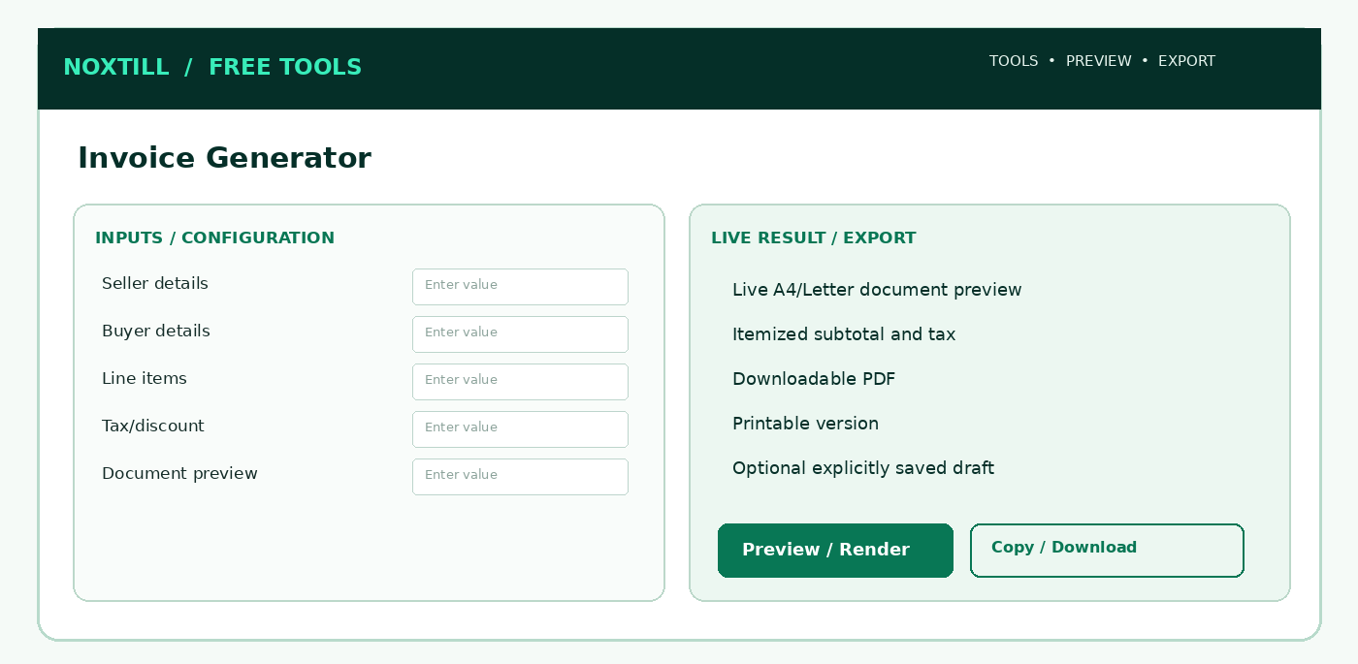
Figure 11. Proposed responsive desktop workbench structure for Invoice Generator; this is a functional wireframe, not a production screenshot.

4.1 Screens, sections and frontend interaction
Use one indexable public utility route with client-side interactive panels, drawers and modals rather than creating unnecessary Noxtill top-level navigation modules. The following are screen AREAS or subviews, not extra canonical sidebar modules:
1. Seller/buyer details wizard panel, document mode and country warning.
2. Editable line-items grid and per-line discount/tax input.
3. Full paginated invoice preview, A4/Letter and print preview.
4. Export/download + explicit save draft confirmation; no “send invoice” without canonical module integration.

4.2 Step-by-step user workflow
1. Select invoice-like document type and locale; explain this generator is not jurisdiction-certified.
2. Enter seller/buyer contact details, document label/reference, issue date, supply date, due date and currency.
3. Add/remove/reorder item rows with quantity, unit, unit price, per-line discount, optional tax category/rate.
4. Preview calculated totals, rounding, footer notes and payment instructions; validate mandatory fields for selected locale template.
5. Preview all pages in print layout, support A4/Letter, deterministic pagination and PDF accessibility text.
6. Download locally or request short-lived stateless export; ask for explicit opt-in before saving to Noxtill account.
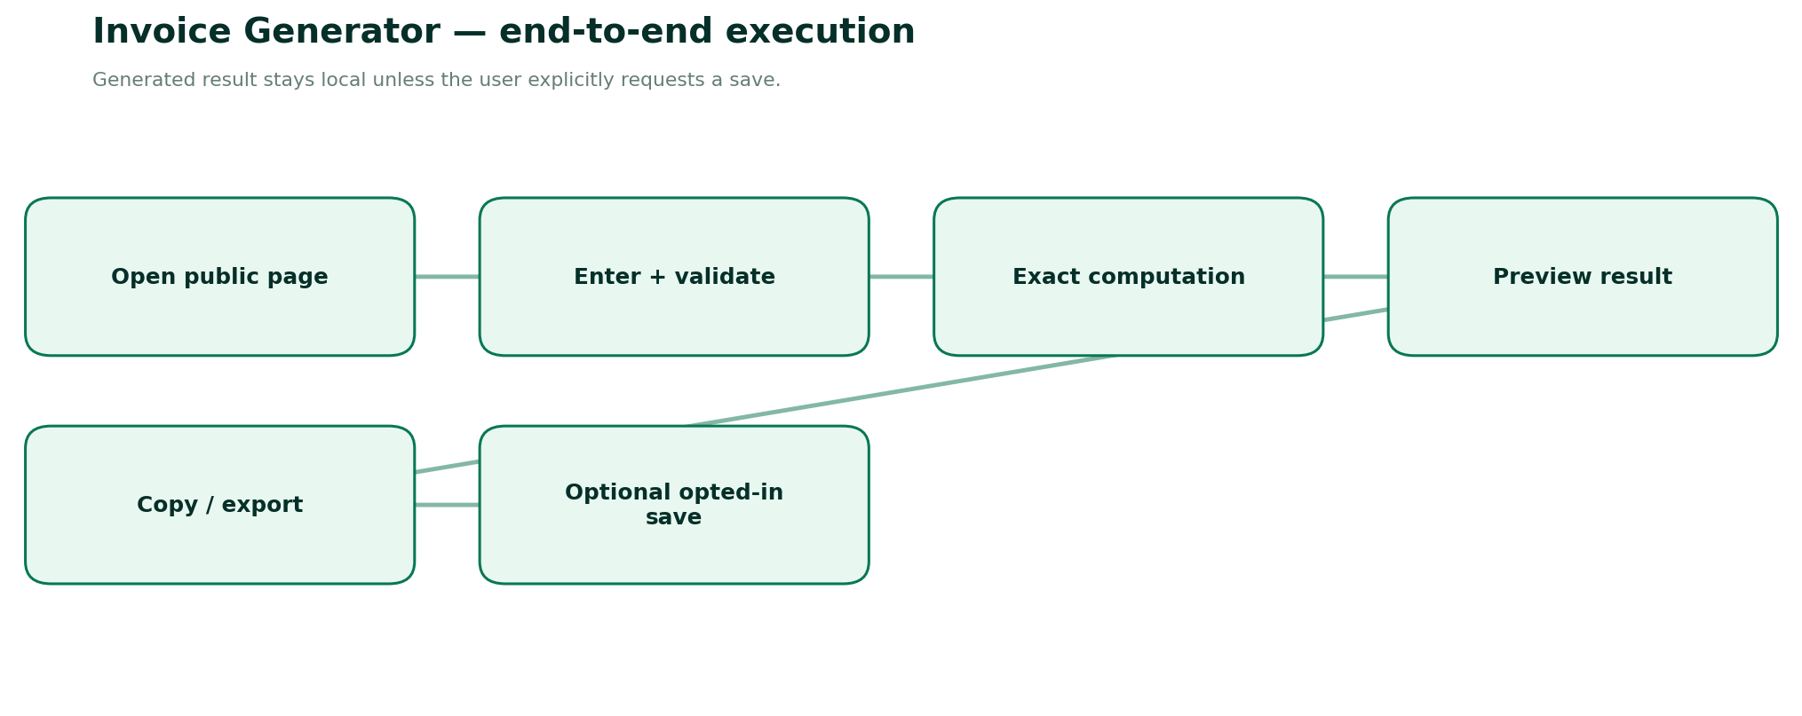
Figure 12. End-to-end execution and explicit persistence boundary for Invoice Generator.

4.3 Detailed form specification and validation dictionary
FIELD / CONTROL | TYPE | RULES, FEEDBACK AND SECURITY
documentMode | enum | basic commercial invoice preview | estimate; lawful official tax invoice only in supported country workflows.
sellerNameAddress | text | Required for commercial invoice; sanitize line breaks and length.
sellerContact | text | Optional email/phone; no automatic marketing collection.
buyerNameAddress | text | Invoice destination; do not send to third party without user action.
documentNumber | string | Anonymous user-supplied reference, not guaranteed legal sequential numbering.
issueDate | ISO date | Required; user-selected timezone/locale display.
supplyDate | ISO date | When applicable; avoid inference.
dueDate | ISO date | Optional; compare with issue date and warn as needed.
currency | ISO 4217 | Single document currency; mixed-currency line items not supported.
lineItems | array | 1..100; label, details, quantity, unit price, tax rate/category, discount.
taxIdentifiers | text | Jurisdiction-specific optional; do not validate tax registration ownership.
taxTreatment | enum | No tax | per-line exclusive | inclusive; explicit.
sellerLogo | image | Optional client-side, bounded bytes and type; strip metadata.
paymentInstructions | string | User-entered only; warn against pasting sensitive card/bank secrets.
notesTerms | text | Bounded length, sanitized; not legal advice.
pageSize | enum | A4 | US Letter; print margins and overflow checks.
consentToSave | boolean | False by default; only for authenticated save.

4.4 Calculation / composition rules
1. Line base = quantity × unitPrice; line discount validated and applied prior to tax per chosen model.
2. Compute tax by jurisdiction-configured rules (not universal). Group amounts by explicit tax rate/category, show taxable base and tax separately.
3. Use decimal minor units and consistent round-per-line policy; discrepancy adjustment, if any, must be transparent rather than hidden.
4. Final due = subtotal − discounts + tax + shipping/other authorized charges − user-entered prepayments; negative due yields credit state only in capable canonical workflow.
5. Never claim issued/paid/sent merely because PDF was generated.

4.5 Frontend build detail — React/Next.js
- Form composition: Create FT-04ClientPage as a publicly accessible feature entry. Use React Hook Form or existing Noxtill form pattern with Zod; type each field as in §4.3.
- Calculation lifecycle: Only run on validated canonical inputs. Debounce outputs that are expensive; for lightweight math compute immediately. Keep last valid result visibly stale if invalid edits occur.
- Result area: Show primary metrics from Live A4/Letter document preview, Itemized subtotal and tax, Downloadable PDF, Printable version with exact units/assumptions, copy/export, and a human-readable computation explanation.
- Responsive behavior: ≥1024 px use two-column inputs/results; tablet stack/resize; mobile single column with sticky result-action (not an overlay hiding fields).
- Accessibility: Use fieldset/legend for mode groups, aria-describedby for hints/errors, keyboard focus restoration for modals, clear contrast, aria-live for final result only.
- Loading/failure: Render/print may take time; show real loading progress, cancel if supported; disable duplicate download. Preserve inputs and provide safe retry.
- Anonymous & authenticated: No login gating on primary function. Optional Save to Noxtill is a separate user click, opens a permission/consent confirmation and uses canonical API.
- Security: Treat every pasted/typed field as untrusted text; URL validation, escaping, length caps and no unsanitized HTML. Do not send raw inputs as marketing analytics.

4.6 Backend services, API contracts and source-of-truth
- Preferred anonymous generation occurs client-side where feasible; server-side PDF renderer optional for cross-device fidelity and accessibility.
- Use validated templating, escaping, HTML/CSS print sandbox or native PDF library; prohibit external URL fetch and script injection.
- Anonymous server render in memory with strict timeout, no long-term storage; no email sent without separate explicit permitted transaction.
- Do not generate legally official sequential invoice IDs for anonymous users. Authenticated issued invoice must call Orders API under tenant permissions and return canonical reference.
- Localized country invoice rules are feature-gated and legally reviewed per market; PDF invoice is not structured e-invoice compliance (EN 16931).
METHOD | ENDPOINT | SERVICE BEHAVIOUR
POST | /api/public/tools/invoice/render | Validated ephemeral PDF generation
POST | /api/private/orders/invoice-drafts | Canonical Orders draft with auth and idempotency
GET | /api/private/orders/invoice-drafts/:id | Owner-permitted retrieval (existing Orders contract)

Request DTO illustration. Names and versioning are proposed—reconcile with the existing Noxtill API conventions before implementation:
{
"tool": "invoice-generator",
"version": "v1",
"input": {
"seller": {
"name": "Example Business",
"city": "Austin, TX"
},
"buyer": {
"name": "Client Example"
},
"currency": "USD",
"lines": [
{
"description": "Consultation",
"quantity": "2",
"unitPrice": "50.00"
}
],
"taxMode": "none",
"pageSize": "LETTER"
}
}
Calculation/render contract sketch (typed pseudocode, not drop-in production code):
function renderInvoice(input) {
const safe = InvoiceInputSchema.parse(input);
const rows = safe.lines.map(x => computeLineWithDecimal(x, safe.taxPolicy));
const totals = aggregateByTaxCategory(rows, safe.currency);
const viewModel = escapeUntrustedInvoiceText({ ...safe, rows, totals });
return renderAccessiblePdf(viewModel, { page: safe.pageSize, noExternalFetch: true });
}
// Authentic issuance is a separate authorized Orders operation.

4.7 Database and persistence policy
Anonymous input kept in browser memory; no automatic uploads. Signed-in draft persisted only through Orders with tenant-scoped audit.
CONCEPT / RESOURCE | OWNERSHIP AND RETENTION POLICY
Anonymous runs | Ephemeral browser state; no row in shared Noxtill CRM/marketing table.
Optional result artifact | Generate short-lived download in memory; if cloud export is unavoidable, use expiring private storage and secure deletion.
Authenticated saves | Anonymous output is a local downloadable document only. Signed-in actual invoice issuance must be handled by canonical Orders; finance and payment status remain canonical owners.
Audit and idempotency | Only actual canonical business writes generate activity/audit events, permission checks and idempotency; copy/download is not a business transaction.
Analytics | Event name, tool slug, status/error group, duration and coarse locale; never raw contacts, prices linked to identity, document contents or UTM private values.

4.8 Edge cases, alerts and error-state design
- Missing seller name, empty item list or invalid money: block download with field focus.
- Logo exceeds size limit or malicious SVG: reject or rasterize safely offline.
- Long descriptions/pagination: do not clip tables or totals; wrap across pages.
- Export service unavailable: offer browser print-to-PDF if feasible, without pretending download succeeded.
Additional all-tool negative paths: locale changed mid-edit; browser clipboard denied; mobile narrow viewport; offline state; malformed JSON/overlong payload; double-click on export; stale last-valid preview; authenticated session expiration during optional save; provider integration not configured; cross-tenant resource ID attempts. These must have deterministic user-facing outcomes and logged request IDs where a server is involved.

4.9 Noxtill integration boundaries and events
Canonical mapping: Anonymous output is a local downloadable document only. Signed-in actual invoice issuance must be handled by canonical Orders; finance and payment status remain canonical owners.
Recommended events: tool.opened (anonymous aggregate), tool.input_validated (no value payload), tool.result_generated (outcome only), tool.export_completed (file type only), tool.save_requested (authenticated), tool.save_confirmed (only after canonical service success), tool.save_failed (reason code only). Do not send phone/email/URLs/invoice parties in generic tracking events. Integrations execute only when the user elects to save/import/apply.

4.10 Verification vectors and acceptance criteria
1. Two items at 2×25 and 1×50 with no tax → 100 before any discounts.
2. Multi-rate taxes subtotal and rounded totals agree with preview/PDF.
3. Zero-rated and exempt are distinct, no silent guessed taxes.
4. PDF fonts embed/display Unicode and accessible text; A4/Letter pagination.
5. No newly assigned paid/issued status without canonical Orders confirmation.
6. Anonymous input absent from server logs, analytics payload and persistence.
DEFINITION OF DONE
A user can complete the stated tool task anonymously, input validation and all listed edge cases work, calculations/encoded output round-trip correctly, mobile/keyboard/screen-reader paths pass, export is semantically consistent with on-screen result, and any authenticated mutation is verified by the canonical owner. The tool may only advertise capabilities actually implemented and passing acceptance tests.
OFFICIAL REFERENCES
R6, R7, R11, R8, R9 — see the full source register and implementation caveats at the end of this document.

FT-05 — QR Code Generator
PUBLIC ROUTE: /FREE-TOOLS/QR-CODE-GENERATOR / STANDARDS-BASED QR PAYLOAD ENCODING
Product promise. Generate readable, high-contrast, exportable static QR codes for safe data types, with proper error correction and quiet zones.
Target audience. Retail businesses, events, restaurants, marketers, staff preparing printed materials.
Data ownership. Public generation client-side; branded saved assets only by explicit consent to Media/Document Library; do not create hidden redirects.
How it works — Roman Urdu: Static QR ka text code ke andar hota hai. Is se analytics automatic nahi milti; tracking ka claim tab hi karein jab authorized separate redirect system ho.
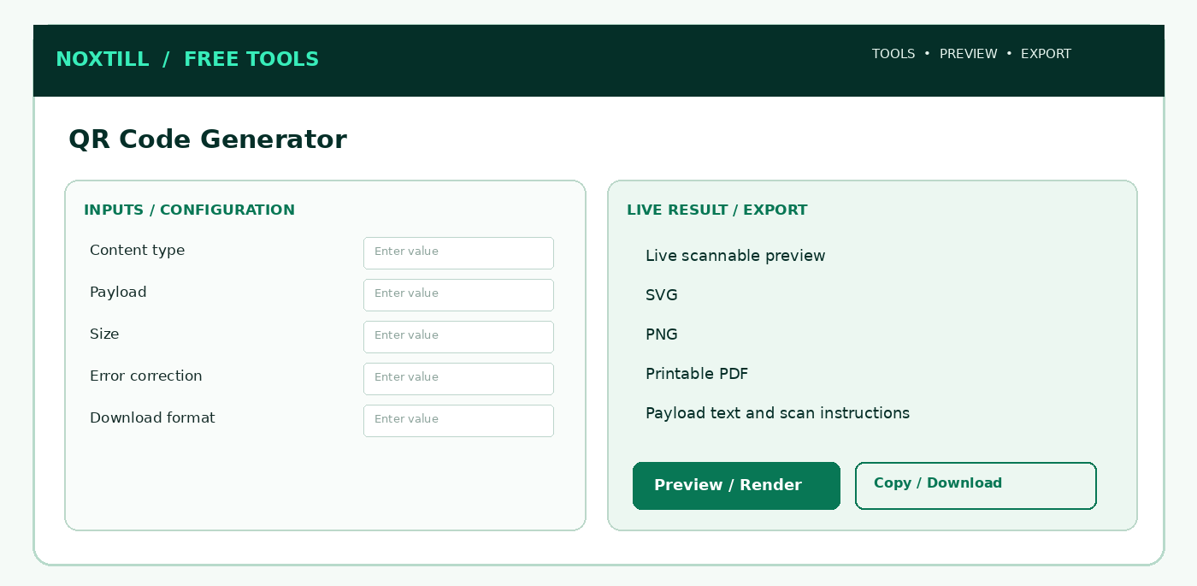
Figure 13. Proposed responsive desktop workbench structure for QR Code Generator; this is a functional wireframe, not a production screenshot.

5.1 Screens, sections and frontend interaction
Use one indexable public utility route with client-side interactive panels, drawers and modals rather than creating unnecessary Noxtill top-level navigation modules. The following are screen AREAS or subviews, not extra canonical sidebar modules:
1. Payload types tabs: URL, text, Wi-Fi, SMS, tel, email, vCard.
2. Customize panel: QR level, margin, colors, output size.
3. High-quality preview and scan reliability warnings.
4. Export tab: SVG/PNG/PDF, exact payload, print preview.

5.2 Step-by-step user workflow
1. Choose QR type: URL, plain text, Wi-Fi, email, phone, SMS, vCard/contact (bounded and standards-aware).
2. Enter fields and compose exact payload; URL types require approved schemes and explicit preview of destination.
3. Select foreground/background contrast, module size, margin/quiet zone and error correction L/M/Q/H.
4. Render client-side deterministically, with no external QR API necessary.
5. Inspect scans at minimum intended print size, offer neutral correction if decorative branding harms reliability.
6. Download SVG/PNG/PDF and copy payload; optional authenticated save with explicit scope.
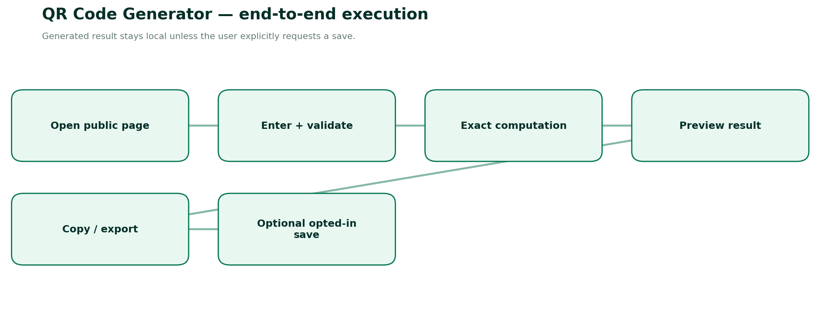
Figure 14. End-to-end execution and explicit persistence boundary for QR Code Generator.

5.3 Detailed form specification and validation dictionary
FIELD / CONTROL | TYPE | RULES, FEEDBACK AND SECURITY
qrType | enum | url | text | wifi | email | phone | sms | vcard.
payload | text | Size bounded by selected QR version/capacity; reject control chars for URL where necessary.
errorCorrection | enum | L | M | Q | H; M practical default; higher for challenging print per DENSO.
foregroundColor | hex | Sufficient contrast against background.
backgroundColor | hex | Solid light recommended.
quietZoneModules | integer | At least four modules around QR output.
outputPixels | integer | Configurable 256..2048, test actual module pixel resolution.
outputFormat | enum | SVG | PNG | PDF.
wifiEncryption | enum | WPA/WPA2 | WEP | nopass; escape delimiters accurately.
contactFields | object | vCard phone/email/name optional and escaped to standard.
visualLogo | image | Optional advanced: constrained safe central overlay only after scan quality validation.
caption | text | Optional human-readable destination label outside quiet zone.

5.4 Calculation / composition rules
1. QR payload must be encoded in correct scheme syntax; validate capacity for selected error correction/version.
2. Quiet zone ≥4 modules. Maintain square aspect ratio and no blurry interpolation (nearest-neighbor raster).
3. Error correction L≈7%, M≈15%, Q≈25%, H≈30% of codewords theoretically restorable (not a logo-destruction guarantee).
4. Static code stores destination text directly; it does not provide click analytics or allow changing URLs post-print without a separately designed redirect service.

5.5 Frontend build detail — React/Next.js
- Form composition: Create FT-05ClientPage as a publicly accessible feature entry. Use React Hook Form or existing Noxtill form pattern with Zod; type each field as in §5.3.
- Calculation lifecycle: Only run on validated canonical inputs. Debounce outputs that are expensive; for lightweight math compute immediately. Keep last valid result visibly stale if invalid edits occur.
- Result area: Show primary metrics from Live scannable preview, SVG, PNG, Printable PDF with exact units/assumptions, copy/export, and a human-readable computation explanation.
- Responsive behavior: ≥1024 px use two-column inputs/results; tablet stack/resize; mobile single column with sticky result-action (not an overlay hiding fields).
- Accessibility: Use fieldset/legend for mode groups, aria-describedby for hints/errors, keyboard focus restoration for modals, clear contrast, aria-live for final result only.
- Loading/failure: Render/print may take time; show real loading progress, cancel if supported; disable duplicate download. Preserve inputs and provide safe retry.
- Anonymous & authenticated: No login gating on primary function. Optional Save to Noxtill is a separate user click, opens a permission/consent confirmation and uses canonical API.
- Security: Treat every pasted/typed field as untrusted text; URL validation, escaping, length caps and no unsanitized HTML. Do not send raw inputs as marketing analytics.

5.6 Backend services, API contracts and source-of-truth
- Client-only QR encoder preferred for privacy/cost; optional deterministic server generation for batch/print.
- Do not fetch/scrape arbitrary destination URLs; for URL type parse URL, allow HTTPS by default, optionally mailto/tel for respective types.
- Sanitize SVG exporter, prevent embedded scripts/external entities, restrict file sizes and output format MIME.
- If a future dynamic QR redirect system is built, it needs distinct consent, ownership, abuse checks, signed destinations and analytics—not implied here.
METHOD | ENDPOINT | SERVICE BEHAVIOUR
POST | /api/public/tools/qr/render | Optional server image rendering, no storage
POST | /api/private/media/qr-assets | Explicit authorized save to canonical file/media owner

Request DTO illustration. Names and versioning are proposed—reconcile with the existing Noxtill API conventions before implementation:
{
"tool": "qr-code-generator",
"version": "v1",
"input": {
"qrType": "url",
"payload": "https://example.com/menu",
"errorCorrection": "M",
"quietZoneModules": 4,
"outputFormat": "SVG"
}
}
Calculation/render contract sketch (typed pseudocode, not drop-in production code):
function staticQr(input) {
const payload = validatedPayloadForType(input.qrType, input);
assertSafeSchemeIfLink(payload, input.qrType);
const qr = encodeQr(payload, { ecLevel: input.errorCorrection });
const svg = renderSafeSvg(qr, { quietZoneModules: Math.max(4, input.quietZoneModules),
foreground: input.foregroundColor, background: input.backgroundColor });
assertScanContrast(input); return { payload, svg, png: rasterizeNearest(svg) };
}

5.7 Database and persistence policy
None by default; saved files only through canonical file/document asset owner.
CONCEPT / RESOURCE | OWNERSHIP AND RETENTION POLICY
Anonymous runs | Ephemeral browser state; no row in shared Noxtill CRM/marketing table.
Optional result artifact | Generate short-lived download in memory; if cloud export is unavoidable, use expiring private storage and secure deletion.
Authenticated saves | Public generation client-side; branded saved assets only by explicit consent to Media/Document Library; do not create hidden redirects.
Audit and idempotency | Only actual canonical business writes generate activity/audit events, permission checks and idempotency; copy/download is not a business transaction.
Analytics | Event name, tool slug, status/error group, duration and coarse locale; never raw contacts, prices linked to identity, document contents or UTM private values.

5.8 Edge cases, alerts and error-state design
- Payload exceeds capacity: show estimated length/version bound; do not truncate silently.
- Bad contrast or reduced quiet zone: block printable download until fixed.
- Unsupported URL scheme javascript/data: reject for destination QR type.
- Oversized logo corrupting QR: warn, reduce size or disable logo; scan smoke test.
Additional all-tool negative paths: locale changed mid-edit; browser clipboard denied; mobile narrow viewport; offline state; malformed JSON/overlong payload; double-click on export; stale last-valid preview; authenticated session expiration during optional save; provider integration not configured; cross-tenant resource ID attempts. These must have deterministic user-facing outcomes and logged request IDs where a server is involved.

5.9 Noxtill integration boundaries and events
Canonical mapping: Public generation client-side; branded saved assets only by explicit consent to Media/Document Library; do not create hidden redirects.
Recommended events: tool.opened (anonymous aggregate), tool.input_validated (no value payload), tool.result_generated (outcome only), tool.export_completed (file type only), tool.save_requested (authenticated), tool.save_confirmed (only after canonical service success), tool.save_failed (reason code only). Do not send phone/email/URLs/invoice parties in generic tracking events. Integrations execute only when the user elects to save/import/apply.

5.10 Verification vectors and acceptance criteria
1. HTTPS URL encodes, SVG and PNG decode to exactly same text.
2. Wi-Fi SSID with semicolon/backslash is escaped and round-trips.
3. SVG has no external assets/scripts and proper viewBox.
4. Foreground/background luminance and scan-test pass at print size.
5. No outbound analytics or redirect for static QR.
6. Very long payload fails gracefully without CPU spikes.
DEFINITION OF DONE
A user can complete the stated tool task anonymously, input validation and all listed edge cases work, calculations/encoded output round-trip correctly, mobile/keyboard/screen-reader paths pass, export is semantically consistent with on-screen result, and any authenticated mutation is verified by the canonical owner. The tool may only advertise capabilities actually implemented and passing acceptance tests.
OFFICIAL REFERENCES
R5, R8, R9 — see the full source register and implementation caveats at the end of this document.

FT-06 — Google Review Link & QR Generator
PUBLIC ROUTE: /FREE-TOOLS/GOOGLE-REVIEW-LINK-QR-GENERATOR / OFFICIAL GOOGLE BUSINESS PROFILE REVIEW SHARING
Product promise. Turn an owner-supplied official Google review share link into a copyable, customer-friendly QR kit without review gating.
Target audience. Local businesses asking genuine customers to leave honest Google reviews.
Data ownership. Public link kit; authenticated connected Business Profile and reputation workflow remain Business Listings / Reviews & Reputation.
How it works — Roman Urdu: Business ko Google ke apne “Get more reviews” se link copy karna hai. Tool ek neutral review card banayega; 5-star maangna ya incentive offer karna allowed default workflow nahi.
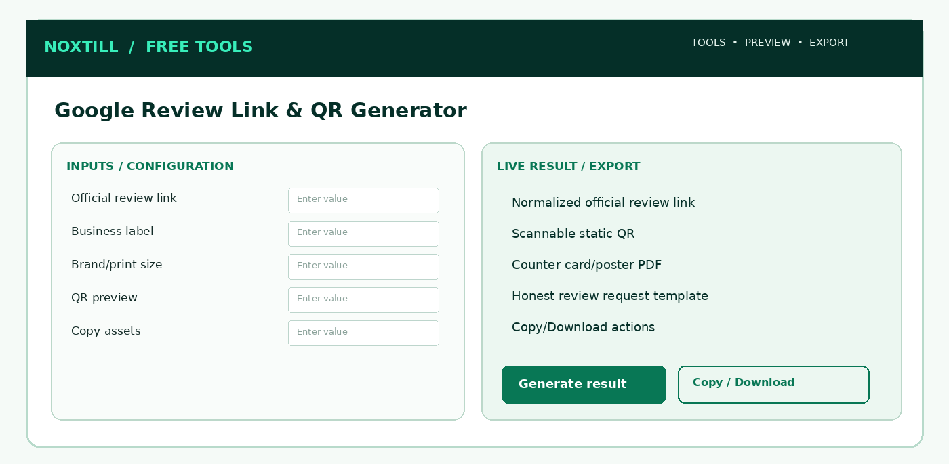
Figure 15. Proposed responsive desktop workbench structure for Google Review Link & QR Generator; this is a functional wireframe, not a production screenshot.

6.1 Screens, sections and frontend interaction
Use one indexable public utility route with client-side interactive panels, drawers and modals rather than creating unnecessary Noxtill top-level navigation modules. The following are screen AREAS or subviews, not extra canonical sidebar modules:
1. Official-link collection help and pasted-link validation.
2. Review card template selection with neutral text.
3. QR preview, print-size proof and downloadable artifacts.
4. How-to-share panel with Google policy and no incentive/review-gating messaging.

6.2 Step-by-step user workflow
1. Explain owner must retrieve their review link from their own Google Business Profile; show brief verified instructions.
2. Paste exact owner-provided share link (avoid inventing direct review URL from business name alone).
3. Validate HTTPS, length, allowlisted trusted host policy or warn/require manual verification for redirects; never fetch untrusted servers by default.
4. Render static QR with reliable quiet zone and destination text readable.
5. Offer neutral “Please share your honest experience” copy without incentives or review gating.
6. Download print card or simple QR; share action only via explicit user interaction, no silent review posting.
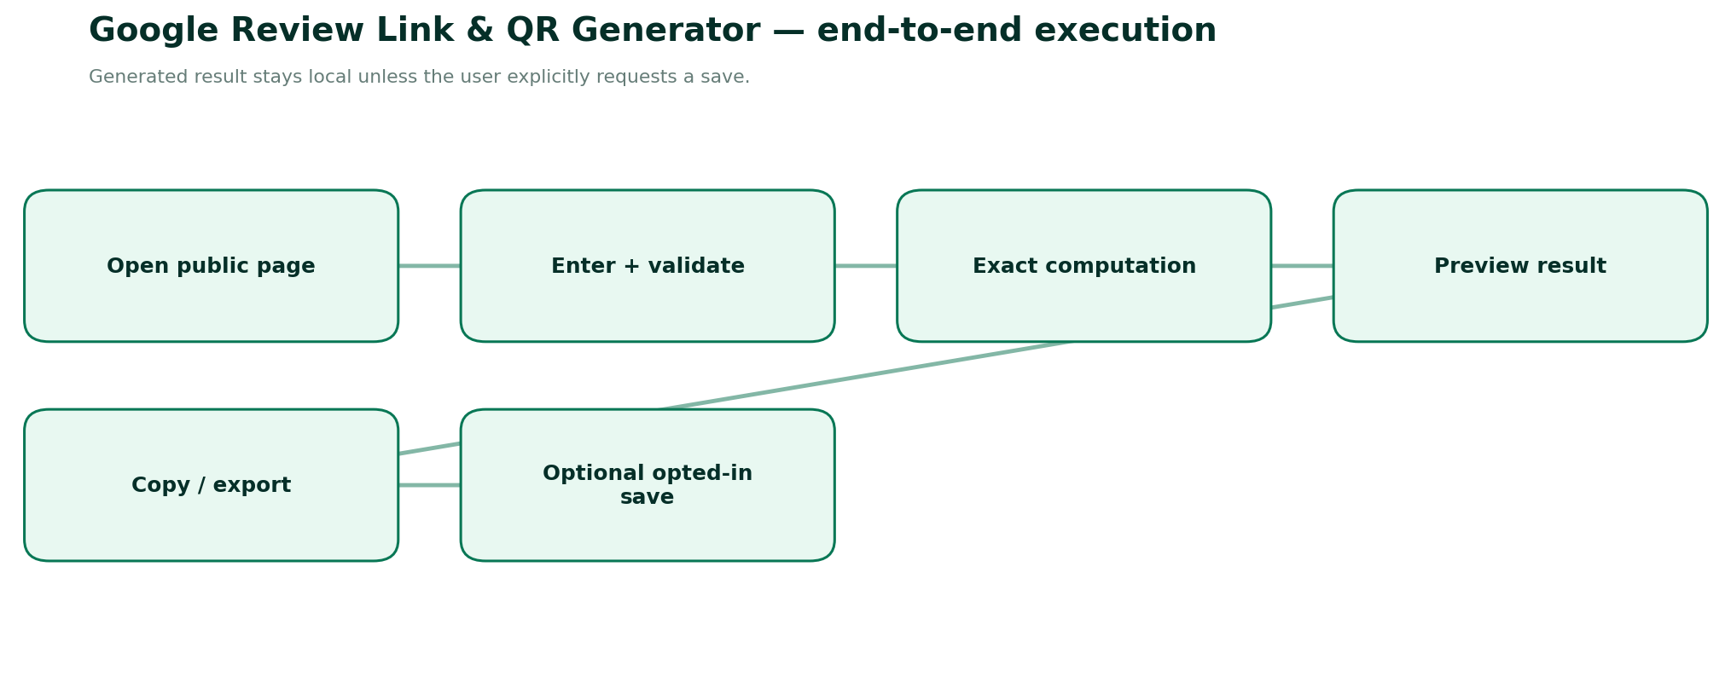
Figure 16. End-to-end execution and explicit persistence boundary for Google Review Link & QR Generator.

6.3 Detailed form specification and validation dictionary
FIELD / CONTROL | TYPE | RULES, FEEDBACK AND SECURITY
reviewLink | HTTPS URL | Required from owner; no fake provider-confirmed verification.
businessDisplayName | string | Optional aesthetic label, not ownership proof.
locationLabel | string | Optional multi-location display.
headline | string | Neutral review request; avoid conditional sentiment prompts.
qrSize | integer | 256..2048 and print resolution.
printTemplate | enum | standee | card | receipt insert | plain QR.
language | BCP47 | Localized neutral copy; default English.
qrErrorCorrection | enum | M default; high for branded print only if scan passes.
brandColors | hex | Noxtill defaults; merchant customization optional.
downloadFormat | enum | SVG | PNG | PDF.
offerIncentive | prohibited | No coupon, reward or giveaway conditional on review.
verificationStatus | derived | Unverified owner-pasted link unless verified by authorized provider integration.

6.4 Calculation / composition rules
1. Link is copied exactly after safe normalization; preserving important path/query fragments when supported.
2. Source of truth for customer review link is the official Business Profile UI workflow, not guessed map IDs or scraped search results.
3. QR uses same static encoding rules as FT-05; scan test must resolve to same intended destination.
4. Do not ask only satisfied users for public reviews; do not suppress or redirect dissatisfied reviewers to a private-only channel.

6.5 Frontend build detail — React/Next.js
- Form composition: Create FT-06ClientPage as a publicly accessible feature entry. Use React Hook Form or existing Noxtill form pattern with Zod; type each field as in §6.3.
- Calculation lifecycle: Only run on validated canonical inputs. Debounce outputs that are expensive; for lightweight math compute immediately. Keep last valid result visibly stale if invalid edits occur.
- Result area: Show primary metrics from Normalized official review link, Scannable static QR, Counter card/poster PDF, Honest review request template with exact units/assumptions, copy/export, and a human-readable computation explanation.
- Responsive behavior: ≥1024 px use two-column inputs/results; tablet stack/resize; mobile single column with sticky result-action (not an overlay hiding fields).
- Accessibility: Use fieldset/legend for mode groups, aria-describedby for hints/errors, keyboard focus restoration for modals, clear contrast, aria-live for final result only.
- Loading/failure: Render/print may take time; show real loading progress, cancel if supported; disable duplicate download. Preserve inputs and provide safe retry.
- Anonymous & authenticated: No login gating on primary function. Optional Save to Noxtill is a separate user click, opens a permission/consent confirmation and uses canonical API.
- Security: Treat every pasted/typed field as untrusted text; URL validation, escaping, length caps and no unsanitized HTML. Do not send raw inputs as marketing analytics.

6.6 Backend services, API contracts and source-of-truth
- No Google API is required for owner-pasted link and QR rendering; do not falsely claim verified listing status.
- Optional authenticated Business Profile connection may check account authorization and use permitted APIs; use canonical Integrations/Business Listings module.
- No custom proxy that fetches arbitrary pasted URLs; block SSRF and open redirects.
- Generated copy must be neutral and consistent with Google policies; avoid incentive templates.
METHOD | ENDPOINT | SERVICE BEHAVIOUR
POST | /api/public/tools/review-kit/render | Optional stateless print rendering
POST | /api/private/reviews/review-assets | Optional explicit share-kit save through canonical Reviews module

Request DTO illustration. Names and versioning are proposed—reconcile with the existing Noxtill API conventions before implementation:
{
"tool": "google-review-link-qr",
"version": "v1",
"input": {
"reviewLink": "https://g.page/r/OWNER_COPIED_SHARE_LINK/review",
"businessDisplayName": "Example Coffee House",
"printTemplate": "card",
"language": "en-US"
}
}
Calculation/render contract sketch (typed pseudocode, not drop-in production code):
const officialLink = requireOwnerPastedOfficialReviewLink(input.reviewLink);
const safeUrl = parseHttpsAndWarnOnUnverifiedDestination(officialLink);
const body = buildNeutralReviewRequest(input.businessDisplayName);
assert(!hasIncentiveOrReviewGating(body));
const qr = staticQr({ qrType: 'url', payload: safeUrl.toString(),
errorCorrection: 'M', quietZoneModules: 4 });
return { link: safeUrl.toString(), qr, body, verifiedByGoogle: false };

6.7 Database and persistence policy
Anonymous link not stored. Signed-in assets bound to tenant/location only with permission and requested save.
CONCEPT / RESOURCE | OWNERSHIP AND RETENTION POLICY
Anonymous runs | Ephemeral browser state; no row in shared Noxtill CRM/marketing table.
Optional result artifact | Generate short-lived download in memory; if cloud export is unavoidable, use expiring private storage and secure deletion.
Authenticated saves | Public link kit; authenticated connected Business Profile and reputation workflow remain Business Listings / Reviews & Reputation.
Audit and idempotency | Only actual canonical business writes generate activity/audit events, permission checks and idempotency; copy/download is not a business transaction.
Analytics | Event name, tool slug, status/error group, duration and coarse locale; never raw contacts, prices linked to identity, document contents or UTM private values.

6.8 Edge cases, alerts and error-state design
- Owner pastes Google Maps listing link rather than review invite: ask for official review share link; do not claim it opens review composer.
- Broken/expired/untrusted URL: warn or reject according to policy and request re-copy from Business Profile.
- Injected non-HTTPS scheme: reject.
- Incentive or positive-only messaging: block/flag templates as non-compliant.
Additional all-tool negative paths: locale changed mid-edit; browser clipboard denied; mobile narrow viewport; offline state; malformed JSON/overlong payload; double-click on export; stale last-valid preview; authenticated session expiration during optional save; provider integration not configured; cross-tenant resource ID attempts. These must have deterministic user-facing outcomes and logged request IDs where a server is involved.

6.9 Noxtill integration boundaries and events
Canonical mapping: Public link kit; authenticated connected Business Profile and reputation workflow remain Business Listings / Reviews & Reputation.
Recommended events: tool.opened (anonymous aggregate), tool.input_validated (no value payload), tool.result_generated (outcome only), tool.export_completed (file type only), tool.save_requested (authenticated), tool.save_confirmed (only after canonical service success), tool.save_failed (reason code only). Do not send phone/email/URLs/invoice parties in generic tracking events. Integrations execute only when the user elects to save/import/apply.

6.10 Verification vectors and acceptance criteria
1. Valid official review link remains identical in generated QR and copy output.
2. Paste “google.com/maps” search link triggers help prompt, not verified status.
3. No review-gating branch based on star rating.
4. No automatic review submissions or fake reviews.
5. QR prints and scans at standee and receipt-insert size.
6. Multi-location tenant cannot access another location’s saved assets.
DEFINITION OF DONE
A user can complete the stated tool task anonymously, input validation and all listed edge cases work, calculations/encoded output round-trip correctly, mobile/keyboard/screen-reader paths pass, export is semantically consistent with on-screen result, and any authenticated mutation is verified by the canonical owner. The tool may only advertise capabilities actually implemented and passing acceptance tests.
OFFICIAL REFERENCES
R1, R5, R8, R9 — see the full source register and implementation caveats at the end of this document.

FT-07 — WhatsApp Link Generator
PUBLIC ROUTE: /FREE-TOOLS/WHATSAPP-LINK-GENERATOR / CLICK-TO-CHAT URL COMPOSITION
Product promise. Generate correctly encoded WhatsApp click-to-chat links and QR codes using international number format.
Target audience. Local businesses, staff, social media managers and marketing creators.
Data ownership. Public static link; two-way WhatsApp inbox and actual message delivery remain Unified Inbox and authorized provider integration.
How it works — Roman Urdu: wa.me link user ke WhatsApp mein chat kholta hai, khud-ba-khud message send nahi karta. Is simple link ke liye paid WhatsApp API ki zaroorat nahi.
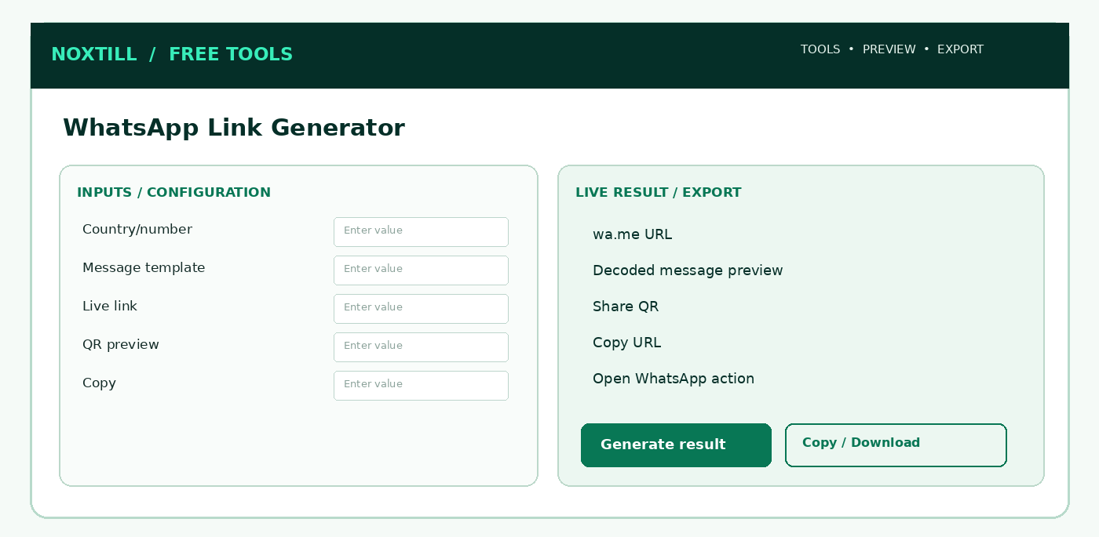
Figure 17. Proposed responsive desktop workbench structure for WhatsApp Link Generator; this is a functional wireframe, not a production screenshot.

7.1 Screens, sections and frontend interaction
Use one indexable public utility route with client-side interactive panels, drawers and modals rather than creating unnecessary Noxtill top-level navigation modules. The following are screen AREAS or subviews, not extra canonical sidebar modules:
1. International country/number input and normalized preview.
2. Optional message template editor and character count.
3. Generated click-to-chat link + QR preview.
4. Copy/open/share actions with no automatic send claim.

7.2 Step-by-step user workflow
1. Select country code, enter full international WhatsApp-capable number and review normalized digits.
2. Enter optional prefilled message with variables as literal static text (dynamic CRM interpolation only if authenticated/template-approved).
3. Show character count, Unicode preservation and an exact preview of message text.
4. Construct wa.me/NUMBER?text=ENCODED_TEXT using standards-based URL encoding, never concatenation without encoding.
5. Copy link, download QR, or open external WhatsApp only after explicit click.
6. Optionally create website CTA/embed snippet and connect through authorized Noxtill channel settings.
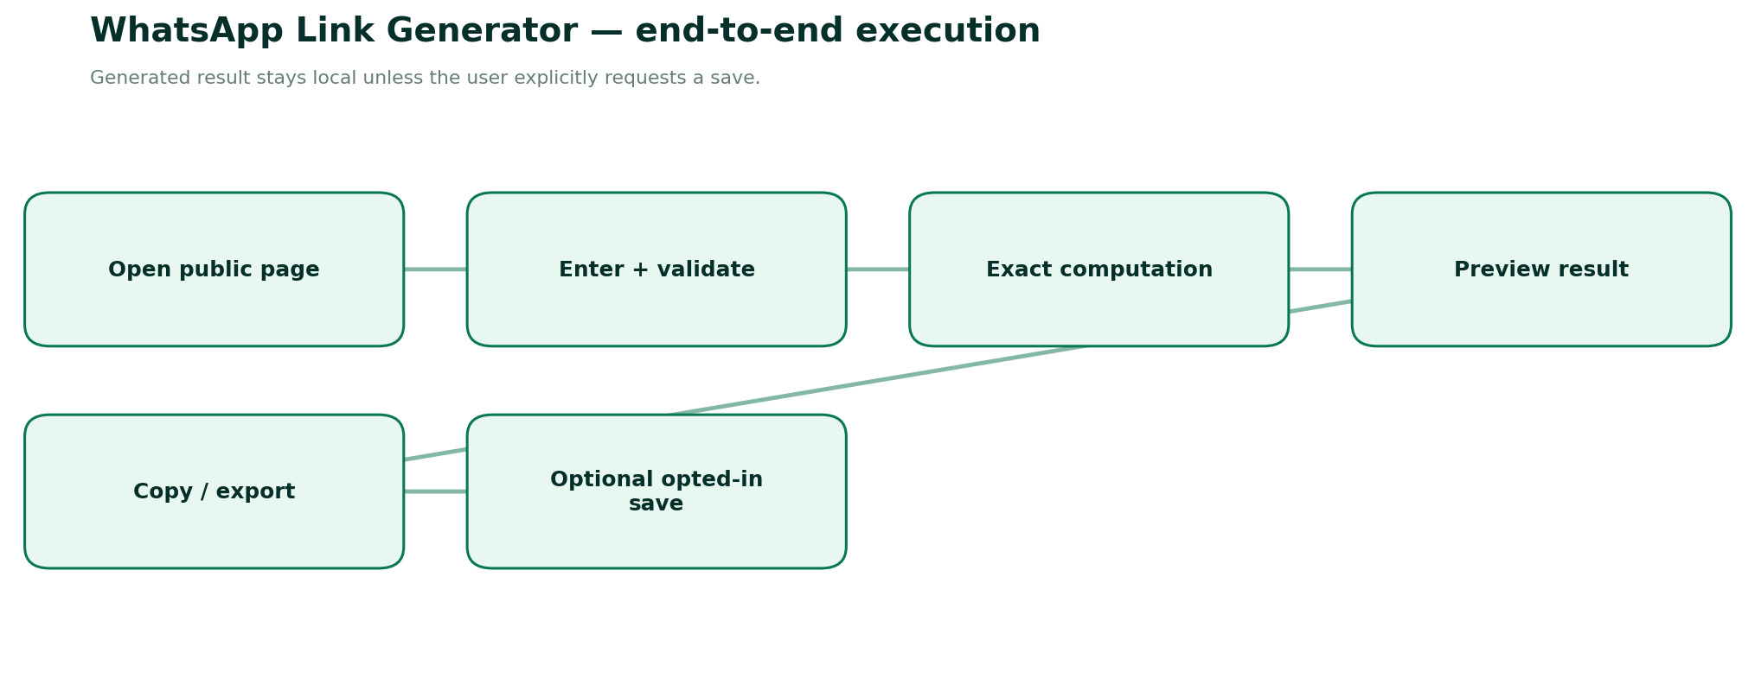
Figure 18. End-to-end execution and explicit persistence boundary for WhatsApp Link Generator.

7.3 Detailed form specification and validation dictionary
FIELD / CONTROL | TYPE | RULES, FEEDBACK AND SECURITY
country | ISO3166 | Optional dropdown for formatting; does not prove number ownership.
internationalNumber | E.164 | Required; strip only formatting, validate country calling code and plausible length.
prefilledMessage | Unicode string | Optional; max configured to fit practical URL/QR sizes.
messageLanguage | BCP47 | Optional client display only.
shareButtonLabel | string | Optional web CTA, sanitized.
qrErrorCorrection | enum | M default.
normalizedNumber | derived | Digits-only country code + subscriber; no plus sign in wa.me path.
encodedMessage | derived | Percent/URL-encoded query parameter, preserving emojis and line breaks.
generatedLink | derived | https://wa.me/DIGITS and optional ?text=VALUE.
consentDisclaimer | boolean/info | Link opening does not prove recipient consent or that a message was sent.

7.4 Calculation / composition rules
1. Normalize number using libphonenumber semantics / E.164 canonical value; strip + only for wa.me path.
2. Construct URL via URL object + URLSearchParams; do not double-encode percent sequences.
3. For emojis, line breaks, ampersands and plus signs, round-trip encoded text exactly.
4. Opening wa.me starts a chat with a prefilled field; it does not send the message automatically.

7.5 Frontend build detail — React/Next.js
- Form composition: Create FT-07ClientPage as a publicly accessible feature entry. Use React Hook Form or existing Noxtill form pattern with Zod; type each field as in §7.3.
- Calculation lifecycle: Only run on validated canonical inputs. Debounce outputs that are expensive; for lightweight math compute immediately. Keep last valid result visibly stale if invalid edits occur.
- Result area: Show primary metrics from wa.me URL, Decoded message preview, Share QR, Copy URL with exact units/assumptions, copy/export, and a human-readable computation explanation.
- Responsive behavior: ≥1024 px use two-column inputs/results; tablet stack/resize; mobile single column with sticky result-action (not an overlay hiding fields).
- Accessibility: Use fieldset/legend for mode groups, aria-describedby for hints/errors, keyboard focus restoration for modals, clear contrast, aria-live for final result only.
- Loading/failure: Render/print may take time; show real loading progress, cancel if supported; disable duplicate download. Preserve inputs and provide safe retry.
- Anonymous & authenticated: No login gating on primary function. Optional Save to Noxtill is a separate user click, opens a permission/consent confirmation and uses canonical API.
- Security: Treat every pasted/typed field as untrusted text; URL validation, escaping, length caps and no unsanitized HTML. Do not send raw inputs as marketing analytics.

7.6 Backend services, API contracts and source-of-truth
- Entire tool can run in browser; no WhatsApp Business API or Meta token needed for static click-to-chat URLs.
- Never ping or validate whether arbitrary phone number has WhatsApp by probing accounts.
- Authenticated integrations into Unified Inbox require consent, WhatsApp message type classification and outbound provider confirmation.
- Do not collect/sell numbers from anonymous tool submissions.
METHOD | ENDPOINT | SERVICE BEHAVIOUR
POST | /api/public/tools/whatsapp/compose | Optional normalized-link generation
POST | /api/private/channels/whatsapp/link-template | Opt-in saved link template through canonical messaging settings

Request DTO illustration. Names and versioning are proposed—reconcile with the existing Noxtill API conventions before implementation:
{
"tool": "whatsapp-link-generator",
"version": "v1",
"input": {
"internationalNumber": "+14155550188",
"prefilledMessage": "Hi! I would like to book an appointment."
}
}
Calculation/render contract sketch (typed pseudocode, not drop-in production code):
const e164 = normalizeWithPhoneNumberLibrary(input.internationalNumber);
if (!isValidInternationalNumber(e164)) throw new InputError('INVALID_PHONE');
const number = e164.replace(/^\+/, '');
const url = new URL('https://wa.me/' + number);
if (input.prefilledMessage) url.searchParams.set('text', input.prefilledMessage);
return { url: url.toString(), sent: false }; // Opening link does NOT send a message.

7.7 Database and persistence policy
None anonymously; optional saved template linked to merchant-owned number/channel.
CONCEPT / RESOURCE | OWNERSHIP AND RETENTION POLICY
Anonymous runs | Ephemeral browser state; no row in shared Noxtill CRM/marketing table.
Optional result artifact | Generate short-lived download in memory; if cloud export is unavoidable, use expiring private storage and secure deletion.
Authenticated saves | Public static link; two-way WhatsApp inbox and actual message delivery remain Unified Inbox and authorized provider integration.
Audit and idempotency | Only actual canonical business writes generate activity/audit events, permission checks and idempotency; copy/download is not a business transaction.
Analytics | Event name, tool slug, status/error group, duration and coarse locale; never raw contacts, prices linked to identity, document contents or UTM private values.

7.8 Edge cases, alerts and error-state design
- Missing country calling code or implausible digits: clear validation.
- Special characters encoded once, no malformed wa.me query.
- QR capacity exceeded by long message: offer shorter copy/URL, never silently truncate.
- WhatsApp unavailable/number unregistered: state that external delivery cannot be guaranteed.
Additional all-tool negative paths: locale changed mid-edit; browser clipboard denied; mobile narrow viewport; offline state; malformed JSON/overlong payload; double-click on export; stale last-valid preview; authenticated session expiration during optional save; provider integration not configured; cross-tenant resource ID attempts. These must have deterministic user-facing outcomes and logged request IDs where a server is involved.

7.9 Noxtill integration boundaries and events
Canonical mapping: Public static link; two-way WhatsApp inbox and actual message delivery remain Unified Inbox and authorized provider integration.
Recommended events: tool.opened (anonymous aggregate), tool.input_validated (no value payload), tool.result_generated (outcome only), tool.export_completed (file type only), tool.save_requested (authenticated), tool.save_confirmed (only after canonical service success), tool.save_failed (reason code only). Do not send phone/email/URLs/invoice parties in generic tracking events. Integrations execute only when the user elects to save/import/apply.

7.10 Verification vectors and acceptance criteria
1. Number +1 (415) 555-0188 becomes digits-only US-form link.
2. Text “Hi & welcome + emoji” round-trips with ampersand plus and Unicode.
3. URL with no message omits ?text parameter.
4. Click-to-chat not mislabeled message “sent”.
5. No telemetry contains raw entered phone/message without consent.
6. Printed QR decodes to exact generated URL.
DEFINITION OF DONE
A user can complete the stated tool task anonymously, input validation and all listed edge cases work, calculations/encoded output round-trip correctly, mobile/keyboard/screen-reader paths pass, export is semantically consistent with on-screen result, and any authenticated mutation is verified by the canonical owner. The tool may only advertise capabilities actually implemented and passing acceptance tests.
OFFICIAL REFERENCES
R2, R4, R5, R8 — see the full source register and implementation caveats at the end of this document.

FT-08 — UTM Campaign Link Builder
PUBLIC ROUTE: /FREE-TOOLS/UTM-CAMPAIGN-LINK-BUILDER / MARKETING ATTRIBUTION URL GENERATION
Product promise. Create clean, valid, reusable UTM-tracked campaign URLs while preserving existing query parameters and URL fragments.
Target audience. Marketers, agencies, campaign managers and owners using GA4-compatible UTM tagging.
Data ownership. Public URL composer. Persisted campaigns and reporting belong to Marketing & Campaigns / Advertising / Business Intelligence.
How it works — Roman Urdu: UTM builder URL ke aakhri parameters banata hai; jo existing query aur #anchor hain unko destroy nahi karna. Report tabhi chalegi jab destination analytics properly set ho.
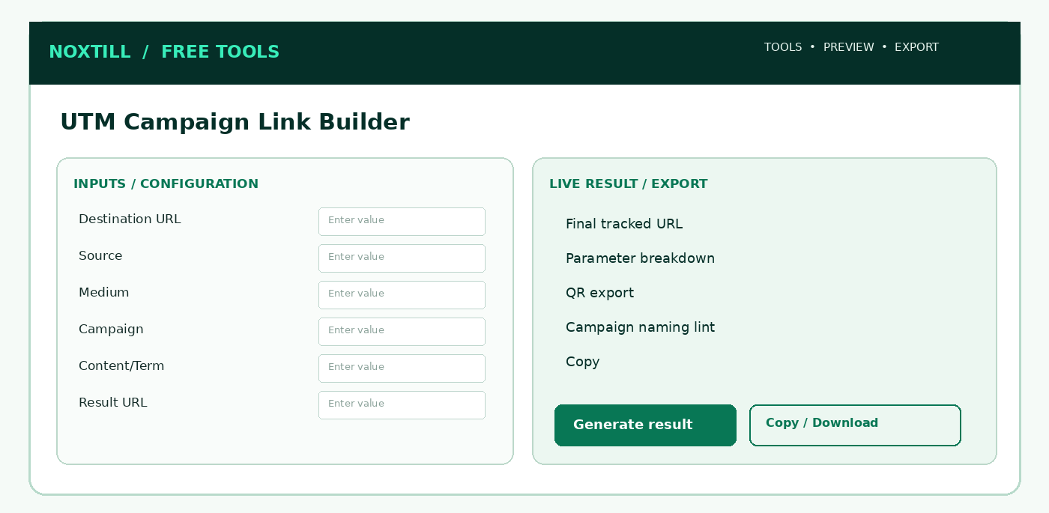
Figure 19. Proposed responsive desktop workbench structure for UTM Campaign Link Builder; this is a functional wireframe, not a production screenshot.

8.1 Screens, sections and frontend interaction
Use one indexable public utility route with client-side interactive panels, drawers and modals rather than creating unnecessary Noxtill top-level navigation modules. The following are screen AREAS or subviews, not extra canonical sidebar modules:
1. Destination parser preview with existing query/fragment.
2. Required UTM inputs, naming conventions and optional advanced fields.
3. Existing-UTM conflict confirmation dialog.
4. Final URL preview, QR/CSV export and optional canonical campaign save.

8.2 Step-by-step user workflow
1. Paste valid HTTPS landing URL and display parsed scheme/host/path/query/fragment for review.
2. Enter required source, medium, campaign and optional term, content, source_platform, id (supported semantics documented).
3. Suggest consistent lowercase naming conventions without silently renaming existing campaign IDs.
4. Preserve unrelated query params and fragments, detect existing utm_* and prompt replace/keep decision.
5. Generate URL with URL object/URLSearchParams, preview exact destination and decoded parameters.
6. Copy URL, create static QR, export CSV of variants and optionally save to authorized Marketing campaign.
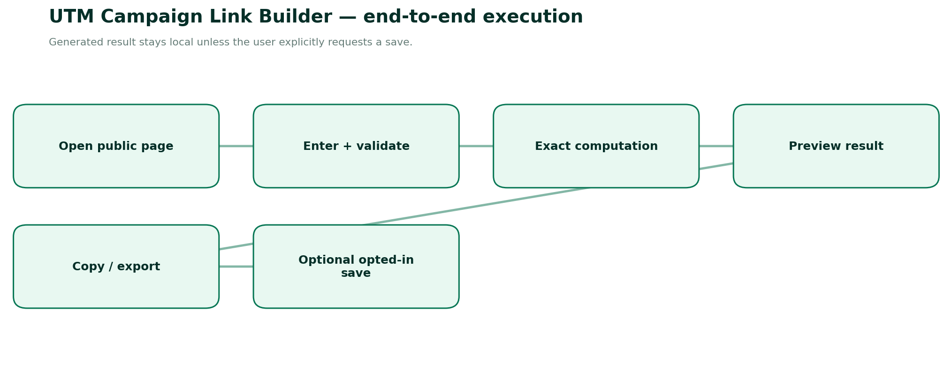
Figure 20. End-to-end execution and explicit persistence boundary for UTM Campaign Link Builder.

8.3 Detailed form specification and validation dictionary
FIELD / CONTROL | TYPE | RULES, FEEDBACK AND SECURITY
destinationUrl | HTTPS URL | Required; no javascript/data; reject localhost/private addresses for public share.
utm_source | string | Required: publisher/referrer, e.g. newsletter.
utm_medium | string | Required: channel, e.g. email.
utm_campaign | string | Required: campaign label, e.g. autumn_launch.
utm_id | string | Optional campaign ID; preserve alphanumeric + safe separators.
utm_term | string | Optional paid keyword or audience label, no sensitive user text.
utm_content | string | Optional creative/CTA variation.
utm_source_platform | string | Optional; only where meaningful for reporting.
utm_creative_format | string | Optional advanced usage; not always supported downstream.
utm_marketing_tactic | string | Optional advanced usage; no guaranteed GA4 native reporting.
overrideExisting | enum | confirm_replace | preserve_existing; never silent duplication.
normalizeConvention | boolean | Opt-in lowercase/space-to-underscore only; raw preview.

8.4 Calculation / composition rules
1. Parse base with WHATWG URL; use searchParams.set for new allowed utm keys; preserve all unrelated parameters and #fragment.
2. Required campaign parameters under Google guidance: utm_source, utm_medium, utm_campaign [R3].
3. Do not encode twice, and never attach UTM to email/phone/WhatsApp dynamic private data.
4. Same URL with different parameter ordering still targets same landing page; display generated canonical string and decode-to-verify.
5. A tagged link does not automatically prove conversions: website analytics must actually collect destination visits.

8.5 Frontend build detail — React/Next.js
- Form composition: Create FT-08ClientPage as a publicly accessible feature entry. Use React Hook Form or existing Noxtill form pattern with Zod; type each field as in §8.3.
- Calculation lifecycle: Only run on validated canonical inputs. Debounce outputs that are expensive; for lightweight math compute immediately. Keep last valid result visibly stale if invalid edits occur.
- Result area: Show primary metrics from Final tracked URL, Parameter breakdown, QR export, Campaign naming lint with exact units/assumptions, copy/export, and a human-readable computation explanation.
- Responsive behavior: ≥1024 px use two-column inputs/results; tablet stack/resize; mobile single column with sticky result-action (not an overlay hiding fields).
- Accessibility: Use fieldset/legend for mode groups, aria-describedby for hints/errors, keyboard focus restoration for modals, clear contrast, aria-live for final result only.
- Loading/failure: Render/print may take time; show real loading progress, cancel if supported; disable duplicate download. Preserve inputs and provide safe retry.
- Anonymous & authenticated: No login gating on primary function. Optional Save to Noxtill is a separate user click, opens a permission/consent confirmation and uses canonical API.
- Security: Treat every pasted/typed field as untrusted text; URL validation, escaping, length caps and no unsanitized HTML. Do not send raw inputs as marketing analytics.

8.6 Backend services, API contracts and source-of-truth
- Entire URL composition may be client only; never fetch arbitrary destination on server.
- Optional POST lint endpoint validates public HTTPS, disallowed sensitive patterns and parameter naming.
- If authenticated, save campaign variant via Marketing & Campaigns with deduplication and explicit permission; unique on tenant+canonical inputs where useful.
- Link QR download uses FT-05 shared encoder and does not imply URL shortener.
METHOD | ENDPOINT | SERVICE BEHAVIOUR
POST | /api/public/tools/utm/compose | Optional validated URL composition
POST | /api/private/marketing/campaign-links | Explicit save to existing Marketing owner

Request DTO illustration. Names and versioning are proposed—reconcile with the existing Noxtill API conventions before implementation:
{
"tool": "utm-campaign-link-builder",
"version": "v1",
"input": {
"destinationUrl": "https://example.com/pricing?ref=footer#plans",
"utm_source": "newsletter",
"utm_medium": "email",
"utm_campaign": "autumn_launch",
"utm_content": "footer_link",
"overrideExisting": "confirm_replace"
}
}
Calculation/render contract sketch (typed pseudocode, not drop-in production code):
const url = requireHttpsUrl(input.destinationUrl);
for (const key of ['utm_source','utm_medium','utm_campaign']) {
assert(nonEmpty(input[key]));
if (url.searchParams.has(key) && !input.overrideExisting) throw new Conflict(key);
url.searchParams.set(key, input[key]);
}
for (const key of OPTIONAL_UTM_KEYS) {
if (nonEmpty(input[key])) url.searchParams.set(key, input[key]);
}
return { url: url.toString(), fragment: url.hash };

8.7 Database and persistence policy
None for anonymous; logged-in campaign attribution objects stored only via canonical Marketing module.
CONCEPT / RESOURCE | OWNERSHIP AND RETENTION POLICY
Anonymous runs | Ephemeral browser state; no row in shared Noxtill CRM/marketing table.
Optional result artifact | Generate short-lived download in memory; if cloud export is unavoidable, use expiring private storage and secure deletion.
Authenticated saves | Public URL composer. Persisted campaigns and reporting belong to Marketing & Campaigns / Advertising / Business Intelligence.
Audit and idempotency | Only actual canonical business writes generate activity/audit events, permission checks and idempotency; copy/download is not a business transaction.
Analytics | Event name, tool slug, status/error group, duration and coarse locale; never raw contacts, prices linked to identity, document contents or UTM private values.

8.8 Edge cases, alerts and error-state design
- Base URL without https://: suggest normalized URL, do not assume silently.
- Existing conflicting utm_source: prompt explicit replace/preserve.
- Sensitive emails/phone numbers detected in UTM values: warn/block under configured policy.
- Unrelated params & #fragment lost: regression failure.
Additional all-tool negative paths: locale changed mid-edit; browser clipboard denied; mobile narrow viewport; offline state; malformed JSON/overlong payload; double-click on export; stale last-valid preview; authenticated session expiration during optional save; provider integration not configured; cross-tenant resource ID attempts. These must have deterministic user-facing outcomes and logged request IDs where a server is involved.

8.9 Noxtill integration boundaries and events
Canonical mapping: Public URL composer. Persisted campaigns and reporting belong to Marketing & Campaigns / Advertising / Business Intelligence.
Recommended events: tool.opened (anonymous aggregate), tool.input_validated (no value payload), tool.result_generated (outcome only), tool.export_completed (file type only), tool.save_requested (authenticated), tool.save_confirmed (only after canonical service success), tool.save_failed (reason code only). Do not send phone/email/URLs/invoice parties in generic tracking events. Integrations execute only when the user elects to save/import/apply.

8.10 Verification vectors and acceptance criteria
1. https://example.com/?ref=a#pricing with UTM retains ref=a and #pricing.
2. utm_source + utm_medium + utm_campaign required validation.
3. A space/plus/emoji campaign term survives roundtrip without double encoding.
4. Existing duplicate utm_source is resolved by explicit replace/preserve rule.
5. No “conversion attributed” success claim without measured downstream events.
6. CSV of multiple campaigns escapes quotes/commas/formula injection.
DEFINITION OF DONE
A user can complete the stated tool task anonymously, input validation and all listed edge cases work, calculations/encoded output round-trip correctly, mobile/keyboard/screen-reader paths pass, export is semantically consistent with on-screen result, and any authenticated mutation is verified by the canonical owner. The tool may only advertise capabilities actually implemented and passing acceptance tests.
OFFICIAL REFERENCES
R3, R4, R8, R9 — see the full source register and implementation caveats at the end of this document.

FT-09 — Email Signature Generator
PUBLIC ROUTE: /FREE-TOOLS/EMAIL-SIGNATURE-GENERATOR / CROSS-EMAIL-CLIENT HTML SIGNATURES
Product promise. Create lightweight, readable email signatures with accessible contact links and reliable copy-to-email-client workflows.
Target audience. Freelancers, staff, founders, small teams needing professional branding.
Data ownership. Public HTML snippet generation. Company staff signatures and company identity belong to Staff / Settings; do not create parallel employee records.
How it works — Roman Urdu: Email signature browser mein HTML banata hai, Gmail/Outlook mein khud insert nahi karta. Image block hone par bhi naam aur contact readable rehna chahiye.
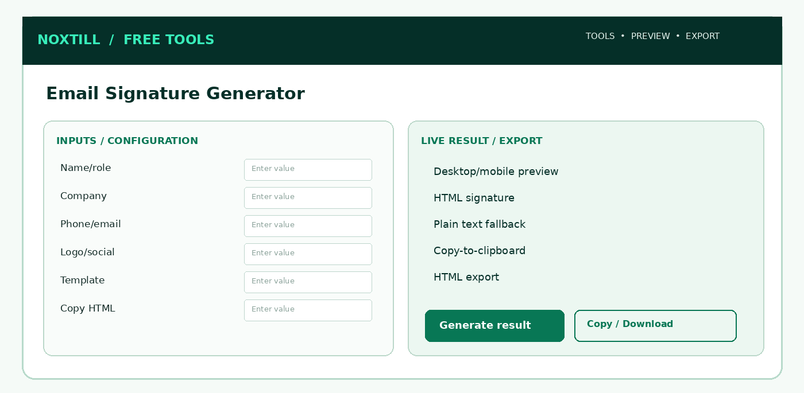
Figure 21. Proposed responsive desktop workbench structure for Email Signature Generator; this is a functional wireframe, not a production screenshot.

9.1 Screens, sections and frontend interaction
Use one indexable public utility route with client-side interactive panels, drawers and modals rather than creating unnecessary Noxtill top-level navigation modules. The following are screen AREAS or subviews, not extra canonical sidebar modules:
1. Profile inputs + contact/social editable list.
2. Template/style controls with image-off/light/dark previews.
3. Live responsive signature card in constrained email container.
4. Rich copy / HTML / plain-text export and client-specific setup instructions.

9.2 Step-by-step user workflow
1. Pick accessible compact template (minimal, classic, brand accent, two-column).
2. Enter name, role, organization, email, phone, website and optional address/social links.
3. Choose style with inline CSS, semantic contact info, limited colors and optional hosted or embedded-safe logo.
4. Preview in simulated light/dark backgrounds, narrow containers and popular email-client constraints (not an exact Outlook renderer).
5. Copy rich HTML, copy plain text or download an HTML fragment with setup instructions.
6. Optional authorized staff-managed signature template save in settings; no send-as user behavior.
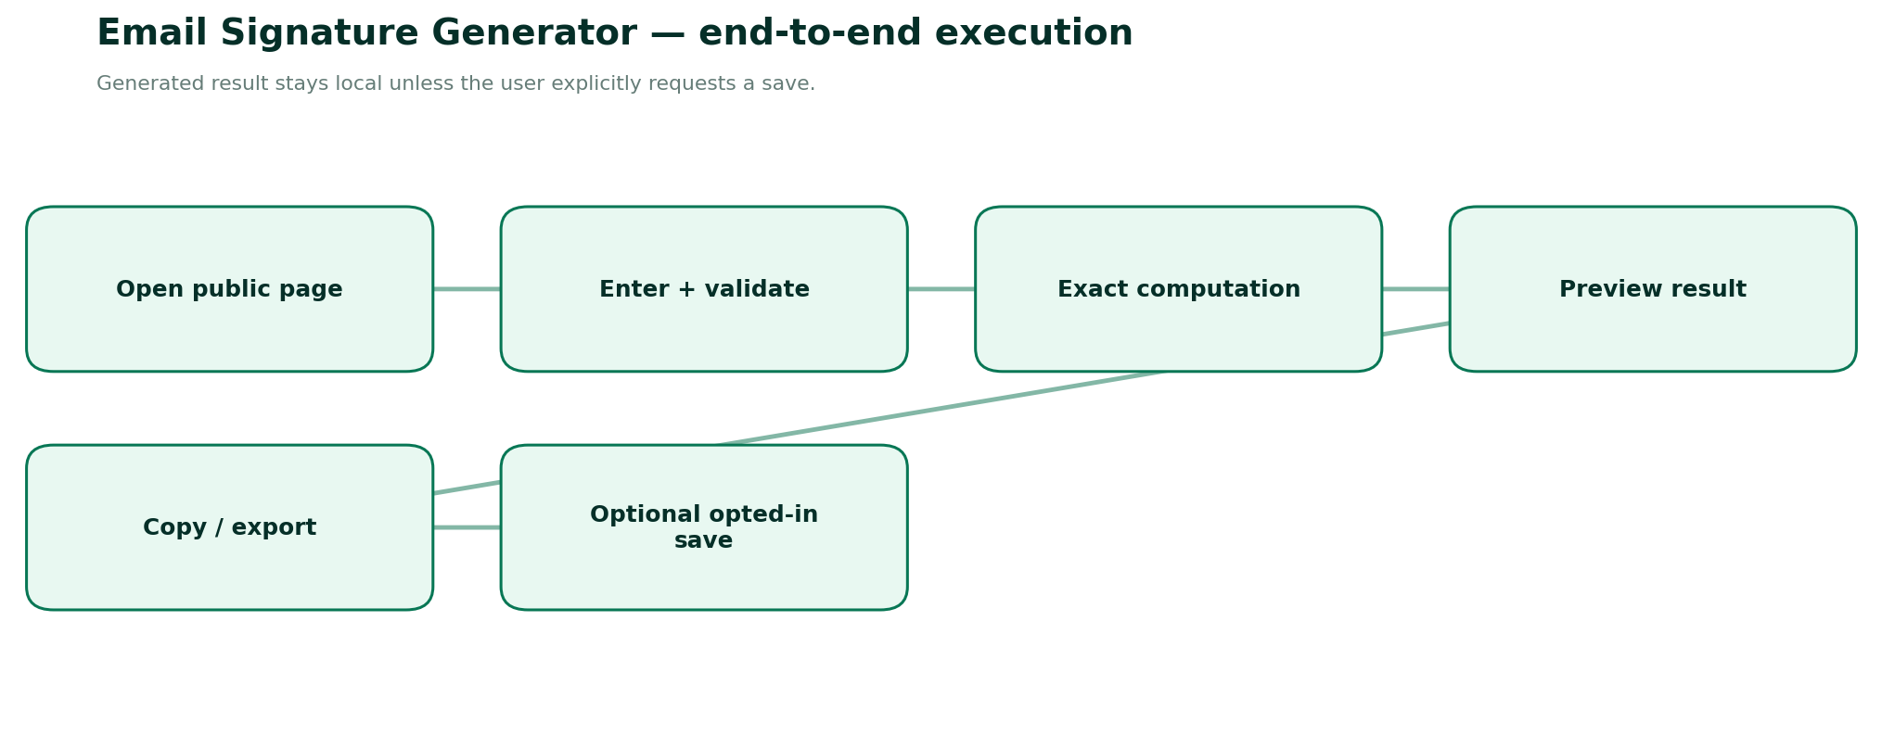
Figure 22. End-to-end execution and explicit persistence boundary for Email Signature Generator.

9.3 Detailed form specification and validation dictionary
FIELD / CONTROL | TYPE | RULES, FEEDBACK AND SECURITY
fullName | string | Required; Unicode letters; max 100.
jobTitle | string | Optional, max 120.
companyName | string | Optional; never pretend verified business identity.
email | email | Optional, links use mailto with valid encoding.
phone | E.164 / display | Optional, tel: canonical destination and accessible display.
website | https URL | Optional, safe href; avoid untrusted JS schemes.
streetOrCity | text | Optional disclosure-sensitive; not required.
socialLinks | array | Allowed social HTTPS domains/URLs; icons optional but accessible links mandatory.
logo | file or HTTPS asset | Optional small image; avoid broken external images and privacy tracking.
brandColor | hex | Contrast compliant, respect dark mode concerns.
fontFamily | enum | System fallback families supported in email clients.
template | enum | 1-4 responsive-friendly templates.
legalDisclaimer | text | Optional, user-entered; no assumption of legal force.
exportType | enum | HTML | plain text | copy rich content.

9.4 Calculation / composition rules
1. HTML uses inline CSS and conservative table layout where needed for email clients; avoid CSS grid, JavaScript, forms, remote fonts.
2. Treat optional images as off-by-default visual enhancement; alt text and visible text contact methods must remain usable when images blocked.
3. Clickable email and phone are encoded with mailto: and tel:; email body should not contain raw scripts or CSS injection.
4. Clipboard API failures fall back to select/copy instructions; never claim content pasted into Gmail/Outlook automatically.

9.5 Frontend build detail — React/Next.js
- Form composition: Create FT-09ClientPage as a publicly accessible feature entry. Use React Hook Form or existing Noxtill form pattern with Zod; type each field as in §9.3.
- Calculation lifecycle: Only run on validated canonical inputs. Debounce outputs that are expensive; for lightweight math compute immediately. Keep last valid result visibly stale if invalid edits occur.
- Result area: Show primary metrics from Desktop/mobile preview, HTML signature, Plain text fallback, Copy-to-clipboard with exact units/assumptions, copy/export, and a human-readable computation explanation.
- Responsive behavior: ≥1024 px use two-column inputs/results; tablet stack/resize; mobile single column with sticky result-action (not an overlay hiding fields).
- Accessibility: Use fieldset/legend for mode groups, aria-describedby for hints/errors, keyboard focus restoration for modals, clear contrast, aria-live for final result only.
- Loading/failure: Render/print may take time; show real loading progress, cancel if supported; disable duplicate download. Preserve inputs and provide safe retry.
- Anonymous & authenticated: No login gating on primary function. Optional Save to Noxtill is a separate user click, opens a permission/consent confirmation and uses canonical API.
- Security: Treat every pasted/typed field as untrusted text; URL validation, escaping, length caps and no unsanitized HTML. Do not send raw inputs as marketing analytics.

9.6 Backend services, API contracts and source-of-truth
- Client-only signature generation preferred; sanitize HTML using audited allowlist if HTML ever received on backend.
- Image upload optional, separate canonical file/media service with explicit consent; disallow SVG or sanitize/rasterize safely.
- No open tracking pixels and no injected analytics in copied signature.
- An organizational signature policy requires authenticated admin and assigned template version through Settings/Staff integration.
METHOD | ENDPOINT | SERVICE BEHAVIOUR
POST | /api/public/tools/signature/render | Optional safe fragment generation
POST | /api/private/settings/staff-signature-templates | Explicit managed organizational template

Request DTO illustration. Names and versioning are proposed—reconcile with the existing Noxtill API conventions before implementation:
{
"tool": "email-signature-generator",
"version": "v1",
"input": {
"fullName": "Emily Carter",
"jobTitle": "Customer Success Manager",
"companyName": "Example Business",
"email": "emily@example.com",
"website": "https://example.com",
"template": "minimal"
}
}
Calculation/render contract sketch (typed pseudocode, not drop-in production code):
const safe = SignatureSchema.parse(input);
const html = renderAllowlistedSignatureTemplate(safe, {
inlineCss: true, noScripts: true, noTrackingPixels: true,
safeLinks: ['https:', 'mailto:', 'tel:']
});
const text = toPlainText(safe);
return { html: sanitizeAllowlist(html), plainText: text };
// Rich clipboard is user-triggered; never sends or installs signature.

9.7 Database and persistence policy
Anonymous fields stay local. Company templates saved only with owner/manager permissions.
CONCEPT / RESOURCE | OWNERSHIP AND RETENTION POLICY
Anonymous runs | Ephemeral browser state; no row in shared Noxtill CRM/marketing table.
Optional result artifact | Generate short-lived download in memory; if cloud export is unavoidable, use expiring private storage and secure deletion.
Authenticated saves | Public HTML snippet generation. Company staff signatures and company identity belong to Staff / Settings; do not create parallel employee records.
Audit and idempotency | Only actual canonical business writes generate activity/audit events, permission checks and idempotency; copy/download is not a business transaction.
Analytics | Event name, tool slug, status/error group, duration and coarse locale; never raw contacts, prices linked to identity, document contents or UTM private values.

9.8 Edge cases, alerts and error-state design
- Missing name: inline error.
- Invalid unsafe website/social scheme: block unsafe destination.
- Unsupported images or stale hosted URLs: show image-disabled preview.
- Rich clipboard blocked by browser: offer explicit HTML file and plain-text copy fallback.
Additional all-tool negative paths: locale changed mid-edit; browser clipboard denied; mobile narrow viewport; offline state; malformed JSON/overlong payload; double-click on export; stale last-valid preview; authenticated session expiration during optional save; provider integration not configured; cross-tenant resource ID attempts. These must have deterministic user-facing outcomes and logged request IDs where a server is involved.

9.9 Noxtill integration boundaries and events
Canonical mapping: Public HTML snippet generation. Company staff signatures and company identity belong to Staff / Settings; do not create parallel employee records.
Recommended events: tool.opened (anonymous aggregate), tool.input_validated (no value payload), tool.result_generated (outcome only), tool.export_completed (file type only), tool.save_requested (authenticated), tool.save_confirmed (only after canonical service success), tool.save_failed (reason code only). Do not send phone/email/URLs/invoice parties in generic tracking events. Integrations execute only when the user elects to save/import/apply.

9.10 Verification vectors and acceptance criteria
1. Copy HTML contains no script, form, iframe, event handler or tracking pixel.
2. All URLs use safe schemes and escaped attributes.
3. Signature remains readable when images disabled and in dark background.
4. Outlook/Gmail/Apple Mail manual smoke tests on representative clients.
5. Phone/email accessible keyboard, screen reader and copy.
6. Long multilingual name does not overflow two-column layout.
DEFINITION OF DONE
A user can complete the stated tool task anonymously, input validation and all listed edge cases work, calculations/encoded output round-trip correctly, mobile/keyboard/screen-reader paths pass, export is semantically consistent with on-screen result, and any authenticated mutation is verified by the canonical owner. The tool may only advertise capabilities actually implemented and passing acceptance tests.
OFFICIAL REFERENCES
R8, R9 — see the full source register and implementation caveats at the end of this document.

FT-10 — Missed Call Revenue Calculator
PUBLIC ROUTE: /FREE-TOOLS/MISSED-CALL-REVENUE-CALCULATOR / SCENARIO-BASED RECOVERY OPPORTUNITY ESTIMATION
Product promise. Estimate potential revenue left on the table by missed calls, with explicit assumptions, uncertainty and recoverable opportunities.
Target audience. Home services, salons, clinics, restaurants, bookings-driven businesses and service operators.
Data ownership. Anonymous assumptions only; live verified missed calls belong to AI Phone Receptionist, customer conversion to CRM/Bookings/Orders, monetary outcomes to Profit & Analytics.
How it works — Roman Urdu: Ye forecast sirf entered assumptions se estimate deta hai. Jo missed calls aur bookings real mein hui hain woh separate modules ki verified data hoti hai; tool unko mix nahi karega.
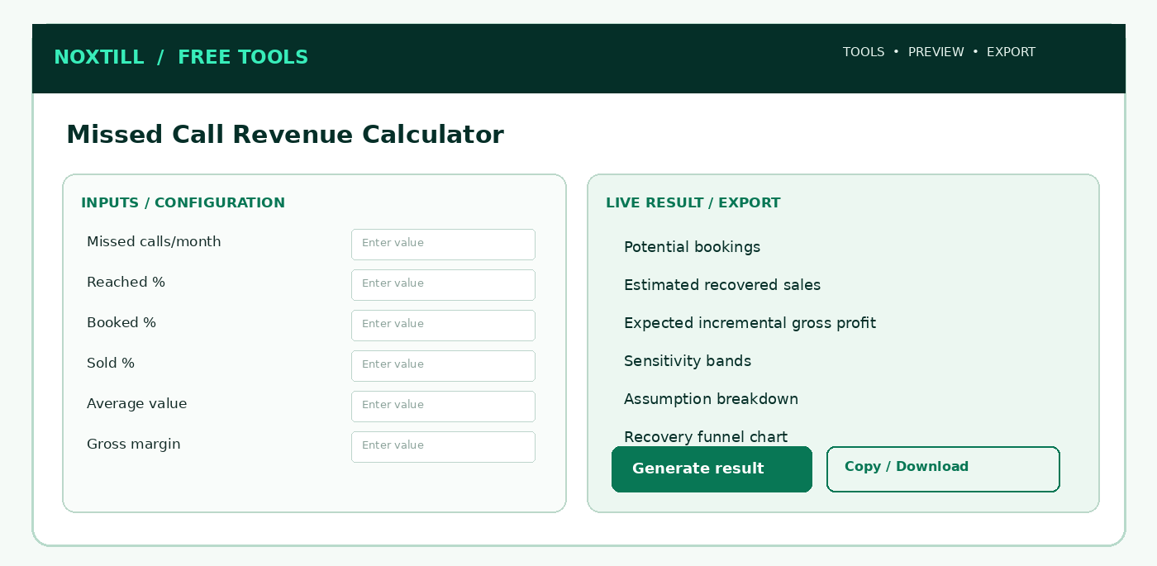
Figure 23. Proposed responsive desktop workbench structure for Missed Call Revenue Calculator; this is a functional wireframe, not a production screenshot.

10.1 Screens, sections and frontend interaction
Use one indexable public utility route with client-side interactive panels, drawers and modals rather than creating unnecessary Noxtill top-level navigation modules. The following are screen AREAS or subviews, not extra canonical sidebar modules:
1. Inputs funnel: missed, eligible, contact, booking, close, ticket.
2. Conversion funnel chart and amount cards.
3. Conservative/base/optimistic user-adjustable assumptions.
4. Export/assumption disclosure and optional connect authorized aggregated call stats.

10.2 Step-by-step user workflow
1. Select industry context for example ranges only; no asserted industry averages without verified source.
2. Enter missed calls per period, eligible/reachable share, booking/lead conversion, sale conversion and average sale value.
3. Show number of prospects at each funnel stage with clear denominator definitions.
4. Display baseline zero recovery vs proposed recovery as an illustrative opportunity, not verified business revenue.
5. Offer conservative/base/optimistic scenarios based on user-controlled sliders, no invented forecasts.
6. Copy results, download visual report and optional explicit connect to Noxtill missed-call actual data.
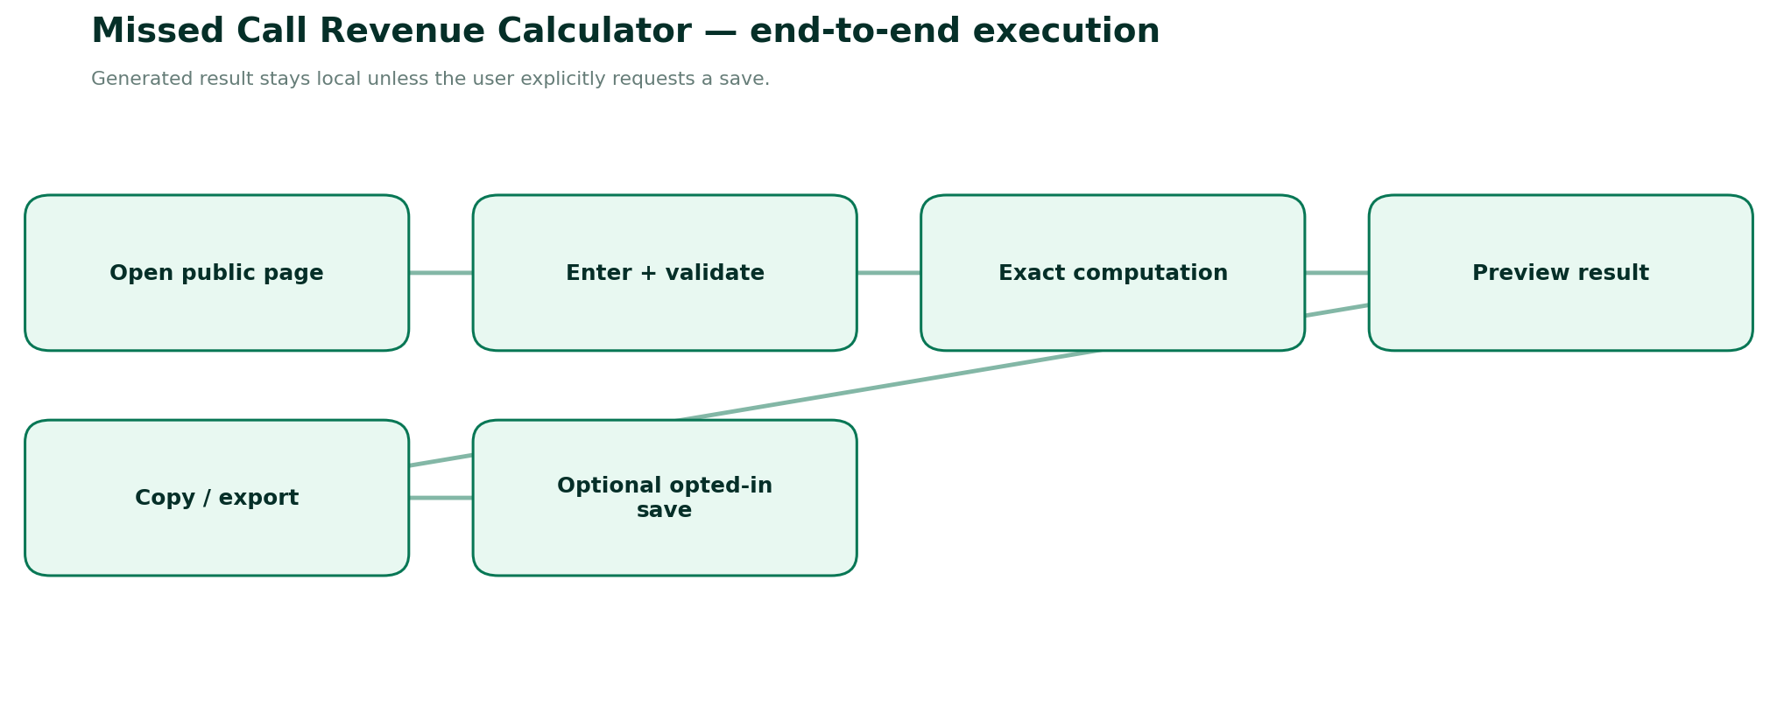
Figure 24. End-to-end execution and explicit persistence boundary for Missed Call Revenue Calculator.

10.3 Detailed form specification and validation dictionary
FIELD / CONTROL | TYPE | RULES, FEEDBACK AND SECURITY
period | enum | week | month; assumptions must be same period.
missedCalls | integer | Nonnegative count, source unknown until connected.
eligibleSharePct | decimal | 0..100; exclude spam/duplicates/unqualified calls.
contactRatePct | decimal | 0..100 of eligible missed calls reached.
bookingRatePct | decimal | 0..100 of reached contacts that book or become qualified leads.
saleClosePct | decimal | 0..100 of booked leads resulting in paid sales.
averageSaleValue | decimal | Nonnegative currency value; exclude refundable deposits if not earned.
grossMarginPct | decimal | 0..100 optional, to estimate gross profit, not revenue.
currentRecoveryPct | decimal | Optional baseline already recovered, subtract incremental opportunities carefully.
scenarioDelta | object | Conservative/base/optimistic ranges editable by user.
currency | ISO4217 | Single currency; do not imply exchange-rate conversion.
attributionQuality | enum | self-reported | connected actual; display badge.

10.4 Calculation / composition rules
1. Eligible = missedCalls × eligibleShare; reached = eligible × contactRate; qualifiedBookings = reached × bookingRate.
2. Expected sales count = qualifiedBookings × saleCloseRate; estimated revenue = expectedSalesCount × averageSaleValue.
3. Estimated gross profit = estimated revenue × grossMarginRate; never call it net profit.
4. For incremental recovery, calculate proposed recovered opportunity minus explicitly defined existing baseline; clamp/warn on negative improvement.
5. Use fractional expectation internally; display estimated counts clearly as expectations and may round shown count separately without altering revenue calculation.
6. Ranges must be driven by disclosed user assumptions, not unsupported universal benchmarks.
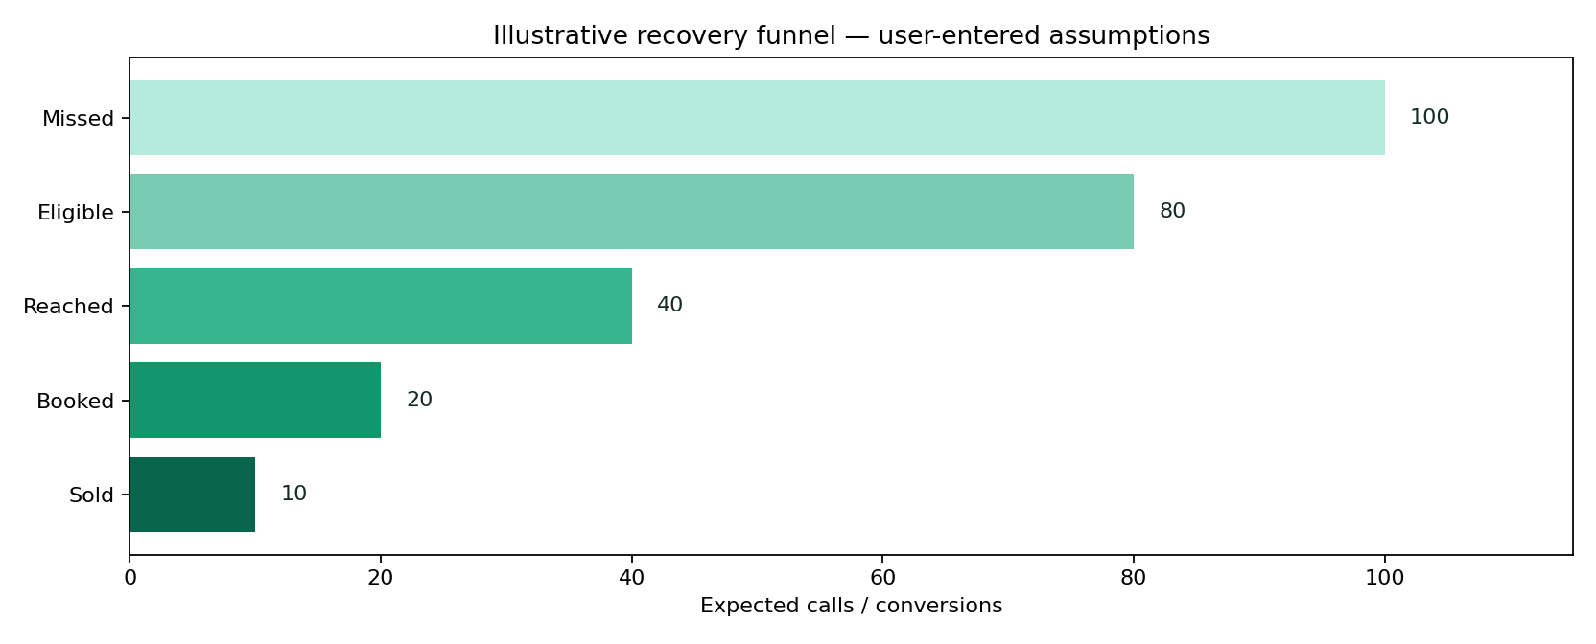
Reference graph. Missed-call scenario funnel, explicitly assumptions-based.

10.5 Frontend build detail — React/Next.js
- Form composition: Create FT-10ClientPage as a publicly accessible feature entry. Use React Hook Form or existing Noxtill form pattern with Zod; type each field as in §10.3.
- Calculation lifecycle: Only run on validated canonical inputs. Debounce outputs that are expensive; for lightweight math compute immediately. Keep last valid result visibly stale if invalid edits occur.
- Result area: Show primary metrics from Potential bookings, Estimated recovered sales, Expected incremental gross profit, Sensitivity bands with exact units/assumptions, copy/export, and a human-readable computation explanation.
- Responsive behavior: ≥1024 px use two-column inputs/results; tablet stack/resize; mobile single column with sticky result-action (not an overlay hiding fields).
- Accessibility: Use fieldset/legend for mode groups, aria-describedby for hints/errors, keyboard focus restoration for modals, clear contrast, aria-live for final result only.
- Loading/failure: Render/print may take time; show real loading progress, cancel if supported; disable duplicate download. Preserve inputs and provide safe retry.
- Anonymous & authenticated: No login gating on primary function. Optional Save to Noxtill is a separate user click, opens a permission/consent confirmation and uses canonical API.
- Security: Treat every pasted/typed field as untrusted text; URL validation, escaping, length caps and no unsanitized HTML. Do not send raw inputs as marketing analytics.

10.6 Backend services, API contracts and source-of-truth
- Entire estimate is stateless, deterministic and can run in browser; backend optional for report PDF.
- If connected, fetch only authorized, aggregate missed-call counts from AI Phone Receptionist; never import raw caller phone numbers for calculator.
- No provider-confirmed return-on-investment guarantee, auto-dialer claim or inferred sales from call counts.
- For signed-in “save scenario,” persist only versioned assumptions in Profit & Analytics scenario store, not actual booked revenue.
METHOD | ENDPOINT | SERVICE BEHAVIOUR
POST | /api/public/tools/missed-call-revenue/calculate | Optional deterministic funnel result
GET | /api/private/voice/missed-calls/summary | Authorized aggregate from Phone module
POST | /api/private/analytics/opportunity-scenarios | Explicit named scenario save

Request DTO illustration. Names and versioning are proposed—reconcile with the existing Noxtill API conventions before implementation:
{
"tool": "missed-call-revenue-calculator",
"version": "v1",
"input": {
"missedCalls": 100,
"eligibleSharePct": "80",
"contactRatePct": "50",
"bookingRatePct": "50",
"saleClosePct": "50",
"averageSaleValue": "200",
"grossMarginPct": "40"
}
}
Calculation/render contract sketch (typed pseudocode, not drop-in production code):
const missed = D(input.missedCalls);
const eligible = missed.times(rate(input.eligibleSharePct));
const reached = eligible.times(rate(input.contactRatePct));
const booked = reached.times(rate(input.bookingRatePct));
const expectedSales = booked.times(rate(input.saleClosePct));
const revenueEstimate = expectedSales.times(D(input.averageSaleValue));
const grossProfitEstimate = revenueEstimate.times(rate(input.grossMarginPct));
return { eligible, reached, booked, expectedSales,
revenueEstimate, grossProfitEstimate, confidence: 'USER_ESTIMATE' };

10.7 Database and persistence policy
Anonymous none; opt-in aggregated scenarios with assumptions, source and estimated flag; no call recordings/caller PII copied.
CONCEPT / RESOURCE | OWNERSHIP AND RETENTION POLICY
Anonymous runs | Ephemeral browser state; no row in shared Noxtill CRM/marketing table.
Optional result artifact | Generate short-lived download in memory; if cloud export is unavoidable, use expiring private storage and secure deletion.
Authenticated saves | Anonymous assumptions only; live verified missed calls belong to AI Phone Receptionist, customer conversion to CRM/Bookings/Orders, monetary outcomes to Profit & Analytics.
Audit and idempotency | Only actual canonical business writes generate activity/audit events, permission checks and idempotency; copy/download is not a business transaction.
Analytics | Event name, tool slug, status/error group, duration and coarse locale; never raw contacts, prices linked to identity, document contents or UTM private values.

10.8 Edge cases, alerts and error-state design
- Zero missed calls or zero conversion yields 0 revenue; do not hide output.
- No connected data: show manual estimate badge, never “verified analytics”.
- Percent denominator mismatch: inline tooltips, reject >100.
- Revenue vs gross profit mislabeled: mandatory QA failure.
Additional all-tool negative paths: locale changed mid-edit; browser clipboard denied; mobile narrow viewport; offline state; malformed JSON/overlong payload; double-click on export; stale last-valid preview; authenticated session expiration during optional save; provider integration not configured; cross-tenant resource ID attempts. These must have deterministic user-facing outcomes and logged request IDs where a server is involved.

10.9 Noxtill integration boundaries and events
Canonical mapping: Anonymous assumptions only; live verified missed calls belong to AI Phone Receptionist, customer conversion to CRM/Bookings/Orders, monetary outcomes to Profit & Analytics.
Recommended events: tool.opened (anonymous aggregate), tool.input_validated (no value payload), tool.result_generated (outcome only), tool.export_completed (file type only), tool.save_requested (authenticated), tool.save_confirmed (only after canonical service success), tool.save_failed (reason code only). Do not send phone/email/URLs/invoice parties in generic tracking events. Integrations execute only when the user elects to save/import/apply.

10.10 Verification vectors and acceptance criteria
1. 100 missed × 80% eligible × 50% reached × 50% booked × 50% sold × $200 = $2,000 estimated sales.
2. At 40% gross margin, estimated gross profit = $800.
3. 0 missed gives $0, not NaN.
4. Changing average ticket only changes revenue/profit, not conversion counts.
5. Connected summary authorization enforced; never expose raw caller details.
6. Display “estimate only” alongside graph and exported summary.
DEFINITION OF DONE
A user can complete the stated tool task anonymously, input validation and all listed edge cases work, calculations/encoded output round-trip correctly, mobile/keyboard/screen-reader paths pass, export is semantically consistent with on-screen result, and any authenticated mutation is verified by the canonical owner. The tool may only advertise capabilities actually implemented and passing acceptance tests.
OFFICIAL REFERENCES
R8, R9 — see the full source register and implementation caveats at the end of this document.

02 — Shared implementation contracts

2.1 Repository structure and packages
apps/web/src/app/(public)/free-tools/
discount-calculator/page.tsx
profit-margin-calculator/page.tsx
break-even-calculator/page.tsx
invoice-generator/page.tsx
qr-code-generator/page.tsx
google-review-link-qr-generator/page.tsx
whatsapp-link-generator/page.tsx
utm-campaign-link-builder/page.tsx
email-signature-generator/page.tsx
missed-call-revenue-calculator/page.tsx
packages/free-tools/
ui/ # Shell, form fields, result panels, safe exports
schemas/ # Shared Zod DTOs, strict bounds, enum versions
money/ # Decimal computations and currency rounding
qr/ # Safe payload composition + deterministic QR rendering
links/ # URL parser, wa.me composer, campaign URL builder
documents/ # Ephemeral invoice/email signature renderers
scenarios/ # Margin, break-even, missed-call economics
tests/golden-vectors/ # Fixed expected outputs and regressions
apps/api/src/routes/tools/ # Optional public compute/render routes
apps/api/src/adapters/ # Optional canonical owner integration adapters
Proposed directory structure, not a claim about the existing repository. Preserve the actual Noxtill pnpm/workspace conventions if they differ. Shared libraries must be versioned and separately unit-tested to avoid divergent results between React previews, optional API recomputation and exported PDFs.

2.2 Public vs authenticated identity flow
OPERATION | ANONYMOUS | SIGNED-IN BUSINESS USER
Compute and preview | Allowed | Allowed
Copy a result | Allowed | Allowed
Download a static artifact | Allowed, within safety limits | Allowed
Create real customer or invoice | Not allowed | Only canonical module with permissions and confirmation
Fetch real missed call counts | Not allowed | Only aggregated, permissioned AI Phone Receptionist metrics
Verify/modify connected business listing | Not allowed | Only through approved OAuth/integration and provider-confirmed status
Save marketing campaign variant | Not allowed | Only into Marketing & Campaigns under tenant scope
Send WhatsApp/email | Never as part of simple free link maker | Separate explicit approved delivery workflow, not the free utility itself

2.3 Money kernel: reproducibility and precision
Financial functions must operate on canonical strings parsed into decimal arbitrary precision. User input locale (e.g., comma decimal separator) must be converted before calculation, without changing magnitude. Round at documented business boundary; never mix a line-rounded sum with a grand-total-only rounded result without reconciliation. Payment gateway or tax jurisdiction rules may require a different strategy, in which case formulaVersion and rule configuration must be explicit.
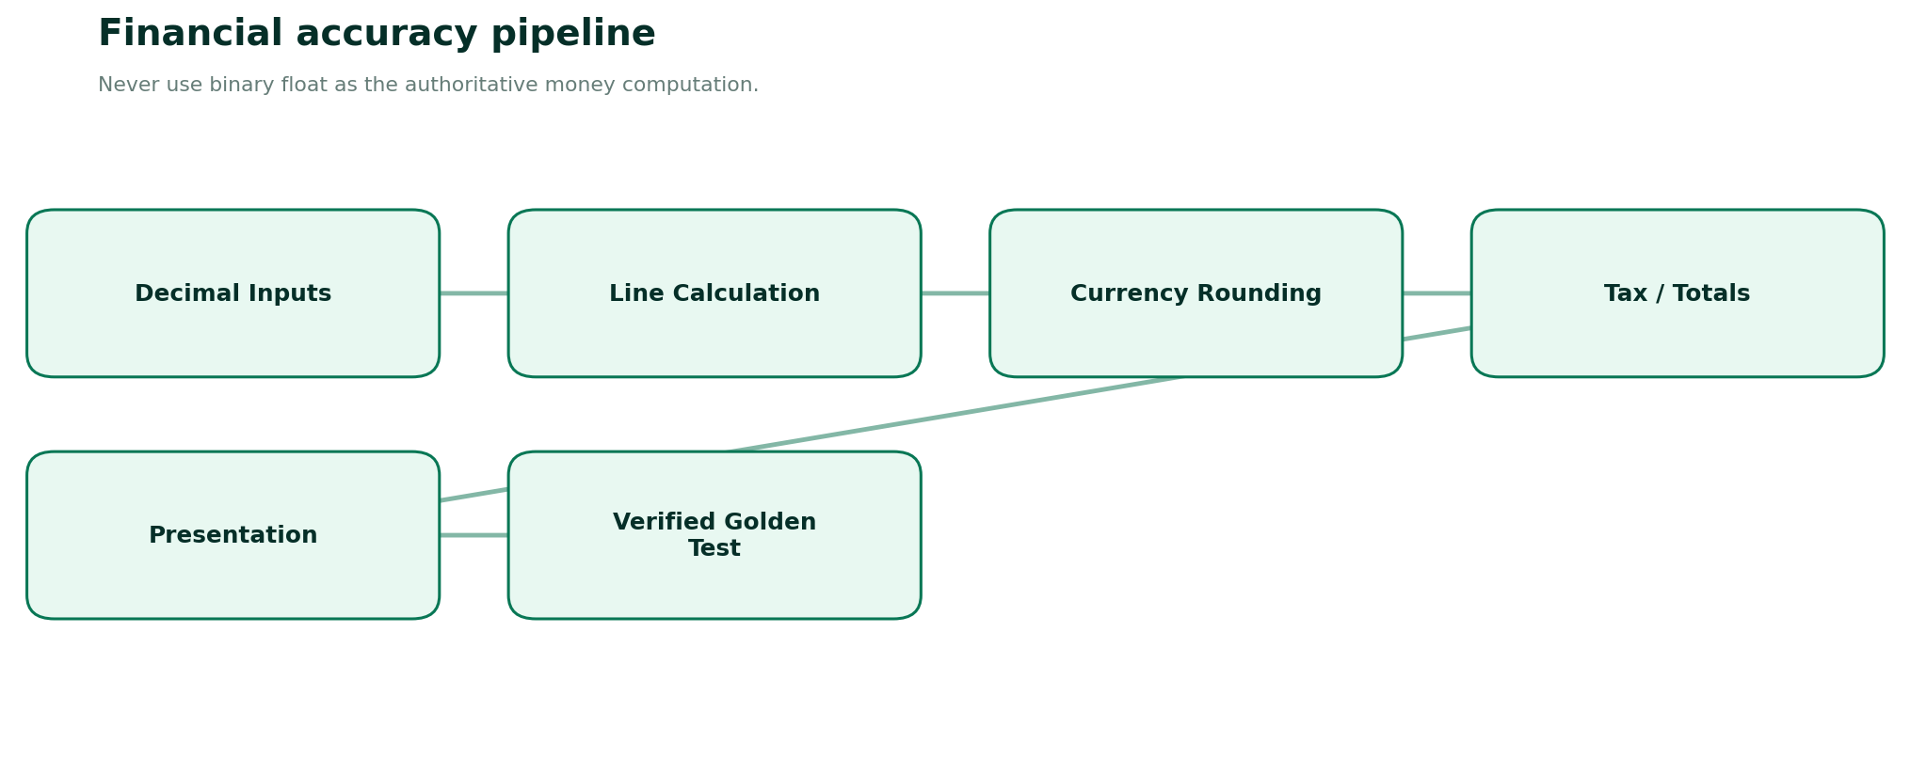
Figure. Precision and traceability pipeline for financial free tools.
NUMERIC RULE | ENFORCEMENT
Decimal canonical input | API accepts string amounts, never JS floating number for final money totals.
Currency precision | ISO 4217 metadata; decimal digits per currency, e.g. special zero/three-decimal currencies.
Round policy | Default decimal half-up at documented point; test all 0.005-like ties.
Percent input | Human “20” means 20%, converted to 0.20 inside algorithm.
Negative output | Losses may be valid for margin; negative payable in discount/invoice requires explicit distinct treatment.
Formula version | Emit version in result/export to support future reproducibility.
Units and period | Every output carries USD, units, weeks/months or years as applicable.
Audit trail | Only authenticated saved financial scenarios/transaction intents audited, not anonymous keystrokes.

2.4 Static QR and safe link service
Use an audited local QR encoder, no external Google Charts QR dependency. Shared payload parser handles URL, Wi-Fi, vCard and WhatsApp data. Google Review and WhatsApp tools reuse this package, but must not duplicate its encoder. “Static” means destination is baked into the QR; there is no link performance data unless a separately designed, consent-aware redirection product exists.
THREAT / FAILURE | MITIGATION
javascript:/data: URL | Reject unsafe scheme for URL link types; special text payload remains harmless plain text.
Arbitrary URL fetch/SSRF | Do not fetch pasted URLs server-side; if absolutely necessary use allowlist + private network block + timeouts.
QR unreadable after logo/color edit | Quiet zone, contrast checks, logo-size restrictions and automated scan roundtrip.
Misleading dynamic QR claims | State “static QR”; no mutable destination/analytics/scan count claims.
PII leaked in public QR | Show explicit full payload preview and user-controlled redaction warning.
Tampered share links | Show domain and full URL before opening; neutral review link only from owner source.

2.5 Export/report pipeline
Printable PDF and image exports should use bounded work queues if server rendering is used. For documents that may contain names, addresses or commercial values, use private expiring download tokens or prefer entirely client-side output; set Cache-Control: no-store, prohibit CDN indexing and redact logs. All downloadable files need correct Content-Type, Content-Disposition, no external network fetch and sanitized filenames.

2.6 Sample error code dictionary
CODE | HTTP | FRONTEND GUIDANCE
VALIDATION_ERROR | 400 | Show field issues; preserve inputs.
UNSAFE_URL | 400 | Explain accepted schemes and affected field.
QR_CAPACITY_EXCEEDED | 422 | Shorten content or lower optional decoration level.
INFEASIBLE_TARGET | 422 | Display denominator issue, keep inputs.
CALCULATION_OVERFLOW | 422 | Lower extreme values; return no invalid numeric result.
RATE_LIMITED | 429 | Show retry guidance and continue local mode if possible.
AUTH_REQUIRED | 401 | Free result still available; optional account save requires login.
FORBIDDEN_TENANT_RESOURCE | 403 | Never reveal existence of other tenant resources.
CONFLICT_EXISTING_UTM | 409 | Prompt replace/preserve prior parameters.
EXPORT_FAILED | 500 | Offer retry/local print where safe; no false “Downloaded”.

2.7 Representative TypeScript domain interfaces
type IsoCurrency = string;
type DecimalString = string;
type ToolRunResult<T> = {
formulaVersion: 'v1'; result: T; warnings: string[];
assumptions: Record<string, string>; verifiedExternalAction: false;
};
type SourceMode = 'anonymous_local' | 'anonymous_server' | 'tenant_explicit_save';
type SafePublicEvent = { toolSlug: string; event: string; status: string;
durationBucket?: string; /* never user input or document content */ };
interface CanonicalSaveRequest { canonicalOwner: string; expectedVersion?: number;
idempotencyKey: string; confirmedByUser: true; }
// Save implementations must validate server session & object-level rights.

2.8 Deployment environment and secrets
- Stateless tools require no secret and should not invent an API dependency.
- Do not place tax credentials, Google OAuth secrets, third-party storage keys or signed export keys in browser bundles.
- Authenticated save flows use existing session/RLS policy; signed-in status alone never implies a user can modify another business record.
- Optional Google Business Profile access must use the existing Integrations module and approved provider scopes; static owner-pasted review link needs no OAuth.
- Error monitoring should capture requestId, toolSlug, errorCode and coarse performance only—not invoice names/amounts, phone numbers, message bodies or complete tracked URLs.
- Maintain disabled-by-default integration feature flags until implementation and QA demonstrate genuine behavior.

03 — Cross-tool integration matrix
FREE TOOL | CANONICAL MODULE | ALLOWED HANDOFF
Discount Calculator | Products & Services / Marketing | Authorized proposal only; never silently discount sale
Profit Margin Calculator | Products / Profit & Analytics | Optional scenario/approved cost update; no ledger posting
Break-Even Calculator | Profit & Analytics | Save forecast assumption, not booked revenue
Invoice Generator | Orders / Payments & Billing | Separate draft vs actual issue/payment status
QR Code Generator | Documents / media assets | Explicit save of final QR artifact only
Google Review Link & QR | Reviews & Reputation / Business Listings | Paste official link; connected listing only if provider-authenticated
WhatsApp Link Generator | Unified Inbox / Settings | Static click-to-chat, not sent message
UTM Campaign Link Builder | Marketing & Campaigns / Advertising | Authorized campaign link variant only
Email Signature Generator | Staff / Settings | Assigned organizational signature when explicitly saved
Missed Call Revenue Calculator | AI Phone Receptionist / Profit & Analytics | Only aggregate actual call counts; opportunity remains estimated

3.1 Approval-aware save transaction
1. User finishes free tool and reviews the complete result.
2. User chooses Save to workspace separately; login if required, with return to exact result.
3. Server revalidates input and canonical object links, checks tenant and role, and requests any required business approval.
4. Canonical owner performs transaction exactly once using idempotency and returns real entity ID and status.
5. Only after confirmed write may UI show Saved, campaign linked, draft created or other factual outcome.
6. On failure, preserve local generated result, show request ID and let user retry safely.

3.2 Analytics taxonomy without private payloads
tool_opened: { slug, locale, device_class }
tool_calculated: { slug, result_status, duration_bucket }
tool_exported: { slug, format, export_status }
tool_save_clicked: { slug, target_module }
tool_save_confirmed: { slug, target_module, status }
// Do NOT track: phone numbers, names, invoice lines, emails,
// message content, target URL query strings, signed URLs, exact revenue assumptions.

3.3 Global SEO and discoverability requirements
Every page should have a unique explanatory article suited to its tool, purpose-based FAQs, human-authored calculations/examples, authoritative references, related tools and accurate metadata. “Free”, “online”, “calculator” and market terms can be used naturally; do not manufacture keyword volume/competition figures. Each page must offer usable interaction above the fold and meaningful structured content below.
TOOL PAGE | SUGGESTED UNIQUE EXPLANATORY INTENT
Discount | Discount vs tax order; stacked vs single discount; retail discount examples.
Margin | Markup vs margin; pricing targets with transaction fees; loss warnings.
Break-even | Contribution margin; fixed vs variable; unit vs revenue threshold.
Invoice | Invoice vs receipt; PDF preview; country-specific required fields.
QR | Static QR vs dynamic; print resolution; quiet zones and error correction.
Google Reviews | Get official review link; scan-friendly cards; review policy and honesty.
WhatsApp | Click-to-chat without save; correct international number; prefilled text.
UTM | UTM source/medium/campaign definitions; duplicates and fragments.
Signature | Compatible HTML across email clients; image-off fallback; setup.
Missed Call Revenue | How funnel math works; assumptions vs actual recovered revenue.

3.4 Product copy and truthfulness rules
- Do not say “Instant PDF issued invoice” if it is only an anonymous PDF document.
- Do not say “Google verified review link” when a user pasted a link; show “Owner-provided link” or “Unverified destination”.
- Do not say “WhatsApp message sent” when wa.me was merely opened.
- Do not say “QR scans tracked” for static codes.
- Do not claim financial planning tools make financial/legal/tax decisions on behalf of user.
- Do not call estimated missed-call revenue “lost confirmed revenue” or “guaranteed ROI”.
- Do not put invisible tracking pixels in email signatures or downloaded QR images.

04 — Test strategy and acceptance checklists

4.1 Automated test pyramid
TEST LAYER | MANDATORY COVERAGE
Pure domain unit tests | Formulas, URL composition, QR payload encoding, rounding, tax modes, zero denominators.
Golden vectors | All fixed examples in FT-01..FT-10, exported to shared test fixtures.
Property/fuzz tests | Input bounds, Unicode roundtrip, URL encoding, no negative total, no unexpected NaN/Infinity.
Schema/contract tests | Every public and private request validates DTO; errors follow envelope; no unknown fields.
Security tests | XSS, unsafe URL schemes, SSRF prevention, oversized PDF inputs, unauthorized save and BOLA.
Integration tests | Canonical module saves only on explicit opt-in; entity IDs, permissions, idempotency, audit.
Browser E2E | Anonymous landing → input → preview → copy/download, tablet/mobile responsive paths.
Accessibility | WCAG 2.2 AA audit + keyboard-only/manual screen-reader smoke checks.
Export snapshots | PDF text/searchable, QR encoded text roundtrip, signature safe HTML, CSV injection.
Resilience | Offline/local, denied clipboard, export timeouts, stale async response, multiple rapid clicks.

4.2 Complete QA matrix
AREA | PASS CONDITION
Forms | Every field has valid/invalid/boundary test; error clear; no data lost on failed submission.
Money | Decimal strings; policy-defined rounding; currencies, negative margin, impossible targets tested.
QR | All types encode/decode; quiet zone, contrast, SVG safe markup, offline available.
Review policy | Owner copy link required; no incentives, review gating, fake verification claims.
WhatsApp | wa.me number digits only, optional message URL-encoded, no auto-send claim.
UTM | URL fragments/existing query preserved; conflict prompt; GA-required parameters enforced.
Invoice | Anonymous no persistence; print pagination; tax rule locality; save/issue separation.
Signature | Sanitized rich HTML, image-off fallback, safe links, no tracking pixels.
Missed calls | Counts and conversion funnel estimates correctly labeled; no fake provider revenue.
API | Request/response DTO contracts, bounded load, rate limiting and no raw PII logs.
Accessibility | Keyboard, focus, screenreader labels/live output, mobile zoom and WCAG checks.
Internationalization | Locale switch no changed amount; currency minor units; Unicode/RTL stress.
Privacy | Anonymous data not saved; consent gates; purge ephemeral render files.
Ownership | Actual business writes delegated to canonical Noxtill module; test tenant isolation.
Observability | Errors classified and actionable; no sensitive event payload.
Truthful UX | No invented verified/sent/paid/confirmed labels.

4.3 Example golden test fixture format
[
{"tool":"discount-calculator","input":{"price":"100.00","quantity":2,
"discountPercent":"20"},"expect":{"discount":"40.00","net":"160.00"}},
{"tool":"profit-margin-calculator","input":{"sale":"100","cost":"60"},
"expect":{"marginPercent":"40","markupPercent":"66.666..."}},
{"tool":"break-even-calculator","input":{"fixed":"1000","price":"50",
"variable":"30"},"expect":{"wholeUnits":50,"revenue":"2500"}},
{"tool":"missed-call-revenue-calculator","input":{"missedCalls":100,
"eligible":0.8,"reached":0.5,"booked":0.5,"closed":0.5,"ticket":200},
"expect":{"estimatedRevenue":"2000.00"}}
]
Fixture keys above are illustrative and must match final typed DTOs. Define exact precision expectations and acceptable display rounding in the executable fixture files. For currency rates, never assert a universal rate or jurisdiction without explicit configuration.

4.4 Non-functional release criteria
- No horizontal scroll at representative widths 320, 375, 768, 1024 and 1440 px.
- All ten pages keyboard usable; focus visible and no modal focus trap failures.
- Tools perform deterministically under slow network or offline where intentionally client-local.
- Accessible charts have tabular/text alternatives; export images include meaningful labels and units.
- Page-specific loading budgets and maximum payload sizes benchmarked under representative devices.
- Instrument performance without collecting user-entered personal data.
- No account/paywall blocks core public calculation/composition.
- Feature flags prevent partial integrations from advertising actions they cannot perform.
- Engineering and legal sign-off needed before supporting official tax invoice templates in each target jurisdiction.

4.5 Developer handoff completion evidence
Each tool needs: source branch/PR; schema and computation tests; screenshots at desktop/mobile; API contract or explicit client-only rationale; screenreader/keyboard QA; generated artifact sample; negative test evidence; analytics event schema; integration permission tests if saving; and product acceptance confirming no false provider-confirmed actions. A feature is not finished because the UI screenshot looks correct.

05 — Official research and reference register
Sources below support specific standards and third-party workflow rules, checked during specification preparation on 11 October 2026. The rest of this document is Noxtill’s proposed architecture/product design, not a claim that the cited source endorses Noxtill or supplies completed integrations.
R1 Google Business Profile Help — create review link or QR code
https://support.google.com/business/answer/16816815?hl=en-GB
Applied for: Official review link workflow; incentive/review-gating restrictions.
R2 WhatsApp Help Center — Click to chat
https://faq.whatsapp.com/5913398998672934
Applied for: wa.me international number and prefilled text syntax.
R3 Google Analytics Help — URL builders and custom campaigns
https://support.google.com/analytics/answer/10917952?hl=en
Applied for: utm_source, utm_medium, utm_campaign naming and usage.
R4 MDN — URLSearchParams
https://developer.mozilla.org/en-US/docs/Web/API/URLSearchParams
Applied for: Safe query encoding, parameter updates and fragment handling.
R5 DENSO WAVE QRcode.com — Error correction
https://www.qrcode.com/en/about/error_correction.html
Applied for: QR L/M/Q/H error-correction tradeoffs.
R6 GOV.UK — Invoices: required information
https://www.gov.uk/invoicing-and-taking-payment-from-customers/invoices-what-they-must-include
Applied for: Illustrative UK invoice fields and legal differences.
R7 European Commission — EN 16931 eInvoicing compliance
https://ec.europa.eu/digital-building-blocks/sites/spaces/DIGITAL/pages/467108950/EN%2B16931%2Bcompliance
Applied for: Structured e-invoicing separate from free PDF generation.
R8 W3C — WCAG 2.2
https://www.w3.org/TR/WCAG22/
Applied for: Accessibility acceptance baseline, target AA.
R9 OWASP — API Security Top 10 2023
https://api-security.owasp.org/editions/2023/en/0x11-t10/
Applied for: BOLA, resource consumption, sensitive workflows, SSRF.
R10 Google Search Central — SoftwareApplication structured data
https://developers.google.com/search/docs/appearance/structured-data/software-app
Applied for: Accurate app structured data where eligible; no rich result guarantee.
R11 GOV.UK — VAT guide, invoice fields
https://www.gov.uk/guidance/vat-guide-notice-700
Applied for: Country-specific VAT requirements; no universal tax rule.
R12 Google Search Central — FAQ rich-result changes
https://developers.google.com/search/blog/2023/08/howto-faq-changes
Applied for: FAQ markup not a dependable rich-result tactic for ordinary commercial sites.

5.1 Verified standards vs proposed product behavior
Officially grounded: WhatsApp wa.me syntax [R2]; Google Business Profile owner review link workflow and no incentivized reviews [R1]; GA4 UTM campaign guidance [R3]; JavaScript URLSearchParams behavior [R4]; QR error-correction tradeoffs [R5]; sample UK invoice disclosure requirements [R6,R11]; EU structured e-invoicing standard boundary [R7]; WCAG 2.2 [R8]; OWASP API guidance [R9]; conditional search structured-data eligibility [R10,R12].
Proposed product decisions: Noxtill web page layout and feature groups, API endpoints, DTO names, database entity mappings, private save handoffs, default precision policies, export limits, UI/UX design and test methodology. Reconcile them with existing Noxtill codebase and market legal requirements before shipping.

5.2 Deliberate exclusions / separate integration scope
- No requirement to use paid Google Review / QR / WhatsApp APIs merely to generate static links or images.
- No anonymous issue of government-compliant electronic invoices; country tax and e-invoicing connectors are separate approved business capabilities.
- No implicit sending email/WhatsApp, no claim that a static QR tracks conversions, and no provider-guaranteed response from destinations.
- No automatic copying of business prices, customers, saved contacts or call records into public calculator submissions.
- No guessed keyword volumes, performance benchmarks, future customer counts or external tax rates.
- No artificial implementation deadline, daily schedule or false claim that every optional integration is implemented.

5.3 Final product acceptance statement
The ten tools together form a cohesive set of useful Noxtill public utilities. Every tool must genuinely work for a user, accurately communicate its assumptions and limitations, have an inspectable result and a safe copy/export path, and integrate into the Business OS only through consented, permissioned canonical writes. Building the visible interface without this behavior is not completion.

