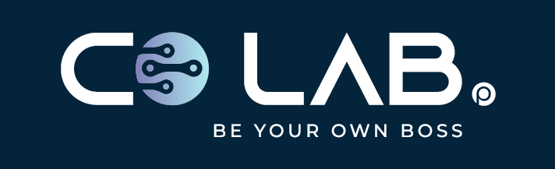
CoLab Point | Digital Agency | Gujrat, Pakistan

CoLab Space Point
Digital Agency Proposal
Website Designing & Development | Digital Marketing
www.colabpoint.com
+92 349 7684322 | +92 347 8986460
colabpoint@gmail.com | hello@colabpoint.com
2nd Floor Anwar Center, Madina Road Near Gymkhana, Gujrat, Pakistan

COMPANY PROFILE
CoLab Space Point | Digital Agency | Gujrat

 | About Us  CoLab Space Point is the digital services division of CoLab Point — a trusted innovation and coworking hub in Gujrat since 2021. We help businesses establish a strong online presence, sell through e-commerce, and acquire customers through data-driven marketing.  Our mission is to deliver premium digital experiences that convert visitors into customers — with transparent pricing, professional delivery, and ongoing support after every launch.

Est. 2021 | Location | Platform | Focus
CoLab Point ecosystem | Gujrat, Pakistan | WordPress & WooCommerce | Websites + Digital Marketing

Our Core Services
✓ Website Designing & Development | ✓ SEO (Search Engine Optimization)
✓ WordPress Development | ✓ Google Ads
✓ E-commerce Solutions | ✓ Meta Ads (Facebook & Instagram)
✓ Branding & Visual Identity | ✓ Business Growth Strategy
✓ Digital Marketing

Why Choose CoLab Space Point
• Experienced multidisciplinary team
• Professional support and clear communication
• Business-focused, results-driven solutions
• Modern technology stack
• Creative design and performance marketing
• Transparent pricing and long-term partnership

WordPress is our primary development platform. Fully custom solutions are available on request.
 | Website Designing & Development

 | BASIC WEBSITE — PKR 50,000  Package Price: PKR 50,000

Best for: Small businesses and startups
WHAT IS INCLUDED IN THIS PRICE:
• Professional business website
• Up to 5 pages
• Responsive mobile design
• WordPress CMS
• Contact form
• WhatsApp integration
• Social media profile links
• Facebook & Instagram — account creation & basic business page setup
• SSL configuration
• 30 days support
IMPORTANT: SEO and e-commerce are NOT included in this package.

 | STANDARD WEBSITE — PKR 80,000  Package Price: PKR 80,000

Best for: Growing brands and online sellers
WHAT IS INCLUDED IN THIS PRICE:
• Everything in Basic Website, plus:
• Up to 10 pages
• Premium UI/UX design
• Blog section
• WooCommerce online store
• Product upload (initial batch)
• Payment gateway integration
• Google Search Console setup
• Facebook Pixel
• Basic SEO
• Speed optimization
• Facebook & Instagram — profile setup, branding & cover/banner design
• Facebook & Instagram — initial launch posts & monthly posting
• WhatsApp Business — profile setup & website linking
• 60 days support

 | PREMIUM WEBSITE — PKR 120,000  Package Price: PKR 120,000

Best for: Established businesses and enterprises
WHAT IS INCLUDED IN THIS PRICE:
• Everything in Standard Website, plus:
• Up to 15 pages
• Fully custom design
• Advanced WooCommerce setup
• Unlimited product catalog setup
• CRM integration
• Booking / appointment system
• API integrations
• Premium security and performance optimization
• Admin training
• Facebook, Instagram, TikTok & LinkedIn — full profile optimization & branding
• All social apps — content calendar, regular posts, stories & reels
• All social apps — engagement, community management & monthly performance report
• 90 days priority support

 | Digital Marketing  Monthly packages

BASIC — PKR 15,000 / month
What is included:
• Meta Ads
• Audience targeting
• Campaign optimization
• Monthly reporting

STANDARD — PKR 30,000 / month
What is included:
• Google Ads + Meta Ads
• Lead generation
• Conversion tracking
• Landing page recommendations
• Monthly reports

PREMIUM — PKR 50,000 / month
What is included:
• Google Ads + Meta Ads
• SEO
• Remarketing
• Conversion optimization
• Marketing strategy
• Weekly meetings
• Detailed reports

 | Contact

Company: CoLab Space Point
Website: www.colabpoint.com
Phone: +92 349 7684322 | +92 347 8986460
Email: colabpoint@gmail.com | hello@colabpoint.com
Address: 2nd Floor Anwar Center, Madina Road Near Gymkhana, Gujrat, Pakistan

