FullSync 0.8 Draft

Documentation

[2004-10-30]

Table of Contents

Table of Contents 2
FileSystems 3
Unbuffered FileSystem 3
A File 3
Buffered FileSystem 3
A File 3
File Attributes 3
The Synchronization Process 4
Abstract 4
Phase One: Task Generation 5
Phase Two: Task Serialization and Execution 6
Authorities 7
StateDecider 7
BufferStateDecider 7
ActionDecider 7
FileComparer 7
Filter 7
Notes 8

FileSystems

Unbuffered FileSystem
Can Flush

A File
Naming: Name, Path
Hierarchy: Parent, Children, createChild
Existence: exists, isFiltered
Buffering: isBuffered, getUnbuffered
Attributes: isDirectory, isFile, FileAttributes
IO Access: Input/Output streams, make directory, delete

Buffered FileSystem
A buffered file system always lies above an unbuffered file system which is used to perform IO operations and to load and save the buffer data.

Can and will Flush
A buffer update:
set isDir
set exists
set attributes of Fs File

A File
Enhances the unbuffered file with:
add/remove Child
FsFileAttributes

File Attributes
Length
LastModified
Permissions
? Checksum
The Synchronization Process

Abstract
The main synchronization process is divided into two phases with user interaction before, between and after them. The first phase is responsible to find out what actions should and can occur for a given source, destination and initial rule set. The result can be modified by the user and is used as input for the second phase, the execution phase. In this phase all chosen tasks are performed and real I/O operations occur.

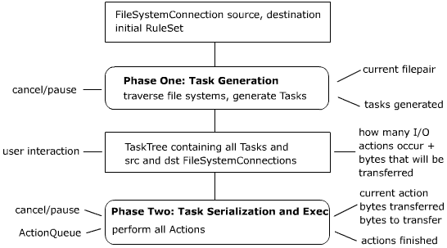

Phase One: Task Generation
Input:
- FileSystemConnection source and destination
- initial RuleSet which provides an initial Filter, ActionDecider, StateDecider and FileComparer.

Actor:
- A Processor

Initialization:
- as it is strictly bound to the ActionDecider he decides the traversal type which can be one of the following:
  - source <-> destination (full comparison)
  - buffer <-> file system (change detection in src or dst)

Actions:
- the Processor traverses through the given file systems using the currently active RuleSet and calls a callback of the ActionDecider for each pair of files. This callback generates a Task using the two given files, source and destination FileSystemConnections, a StateDecider and it’s personal Properties. While comparing the RuleSet may change when applying directory rules or RuleSet files. Absolutely no changes occur during this phase, not to the file systems on disk or to the data in memory.

Output:
- A TaskTree object is returned with source and destination FileSystemConnections and all the generated Tasks in a tree-like manner.

Feedback:
- Which file pair is processed at the moment
- The last Task generated (for statistics and maybe pipelining)

User Interaction:
- Cancel the process
- Pause the process

Pipelining notes:
Is there a better way to get the Task objects more fluently plus the filesystems than a listener? Maybe the listener should have 3 methods: taskTreeStarted, taskGenerated, taskTreeFinished

Phase Two: Task Serialization and Execution
Input:
- A TaskTree with Tasks and source and destination FileSystemConnections

Actor:
- An ActionQueue

Actions:
- All Tasks are committed / serialized to the ActionQueue which will perform the actions by for example generating buffer entries and emitting them to an ExecutionBuffer.

Feedback:
- How many real I/O actions will occur and how many bytes must be copied (must be counted in advance by giving the TaskTree to the ActionQueue or serializing it to it)
- Which Action is currently processed and how many bytes must be and have already been transferred
- Action that has just been finished (maybe giving back an id, transferred bytes, …)

Authorities

StateDecider
This class decides which state two files have.

BufferStateDecider
This class decides which state the buffer of a node has.

ActionDecider
The ActionDecider is responsible for deciding which actions are possible for the state of two files and they buffers. The implementation of this class represents the type of synchronization that is performed like backup, update or two-way synchronization.

FileComparer
The FileComparer is responsible for determining whether two files are equal or unequal and if unequal which one is newer or whether this is not decidable.
It may be rule driven and change on a per directory basis.

Filter
A filter is responsible for masking the files that are synchronized. It is used during the comparison phase to filter out ignored files.
It may be rule driven and change on a per directory basis.
Notes
Actions must be bound to BufferActions as they must change in an atomic way.

