DJCollects | COMING SOON
Want first dibs?
Ask us how to get on the interest list for
Gem Pack Vol. 7 & Aura Seeker

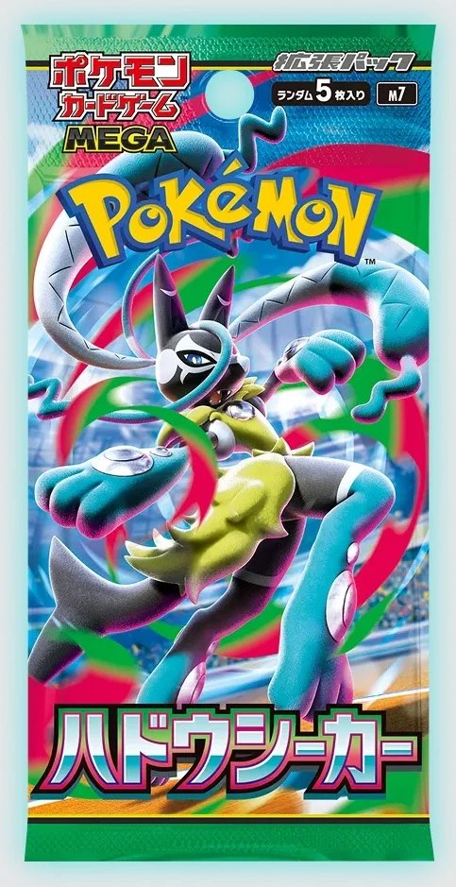 | 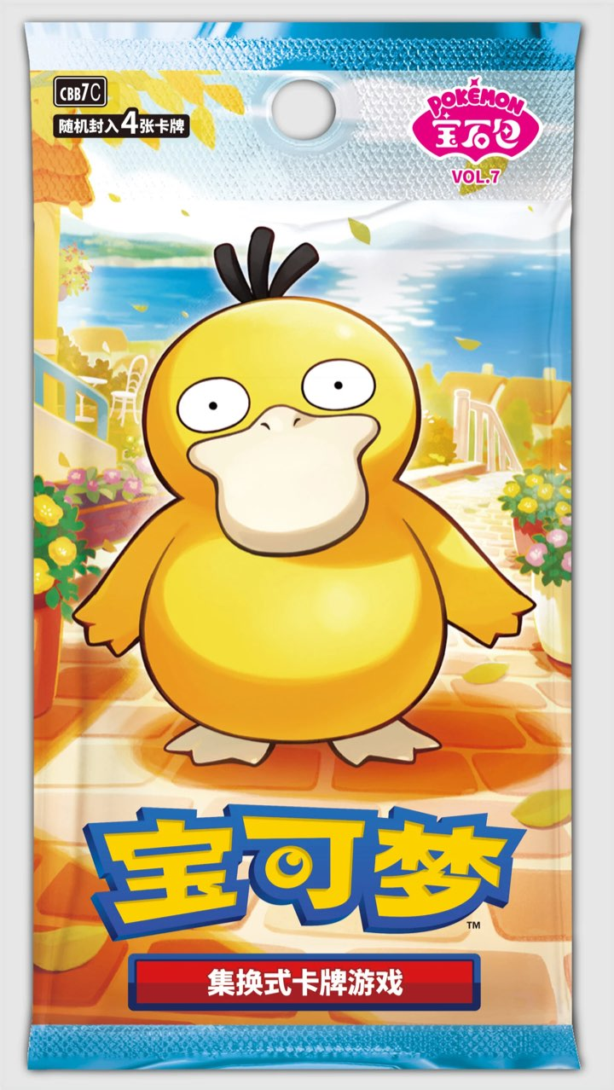 | 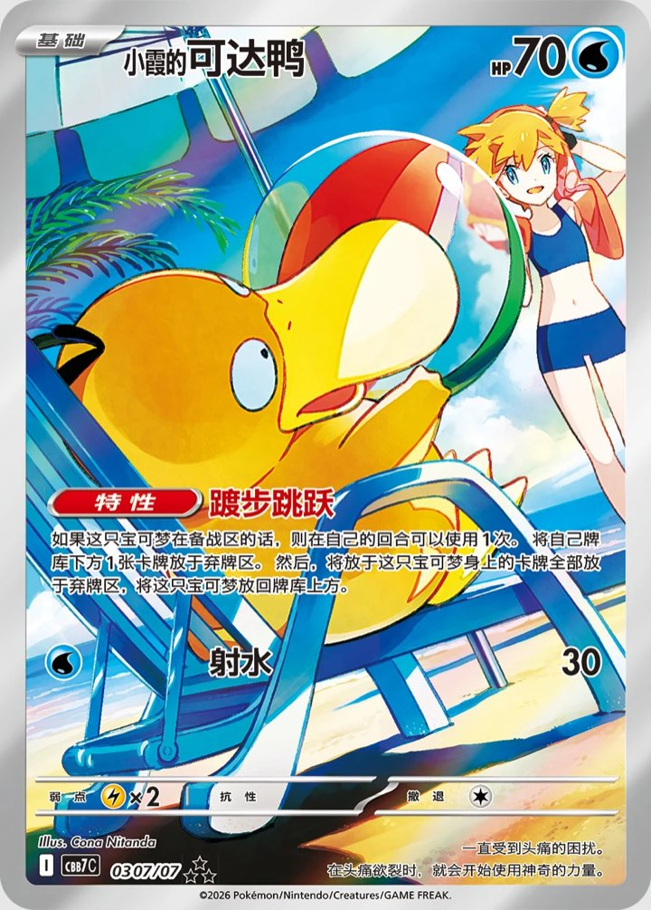
JAPANESE · MEGA · M7  Aura Seeker | SIMPLIFIED CHINESE · CBB7C  Gem Pack Vol. 7

Ask us how!
Drop your email and be the first to know when they land. No spam — just drops.
djcollects.com

