1. List of technologies and design patterns used are

# List Of technologies :

a) PHP as a server side scripting language &

b) Mysql as a database

# Design Pattern

MVC (Model-View-Controller) architecture

2. Sequence diagram

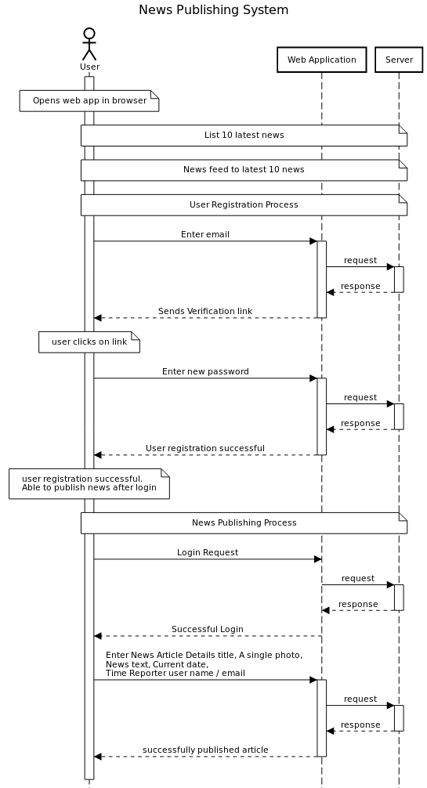

3. An overall layer or component interaction diagram

