Tri-Lion
Online Judge Platform
React + Vite · Node.js + Express · MongoDB Atlas · Docker · Redis (Upstash) · Gemini AI
Deployed on Vercel (frontend) & AWS EC2 / ECR (backend) · onlinejudge.site
High Level Design Document

Table of Contents
1. Overview & What is an Online Judge?
2. Technology Stack & Deployment
3. Database Design & Collection Relationships
4. Backend – REST API & Submission Flow
5. Code Execution Engine – Docker Isolation & Resource Limits
6. AI Integration – Google Gemini
7. System Architecture Diagram
8. Reliability, Failure Handling & Retry Mechanisms
9. Redis Usage & Session Model Clarification

1. Overview
Tri-Lion is a full-stack Online Judge platform that lets users solve programming problems by writing code in supported languages. Submissions are compiled and executed against hidden test cases inside a secure Docker sandbox, and automatically evaluated to produce a real-time verdict.

What is an Online Judge?
An Online Judge is a software system that allows users to solve programming problems by writing code in supported programming languages. The submitted code is compiled, executed against predefined test cases in a secure environment, and automatically evaluated.

Submission Flow (Overview)
Step | Actor | Action
1 | User | Selects a problem from the library
2 | User | Writes a solution in the Monaco Editor
3 | User | Submits code to the platform
4 | Backend API | Validates request & stores the submission
5 | Execution Engine | Docker container compiles & runs the code
6 | Judge | Runs all hidden test cases
7 | Judge | Compares actual vs expected output
8 | System | Returns verdict; updates score if Accepted

Key Features
- JWT-based Authentication (Register / Login) with OTP-verified password reset
- Problem Library with Search, Tags, and Difficulty Filters
- Monaco Code Editor with Multi-language Support (C++, Java, Python, JavaScript)
- Docker-based Secure Code Execution & Automated Judging
- Submission History with Runtime & Memory Statistics
- User Dashboard with Progress Tracking and Streaks
- Global Leaderboard (Redis-cached)
- AI-powered Hints, WA/TLE Analysis, Code Explanation, and Personalised Problem Recommendations
- Admin Dashboard for Problem and Test Case Management

2. Technology Stack & Deployment
Tri-Lion uses a modern, open-source stack designed for performance, scalability, and developer productivity. The platform runs as three independently deployed services behind a shared MongoDB Atlas cluster and Upstash Redis instance.
Layer | Technology | Purpose
Frontend | React 18 + Vite 5 | Single Page Application (SPA) with fast builds
State Mgmt | Redux Toolkit | Global state: auth, user data, submissions
Routing | React Router v6 | Client-side routing & protected routes
Styling | Tailwind / Bootstrap v3 | Utility-first CSS, responsive UI
HTTP Client | Axios | API calls with JWT interceptors
Backend | Node.js 20 + Express.js | RESTful API for auth, problems, submissions
Authentication | JWT + bcryptjs | Stateless auth + secure password hashing
Database | MongoDB Atlas + Mongoose | Users, problems, test cases, submissions
Caching / Queue | Redis (Upstash) + BullMQ | Leaderboard cache, rate-limiting, async job queue
Execution | Docker | Isolated sandbox with CPU/memory/time limits
Container Registry | AWS ECR | Stores language-runtime Docker images pulled by the judge
AI Services | Google Gemini 1.5 Flash | Hints, WA analysis, recommendations
Process Management | PM2 | Process supervision, auto-restart, log management on EC2
Version Control | Git + GitHub | Source code management & collaboration
Frontend Hosting | Vercel | CDN-served React build, auto-deploy on push
Backend Hosting | AWS EC2 | Runs yt-auth, compiler-api, compiler-worker under PM2
Custom Domain | onlinejudge.site | Purchased domain; DNS routed to Vercel (frontend) and EC2 (auth.onlinejudge.site)

3. Database Design & Collection Relationships
The system uses MongoDB Atlas as the primary database, organised into four main collections. Relationships between collections are implemented as Mongoose ObjectId references rather than SQL-style foreign keys, since MongoDB is document-oriented.

3.1 User Collection
Field | Type | Description
userID | String | Unique user identifier
fullName | String | User's full name
email | String | Unique email address
password | String | Bcrypt-hashed password
score | Number | Total accumulated score
problemsSolved | Number | Count of accepted problems
refreshToken | String | Current active refresh token (single-session model)
otpHash / otpExpiry | String / Date | Hashed OTP and expiry for password reset / email verification

3.2 Problem Collection
Field | Type | Description
problemID | String | Unique problem identifier
title | String | Problem title
statement | String | Full problem description (Markdown)
difficulty | String | Easy / Medium / Hard
topics | Array | Tags (e.g. DP, Graph, Greedy)
timeLimit | Number | Execution time limit (ms)
memoryLimit | Number | Memory limit (MB)

3.3 Test Case Collection
Field | Type | Description
testCaseID | String | Unique test case identifier
problemID | String | Reference to parent Problem (FK)
input | String | Test case input data
output | String | Expected output
isHidden | Boolean | True = hidden; False = sample/visible

3.4 Submission Collection
Field | Type | Description
submissionID | String | Unique submission identifier
userID | String | Reference to submitting User (FK)
problemID | String | Reference to Problem (FK)
language | String | Programming language used
code | String | Raw source code
verdict | String | AC / WA / TLE / MLE / RE / CE
runtime | Number | Execution time (ms)
memory | Number | Peak memory usage (MB)
aiReport | String | AI-generated feedback (optional)

3.5 Collection Relationships
The diagram below shows how the four collections relate. A Problem owns many TestCases (used only at judge time, never sent to the client for hidden cases). A User produces many Submissions, and each Submission targets exactly one Problem. There is no direct reference from Submission to TestCase — at judge time, compiler-worker looks up the TestCase set for the Submission's problemID.
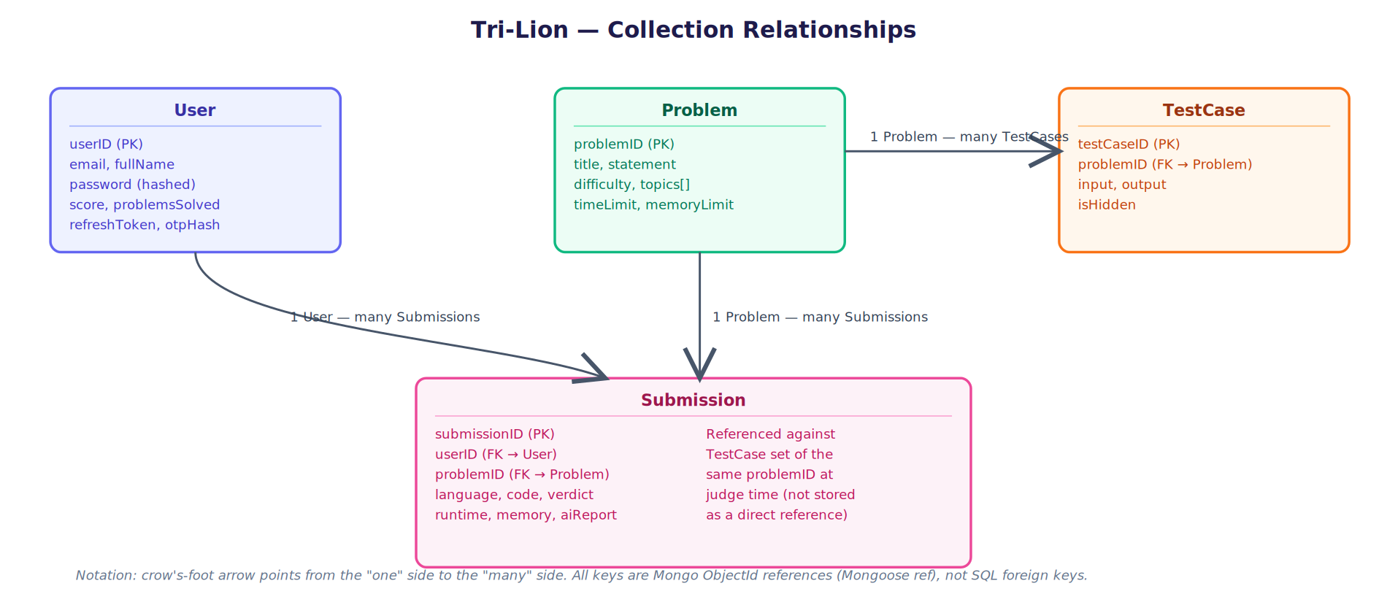
Figure 1 — Tri-Lion collection relationships (crow's-foot notation, Mongoose ObjectId references)

Relationship Summary
Relationship | Cardinality | Implementation
User → Submission | One-to-many | Submission.userID references User.userID
Problem → Submission | One-to-many | Submission.problemID references Problem.problemID
Problem → TestCase | One-to-many | TestCase.problemID references Problem.problemID

4. Backend – REST API
The backend is split across two services — yt-auth and compiler-api — both built with Node.js 20 and Express.js. yt-auth exposes authentication, problem, leaderboard, and AI endpoints; compiler-api accepts submissions and enqueues them for judging. All protected endpoints require a valid JWT in the Authorization header.

4.1 API Endpoints
Method | Endpoint | Description
POST | /api/auth/register | Register a new user account
POST | /api/auth/login | Login and receive a JWT token
POST | /api/auth/refresh-token | Rotate access token using refresh token cookie
POST | /api/auth/forgot-password | Request an OTP for password reset
POST | /api/auth/reset-password | Reset password using a verified OTP
GET | /api/problems | List all coding problems (with filters)
GET | /api/problems/:id | Get full problem details
POST | /api/submissions | Submit code for automated judging
GET | /api/submissions/:id | Get submission status & verdict
POST | /api/run | Run code with custom test input
GET | /api/leaderboard | Fetch global leaderboard rankings
GET | /api/users/:id | Get user profile & statistics
POST | /api/ai/hint | Generate step-by-step AI coding hints
POST | /api/ai/report | Analyse WA/TLE submissions with AI
POST | /api/ai/recommend | Recommend problems based on progress

4.2 Submission Processing Flow
Step | Description
1 | User submits code from the Monaco Editor in the frontend.
2 | compiler-api validates the request and stores the submission in MongoDB.
3 | The submission is queued for execution (BullMQ + Redis).
4 | compiler-worker picks the job; a Docker container is spawned for the target language.
5 | The program is run against all hidden test cases sequentially.
6 | Verdict is determined: AC, WA, TLE, MLE, RE, or CE.
7 | Result is persisted to the Submission collection.
8 | If Accepted, user score and statistics are updated atomically.
9 | Frontend polls / receives the final verdict and execution details.

5. Code Execution Engine
Tri-Lion uses Docker to execute user-submitted code in a secure, isolated environment. Each submission runs inside a freshly created, single-use container with strict resource constraints to guarantee fairness, prevent abuse, and keep the host system stable.

5.1 Supported Languages & Limits
Language | Time Limit | Memory Limit | Compilation
C++ | 2 seconds | 256 MB | g++ -O2
Python | 5 seconds | 256 MB | CPython 3.x
Java | 5 seconds | 512 MB | javac / JVM
JavaScript | 5 seconds | 256 MB | Node.js 20

5.2 Docker Isolation Model
Every submission is executed inside a dedicated, ephemeral Docker container built from a language-specific image (pulled from AWS ECR). The isolation model is deliberately conservative — a submission is treated as untrusted code by default:
- Process isolation: each container has its own PID namespace; user code cannot see or signal host or sibling-container processes.
- Filesystem isolation: the container filesystem is a fresh, throwaway layer per run — no writes persist, and the container has no access to the host filesystem beyond a narrow, read-only mount of the submitted source file.
- Network isolation: containers run with networking disabled, so submitted code cannot make outbound requests, exfiltrate data, or reach internal services (including MongoDB, Redis, or the AWS metadata endpoint).
- No privilege escalation: containers run as a non-root user with capabilities dropped; the judge does not grant --privileged or extra Linux capabilities.
- Single-use lifecycle: a container is created immediately before execution and destroyed immediately after, whether the run succeeds, fails, or times out — no container is reused across submissions or users.

5.3 Resource Limits Enforced Per Container
Resource | Enforcement | Rationale
CPU | CPU quota / shares capped per container | Prevents one submission from starving the host or other concurrent judge jobs
Memory | Hard memory limit per language (see 5.1); OOM-killed on breach | Enforces MLE deterministically instead of crashing the host
Wall-clock time | Timer around the run; container killed on breach | Enforces TLE deterministically, bounds worst-case job duration
Process count | PID limit inside the container | Blocks fork-bomb style denial-of-service attempts
Disk / output size | Output stream capped | Prevents runaway output from exhausting worker memory/disk

5.4 Execution Process
Step | Action
1 | User submits code via the frontend.
2 | compiler-api stores the submission and adds it to the execution queue.
3 | compiler-worker picks the job; a Docker container is created for that language.
4 | Code is compiled (where applicable) inside the container.
5 | The binary / script is executed against every test case in order, under the limits in 5.3.
6 | Output is captured and compared against expected results.
7 | Final verdict is computed and stored in the database.
8 | The container is destroyed. Frontend receives and displays the verdict with runtime & memory stats.

5.5 Verdict Reference
Verdict | Code | Meaning
Accepted | AC | All test cases passed within limits
Wrong Answer | WA | Output does not match expected output
Time Limit Exceeded | TLE | Execution exceeded the allowed wall-clock time
Memory Limit Exceeded | MLE | Memory usage exceeded the allowed limit
Runtime Error | RE | Program crashed or exited abnormally
Compilation Error | CE | Code failed to compile successfully

6. AI Integration – Google Gemini
Tri-Lion integrates Google Gemini 1.5 Flash to provide intelligent assistance to users. All AI requests are proxied through the yt-auth backend to keep the API key secure and to enforce user authentication.

6.1 AI Features
Feature | Description
AI Hints | Provides step-by-step hints to guide the user without revealing the complete solution. Using AI hints reduces the score awarded for that problem.
Submission Analysis | Analyses Wrong Answer (WA) and Time Limit Exceeded (TLE) submissions; identifies likely issues and suggests concrete improvements.
Problem Recommendations | Recommends problems tailored to the user's solved history, target difficulty level, and topics of interest.

6.2 AI Request Workflow
Step | Action
1 | User triggers an AI feature (hint / analysis / recommendation) from the UI.
2 | Frontend sends an authenticated POST request to the relevant yt-auth endpoint.
3 | Backend validates the JWT and constructs the Gemini prompt.
4 | Backend forwards the request to the Google Gemini 1.5 Flash API.
5 | Gemini generates and returns the AI response.
6 | Backend sanitises and returns the response to the frontend.
7 | Frontend displays the AI output in the appropriate UI panel.

6.3 Security
- Gemini API key is stored as a server-side environment variable — never exposed to the client.
- AI endpoints are protected; unauthenticated requests are rejected with 401.
- User code and problem data are sanitised before being included in prompts.

7. System Architecture
The platform follows a three-tier architecture split across three independently deployed services, with an asynchronous execution layer for code judging. The diagram below shows the full request path, data stores, and external services.
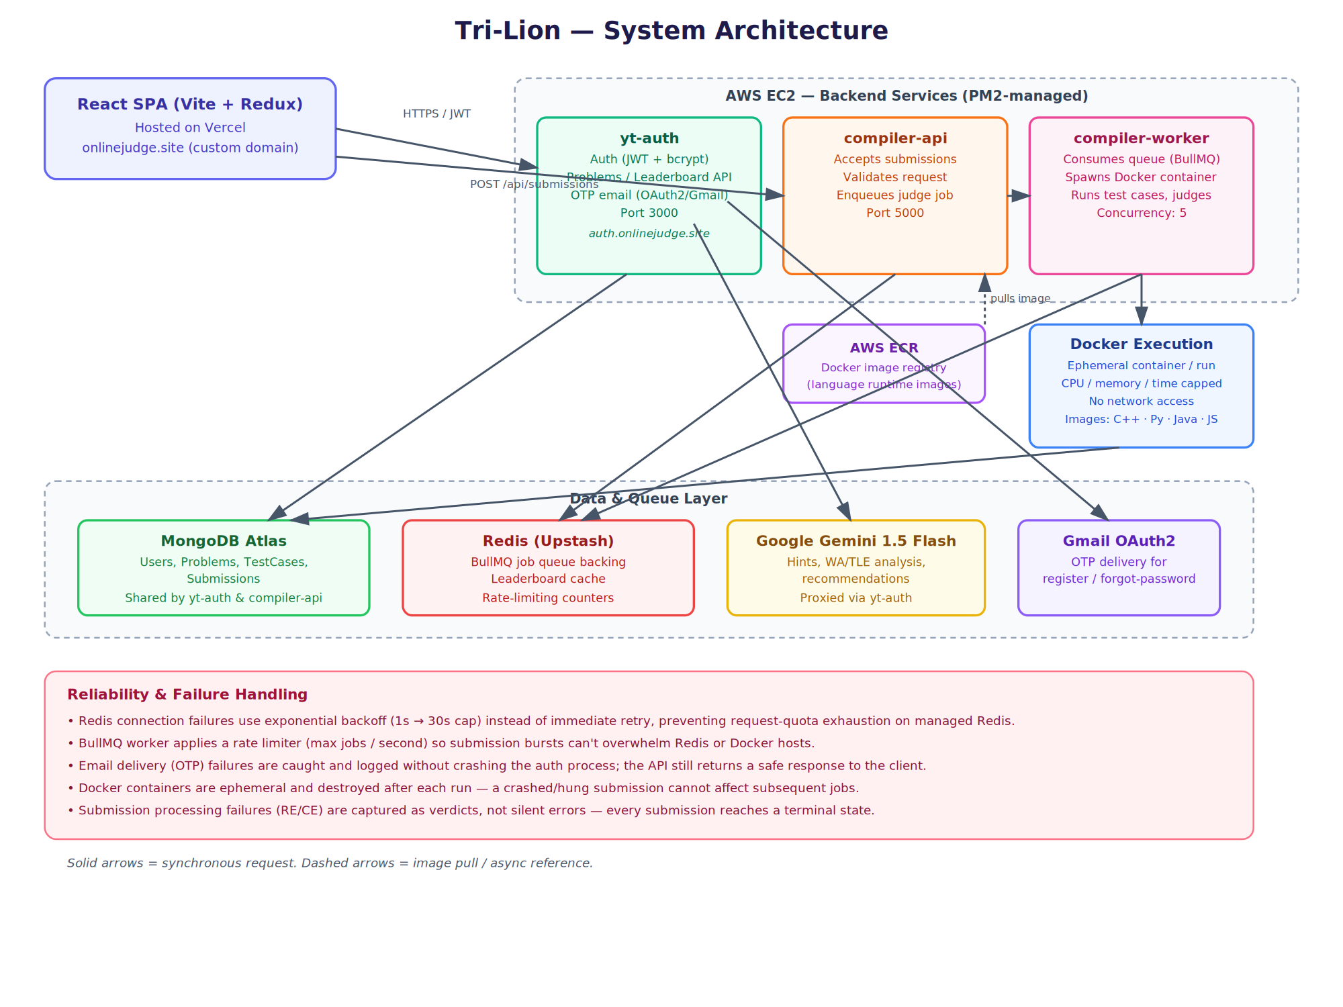
Figure 2 — Tri-Lion / Tri-Lion system architecture

Tier Summary
Tier | Component | Technology | Responsibility
Client | React SPA | React 18 + Vite + Redux | Problem browsing, code editing, result display
API Layer | yt-auth | Node.js + Express.js | Auth, problem CRUD, leaderboard, AI proxy
API Layer | compiler-api | Node.js + Express.js | Submission intake, request validation, enqueue
Execution | compiler-worker | Node.js + BullMQ | Job consumption, Docker orchestration, judging
Data | MongoDB Atlas | Mongoose ODM | Persistent storage for all entities
Data / Cache / Queue | Redis (Upstash) | ioredis + BullMQ | Leaderboard cache, rate-limiting, job queue
Execution | Docker Judge | Docker + AWS ECR | Isolated, resource-capped code execution
AI | Gemini API | Google Gemini 1.5 Flash | Hints, WA analysis, problem recommendations
Hosting | Frontend | Vercel | CDN-served React build, custom domain onlinejudge.site
Hosting | Backend | AWS EC2 (PM2) | Runs yt-auth, compiler-api, compiler-worker as managed processes

8. Reliability, Failure Handling & Retry Mechanisms
Distributed pieces of this system — a managed Redis instance, a managed Mongo cluster, an OAuth-based email provider, and a third-party AI API — can all fail independently of application code. The sections below describe how each failure mode is contained so that one dependency's outage degrades gracefully instead of taking down the whole platform.

8.1 Redis Connection Failures
The Redis client (used by both compiler-worker and, indirectly, by BullMQ) is configured with an exponential backoff retry strategy instead of retrying instantly:
- Retry delay grows with each attempt (1s, 2s, 3s, …) up to a 30-second cap, rather than retrying in a tight loop.
- This was a direct response to a real incident during development: an earlier version retried Redis connections with no backoff and burned through the entire monthly request quota on the managed Redis plan within minutes of an outage, taking the submission queue down for the rest of the billing cycle.
- reconnectOnError inspects the error type — a quota-exceeded error stops automatic reconnection instead of retrying forever against a provider that has already rejected the connection, avoiding the same failure mode recurring.

8.2 Submission Queue Throughput Control
- compiler-worker's BullMQ Worker is configured with a rate limiter (bounded jobs per second) so a burst of submissions cannot overwhelm Redis or spawn more concurrent Docker containers than the EC2 host can handle.
- Worker concurrency is explicitly capped (currently 5 concurrent jobs) rather than left unbounded.

8.3 Email / OTP Delivery Failures
- Nodemailer (Gmail OAuth2) failures inside forgotPassword / register are caught in a try/catch and logged; they do not crash the yt-auth process or leave it in a bad state.
- The API still returns a safe, generic response to the client (e.g. "If that email exists, an OTP was sent") regardless of whether the lookup succeeded, which also avoids leaking which emails are registered.
- A startup-time transporter.verify() check logs whether the email service is reachable and correctly authenticated as soon as the process boots, surfacing OAuth credential problems (e.g. an expired or rotated client secret) immediately in the logs rather than only on the first user-triggered failure.

8.4 Docker Execution Failures
- Containers are single-use and destroyed after every run, so a submission that crashes, hangs, or corrupts its own container cannot affect any other submission.
- Timeouts and memory limits (Section 5.3) convert what would otherwise be an unbounded hang into a deterministic TLE/MLE verdict.
- Any submission that fails to judge cleanly still resolves to a terminal verdict (RE/CE) rather than being left in a stuck "processing" state indefinitely.

8.5 Database & Network Failures
- MongoDB Atlas connection issues (e.g. DNS/TLS handshake failures seen on restrictive networks) are logged with the underlying driver error rather than a generic failure, to make root-causing faster.
- Scoring updates after an Accepted verdict are wrapped separately in their own try/catch so that a scoring failure is logged but does not roll back or fail the already-completed judging result.

8.6 Secrets & Credential Rotation
- Environment variables (DB credentials, JWT secrets, OAuth client secret, Redis credentials) are kept out of version control and set directly on each deployment target (Vercel project settings, EC2 .env).
- When a credential is rotated (e.g. after an accidental exposure), the fix is: rotate the value at the provider, update the .env on the affected host, then restart the process with an explicit environment refresh so stale, cached credentials are not held in memory by the running process.

9. Redis Usage & Session Model Clarification
Authentication in Tri-Lion is stateless: JWT access and refresh tokens are issued and verified without any server-side session store. Redis is deliberately not used to store login sessions. Its role in the system is entirely separate from authentication, and is limited to three purposes:
Use | What is stored | Why Redis (not JWT / not Mongo)
BullMQ job queue backing | Submission job payloads, queue state (wait/active/completed/failed lists) | BullMQ requires a fast, ordered, atomically-updatable store for queue operations — this is a queueing problem, not an auth problem, and is unrelated to how a user is authenticated.
Leaderboard cache | Precomputed/sorted leaderboard rankings | Avoids recomputing an expensive aggregate query against MongoDB on every leaderboard page view; Redis sorted sets are a natural fit for ranked data.
Rate-limiting counters | Per-IP / per-account request counts within a time window | Rate limiting needs a fast, shared counter that expires automatically (TTL) — MongoDB is unnecessarily heavy for this, and an in-memory counter wouldn't be shared across multiple backend instances.

Why this separation matters
- Because auth is JWT-based and stateless, a Redis outage does not log any user out or block new logins — Redis being unreachable only degrades the queue, leaderboard freshness, and rate limiting, not authentication.
- Conversely, JWT tokens are never stored in or validated against Redis; they are verified purely by signature (JWT_ACCESS_SECRET / JWT_REFRESH_SECRET), so no Redis round-trip is on the critical path of a normal authenticated request.
- The one exception is the single-active-refresh-token model: the current refresh token is stored on the User document in MongoDB (not Redis) so that logout / logout-all can invalidate it — this is a deliberate Mongo choice, not a Redis session.
In short: JWT answers "is this request authenticated?"; Redis answers "what's currently queued, cached, or rate-limited?" — the two are intentionally decoupled so that a failure in one does not cascade into the other.

