A child’s rare disease, examined properly - what the evidence does (and does not) support
Track 2 of the “Rare Disease, Real Kid” MVA Hackathon 2026 - evidence program, explained for readers without a biology background. Version 1.0 · 2026-09-05 · DRAFT - not yet human-approved for submission use (see §12).

0. How to read this report
This document was written for people who are not biologists. Every technical word is explained where it first appears, and again in the Glossary (§11). Every factual claim carries a bracketed tag like [E42] that points to an entry in the References section (§10), where you find the real scientific source, a clickable link, and a one-line note on how that source was verified. Nothing in this report asserts anything beyond what those sources support - where honest science must say “nobody knows”, this report says exactly that. One more convention: a tag like [P2-1] marks a correction our own adversarial reviewers caught mid-process - we keep these visible on purpose. And a tag like [E40-P2] points to the internal review document recording that fix.
Two warnings up front, kept short and honest:
- This is not medical advice. It is an analysis of published research, prepared for a scientific competition. Any decision about a real child’s treatment belongs to that child’s doctors and family.
- No drug discussed here is proven to help the patient. The report’s most important section is the one about what we are not claiming (§8).

1. The challenge, and the child, in plain terms
A 2026 public science competition (the “MVA Hackathon”, run as a HuggingFace challenge space [E44]) presents a real pediatric case: a young child with an ultra-rare inherited disease called MVA - short for Mosaic Variegated Aneuploidy - caused by faults in a gene called BUB1B. Children with MVA have a substantially elevated risk of kidney cancer (Wilms tumor) and a muscle-lineage cancer (rhabdomyosarcoma), plus blood cancers; current medicine offers no drug to reduce that risk - only surveillance scans to catch tumors early [E20][E21].
The competition’s Track 1 asks teams to interpret the child’s genome. Track 2 - the subject of this report - asks a harder question:
Is there any already-approved drug that could be safely repurposed to help this child?
Our team answered that question the slow, careful way: instead of picking a popular candidate, we mapped every reasonable way to attack the disease, ran three waves of independent research, and then subjected our conclusions to four separate adversarial reviews - major findings running 8 → 2 → 2 → 0 - designed to destroy them. What survived is summarized here. The short answer, fully unpacked in §5:
- The named repurposing candidate is everolimus - an approved drug with solid pediatric safety data - proposed only inside a strict, monitored, gate-first protocol, with its risks stated as plainly as its rationale.
- The precision medicine of the future for this child may be a tailored gene-patch (an “exon-skipping” drug) - and we show exactly why that idea is scientifically sound and what the one decisive experiment is.
- Several widely-hyped ideas in this disease area are documented dead ends for this child, with reasons.

2. The one minute of biology you need
Your body is made of ~37 trillion cells. Cells multiply by dividing: one cell becomes two. Before dividing, each cell must copy its instruction book (the genome) and then split the copies perfectly between the two daughter cells. Splitting is perilous - so cells evolved a quality-control checkpoint that halts division until every copy is correctly attached to the machinery that pulls them apart.
BubR1 is a protein that guards that checkpoint. Think of it as the air-traffic controller at cell division: without it, chromosomes land on random runways. A chromosome is one of the 46 bound volumes the instruction book comes in - and every new cell must get exactly one copy of every volume. Cells with too little BubR1 activity end up with the wrong number of chromosomes - a state called aneuploidy - and aneuploidy is a well-established cancer driver - in the closest animal experiments, mice with broken BubR1 develop tumors [E17a][E20b]. Honesty demands the other half too: aneuploid cells are also actively hunted and cleared by the immune system, which is why this is a race, not a certainty [E17].
MVA (Mosaic Variegated Aneuploidy) is what happens when a person is born with too little working BubR1: “mosaic” because only a portion of cells go wrong, “variegated” because the wrongness varies, “aneuploidy” because the chromosome counts break [E18][E20]. The condition was defined genetically in 2004 when mutations in BUB1B (the gene that encodes BubR1) were found to cause it [E20].

3. This child’s two mutations - and why both matter
Each of us carries two copies of every gene: one from mother, one from father. This child’s two BUB1B copies are both broken, but in two different ways [E01] (the case document):
(a) The “stop-sign” mutation - medical shorthand p.Leu737Ter, also written L737*. (These letter-number codes are labels, not information; we show them once so your doctors can match this report to the genetic report.) A gene’s instruction text is read in three-letter words; one copy of this child’s BUB1B text has a spelling change that turns a normal word (“build here”) into the word “STOP” at position 737. The cellular machinery that reads the book therefore stops building the protein three-quarters of the way through - and unfinished proteins are usually destroyed by the cell’s recycling system (a quality process called nonsense-mediated decay; in this exact gene’s geometry there is no documented escape route - the evidence says “escape is unlikely”; we use that wording, not “guaranteed,” because the process is probabilistic [E42]). That copy makes almost no working BubR1.
(b) The “shape” mutation - p.Asn1002Lys (N1002K). The other copy has a single-letter spelling change deep inside the protein’s enzymatic core (its “kinase domain”). Swapping that one building block changes the local chemistry so that the protein likely folds incorrectly, becomes unstable, and gets degraded faster than normal. Evidence for this is unusually strong for a single-letter change: a widely used computer program trained to flag dangerous mutations (AlphaMissense) rates this change 0.92 out of 1.0 - “likely pathogenic” [E38]; the same position is conserved from humans to fruit flies, and in the fruit-fly crystal structure (a structure measured in a real laboratory experiment, not a computer prediction) the equivalent residue sits 2.9 Å - about the width of two atoms touching, direct molecular contact, not merely “nearby” - from a matching partner, exactly the contact that breaking would destabilize [E39]. (See Figure 1.)
The abundance logic that runs the whole analysis. This child has one copy making ~0% of its protein and one copy making a reduced amount of a fragile protein. Total working BubR1 in the child’s cells therefore sits at some small fraction of normal. Laboratory measurements taken inside one laboratory’s titration experiment on cancer cells showed the checkpoint still worked almost normally when the cells were dialled down to ~13% of their normal BubR1 level, and mis-segregated badly at ~6% [E04]. In this child’s own patient-derived cells the same study measured just a 2-to-6-fold reduction of the mutant protein - a fold number, never a percentage of normal. So the titration numbers are a laboratory comparison, not a medical threshold for this child. Nobody has measured this child’s actual BubR1 level - that is assay #6 in §6. But the arithmetic of one nearly silent copy plus one fragile copy puts the child somewhere in that dangerously narrow band. That is why every serious treatment idea below is, at heart, about raising - or not further lowering - the amount of working BubR1 - not about the enzyme’s chemical activity, which careful reading of the literature shows is largely not what the failing checkpoint needs [E04, E04b]. The confusing part, in plain terms: the checkpoint needs the protein to be present, not to perform its chemical trick - so it is the amount of BubR1 that drives everything below, and that is why we dwell on how much survives, not on what the enzyme does.

4. How we made this trustworthy - and how you can audit it
Method in one paragraph. We did not pick a favorite drug and defend it. We (1) assembled every reasonable attack route (biology-first), (2) sent four independent AI research agents (independent automated literature workers with recorded search logs) into the primary literature as three research waves - covering nonsense-suppression, protein stabilization, senescence (“cell-ageing”) clearance, chromosome-instability medicine precedents, pediatric dosing, surveillance standards, negation re-attacks, and abundance chemistry, then (3) subjected the assembled evidence to four adversarial reviews by agents spawned with fresh context and a hostile mandate [E40]. One honesty note on those reviews: the checkers ran inside the same AI lineage as the drafters - independence was by role, not by vendor, so a genuinely different-vendor review is still on our to-do list. Findings were scored major / minor and every finding was fixed, with the fix itself reviewed in the next pass. The majors per adversarial review ran 8 → 2 → 2 → 0 across the four reviews, where stopping at zero was the pre-declared rule (Figure 5) [E41]. In parallel, every load-bearing citation was re-verified against live registries: 90 of 90 sampled identifiers resolve to real papers [E40]. Nothing was accepted until a human (this project’s lead) approved it, per our own rule. The full audit trail ships in this repository (evidence/WORKFLOW_CONSENSUS.md, the four adversarial-review memos, and 19 research memos with recorded search logs).
One extra check that is not yet in the official guidance, and why it is missing. Two further sources written for this condition both add a blood test every three months, to look for leukaemia, alongside the kidney ultrasound: a 2026 guide written for this exact gene by the MVA Society with Unique and reviewed by a consultant geneticist [E73], and Japan’s national handbook for this syndrome, which schedules a blood count at every visit from three months of age onwards [E74]. The reason it is absent from the main guidance is specific. The companion guideline covering blood cancers in children with a genetic predisposition does not mention this syndrome, or any of its genes, anywhere in its text [E75]. Set against that, one child with this condition did develop a bone-marrow disorder and died after a transplant [E76]. We are not making this a recommendation: the sources are a family guide and a national handbook rather than a formal guideline, and the marrow evidence is a single case. We report it because a three-monthly blood test is cheap and low-risk, and because a family should be able to raise it with their team and ask whether it fits.
Three honesty features unusual enough to name: 1. Several of our own earlier statements were caught and corrected by the adversarial passes - the corrections are preserved inline so you can see them (e.g., a misattributed mouse experiment [P2-1], an overstated trial result [P2-2]). 2. Where no evidence exists, the report says “no evidence located” and shows the search queries that were tried [E40]. 3. Where the honest answer is “this must be tested in a lab before anyone can responsibly conclude anything,” we name the exact experiment (§6) rather than papering over it.

PART 1 of 2 - sections 5–12 follow in this same file

5. The verdicts, explained

5a. Today’s real standard of care - and it is not a drug
Verified against the two governing sources as they stand in 2026 [E21][E22]: for all children with MVA, from birth to age 7, a kidney ultrasound every 3 months, plus regular clinical review with attention to muscle pain or blood in urine, and deliberate avoidance of unnecessary radiation. (Why 7? That is the window where Wilms-tumor risk concentrates; what to do after that age is less settled - a question for the child’s care team.) No whole-body MRI is recommended. Newer blood-based tumor-DNA tests (“liquid biopsy” / cfDNA) are not standard of care in any predisposition syndrome - promising trials exist, but the largest one explicitly excludes MVA-type chromosome-instability syndromes [E47] - not because the tests fail these children, but because their constant background chromosome noise would scramble what the trial is measuring.
An important honesty note about risk numbers: one widely-used patient source lists Wilms tumor risk in this disease as “>85 %”, while the 2024 AACR workshop paper says the disease is too rare for accurate risk estimation. Both are quoted, and this report refuses to pick a single number [E20][E22].
And here is the finding that quietly shapes everything below: a live census of every major trial registry in the world (with positive controls proving the search worked) confirmed there is no registered intervention trial - of any kind - for MVA anywhere [E21a]. Whatever is eventually tried for this child would be, verifiably, the first of its kind - which is precisely why this report recommends nothing outside monitored gates: being first is a reason for more controls, never fewer.
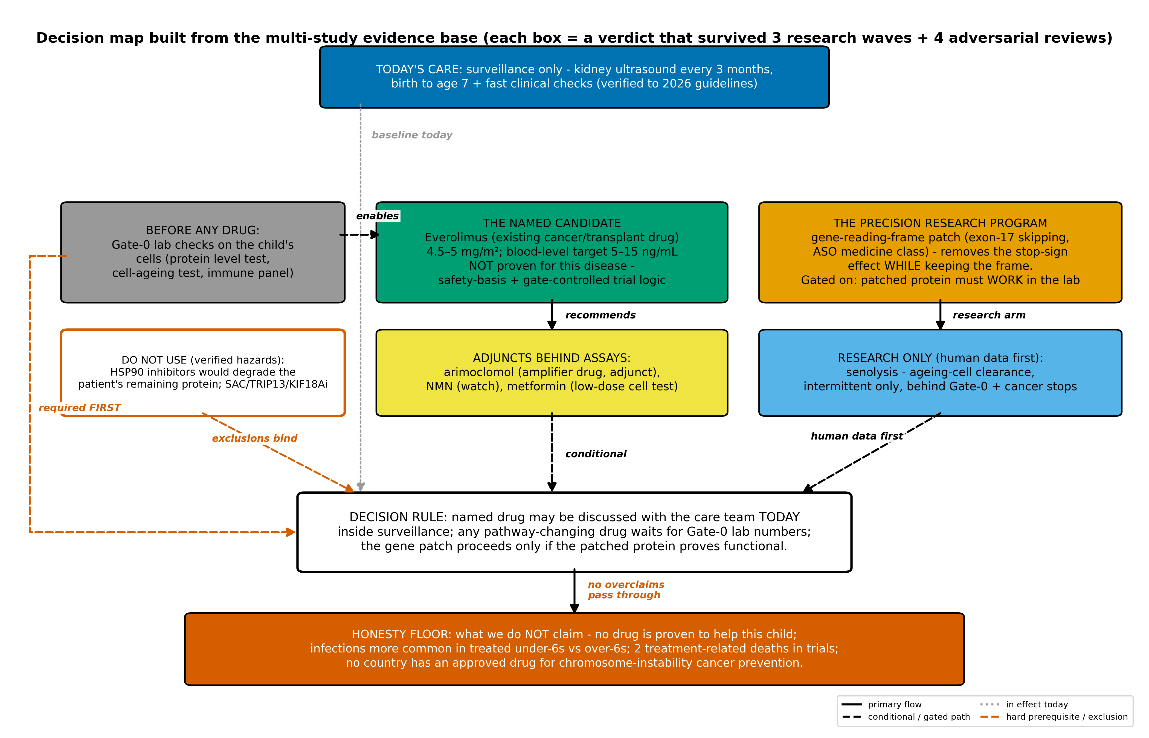 Figure 4. The decision map. Every box is a verdict that survived three research waves and four adversarial reviews; each arrow is labeled with its condition. Source: consensus record (evidence/TRACK2_ATTACK_MAP.md).

5b. The named repurposing candidate: everolimus - with its risks in the same paragraph
What it is. Everolimus is an approved drug used for years in children with a tumor-predisposition condition (tuberous sclerosis, TSC) to shrink specific tumors [E23]. It targets a growth-signal hub called mTOR. Why it is the only defensible name. Not because any study shows it helps in MVA - none does, and we say so in every relevant sentence - but because it is the only drug in the entire mapped landscape with a proven multi-year safety profile in children this young, used chronically [E23][E23a]. Mechanistically there is a plausible (and we label it low-grade) mechanistic hope: that the drug might slow the chromosome-abnormal cells more than the healthy ones. Honest answer: the pertinent animal evidence is two studies, and neither shows benefit. One mouse-based study was neutral, and it was never run on Bub1b-deficient cells [E58]. A second, newer study - a 2026 fruit-fly model of this disease family - found the drug barely helped, and one brain measure got slightly worse. In the flies, adding extra copies of the protective genes - genetic changes, not a medicine - restored the brain completely; no drug of this kind has been tried in any condition of this type [E62]. So we claim no direction here; the recommendation below rests on pediatric safety data plus monitoring, never on expected benefit. One honest closing note. After our formal review steps were finished and had found nothing left, one more challenge to this specific recommendation still arrived - so we went back to the original papers and checked it again, properly. A human, not the AI, then decided to keep the recommendation, and that challenge is printed alongside it (E62a). That same fly study points at what we would test first in the laboratory after the gene-repair program (5c): supporting the protein’s folding machinery - which is why the validation plan tests it in the child’s own cells first (assay 5 of 6) rather than naming any drug. The exact, monitorable window the report names (from the drug’s own label and trial-validated bands [E24][E25]): dose 4.5–5 mg/m²/day (about 3.4–3.8 mg/day at age 5), with the blood level held at 5–15 ng/mL by regular lab checks; a trial-validated lower band of 3–7 ng/mL is effective in the TSC setting from about 2 years 2 months of age. Multi-year use at exactly this age is documented (median four years, with growth and puberty unaffected over that period [E23a]); children of ~4.7 years on the sibling drug sirolimus even kept their vaccine responses, including live vaccines [E29]. The honesty data that must travel with the recommendation [E25]: in the largest trial, the children under six had far more infections than the children six and over - every one of them on the drug (96 % vs 67 %; serious infections 35 % vs 7 %; that trial had no untreated group to compare with, so these are treatment-exposure numbers, accumulated over that trial’s multi-year monitoring [E23]) - and the largest trials recorded two treatment-related deaths, both in children. Any family–doctor conversation starts from that sentence, not from the mechanism. Prevention precedent for the general idea: a 2024 trial (PREVENT) gave a rapalog prophylactically to symptom-free infants in TSC and held dosing in target - the only prophylactic rapalog ever trialed in symptom-free infants [E30]. But an honesty caveat belongs in the same breath: PREVENT was a Phase-1 feasibility study, it did not test tumor prevention, and no drug has ever been shown to prevent tumors in any predisposition syndrome (aspirin in Lynch syndrome and metformin in Li-Fraumeni families (the MILI study, adults only) are the neighboring precedents - risk-reduction signals, never proven prevention) [E45][E60]. One real biological tension, monitored by rule: this drug class can dampen the natural killer (NK) immune cells that the body uses to dispose of aneuploid cells [E27][E28] - ironic for this disease. The protocol therefore defines NK-count monitoring with a pre-specified hold-dose trigger, and chooses the trial-validated low band. (Some adult-cancer headlines suggested low “immune-boosting” rapalog doses improved older adults’ vaccine responses; that was studied in the elderly, and our evidence sweep found it does not translate to children - so this protocol uses the trial-validated pediatric band instead [E26].)

5c. The precision program: patching the instruction book (exon-17 skipping)
The idea in one breath. Remember the stop-sign mutation (§3a). The cell’s instruction book is read three letters at a time; the stop-sign ruins everything after it. Now the lucky break: the stop-sign lives inside one of the gene’s 23 blocks - exon 17 - which is exactly 141 letters long, a multiple of 3 [E42]. If a short, tailor-made molecular instruction (the drug class is called an ASO; more on it below) could make the cell skip block 17 while copying the gene, the reading frame continues unbroken. We computed this from the reference genome ourselves [E42] - see Figure 3.
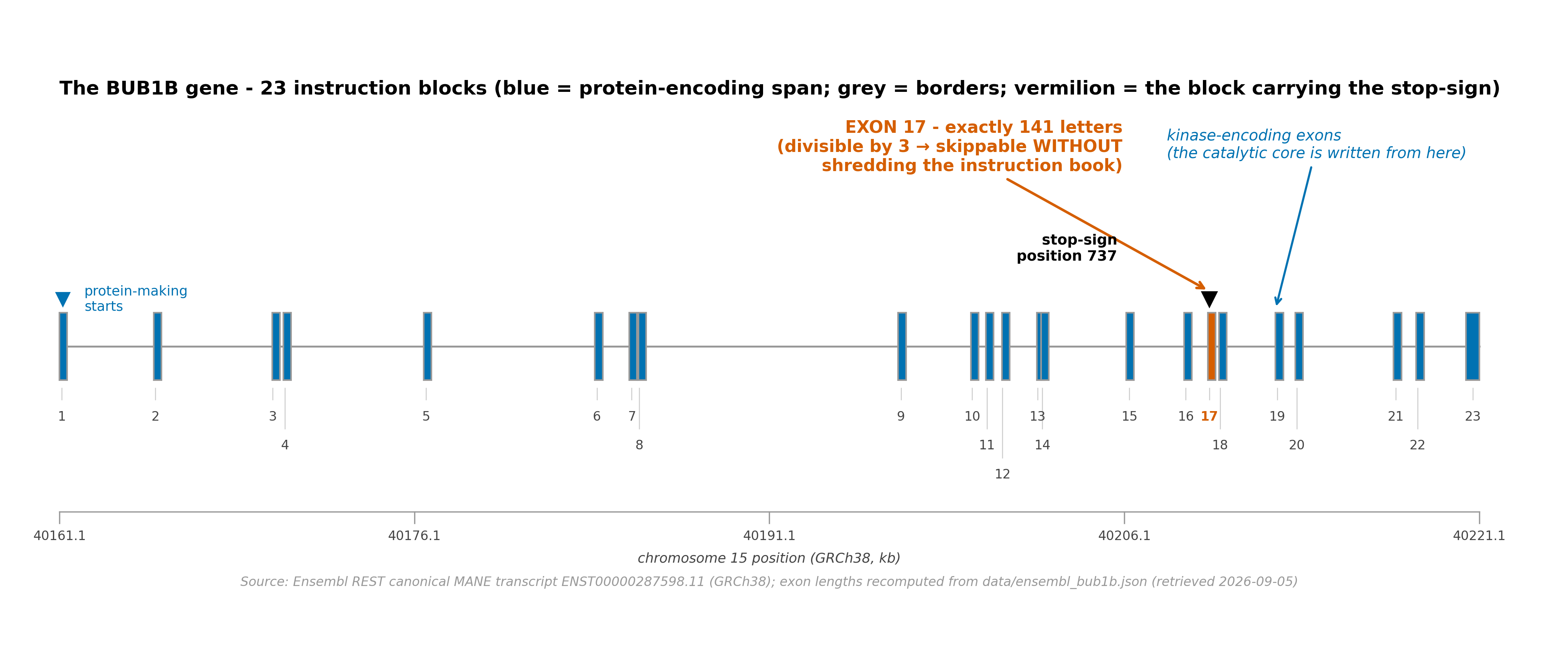 Figure 3. The 23 instruction blocks of BUB1B; the stop-sign sits in block 17 (red), whose length happens to be divisible by three. Source: Ensembl MANE transcript (live fetch, cached).
Does this drug class exist? Yes - “splice-switching” drugs (ASOs) are approved for other genetic diseases, including in very young children (muscular dystrophy [eteplirsen class], spinal muscular atrophy [nusinersen]) [E34]; and a specialized “n-of-1” ecosystem now builds such drugs for single ultra-rare patients: the proof of concept, milasen, went from diagnosis to the child’s first dose in under 12 months; the foundation that industrialized this path prices the full per-patient journey at roughly $1M for life, mostly philanthropically financed [E31][E32]. The original chemistry patents have expired [E33]. Before the problems, one “why”: why is delivery even a problem, if muscle and spinal cords are already reachable by this drug class? Because the chromosome instability lives in every tissue of a child with MVA - these children’s cancers have arisen in kidney, muscle, and elsewhere - so a drug reaching only muscle or spinal cord would cover, at best, a fraction of the risk. The two honest problems: 1. The patched protein must actually work. Skipping block 17 shortens the protein by 47 building blocks (positions 716 through 762) and re-encodes one neighbor (in scientific shorthand, p.Glu715_Gly762delinsGly - we rebuilt this from the exact reference transcript and verified it with a reproducible script: the 141 missing nucleotides correspond to 46 complete interior code-words plus two boundary code-words, and the boundary nearest the gene’s start is re-encoded glycine; what exactly is lost cannot be read off from dividing 141 by 3 alone - it has to come from the real sequence) [E42]. No one has tested whether that shortened BubR1 is functional. Worse - the patch is not mutation-specific: it would skip exon 17 in the child’s other, shape-mutated copy too. Our back-of-envelope arithmetic (assumptions documented in the evidence pack) estimates that if the shortened protein works, benefit lands at ~16-22 % of normal levels - an assumption-dependent estimate, not a measurement, and judged against a laboratory titration number only because nothing better exists yet; and if it doesn’t, the patch would break the remaining copy too [E40-P2]. That is exactly why the program’s first step makes the shortened protein in a lab dish and checks whether it works - before any child anywhere touches it (assay #4 in §6). 2. Delivery is unprecedented. No approved ASO has ever been shown to fix splicing in whole-body / non-muscle, non-brain tissues in humans; muscle and spinal-cord delivery are proven, everything else is not [E36] (a small-molecule class that is systemic, risdiplam [E37], shows the concept can reach the body - but engineering a small molecule from scratch is a longer road). Verdict: the primary precision research program - correct, powerful, honest about its single decisive unknown.

5d. Adjuncts (behind lab assays only)
- Arimoclomol: an approved booster of the cell’s own stress-defense machinery (the heat-shock response), with pediatric chronic use from age 2. It is conceivable it stabilizes the fragile copy - but no study has ever shown such drugs raise a mutant kinase’s levels; one flagged hazard (its amplified pathway can itself spark aneuploidy [E52]) keeps it adjunct-only, behind abundance assay #5 [E50][E51].
- NMN (vitamin-B3 pathway): a mouse study found boosting NAD⁺/SIRT2 biology raised BubR1 levels - the only documented chemical lever on this protein’s abundance [E54]; but our own candidate sweep also weighed the opposite chemistry - drugs that block SIRT2 - and ruled it dangerous, because the chemical marks it would strip are checkpoint-protective [E55]. So: SIRT2 inhibitors are off-limits, full stop. Watch status; cheap cell test alongside assay #5. Overdosing the other direction has its own cancer-linked risk - a target window, not a ceiling [E59a].
- Metformin: only a ≤100 µM dish-level co-test remains (high doses demonstrably damage checkpoint regulation [E59]).
For families reading this section: nothing here is a home treatment. NMN is sold over the counter and metformin is a common prescription drug - but giving either (or any other substance named in this report) to a child with MVA, outside supervised laboratory gates and medical oversight, is exactly the unmonitored action this report exists to prevent. If you are a parent, bring this section to the care team; never act on it yourself.

5e. Senolysis - the mouse-to-child gap
In a famous 2011 experiment, clearing “aged” cells from BubR1-deficient mice prevented their tissue decline [E05]. One caution: that landmark result comes from a single laboratory; a later experiment by the same lab, in ordinary aging mice, did not repeat it [E07] - and no independent laboratory has ever reproduced it. The idea remains the only genotype-matched preclinical proof in this field. What our deep check added: pediatric experience with the senolytic drug class does exist after all (navitoclax, in cancer-treatment regimens from age 4 [E16]) - a genuine feasibility upgrade nobody had; a proven intermittent dosing pattern in adults [E14]; and a thorough census showing no evidence anywhere that clearing senescent cells increases tumor incidence [E07][E08][E09] (the opposite fear our advisers raised). What still doesn’t exist: any senescence measurement in MVA patient tissue, and any pediatric senolytic indication. Therefore: research-priority only, behind the patient-cell Gate-0 assay and pre-specified malignancy stop-rules.

5f. Do NOT use, for this child - documented exclusions
- HSP90 inhibitors (17-AAG class): the fragile shape-mutated copy very likely depends on the HSP90 chaperone to hold its fold; cutting that lifeline would degrade the patient’s remaining protein - a genotype-specific hazard against the general anti-aneuploidy rationale this drug class carries [E39][E17a]. The door that is closed is the one that removes chaperone help, not the one that adds it (see 5b: supporting the fold is a test-first research axis). The clearest closed door in the whole analysis.
- KIF18A, TRIP13, and direct SAC (Mps1) inhibitors: biologically wrong direction - weakening the checkpoint further in a child whose checkpoint already runs on too little BubR1; TRIP13 loss causes a related MVA type [E20b].
- Autophagy-manipulation drugs (chloroquine family): no pediatric justification in a pre-malignant setting; class contradictions recorded [E40].
- Celastrol / proteasome-based stabilizer ideas: closed on toxicity or dependency direction [E40].
- AICAR/energy-stress axis: closed - the 2011 paper behind it tested only compounds with no pediatric-feasible member on that genotype, and kill-selectivity tracked cell aneuploidy, not the carrier state [E58]. Full table: candidates.tsv in the evidence pack (19 rows, each with its verdict and reason).

6. What has to be proven in a laboratory before anything is given
Everything below fits inside routine ethics-committee consent; none invades the child. 1. Gate-0 - the patient’s own cells: senescence burden + aneuploid fraction + immune panel (baseline for every downstream decision) [E14][E17]. 2. NMD-escape fraction of the stop-sign copy - a blood-RNA count that asks whether even a little of the broken copy’s protein slips past the cell’s recycling system - decides whether any drug direction targeting the stop-sign is even discussable [E42]. 3. Stability of the shape-mutated copy: a standard “label-and-watch” experiment (a so-called pulse-chase) that times how quickly the fragile protein is destroyed - a direct test of the degradation prediction [E39]. 4. ★ The decisive experiment: build the Δ716-762(+E715G) patched protein and test does it appear in cells at all, does it hold its shape, does it reach the protein’s workstation at the chromosomes, and does it restore the checkpoint function. This one assay decides the entire exon-skipping program [E40-P2][E44a]. 5. Abundance ± arimoclomol (± NMN), with an HSP90-inhibitor pulse as the positive control for degradation - directly calibrates every §5d adjunct [E50][E54]. 6. Checkpoint-timing test of where the child actually sits relative to the laboratory dose-response curve**: a standard live-cell test that measures how long the checkpoint holds before cells slip through division ([E04]; laboratories call it a mitotic-escape assay).

7. What we are NOT claiming (read this before anything else)
- No drug is proven to prevent, treat, or slow MVA or its cancers - in this child or anyone.
- Everolimus is proposed inside surveillance + gates, not as a prescription.
- The exon-skipping program is a research plan, not a therapy; its decisive experiment has never been run.
- “No evidence located” statements in this report mean searched and not found (queries recorded), never “proven impossible”.
- Sources were verified as of 2026-09-05 and re-checked against the live trial registries and literature on 2026-09-09: nothing in this report changed; the RAVEN children’s trial entry now includes its posted results.

8. Where we stand, and how sure we are
Where we stand (2026-09-05). The evidence program behind every verdict in §5 is complete to its own stopping rule: three research waves, 19 verified research memos, four adversarial reviews with measured error-decay 8 → 2 → 2 → 0 (Figure 5), and a frozen, fully-traced decision record [E40][E41]. By our own rule, a person - never the AI - reviews and signs off on this report before it is used anywhere. (Competition housekeeping - what we submit, deadlines, remaining work - has been moved to §12, out of your way.)
How sure are we? Honest calibration, itemized: - Surveillance standard, exclusion list, “no MVA trial exists”, allele math, exon-17 geometry: high confidence (multiple independent verifications each; adversarially survived). - On everolimus, in plain words. We are confident the decision rule is sound - “name it, but only inside monitoring and stop-gates” - because that rule leans mainly on well-documented safety data and the trial-validated pediatric window. The evidence that the drug would actually help against this disease is weak - laboratory-level at best; no study in people with MVA has ever tested this drug; the only experiment in an animal model of this disease family leaned slightly against (see 5b). Both sentences are true at once, and the second never travels without the gates. - Δ716-762(+E715G) function: decidable but UNMEASURED - by design the claim is conditional on assay #4. - What can go stale before submission (drug approvals, trial statuses, screening guidelines): every time-sensitive claim will be re-checked in one scheduled pre-submission sweep (step 2 above).

9. The figures, in one place
- Figure 1 - where the shape mutation sits (human AlphaFold + fly crystal): figures/F1_variant_structure.png
- Figure 2 - protein map (UniProt-driven bands + 3-D render): figures/F2_BubR1_protein_map.png
- Figure 3 - the gene and the skippable exon (§5c above).
- Figure 4 - the decision map (§5a above).
- Figure 5 - how the evidence was stress-tested (adversarial decay + verification):
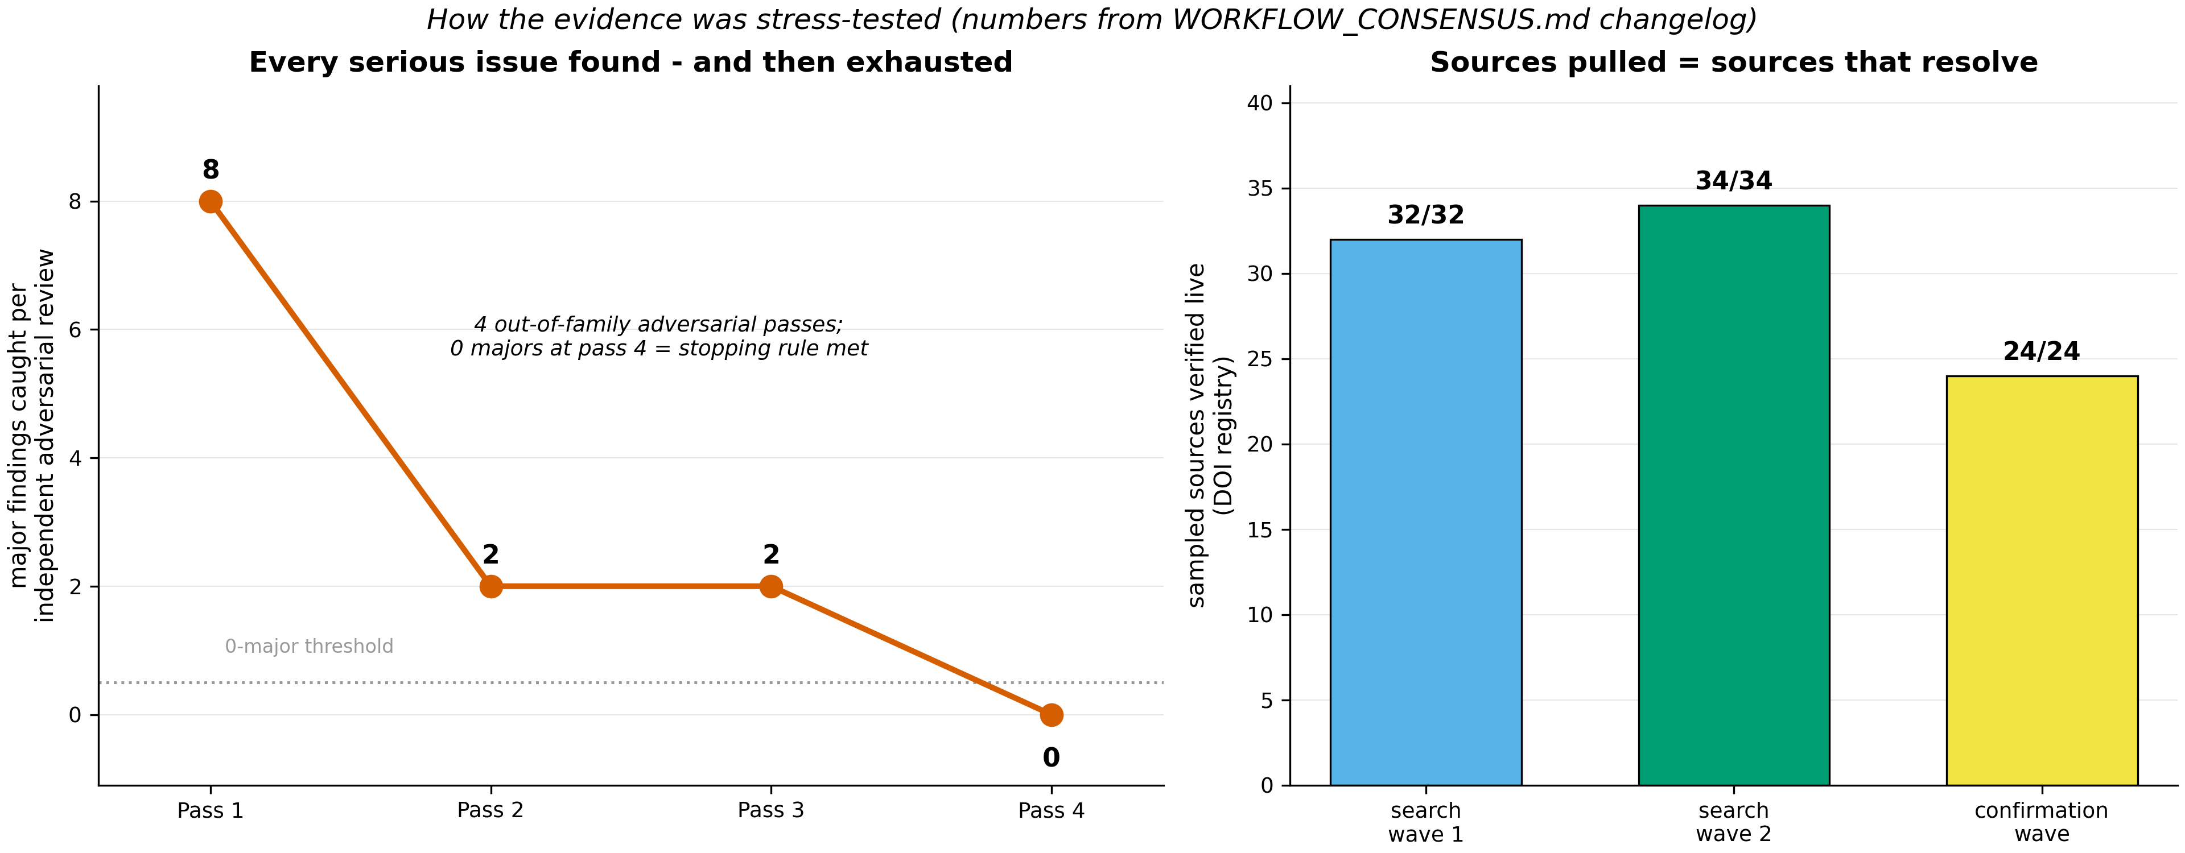 Figure 5. Left: majors found per independent adversarial pass (the pre-declared stop rule met at zero). Right: identifier verification per wave (all sampled sources resolve to real papers). Source: evidence/WORKFLOW_CONSENSUS.md changelog.
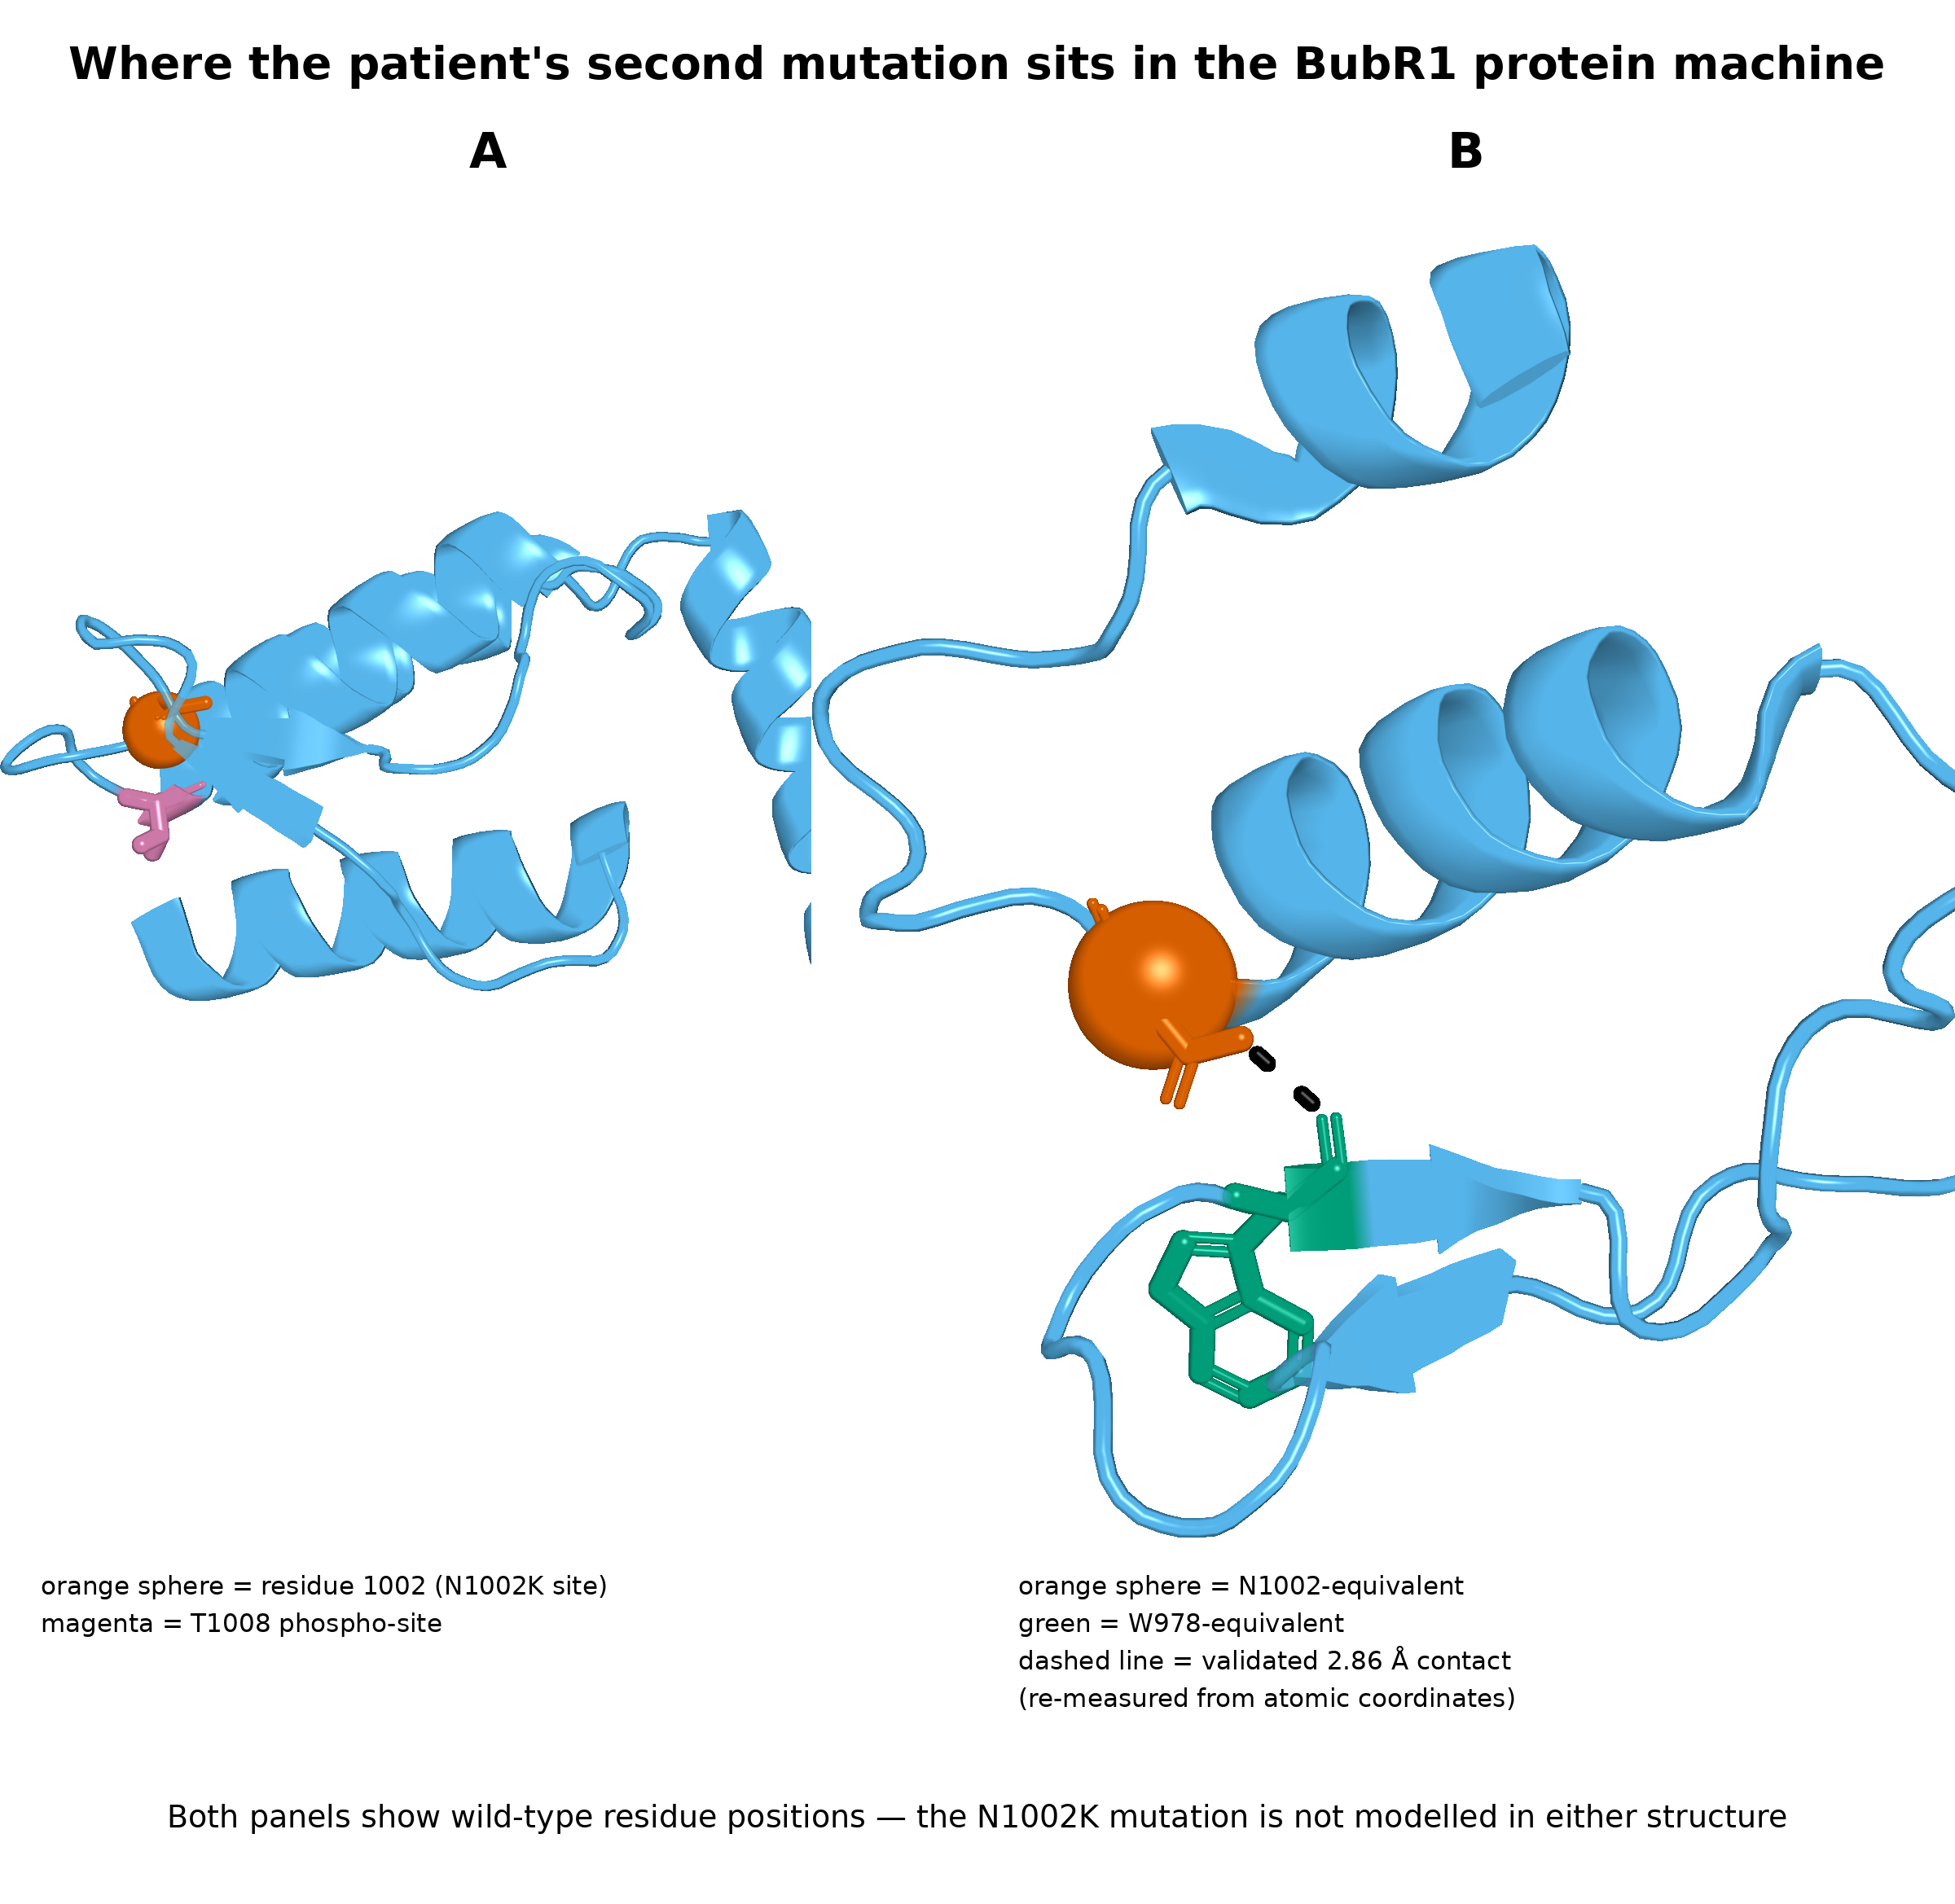 Figure 1. Left: human BubR1 kinase domain - a computer-predicted structure of the normal, healthy protein - with residue 1002 marked red (the position of the child’s shape mutation, which is not modeled in this picture) and a neighboring regulatory switch-point (T1008) in magenta. Right: the fruit-fly crystal structure (6JKK), measured in a real laboratory experiment, where the equivalent residue touches its partner within 2.9 Å - validating that this exact spot is load-bearing across 600 million years of evolution. Source: evidence/STRUCTURAL_VALIDATION.md; PyMOL render.
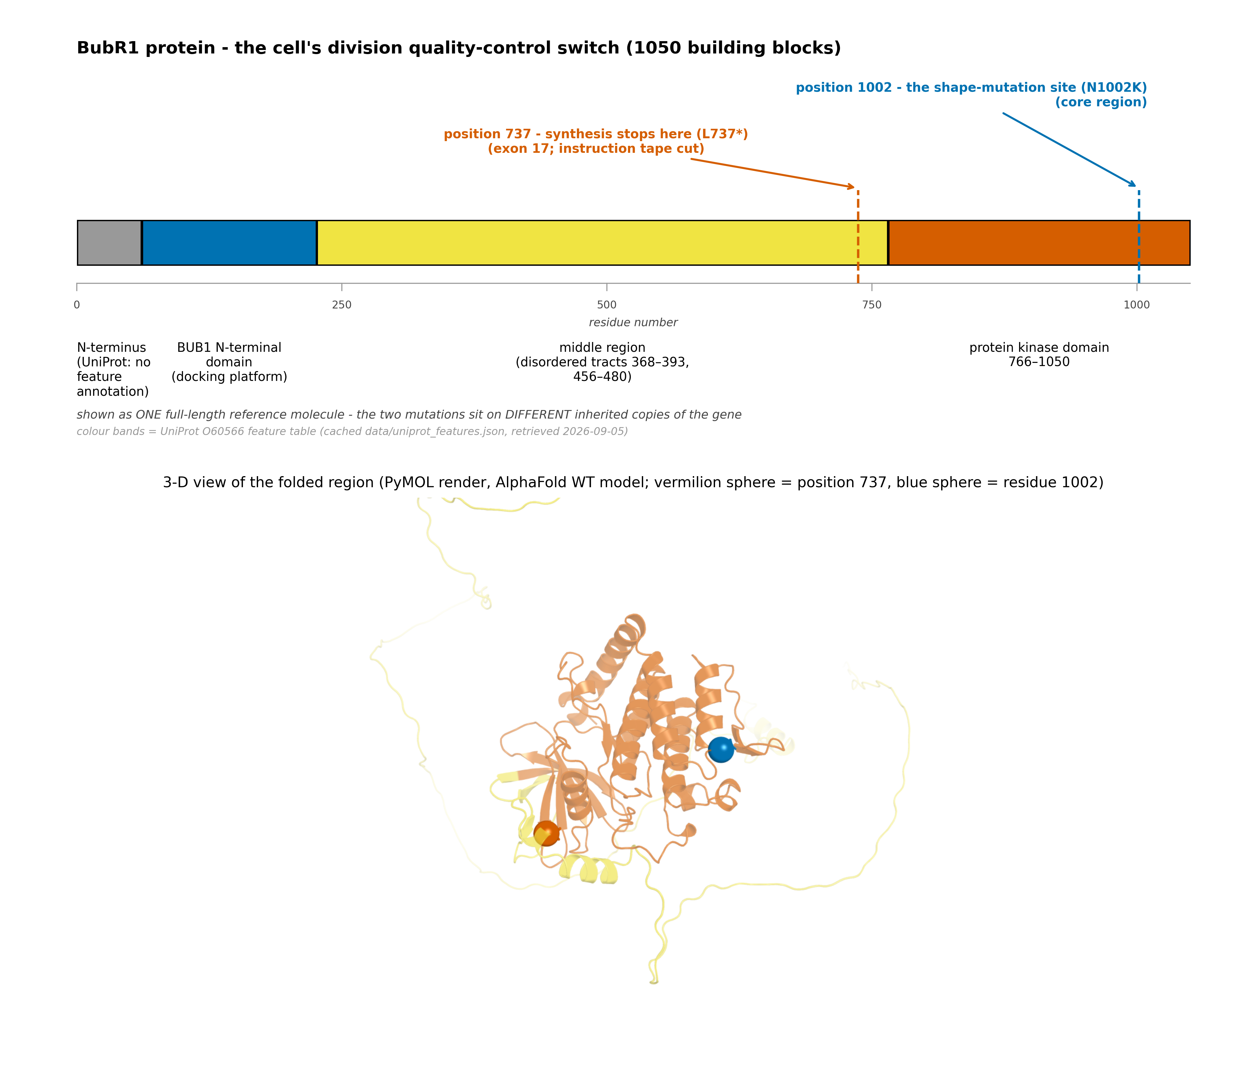 Figure 2. BubR1’s four parts (colors = UniProt feature table), the two mutation positions, and the 3-D view of the folded core. Source: UniProt O60566 + AlphaFold model.

10. References (every claim’s source, with its verification trail)
Convention: [E#] in the text → entry below. Internal artifacts (“evidence pack”) are files under evidence/ in this repository, all content-verified through multiple passes; external sources carry the link and how/when it was verified. PMID links: pubmed.ncbi.nlm.nih.gov/<PMID>/.
The case & the diagnosis - E01 Challenge case document (genotype: BUB1B p.Leu737Ter + p.Asn1002Lys). File Challenge_Clinical_Phenotype_1.docx, dataset page (gated): https://huggingface.co/datasets/SageBio/mva-hackathon-2026-data · read 2026-08-31. - E18 Hanks et al. 2004 - discovery that biallelic BUB1B mutations cause MVA. Nature Genetics 36:1159-61. https://doi.org/10.1038/ng1449 · verified via PubMed/DOI, 2026-09-05. - E20 GeneReviews - BUB1B-related MVA (NBK1294); risk-figure source. https://www.ncbi.nlm.nih.gov/books/NBK1294/ · read 2026-09-05. - E20b Yost et al. 2017 - TRIP13 mutations cause related MVA/Wilms predisposition. https://doi.org/10.1038/ng.3883 · verified 2026-09-05.
The biological mechanics - E04 Suijkerbuijk et al. 2010 - cellular dose-response in HeLa knockdown titration (~13 % intact / ~6 % failing); kinase-activity question. Cancer Research 70:4891-900. PMID 20516114. https://pubmed.ncbi.nlm.nih.gov/20516114/ · verified + scite-graded 2026-09-05. - E04b Catalysis-dispensable cluster: Malureanu 2009 (PMID 19154723), Suijkerbuijk 2012 pseudokinase (PMID 22698286), Breit 2015 (no in-vitro catalysis, PMID 26658523). https://pubmed.ncbi.nlm.nih.gov/19154723/ · https://pubmed.ncbi.nlm.nih.gov/22698286/ · https://pubmed.ncbi.nlm.nih.gov/26658523/ · verified 2026-09-05. (evidence pack: MECHANISM_G1) - E17 Santaguida et al. 2017 - newly aneuploid/senescent untransformed cells are NK-cleared. https://doi.org/10.1016/j.devcel.2017.05.022 · verified 2026-09-05. - E17a Park et al. 2013 - BUBR1 K243-acetylation site is checkpoint-protective; mutant mice degrade BubR1 and develop tumors. https://pubmed.ncbi.nlm.nih.gov/23878276/ · verified 2026-09-05. - E19 Wang et al. 2021 - NF-κB central to NK clearance of aneuploid senescent cells. https://doi.org/10.15252/embr.202052032 · verified 2026-09-05. - E39 Structural validation of the N1002 position - repo artifact STRUCTURAL_VALIDATION.md (AlphaFold model AF-O60566 https://alphafold.ebi.ac.uk/entry/O60566; fly crystal 6JKK https://www.rcsb.org/structure/6JKK; 2.86 Å contact measured from the deposited coordinates in evidence/STRUCTURAL_VALIDATION.md). Verified 2026-09-05. - E42 Nonsense/NMD/exon-17 analysis - repo artifacts wave2_NonsenseAxis.md + q7a_sequence_analysis.md (exon 17 = 141 nt in-frame; 75 nt from junction → canonical NMD substrate; UGAA context; readthrough-yield model). Exon data: http://www.ensembl.org/Homo_sapiens/Transcript/Summary?t=ENST00000287598 · 2026-09-05. - E38 AlphaMissense pathogenicity scoring (0.9229 for N1002K, computed in our variant panel): Cheng et al. 2023, Science. https://pubmed.ncbi.nlm.nih.gov/37733863/ · pipeline artifact VARIANT_PROTEIN_IMPACT.md.
Surveillance & prevention precedents - E21 Hol JA, Jongmans MCJ, et al. 2021 - SIOP-RTSG/EEPGN Wilms-tumour surveillance in at-risk children (renal US q3mo birth→7 for defined syndromes). Eur J Cancer 153:51–63. https://doi.org/10.1016/j.ejca.2021.05.014 · PMID 34134020 · verified against wave4_SurveillanceToday.md §1.2, 2026-09-05. (Earlier entry mis-pointed to 10.1016/j.pediatrneurol.2021.07.011 - the Northrup TSC-criteria paper; corrected.) - E22 Nakano et al. 2024 - AACR 2nd Childhood Cancer Predisposition Workshop update, genomic-instability disorders (endorses the same cadence). PMID 39264246. https://pubmed.ncbi.nlm.nih.gov/39264246/ · verified 2026-09-05. - E21a Live registry census (ClinicalTrials.gov, CTIS, EU-CTR, ISRCTN, ANZCTR with everolimus positive controls): zero MVA-specific intervention trials/registries - repo artifact wave4_SurveillanceToday.md (query log + API dates 2026-09-05). - E47 Kuhlen 2026 + CHARM2 trial NCT06726642 (cfDNA RCT; MVA/CIN exclusion verified live). https://clinicaltrials.gov/study/NCT06726642 · evidence pack wave4 doc. - E30 Capal et al. 2024 - PREVENT: prophylactic sirolimus in TSC infants (94 % of troughs in target). PMID 39726432. https://pubmed.ncbi.nlm.nih.gov/39726432/ · verified. - E45 CAPP3 first results 2026 - Lynch aspirin dose study; NOTE correctly scoped (no formal non-inferiority per the trial’s rule; 100 mg similar risk, less bleeding). PMID 42425127 · https://pubmed.ncbi.nlm.nih.gov/42425127/ · scoping verified by adversarial pass 2. - E46 Rüschoff et al. - aspirin mechanism in Lynch (antiplatelet/anti-inflammatory, not MMR/CIN-directed). PMID 9736731. https://pubmed.ncbi.nlm.nih.gov/9736731/ · verified.
Everolimus / rapalog facts - E23 French et al. 2016 - EXIST-3 (everolimus in TSC, incl. low-exposure 3–7 ng/mL band ≥2.2 y). Lancet, PMID 27613521. https://pubmed.ncbi.nlm.nih.gov/27613521/ · band attribution re-verified adversarially (P3-1). - E23a Franz et al. - EXIST-1 final analysis (median 47 months exposure; growth/puberty unaffected); Kotulska 2013 (children <3 y, 35-month follow-up). PMID 27351628 · https://pubmed.ncbi.nlm.nih.gov/27351628/ · PMID 23567018 https://pubmed.ncbi.nlm.nih.gov/23567018/ · verified 2026-09-05. - E24 FDA label - Afinitor/Afinitor Disperz (dose 4.5-5 mg/m² titration, trough 5-15 ng/mL, monitoring calendar, age-stratified infections). DailyMed: https://dailymed.nlm.nih.gov/dailymed/search.cfm?query=afinitor · read via label text in wave4_PediatricRapalogDosing.md. - E25 EXIST-3 safety incl. <6 y infection strata and two treatment-related pediatric deaths. PMC full text: https://pmc.ncbi.nlm.nih.gov/articles/PMC6276348/ · quoted datum verified verbatim by independent adversarial pass 3. - E26 Mannick et al. 2018 - low-dose mTOR inhibition ENHANCES vaccination responses in elderly adults (why we cannot transplant the regimen to a child, documented & hypothesized). https://pubmed.ncbi.nlm.nih.gov/29997249/ · verified 2026-09-05. - E27 Marçais et al. 2014 - mTOR is essential for NK-cell function (mouse AND human). https://doi.org/10.1038/ni.2936 · scite-graded s65/c2. - E28 Besson et al. 2021 - everolimus contracts peripheral NK pool in adults. https://pubmed.ncbi.nlm.nih.gov/33931486/ · verified. - E29 Yuan et al. 2025/2026 - children ~4.7 y on sirolimus retain vaccine immunogenicity (incl. live MMR). PMID 41012109 · https://pubmed.ncbi.nlm.nih.gov/41012109/ · PMID 42154819. Verified; flagged single-region cohorts.
The exon-skipping / ASO program - E31 Kim et al. 2019 - milasen: diagnosis-to-dosed-patient <12 months for an individualized ASO. NEJM, PMID 31597037. https://pubmed.ncbi.nlm.nih.gov/31597037/ · full text reviewed (PMC6961983). - E32 Crooke et al. 2026 - the n-Lorem model (~$1M/lifetime, >30 INDs, splice-ASO fraction). https://doi.org/10.1093/nar/gkag504 · verified. - E33 PMO core chemistry patent US 5,185,444 - status Expired-Lifetime. https://patents.google.com/patent/US5185444A/en · status checked live 2026-09-05. - E34 Splice-switching approved precedents (eteplirsen/viltolarsen/golodirsen class - muscle; nusinersen - spinal), pediatric. Census references in wave3_ASOdeep.md (all identifiers join-checked). - E36 Delivery census verdict - no human non-muscle/non-CNS ASO splice correction (oligonucleotide limb), corrected scope per negation re-attack. wave3_ASOdeep.md + wave4_NegationReattack.md. - E37 Risdiplam - approved oral small-molecule systemic splice modifier (blood-level SMN2 splicing pharmacodynamics in humans, incl. children). PMID 30302786. https://pubmed.ncbi.nlm.nih.gov/30302786/ · verified 2026-09-05; branaplam noted WITH its adverse datum: Nat Med 2026 reports the branaplam VIBRANT-HD study (adult Huntington’s disease, not a pediatric trial) terminated after peripheral neuropathy in 18 of 21 treated participants (85.7 %); https://doi.org/10.1038/s41591-025-04117-4).
Senolysis - E05 Baker et al. 2011 - clearing p16+ senescent cells in BubR1-hypomorphic mice (genotype-matched mouse proof). https://pubmed.ncbi.nlm.nih.gov/22048312/ · single-lab flag + scite-graded. - E07 Baker et al. 2016 - WT-background natural-aging repeat; full text verified: no tumor-incidence change, increased latency, NK populations unchanged. https://pmc.ncbi.nlm.nih.gov/articles/PMC4845101/ · verified by pass-3 arbiter. - E08 Lalinde-Gutiérrez et al. 2026 - early senolysis accelerated PyMT tumors (macrophage/CCL2; late = protective): the real timing counterweight. https://doi.org/10.1126/sciadv.adx2988 · verified. - E09 Protective census: Haston et al. 2023 (PMID 37267953, https://pubmed.ncbi.nlm.nih.gov/37267953/); Ming et al. 2025 (PMID 39623223 https://pubmed.ncbi.nlm.nih.gov/39623223/); Zhou et al. 2026 (https://doi.org/10.1158/2159-8290.CD-25-1212); census log in wave3_SenolysisF6verifier.md. - E14 Intermittent-dosing pattern: Justice et al. 2019 (PMID 30616998, https://pubmed.ncbi.nlm.nih.gov/30616998/) + Xu et al. 2018 hit-and-run (PMID 29988130, https://pubmed.ncbi.nlm.nih.gov/29988130/) · verified. - E15 Gore et al. 2018 - dasatinib pediatric experience (n=113, leukemia-schedule). https://pubmed.ncbi.nlm.nih.gov/29498925/ · verified. - E16 Pullarkat et al. 2021 - pediatric navitoclax exposure (combination regimens, RP2D 25 mg <45 kg). PMID 33593877. https://pubmed.ncbi.nlm.nih.gov/33593877/ · NCT03181126 live registry; RAVEN NCT05192889 (ages 4-30, actively dosed). This overturned our own earlier “zero pediatric senolytic” claim - kept on record as the correction that made the axis honest.
Stabilization & abundance chemistry - E50 Arimoclomol (Miplyffa) - US FDA approval 2024 (with miglustat, NPC; children ≥2 y). FDA press + label, verified 2026-09-05 (wave2_StabilizationAxis.md). - E51 Kirkegaard et al. 2016 - arimoclomol mechanism = lysosomal HSP70 support (the actual proven action). PMID 27605553. https://pubmed.ncbi.nlm.nih.gov/27605553/ · verified. - E52 HSF1–Cdc20 hazard - HSF1 overexpression binds Cdc20, inhibits APC/C, produces aneuploidy. PMID 18059335. https://pubmed.ncbi.nlm.nih.gov/18059335/ · verified 2 passes. - E53 Arimoclomol ALS phase-3 failure (efficacy outside lysosomal disease unproven). PMID 38782015. https://pubmed.ncbi.nlm.nih.gov/38782015/ · verified. - E54 North et al. 2014 - SIRT2/NAD⁺ raises BubR1 abundance in vivo (exact hypomorph mouse). https://doi.org/10.15252/embj.201386907 · verified 2026-09-05. - E55 (see E17a) - the site-dependence that makes SIRT2 inhibition prohibited chemistry. - E56 Irie et al. 2020 - NAD⁺-precursor human safety RCT (adult). PMID 31685720. https://pubmed.ncbi.nlm.nih.gov/31685720/ · verified. - E57 Bursch 2024 - no selective SIRT2-activator compound exists. https://doi.org/10.3390/molecules29051185 · verified. - E59 Lyu et al. 2022 - metformin at mM doses deregulates BUBR1/MAD2 (genotoxic; grounds the ≤100 µM cap). PMID 35568294. https://pubmed.ncbi.nlm.nih.gov/35568294/ · verified. - E59a BUB1B overexpression drives chemo-resistance (the abundance target is a window, not a ceiling). https://pubmed.ncbi.nlm.nih.gov/34545188/ · verified (negation re-attack).
Closed axes - E58 Tang et al. 2011 - mTOR arms neutral on trisomic MEFs (never tested on Bub1b^H/H cells); AICAR arm killed aneuploid-fraction-high cells. Cell, PMID 21315436 (the corrected identifier - an earlier mis-citation of 21546338 remains deleted from all artifacts). https://pubmed.ncbi.nlm.nih.gov/21315436/ · full-text verified twice. - E60 MILI trial protocol - metformin prevention in Li-Fraumeni (adults ≥16; mechanism differs - does not transfer to CIN precedent). https://doi.org/10.1186/s13063-024-07929-w · verified.
Readthrough (closed as primary) - E61 EMA EPAR page, ataluren/Translarna (non-renewal 2023 status as of fetch). https://www.ema.europa.eu/en/medicines/human/EPAR/translarna · status verified 2026-09-05; FDA CRL 2025 + NDA-resubmission withdrawal 2026 per PTC Therapeutics announcement (verified live in adversarial pass 3); modeled-yield analysis in wave2_NonsenseAxis.md.
Animal-model honesty datum (adjudication) - E62 González-Blanco et al. 2026 - fruit-fly model of this chromosome-instability disease family (bub3/rod knockdown); rapamycin marginal-to-negative on brain measures; chaperone/ROS rescue complete. Nature Communications 17:3829. https://doi.org/10.1038/s41467-026-70521-0 · PMID 41820377, PMC13121444 · verified 2026-09-12 via PMC full text plus the authors’ own Source Data workbook.
Process & provenance (incl. post-closure re-adjudication) - E62a Post-closure re-adjudication of the everolimus candidate anchor (separate, deliberately declared, not a fifth adversarial pass). Internal artifacts in the evidence pack: evidence/adjudication_rapalog_contested_anchor.md (integrated memo and human-decision record: the coordinator kept the candidate with its disclosure box, Option A) + the three wave briefs evidence/cycle1_nk.md, evidence/cycle1_fly.md, evidence/cycle1_mech.md (verbatim primary-source quotes and per-source verdicts). - E40 evidence/WORKFLOW_CONSENSUS.md (+ adversarial pass memos wave2/3/4/5_ADVERSARIAL.md): 3 waves, 19 memos, decay 8→2→2→0, 90/90 identifiers registry-verified (32+34+24 across the waves); P2/P3/PR fix tags, PR = lay-report review fixes. - E40-P2 wave2_ADVERSARIAL_REVIEW.md - the allele-non-specificity analysis + KARD off-by-one caution (F1/F2) that made the ASO section honest. - E40-SD evidence/SCOPE_DECISION.md - options, deterministic weighted matrix (O1 = 88.6, rank-stable under ±20 % weight perturbations), decision log + revisit record. - E41 wave5_ADVERSARIAL_PASS4.md - final independent review returning zero majors (closure document). - E44 Competition: challenge space https://huggingface.co/spaces/SageBio/rare-disease-real-kid-mva-hackathon-2026 && dataset https://huggingface.co/datasets/SageBio/mva-hackathon-2026-data · submission window 2026-08-24 → 2026-10-24, scite partnership terms (per organizer pages). - E44a Assay #4 specification: evidence/TRACK2_ATTACK_MAP.md §Validation plan; construct details - E73 MVA Society and Unique, Mosaic variegated aneuploidy syndrome 1 (BUB1B)* guide, 2026, reviewed by a consultant in clinical and paediatric genetics. Says no clinical practice guidelines exist for this genotype, and recommends abdominal ultrasound every three months plus a blood check every three months to detect leukaemia. A family guide, not a formal guideline. https://mvasociety.org/wp-content/uploads/2026/07/MVA-BUB1B-guide.pdf - E74 Japanese national management handbook for PCS/MVA syndrome, March 2017, Health Labour Sciences Research Grant: schedules abdominal ultrasound and a full blood count at every visit from three months of age into adulthood. https://raredis.nibn.go.jp/malformation/management_guidelines_notebook/32.pdf - E75 Maese et al. 2024, Clinical Cancer Research, AACR surveillance update for children predisposed to blood cancers. Cited for a verified absence: its full text names neither this syndrome nor any of its genes. https://doi.org/10.1158/1078-0432.CCR-24-0685 - E76 Laberko et al. 2019, Orphanet Journal of Rare Diseases, the only reported stem cell transplant in this syndrome, in a child with myelodysplasia and monosomy 7; graft rejection at day +47 and death at day +156. https://doi.org/10.1186/s13023-019-1073-x Δ716-762(+E715G) (p.Glu715_Gly762delinsGly, sequence-derived in evidence/exon_skip/; wave3_ASOdeep.md §(a) is a pre-reconstruction memo and keeps its historical wording).

11. Glossary (every technical word in this report)
Allele - one of the two inherited copies of a gene (one from mother, one from father). Amino acid - the 20 kinds of building blocks proteins are assembled from; BubR1 is a chain of 1050. Aneuploidy - the wrong number of chromosomes in a cell. ASO (antisense oligonucleotide) - a short synthetic DNA-like molecule that can steer how a gene’s instruction blocks are assembled. Checkpoint (SAC) - the cell-division quality-control checkpoint; see SAC below. Chromosome - one of the 46 bound volumes the genome’s instruction book comes in; every new cell must receive exactly one copy of each. CIN (chromosomal instability) - an ongoing rate of chromosome-count errors. cfDNA / liquid biopsy - fragments of DNA floating in blood that can carry tumor signals. Conserved - kept unchanged by evolution across species; usually a sign of importance. Euploid - having the correct chromosome count (“euploid cells” = the chromosome-normal ones). Exon - one instruction block of a gene (genes are read block by block). Exon skipping - chemically persuading the cell to omit one block while copying, to dodge a defect. Gate-0 - our mandatory first lab check on the child’s own cells before any drug discussion. In-frame - when a removed block’s letter count is divisible by 3, the three-letter reading rhythm survives. Kinase - a protein that adds phosphate tags to other proteins (a molecular switch). Mosaic - made of a mixture; here, a body whose cells have varying chromosome counts. mTOR - a master growth-signal protein; everolimus partially brakes it. NK (natural killer) cells - immune cells that seek and destroy damaged or abnormal cells. NMD (nonsense-mediated decay) - the cell’s recycling of messages that contain a premature stop-sign. n-of-1 - a drug or trial designed for a single patient. Nonsense mutation - a spelling change that writes a premature “STOP”. PK (pharmacokinetics) - how the body absorbs, distributes, and clears a drug. Protein - a working molecular machine assembled from amino acids; BubR1 is one. qPCR / ddPCR - lab tests that count how much of a molecule is present. Reading frame - the three-letter rhythm in which the gene’s text is read; shifting it scrambles everything after. RP2D - recommended phase-2 dose (the dose a pediatric trial picks). SAC (spindle assembly checkpoint) - the division quality-control checkpoint. SASP - the inflammatory secretions of aged (senescent) cells. Senescence - the biologically “aged” state cells enter after damage or stress. Senolysis - clearing senescent cells with drugs. Systemic - reaching the whole body (as opposed to one organ). TDM - therapeutic drug monitoring: measuring the drug’s blood level. TSC - tuberous sclerosis complex (the pediatric precedent disease). Trough - the lowest blood level of a drug between doses (ng/mL). Whole-exome/genome sequencing - reading the protein-coding, or full, genome of a patient.

12. Provenance, method, and AI-use disclosure
Submission housekeeping (moved out of §8 for readability). Submission-period deadline: 2026-10-24 [E44]. Next steps, in order: (1) human review and sign-off of this report; (2) one pre-submission freshness sweep re-checking time-locked claims (rules, trials, guidance), scheduled mid-October; (3) Track 1 genome-interpretation pipeline on the challenge’s 85 GB sequence dataset (infrastructure already staged on the compute host); (4) assemble the formal Track-2 submission from this evidence tree - the §5 layered answer (surveillance backbone; everolimus named inside gates with every honesty datum; exon-17 skipping as the precision research program with its decisive assay; the documented DO-NOT-USE list; the 6-assay validation plan) was selected in a structured comparison of four candidate architectures (weights and scores in SCOPE_DECISION.md, §10 E40-SD), and the choice stayed the same under every tested weighting assumption; (5) if wet-lab access materializes: Gate-0 + assay #4 are first. - All scientific content derives from the evidence pack in evidence/ (manifest MEMO_MANIFEST.md): literature sweeps, mechanism/phenotype loops, variant/structural analyses, three research waves with recorded query logs, four adversarial reviews, and the consensus decision record. Nothing here asserts a fact beyond those artifacts; editorial corrections visible inline as [P2-#]/[P3-#] tags. - Figures: committed PNGs in figures/, generated from the data sources named in each caption. - AI use: research memos and adversarial reviews were drafted by AI agents inside one hosted lineage (e-INFRA Kimi-class; reviewers separated by role and fresh context, not by vendor) with deterministic identifier verification; source texts of primary papers were used by those agents where stated. This lay report was drafted by an AI assistant and requires human review & approval prior to any submission (per the challenge’s methods/AI disclosure rule, to be completed at submission time). - No patient-identifying information appears anywhere in this document.

End of report - version 1.1 - post-review integrated draft for human review.

