目录

crawler_data_type(数据类型管理) 1

recruit(招聘) 1

crawler_data_type(数据类型管理) 2

crawler_task(爬虫任务管理) 2

爬虫数据:

select r.id as id, r.title as title, r.city as city,

r.companyName as companyName, r.companySize as companySize,

r.companyType as companyType, r.companyUrl as companyUrl, r.welfare as welfare, r.companyAddress as companyAddress,

r.monthlySalary as monthlySalary, r.minSalary as minSalary, r.maxSalary as maxSalary, r.releaseDate as releaseDate,

r.workNature as workNature, r.experience as experience, r.eucation as eucation, r.rNum as rNum, r.positionCategory as positionCategory,

r.jobDescription as jobDescription, r.listUrl as listUrl, r.detailUrl as detailUrl, r.uuid as uuid, r.dataType as dataType, cdt.typeName as typeName,

r.website as website, r.status as status,

ct.taskName as taskName, ct.id as taskId, r.createdTime as createdTime, r.updatedTime as updatedTime

from recruit r left JOIN crawler_task ct on

r.taskId=ct.id left join crawler_data_type cdt on

r.dataType=cdt.id order by r.createdTime desc limit 0,10;

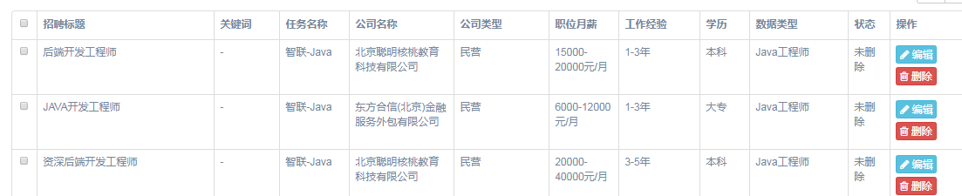

# crawler_data_type(数据类型管理)

# recruit(招聘)

|  |  |  |
| --- | --- | --- |
| 字段名称 | 字段意思 | 解释 |
| id |  |  |
| Title | 标题 |  |
| city |  |  |
| companyName | 公司名称 |  |
| companyType | 公司类型 |  |
| companyUrl | 公司网址 |  |
| welfare | 福利 |  |
| companyAddress | 公司地址 |  |
| monthlySalary | 职位月薪 |  |
| minSalary |  |  |
| maxSalary |  |  |
| releaseDate | 发布日期 |  |
| workNature | 工作性质 |  |
| experience | 工作经验 |  |
| eucation | 学历 |  |
| rNum | 招聘人数 |  |
| positionCategory | 职位分类 |  |
| jobDescription | 工作描述 |  |
| listUrl | 列表类url |  |
| detailUrl | 详情页url |  |
| uuid |  |  |
| dataType |  |  |
| website |  |  |
| status | 0:未删除 1:已删除 |  |
| companySize | 公司规模 |  |
| taskId | 任务id |  |
| createdTime |  |  |
| updatedTime |  |  |

# crawler_data_type(数据类型管理)

# crawler_task(爬虫任务管理)