Beer/Malt Beverage
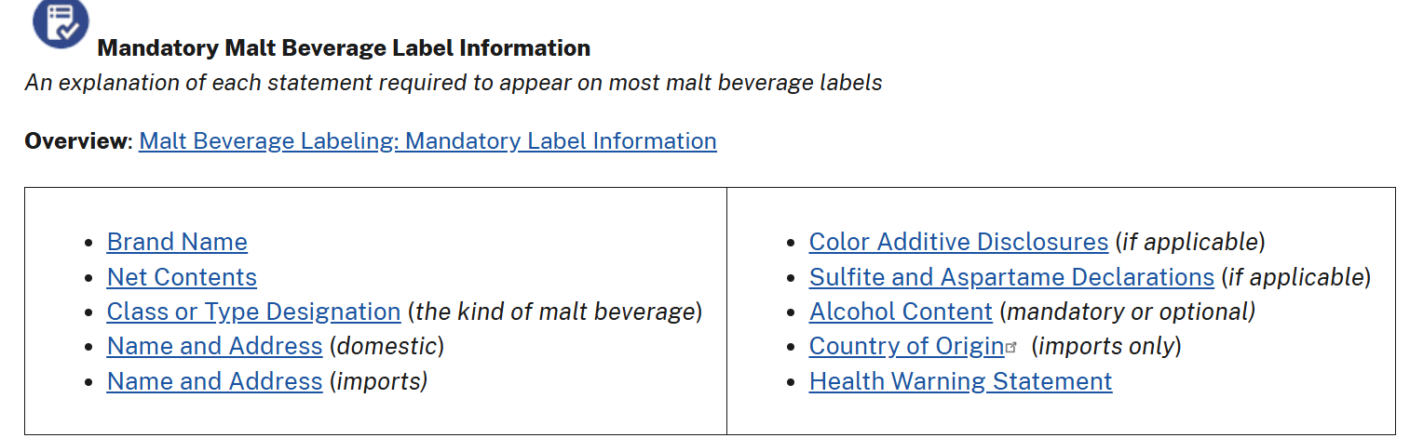

Distilled Spirits Labels
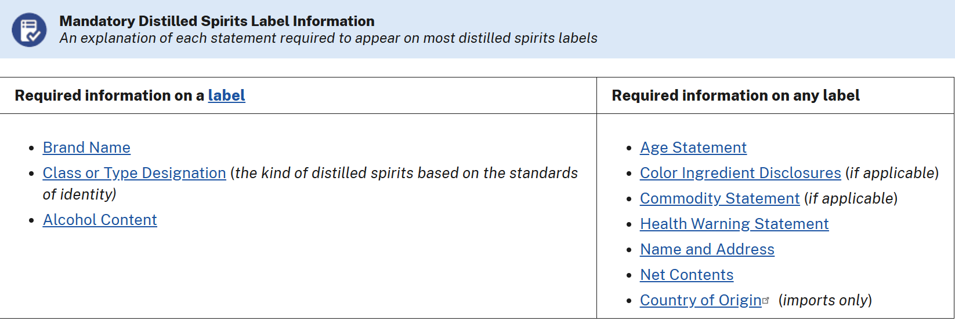

Wine Label
