Introduction

1.1. Scope of the document
This document is part of the JTCL project set of documentation, it aims at describing how to use the JTCL set of classes to write client/server applications. A knowledge of Tcl/Tk and jTcl, the underlying languages of the JTCL libraries, is required.
A brief introduction to the Tcl language can be found in [2] and a complete tutorial in [3]. The structure of jTcl is described in [2]. A general overview of JTCL is given in [1].
This document has the following structure:
• Chapter 2 – The lang set of packages: explains the content and use of the packages defining basic function for the jTcl language.
• Chapter 3 – The tcp set of packages: explains the content and use of the packages providing a functional basis for client/server applications using the HTTP and RPC protocols.
• Chapter 4 – The ic set of packages: explains the content and use of the packages enabling the use of the rule-driven graphical interface.
Table of Contents
Introduction 1
1.1. Scope of the document 1
1.2. Glossary 3
1.3. Bibliographic references 3
1.4. Typographic conventions 4
1.5. Trademarks and copyrights 4
2. The lang set of packages 5
2.1. Overview 5
2.2. Reference 5
2.3. Examples 7
3. The tcp set of packages 8
3.1. Overview 8
3.2. Reference 9
3.3. Examples 24
4. The ic set of packages 25
4.1. Overview 25
4.2. Reference 26

1.2. Glossary
The following terms and abbreviations are used throughout this document.
FTP File Transfer Protocol
HTML Hypertext Mark-up Language
HTTP Hypertext Transfer Protocol
HTTPd Hypertext Transfer Protocol (HTTP) daemon
jTcl Java-like Tool Command Language, an object-oriented extension to the Tcl language.
MIME Multipurpose Internet Mail Extensions
RPC Remote Procedure Call
Tcl Tool Command Language, a free platform-independent scripting language designed in the late 1980’s by Prof. John Ousterhout of the University of California, Berkeley.
TCP/IP Transmission Control Protocol / Internet Protocol, a set of network protocols used in the Internet.
Tk Tool Kit, a graphical tool-set (also platform-independent) associated with Tcl.
URL Universal Resource Locator

1.3. Bibliographic references
The following references are used throughout this document.
[3] Brent B. Welch
Practical Programming in Tcl and Tk, 2nd edition
Prentice Hall, 1997
ISBN 0-13-616830-2
[4] T. Berners-Lee, R. Fielding, H. Frystyk
Hypertext Transfer Protocol -- HTTP/1.0
RFC 1945, May 1996
[5] R. Fielding, J.Gettys, J.Mogul, H. Frystyk, T. Berners-Lee
Hypertext Transfer Protocol -- HTTP/1.1
RFC 2068, January 1997
[6] M. St. Johns
Authentication Server
RFC 931, January 1985
[7] M. St. Johns
Identification Server
RFC 1413, February 1993
[8] N. Freed, N. Borenstein
Multipurpose Internet Mail Extensions (MIME) Part One: Format of Internet Message Bodies
RFC 2045, November 1996
[9] N. Freed, N. Borenstein
Multipurpose Internet Mail Extensions (MIME) Part Two: Media Types
RFC 2046, November 1996
[10] K. Moore
MIME (Multipurpose Internet Mail Extensions) Part Three: Message Header Extensions for Non-ASCII Text
RFC 2047, November 1996
[11] N. Freed, J. Klensin, J. Postel
Multipurpose Internet Mail Extensions (MIME) Part Four: Registration Procedures
RFC 2048, November 1996
[12] N. Freed, N. Borenstein
Multipurpose Internet Mail Extensions (MIME) Part Five: Conformance Criteria and Examples
RFC 2049, November 1996

1.4. Typographic conventions
The following typographic conventions apply throughout this document.
• Names of Tcl keywords are printed with a typewriter-like font, for example: “the else part of an if command is optional”.
• In extract of Tcl code, the characters typed at the shell prompt are shown preceded by the percent character (which is the default prompt character for the Tcl shell). If a single command is spawn onto several lines, each continuing line is preceded by the “>” character. Output from the shell is shown preceded by the “⇒” character.

1.5. Trademarks and copyrights
Windows, Windows 3.x, Windows 95, Windows NT are trademarks from Microsoft Corporation.
Macintosh, MacOs are trademarks from Apple Computers.
Tcl/Tk is copyrighted by the Regents of the University of California, Sun Microsystems, Inc., and other parties.
jTcl is copyrighted by FRIDU, a free software company, South Brittany University and other parties.

2. The lang set of packages

2.1. Overview
This set of packages performs basic tasks related to the jTcl language. It consists of the following packages:
lang.debug contains several debug-oriented procedures.
lang.serial contains several serialization procedures used to store permanently object contents on disk.
lang.doit test routines.
lang.object contains the definition of a root class named Object.
lang.search contains the search mechanism used to retrieve the jTcl file distribution.

package name | associated file | imported packages | content
lang.object | Core/Lang/Tcl/objectLang.jTcl | lang.debug | Object class
lang.debug | Core/Lang/Tcl/debugLang.jTcl | -
lang.serial | Core/Lang/Tcl/serialLang.jTcl | lang.object
lang.doit | Core/Lang/Tcl/doitLang.jTcl | -
lang.search | Core/Lang/Tcl/searchPkgLang.jTcl | -
Table 2-1: contents of the lang.* packages.

2.2. Reference
This chapter is intended to be used as a reference guide for all classes defined in the lang packages.

Object  package: lang.object  This is the root class of the inheritance tree of the JTCL package. It provides some basic mechanisms useful for debugging. | 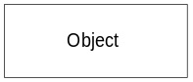
instance variables:
clog name of the log file used by the log method. Initial value is stdout.
errno last error status. Initial value is {}.
level trigger for the logging mechanism: the logging mechanism is enabled only if the JTCL_LOG environment variable is set to a value greater or equal to the value of level. Initial value is 0.
public methods:
log {args} according to the values of the JTCL_LOG environment variable and level instance variable, may write an output message to the log file defined by the clog instance variable. If JTCL_LOG is greater or equal than level, then the message is written. The format of the message is the following:
_C_class._O_instance:errno: args
where class is the name of the class, instance is the concatenation of the name of the class and the instance counter (automatically incremented with each creation of a new object of that class), errno is one of the instance variables of the Object class (see above) and args is the list of arguments passed by the user to this method (usually it consists of a human-readable message).
dump {{TYPE Object}}
dump the content of the object according to the value of the TYPE parameter. TYPE can take one of the following values: “Object” (dumps only instance variables), “Class” (dumps only class variables and public methods), “All” (dumps everything). For any other value of TYPE, nothing is dumped. Default value for TYPE is “Object”. The dump is always directed to the standard output (stdout). The format of the printed message is the following:
dump Object=_O_instance
*Object owned
+name->value
...
*Class owner
+name->value
...
where instance is the concatenation of the name of the class and the instance counter (automatically incremented with each creation of a new object of that class). The first part named “*Object owned” appears only if TYPE is “Object” or “All”, in that part all instance variables are listed, including the inherited ones and the default ones (such as class and my). The second part named “*Class owner” appears only if TYPE is “Class” or “All”, in that part all class variables and all public methods are listed, including the inherited ones and the default ones (such as extends, super, instanceCounter and my). For both parts, name is the name of the variable or the method and value is the value of the variable or, for a method, the name of the method preceded by the name of the class in which the method is defined.
signal {MSG} stops the interpretation and displays an error message to the standard output. The message consists of the name of the instance (under the form “_O_”, followed by the name of the class, followed by the instance counter) and the message provided by the user via the MSG parameter.

2.3. Examples
For an example of use of the Object class, refer either to the “Gum machine” sample given in [2] or to the following chapters.

3. The tcp set of packages

3.1. Overview
These packages provide means to create client/server applications using the HTTP and RPC protocols. The following classes are defined: TcpChannel, TcpServer, TcpServerCl, TcpHttpd, TcpHttpdCl, TcpHttpdRpc. Relations between these classes are described in the following diagram.
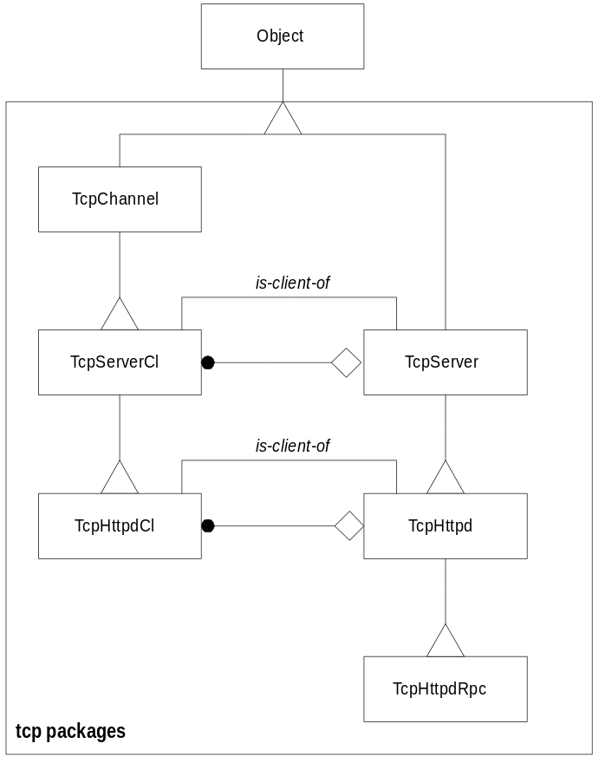
Figure 3-1: OMT diagram of the tcp classes
The class are organized into the following packages:
tcp.channel provides the basic functionality (management of a virtual channel) for all the network classes defined in the next packages. Defines the TcpChannel class.
tcp.server provides the basic classes for TCP/IP communication (management of actions of the server). Defines the TcpServerCl and TcpServer classes.
tcp.httpd Provides a small HTTP server. Defines the TcpHttpdCl and TcpHttpd classes.
tcp.rpc Provides RPC communication. Defines the TcpHttpdRpc class.

package name | associated file | imported package | content
tcp.channel | Core/Tcp/Tcl/channelTcp.jTcl | lang.object | TcpChannel class
tcp.server | Core/Tcp/Tcl/serverTcp.jTcl | tcp.channel | TcpServerCl and TcpServer classes
tcp.httpd | Core/Tcp/Tcl/httpdTcp.jTcl | tcp.server | TcpHttpdCl and TcpHttpd classes
tcp.rpc | Core/Tcp/Tcl/rpcTcp.jTcl | tcp.httpd | TcpHttpdRpc class
Table 3-2: contents of the tcp.* packages.

3.2. Reference
This chapter is intended to be used as a reference guide for all classes defined in the tcp packages.

TcpChannel  package: tcp.channel  This class provides basic management of a communication channel based on the use of sockets. It is used as the base class for all client-side communication classes. | 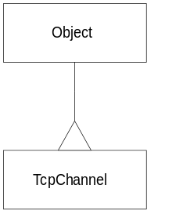
class variables:
blocking configuration parameter for the output socket. This option determines whether I/O operations on the channel can cause the process to block indefinitely. The value of the option must be a proper boolean value (0 for non-blocking, 1 for blocking). Channels are normally in blocking mode; if a channel is placed into non-blocking mode it will affect the operation of the gets, read, puts, flush, and close Tcl built-in commands. Initial value for this variable is 1.
translation configuration parameter for the output socket. In Tcl scripts the end of a line is always represented using a single newline character (\n). However, in actual files and devices the end of a line may be represented differently on different platforms, or even for different devices on the same platform. The Tcl I/O system performs all the necessary translations. The default translation mode, auto, handles all the common cases automatically, but it is possible to provide explicit control with the following values: binary, no end-of-line translations are performed, cr, the end of a line in the underlying device is represented by a single carriage return character, crlf, the end of a line in the underlying device is represented by a carriage return character followed by a linefeed character, lf, the end of a line in the underlying device is represented by a single newline character. Initial value for this variable is auto.
instance variables:
buffer input buffer. Initial value is {}.
bufOut output buffer. Initial value is {}.
in input socket.
out output socket.
constructor:
TcpChannel {SOCK_IN SOCK_OUT}
this method (1) sets the in and out instance variables to the values given by SOCK_IN and SOCK_OUT, (2) configures the output socket using information provided by the blocking and translation class variables and (3) assigns the read method as the call-back for the input socket, i.e. as soon as data is present in the input socket, the read method will be called.
SOCK_IN: input socket, shall be defined using the socket Tcl built-in command, no default value.
SOCK_OUT: output socket, if used, shall be defined using the socket Tcl built-in command, otherwise, if {} is given as a value, then the output socket will be the same as the input socket, default value is {}.
destructor:
free {} closes the sockets.
return value: none.
public methods:
read {} this procedure is associated with an event handler, it is called whenever the input socket (in) becomes readable. In that case the characters read in the socket are appended to the input buffer (buffer). In case an “End-Of-File” (EOF) character is read from the socket, this procedure is release from the event handling binding and the errno instance variable is set to EOF.
return value: none.
write {BUFFER} this procedure enables to write data to the output socket. The procedure does not write directly to the socket (to write directly to the socket, one should use the writeAndFlush method with the buffer passed as argument) but rather install the writeAndFlush method as an event handler associated with the output socket in order to write the data contained in the BUFFER argument in non-blocking mode.
BUFFER: the buffer to be written to the output socket, can contain any data, no default value.
return value: none.
writeAndFlush {{BUFFER "\000"}}
this procedure can be invoked either directly, either asynchronously. If it is invoked directly, then the content of BUFFER is written to the output socket (out) in only one shot, which can lead to some blocking problems since if there is no available room for data in the socket, the program will freeze until the socket becomes writable again. If the procedure is invoked asynchronously, then the data from the output buffer (bufOut) is written to the output socket byte by byte until the buffer becomes empty.
BUFFER: the buffer to be written to the output socket in case of direct call of the procedure, in the case of asynchronous use, BUFFER shall have the “\000” value. Default value is “\000”.
return value: none.

TcpServerCl  package: tcp.server  Generic client channel class. An object of this class is located in the server side and is created by the TcpServer class to handle all communications with a given client connected by TCP socket. | 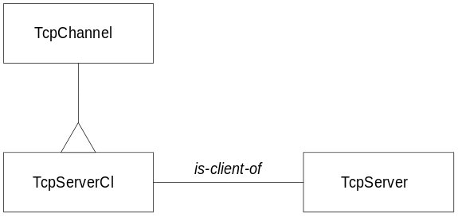
instance variables:
server identifier of the server the object is connected to, set by the constructor.
host TCP/IP name of the remote host the object is connected to, set by the constructor.
port TCP/IP port number on the remote host, set by the constructor.
user user name, set by the auth method.
constructor:
TcpServerCl {SERVER_ID HOST SOCK PORT}
this method (1) sets the server, host and port instance variables to the values given by (resp.) SERVER_ID, HOST and PORT, (2) calls the constructor of the superclass (TcpChannel) passing SOCK as argument. This method is most always called by the TcpServer class.
SERVER_ID: object identifier (as returned by the new jTcl command) of the server the client is connected to, no default value.
HOST: name of the remote host, no default value.
SOCK: socket for communication between the client and the server, shall be defined using the socket Tcl built-in command, no default value.
PORT: port number on the remote host, no default value.
destructor:
free {} call the clientLeaved method of the associated server.
return value: none.
public methods:
auth {} this method is called by the associated server in order to authenticate the client. It follows the procedure defined in RFC 931 [5] (which is now superseded by RFC 1413 [6]). A new socket is temporarily created to the port #113 of the server, query data is sent on this socket and the result is read on the same socket. The result is parsed to retrieve the user name, stored in the user instance variable. If this procedures fails, then user is set to “Unknow” [sic].
return value: always returns “OK”.
refused {args} this procedure is called by the associated server each time a client connection is refused by the server. It simply outputs a message and then terminates
args: the list of arguments passed by the user to this method (usually it consists of a human-readable message). It is sent to the output socket of the client.
return value: none.

TcpServer  package: tcp.server  Generic server class using TCP/IP connection. | 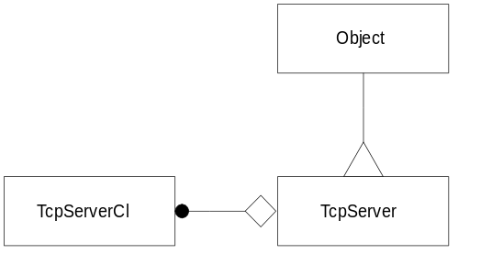
class variables:
clientsClass name of the class representing the clients allowed to connect to this server class. Initial value is TcpServerCl.
vwait name of the variable to wait for in the event handling process. Initial value is _TCP_SV_VWAIT.
instance variables:
clientsAddr list of the currently connected clients. Initial value is {}.
clientsNum number of currently connected clients. Initial value is 0.
clientsMin minimum number of clients allowed to connect, if actual number of clients goes below that limit, then the server terminates. Initial value is 0.
clientsMax maximum number of clients allowed to connect. Initial value is 64.
port port number on the server host. Set by the constructor.
socket server socket (listens for new connections). Set by the constructor.
constructor:
TcpServer {PORT}
this method (1) sets the port and socket instance variables to the values given by (resp.) PORT and a server socket opened to that port, and (2) assigns the accept method as the call-back for the server socket, i.e. as soon as a client tries to connect to the socket, the accept method will be called. Note: if the socket cannot be created (e.g. an illegal port number is given), then an error message is displayed and the execution is aborted.
PORT: port number on which the server will be listening to client connections, no default value. Note: port numbers below 1024 are reserved by most systems (e.g. port #80 is used by HTTP servers).
destructor:
free {} kills all the connected clients and closes the socket.
return value: none.
public methods:
vwait {} this is the main event loop. It loops until the variable defined by the vwait instance variable is set. This variable is set when a new client is disconnected. If there are less clients than defined by the clientsMin instance variable, then the server terminates.
return value: none.
clientLeaved {CLIENT_ID}
this procedure is called by the client just before it terminates. The client is then removed from the list of connected clients and the variable defined by the vwait class variable is set to some value in order to interrupt the main event loop.
CLIENT_ID: identifier of the client about to leave, no default value.
return value: none.
accept {SOCK CLIENT_HOST PORT}
this procedure is automatically called when a client wants to establish a new connection. It creates a new object of class TcpServerCl which will be used to handle all the communication with the client. Arguments are passed “as-is” to the constructor of TcpServerCl. Authentication is performed calling the auth method of TcpServerCl. The connection can fail if (1) the client authentication fails, or (2) the maximum number of authorized clients to connect is reached. In case of failure, the client is informed via the refused method of the TcpServerCl class.
SOCK: identifier of the socket created by the client trying to connect, no default value.
CLIENT_HOST: host name of the client trying to connect, no default value.
PORT: port number on the server, no default value.
return value: none.

TcpHttpdCl  package: tcp.httpd  Generic client class. A object of his class is located in the server side and is created by the TcpServer class to handle all communications with a given client connected by TCP socket. | 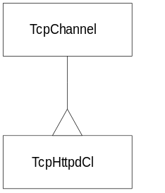
instance variables:
req request method of the client to retrieve information on the server, possible values are GET or POST, set by the process method of the associated server class.
url URL on the server the client wants to connect to, set by the process method of the associated server class.
query query on the server the client wants to connect to, set by the process method of the associated server class.
length contains the value given by the “Content-length” field of the HTTP header, set by the process method of the associated server class.
keep-alives contains the value given by the “Keep-Alives” field of the HTTP header, set by the process method of the associated server class.
cookie contains the value given by the “Cookie” field of the HTTP header, it is a pair name and value, set by the process method of the associated server class.
if-modify contains the value given by the “If-Modified-Since” field of the HTTP header, set by the process method of the associated server class.
data data following the HTTP header sent by the client, contains length bytes, set by the process method of the associated server class.
page contains the body of an HTTP page.
header contains the header of an HTTP page.
constructor:
TcpHttpdCl {HTTP_ID HOST SOCK PORT}
this method does nothing but send the arguments to the constructor of its superclass.
HTTP_ID: class identifier (as returned by the new jTcl command) of the server the client is connected to, no default value.
HOST: name of the remote host, no default value.
SOCK: socket for communication between the client and the server, shall be defined using the socket Tcl built-in command, no default value.
PORT: port number on the remote host, no default value.
public methods:
fCopyDone {FD LEN}
this method closes the file which descriptor is FD and destroys the object (except if the keep-alives instance variable is defined).
FD: file descriptor of the file to be closed, no default value.
LEN: length of the file, only used to print debug message, no default value.
return value: none.
read {} this method overrides the read method defined in the TcpChannel class. It is automatically called whenever there is new data to read in the input socket. This method reads data from the input socket, if this data corresponds to the End-Of-File character, then the execution is stopped. If the data corresponds to a blank line, then the HTTP page is processed by the server (using the process method of the server class) and effectively sent to the client (using the write method). if the data corresponds to something else (non-blank line), then the data is appended to the buffer instance variable.
return value: EOF if the End-Of-File (EOF) character is read.
write {PAGE} this method is called by the read method in order to send back to the client the requested page. An action is performed depending on the value of the first part of the PAGE parameter, possible values are the following:
“PAGE”: in that case, the body of the data is contained in the page instance variable and the header in the header instance variable.
“HTML”: in that case, the data to send back is located in the second part of the PAGE parameter.
“FILE”: in that case, the body of the data to send back is contained in a file on the server which descriptor is given by the second part of the PAGE parameter. The header of the data is located in the header instance variable of the client channel.
After that, the class is destroyed (since HTTP/1.0 is a stateless protocol) except in the case where the keep-alives instance variable is defined.
PAGE: this parameter is a pair consisting of a keyword (“HTML”, “FILE” or “PAGE”) and a pair (file descriptor, full path name of the file) as returned by the openUrl method, no default value.
return value: none.

TcpHttpd  package: tcp.httpd  An HTTP server class. | 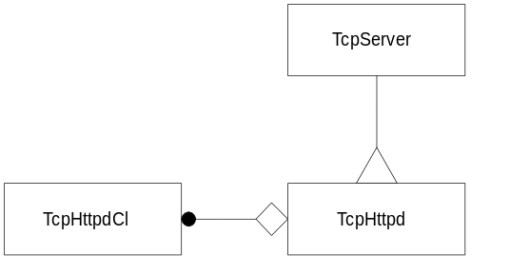
class variables:
clientsClass Name of the class used for communication with the client. A new instance of that class is created each time a new client tries to connect. Initial value is TcpHttpdCl.
mimes name of an array variable defining all the supported MIME types, the index of the array shall be the file extensions. Initial value is _HTTPD_MIME_TYPE. This variable contains the following:
index content
.gif “image/gif”
.jpg “image/jpg”
.html “text/html”
.htm “text/html”
.txt “text/html”
.class “image/gif”
.tcl “application/x-tcl”
.tk “application/x-tk”
MIME media types are defined in RFC 2046 [9].
errors name of an array variable defining all the error messages, the index of the array shall be the error numbers. Initial value is _HTTPD_ERROR_MSG. This variable contains the following:
index content
204 “204 No Content”
304 “304 Not Modified”
400 “400 Bad Request”
404 “404 URL/File Not Found”
503 “503 Service Unavailable”
504 “504 Service Temporarily Unavailable”
The complete list of error codes is given by RFC 1945 [4] for HTTP/1.0 and RFC 2068 [5] for HTTP/1.1.
errFmt name of the variable containing the format of an error message. Initial value is _HTTPD_ERROR_FMT. This variable is a string containing a fragment of an HTML page to be displayed in case of error. Various information are provided, such as error code, error message, URL, etc.

instance variables:
rootDir root directory of the HTTP file tree, set by the constructor.
index name of the index file in an HTTP file tree, initial value is “index.html”.
host name of host as given by the “host:” field in the HTTP header the client sends, set by the process method.
constructor:
TcpHttpd {PORT ROOT_DIR}
sets the rootDir instance variable to the value provided by ROOT_DIR (a check is perform, if ROOT_DIR does not match a valid directory, then the execution is aborted) and call the constructor of the superclass (i.e. TcpServer) passing PORT as argument.
PORT: port number on which the server will be listening to client connections, no default value.
ROOT_DIR: root directory of the HTTP file tree (only files and directories found below this level will be available to the clients), shall be a valid directory, no default value.
public methods:
date {SECONDS} generate a date in HTTP format from a system date given by the CLICKS parameter. The format is “%a, %d %b %Y %H:%M:%S %Z”, where:
%a: abbreviated weekday name
%d: day of month
%b: abbreviated month name
%Y: year with century
%H: hour in 24-hour format
%M: minutes
%S: seconds
%Z: time zone name
for example: “Wed, 31 Dec 1997 09:17:58 WDT”. This format is referred as the preferred of the three authorized formats in the HTTP specification document [5].
SECONDS: an integer time value, typically returned by one of the following Tcl built-in command: clock seconds, clock scan, or the atime, mtime, or ctime options of the file command, no default value.
return value: the date formatted as described above.
error {CODE URL MSG {ACTION {Html/error.html}}
builds an HTTP page (header and body) which body is an HTML page to be displayed in case of an error.
CODE: HTTP error code, shall be present in the array indicated by the errors class variable, no default value.
URL: the list of arguments passed by the user to this method (usually it consists of a human-readable message). It is sent to the output socket of the client.
MSG: the list of arguments passed by the user to this method (usually it consists of a human-readable message). It is sent to the output socket of the client.
ACTION: the list of arguments passed by the user to this method (usually it consists of a human-readable message). It is sent to the output socket of the client.
return value: the HTTP message as defined above.
header {CLIENT_ID MIME FILE}
this method generates an HTTP header. This header is appended to the header instance variable of the associated client (given by CLIENT_ID). The generated header has the following format:
HTTP/1.0 200 Data follows
Date: current-date
Last-Modified: last-modif-date
Content-Type: mime-type
Content-Length: file-size
where:
− current-date is the current date, formatted by the date method,
− last-modif-date is the date of last modification of the file which name is given by FILE, this date is also formatted by the date method,
− mime-type is a MIME type given by MIME,
− file-size is the size in bytes of the file which name is given by FILE.
CLIENT_ID: instance identifier (as returned by the new jTcl keyword) of the associated client, shall be of type given by the clientsClass class variable, no default value.
MIME: shall be a valid MIME type, no default value.
FILE: shall be a valid file name, no default value.
return value: none.
openUrl {URL} tries to open the file given in the URL provided as parameter. This function (1) tests if the provided file name is legal (valid file or directory name located below the HTTP root directory), (2) creates a full path name out of the provided file name, by concatenation with the HTTP root directory given by the rootDir instance variable and, in the case of a directory, by appending the default index file name given by the index instance variable, and (3) opens the specified file.
URL: shall be a valid URL as described in [4] and [5], no default value.
return values:
− “Error BelowRoot” if the URL indicates a path name located below the HTTP root directory,
− “ERROR error-msg” where error-msg is a string describing the error, if another kind of error occurs (e.g. the file does not exist),
− a pair consisting of the file descriptor (as returned by the open Tcl built-in command) and the full path name of the file, if the command proceeded correctly.
mime {EXT CLIENT_ID}
gets file type from extension (given by EXT) and retrieve URL from associated client (given by CLIENT_ID).
EXT: shall be a valid MIME extension listed in the array referenced by the mimes class variable, default value is .html.
CLIENT_ID: identifier of the associated client, no default value.
return value: an error page (formatted with the error method) if the given extension is unknown or if the URL cannot be opened (openURL returns an error message), a pair (HTML, HTTP header) if the file has not been modified since last load as indicated by the modify-since instance variable of the client channel, otherwise returns the pair (file descriptor, full path name) corresponding to the URL.
process {CLIENT_ID}
process HTTPD request from client. The line contained in the input buffer of the associated client channel (TcpHttpdCl class) is parsed, it should have the following format:
REQ URL?QUERY HTTP/1.0
where REQ is equal to GET or POST, URL is a string containing any characters except “?” and QUERY is a string containing any character except space. URL shall have at least one character and QUERY can have zero character. The req, url and query instance variable of the associated client channel are set accordingly.
After that, the parsing of the input buffer goes on. The following fields and their associated values are retrieved:
Content-length:
Keep-Alives:
End-Data:
End-Eol:
Cookie:
If-Modified-Since:
Host:
Then the data following the HTTP header in the input buffer is retrieved.
CLIENT_ID: identifier of the associated client, no default value.
return values: an error page displaying “Invalid HTTPD-1.0 header” if an error occurs during the parsing of the input buffer of the associated client channel, otherwise, if no error occurs, return the file descriptor of the URL (using the mime method).

TcpHttpdRpc  package: tcp.rpc  This class provides a server which waits for commands on a TCP socket. Commands are one-line lists and are executed in a private slave interpreter attached to each client. | 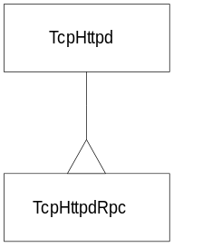
instance variables:
timeout time of no-activity to wait before killing a slave (time is given in seconds and 0 means infinite time). initial value is 900.
jTclPath contains the file path to the package.jTcl and slave.jTcl files, set by the constructor.
constructor:
TcpHttpdRpc {PORT ROOT_DIR {AUTO {}} {INDEX {}}}
sets the jTclPath and index instance variables using the values given by AUTO and INDEX and then calls its superclass constructor (TcpHttpd) passing PORT and ROOT_DIR as arguments.
PORT: port number on which the server will be listening to client connections, no default value.
ROOT_DIR: root directory of the HTTP file tree (only files and directories found below this level will be available to the clients), shall be a valid directory, no default value.
AUTO: contains a list of file path where the slave.jTcl file may be found, default value is {}.
INDEX: alternative name for the index file, if {} is given as a value, then the value from the index instance variable will be used, default value is {}.
public methods:
logout {INTERP} frees all client session resources. This method is usually called after the timeout period has expired.
INTERP: handle of the slave interpreter the client agent is running in, no default value.
return value: none.
exec {CLIENT_ID} executes a remote command. The command is given by the data instance variable of the client channel.
CLIENT_ID: object identifier of a client channel, no default value.
return value: return value of the executed command.
eval {CLIENT_ID} processes an RPC request. If the slave interpreter associated to the client does not exist, then try to retrieve it from the interp field of the cookie associated with the client. If the associated interpreter cannot be retrieved, then an error page is sent. After that, the timeout is reset and the exec method is called.
CLIENT_ID: object identifier of a client channel, no default value.
return value: error page (with error 400) if something goes wrong.
parse {CLIENT_ID TYPE}
Parse a file in order to add a slave interpreter cookie.
CLIENT_ID: object identifier of a client channel, no default value.
TYPE: type of the client, can be one of the following values: TCLET, JAVA or URL, no default value.
return value: error page (with error 400) if something goes wrong, otherwise PAGE.
alias {CLIENT_ID} this procedure does nothing. It is automatically called when a new client logs in. It is useful to add new authorized commands in the slave interpreter.
CLIENT_ID: not used, no default value.
return value: none.
login {CLIENT_ID} if the client is already logged, an error page is sent back, otherwise a Tcl slave interpreter is created and associated to the client (for the occasion, a interp instance variable is created in the client object)
CLIENT_ID: object identifier of a client channel, no default value.
return value: error page (with error 400) if the client is already logged.
mime {EXT CLIENT_ID}
performs a given action according to the value of the EXT parameter.
EXT value: action performed:
.login call the login method
.logout call the logout method
.rpc call the eval method
.htt call the parse method with TYPE = TCLET
.htj call the parse method with TYPE = JAVA
.htcl call the parse method with TYPE = URL
EXT: indicates which action to perform, possible values are: .login, .logout, .rpc, .htt, .htj, .htcl, no default value.
CLIENT_ID: object identifier of a client channel, no default value.
return value: return value of the action performed.

3.3. Examples
Examples will be provided at a later stage.

4. The ic set of packages

4.1. Overview
These packages provide means to create rule-driven graphical user interfaces. The following classes are defined: IcClient, IcRpcClient, IcError, jTkContainer, IcRuleClass, IcRuleEngine, IcPopup, IcHelp, IcDispatch, IcBinder, jTkIcWidget, jTkIcButton, jTkIcEntry. Relations between these classes are described in the following diagram.
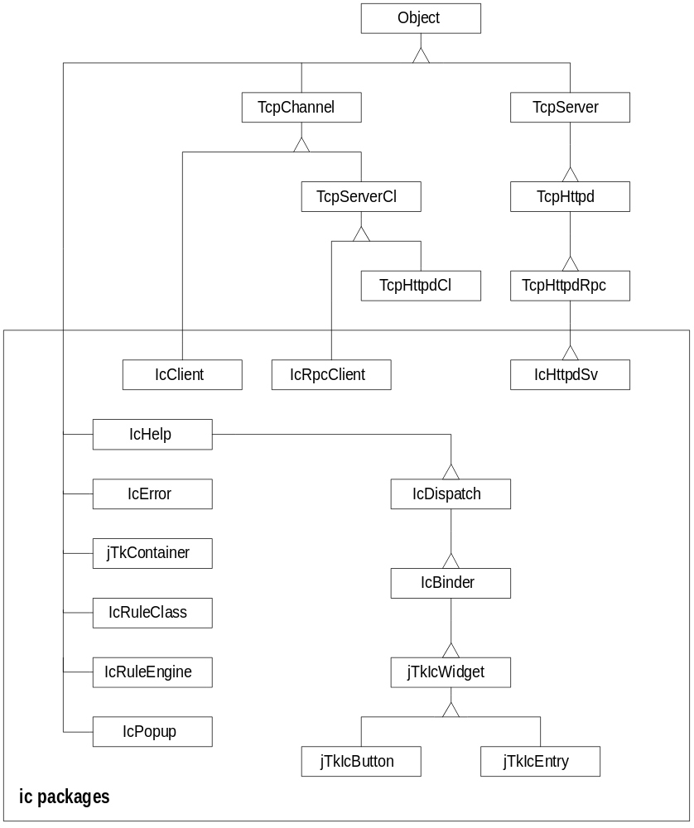
Figure 4-1: OMT diagram of the ic classes
package name | associated file | imports | content
ic.client | Core/Ic/Tcl/clientIc.jTcl | tcp.channel | IcClient class
ic.rule | Core/Ic/Tcl/ruleIc.jTcl | lang.object | IcRuleClass and IcRuleEngine classes
ic.server | Core/Ic/Tcl/serverIc.jTcl | tcp.rpc, ic.rule | IcRpcClient and IcRpcServer classes
ic.httpd | Core/Ic/Tcl/httpdIc.jTcl | tcp.rpc, ic.server | icHttpdSv class
ic.help | Core/Ic/Tcl/helpIc.jTcl | lang.object | IcHelp class
ic.popup | Core/Ic/Tcl/popupIc.jTcl | lang.object | IcPopup class
ic.error | Core/Ic/Tcl/errorIc.jTcl | ic.popup | IcError class
ic.dispatch | Core/Ic/Tcl/dispatchIc.jTcl | ic.help, ic.popup, ic.error | IcDispatch class
ic.binder | Core/Ic/Tcl/binderIc.jTcl | ic.dispatch | IcBinder class
ic.jTk | Core/Ic/Tcl/jTkIc.jTcl | ic.binder, ic.client | jTkIcContainer, jTkIcWidget, jTkIcEntry and jTkIcButton classes
Table 4-2: contents of the ic.* packages.

4.2. Reference
This chapter is intended to be used as a reference guide for all classes defined in the ic packages.

IcClient  package: ic.client  base class for a client channel using the IC rules. | 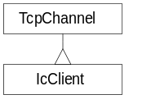
instance variables:
errorId object of IcError class, set by the constructor.
host name of the remote host, set by the constructor.
status status of the client channel, set by the read method.
_RL_* contains a list of widget descriptors which are connected with a given rule, the name of the rule is given in the name of the variable (instead of the “*” character), set by the register method.
constructor:
IcClient {ERROR_ID HOST PORT}
this constructor (1) sets the errorId instance variable to the value provided by ERROR_ID and the host instance variable to the value provided by HOST, (2) creates a socket to the port PORT of the host HOST and passes it to the superclass constructor (TcpChannel), (3) if the supported shell (wish or tclsh) has been started with an option following the “--” sequence, then the string “icClient option” is sent to the server (via the socket), otherwise the string “icClient NoSlaveInterp” is sent to the server, (4) if the LANG environment variable is defined, then the string “icEngine valid lang LANG” is sent to the server.
ERROR_ID: object of IcError class, no default value.
HOST: name of the remote host, no default value.
PORT: port number on the remote host, no default value.
destructor:
free {} displays an error message using the error object to indicate that the connection with the server is lost.
return value: none.
public methods:
read {} this procedure overrides the read method defined in the TcpChannel class, it is automatically called whenever there are data available in the input socket. The data read shall be either the End-Of-File (EOF) character, in that case the object is destroyed, either a one item list. If something different is read, then an error is displayed using the associated error object.
The data read from the socket shall have the following format:
{{RULE₁ FRAME₁…} {RULE₂ FRAME₂…}…}
where RULE shall be a rule previously registered using the register method, otherwise an error message is displayed using the associated error object. For each rule, the update method of each associated widget is called with FRAME as parameter.
Each time an error is issued, the status instance variable is set to FX. Before finishing, the procedure always calls the current method of the associated error object.
return value: none.
focus {} dummy method, this function does nothing.
return value: none.
send {ACTION RULE args}
sends the string “icEngine ACTION RULE args” to the output socket.
ACTION: name of the action, no default value.
RULE: name of the rule, no default value.
args: additional arguments, no default value.
return value: none.
query {ACTION QUESTION}
sends the string “icEngine ACTION QUESTION” to the output socket using the send method and retrieve the answer from the input socket.
ACTION: name of the action, no default value.
QUESTION: name of the question, no default value.
return value: answer read on the input socket.
register {JTK_WD RULE}
appends the widget descriptor given by JTK_WD to the rule RULE represented by the _RL_RULE instance variable. If _RL_RULE does not exist, then it is created.
JTK_WD: widget descriptor, no default value.
RULE: rule name, no default value.
return value: none.

IcRpcClient  package: ic.server  base class for a client channel using the IC rules. | 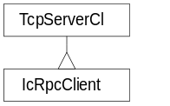
class variables:
engineClass class of the associated rule engine object. Initial value is IcRuleEngine.
instance variables:
engine object of IcError class, set by the constructor.
interp name of the remote host, set by the constructor.
constructor:
IcRpcClient {RPC_ID HOST SOCK PORT}
does nothing specific, simply call the superclass constructor (TcpServerCl), passing its arguments.
RPC_ID: object identifier (as returned by the new jTcl command) of the server the client is connected to, no default value.
HOST: name of the remote host, no default value.
SOCK: socket for communication between the client and the server, shall be defined using the socket Tcl built-in command, no default value.
PORT: port number on the remote host, no default value.
destructor:
free {} destroys the associated rule engine if it exists.
return value: none.
public methods:
read {} this procedure overrides the read method defined in the TcpChannel class, it is automatically called whenever there are data available in the input socket. The data read shall be either the End-Of-File (EOF) character, in that case the object is destroyed, either a one item list. If something different is read, then an error is displayed using the associated error object.
The data read from the socket shall have the following format:
{{RULE₁ FRAME₁…} {RULE₂ FRAME₂…}…}
where RULE shall be a rule previously registered using the register method, otherwise an error message is displayed using the associated error object. For each rule, the update method of each associated widget is called with FRAME as parameter.
Each time an error is issued, the status instance variable is set to FX. Before finishing, the procedure always calls the current method of the associated error object.
return value: none.
auth {} dummy method, this function does nothing.
return value: none.

IcError  package: ic.error  Manages an error window which is used to display error messages and allow to navigate through the stack of current errors. | 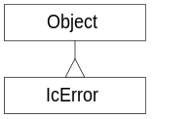
instance variables:
color-Message color used to display an informational message in the text entry of the error window. This variable should be a list of two values, the first value is the name of the foreground color and the second value is the name of the background color. Initial value is {black Bisque1}.
color-Empty color used when there is no message to display in the text entry of the error window. This variable should be a list of two values, the first value is the name of the foreground color and the second value is the name of the background color. Initial value is {grey grey}.
color-Error color used to display an error message in the text entry of the error window. This variable should be a list of two values, the first value is the name of the foreground color and the second value is the name of the background color. Initial value is {red Bisque1}.
count number of errors currently pending. Initial value is 0.
num number of the error currently displayed in the error window. Initial value is 1.
wnum widget corresponding to the entry field for the error number in the error window, set by the constructor.
last last associated IcDispatch object referred to, i.e. the one which error message is currently displayed in the text entry of the error window.
tiped boolean value to indicate whether or not we are in “tipped” mode, set to 0 by the constructor.
widget widget corresponding to the entry field for the error message in the error window, set by the constructor.
owner handle of the object which will make use of this class, set by the constructor.
root root widget as given by the owner's root method, set by the constructor.
_err* represents the associated IcDispatch object to a given error, there are as many _err* variables as there are errors pending. '*' is the same as the value of the variable, i.e. an object handle.
constructor:
IcError {OWNER_ID}
creates a new window containing widgets to display and navigate through error messages. The created window looks like this:
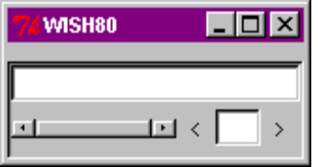
OWNER_ID: handle of the owning object, no default value.
public methods:
clean {} resets all the counters to zero, removes all the errors (represented by the _err* instance variables) and displays no message (empty string) in the text entry of the error window.
return value: none.
del {JTK_ID} removes an existing error, identified by JTK_ID (the _errID instance variable is deleted).
JTK_ID: handle of an object of class IcDispatch (or sub-class of IcDispatch), used here to identify an error, no default value.
return value: none.
add {JTK_ID} adds a new error, identified by JTK_ID (the _errID instance variable is created with the value ID).
JTK_ID: handle of an object of class IcDispatch (or sub-class of IcDispatch), used here to identify an error, no default value.
return value: none.
tip {JTK_ID} displays an help message in the text entry of the error window. The message displayed is contained in the tip instance variable of the object represented by JTK_ID. The message is displayed until the mouse pointer leaves the JTK_ID associated widget.
JTK_ID: handle of an object of class IcHelp (or sub-class of IcHelp), no default value.
return value: none.
display {COLOR MSG}
displays the message MSG in the text entry field of the error window. The text entry field is in read-only mode.
COLOR: indicates the color used to display the message, possible values are “Message”, “Empty” or “Error”, additional values can be added provided that a corresponding color-xxx class variable is created, no default value.
MSG: message to display, no default value.
return value: none.
current {{THIS_INCR 999}}
this method is automatically invoked whenever the user clicks on the “<” or the “>” buttons or type a number in the number entry field and press <Return> in the error window.
This method does nothing if we are in “tipped” mode (i.e. the tip method is currently invoked) or if there is currently no pending error. Otherwise it increments the number of the currently displayed error of the value given by THIS_INCR and displays the corresponding error.
THIS_INCR: value to increment the currently displayed error counter, default value is 999.
return value: none.
popup {} constructs a new pop-up window (with an IcPopup object) displaying the error messages associated with all of the pending errors.
return value: none.

jTkIcContainer  package: ic.jTk  Frame containing widgets. | 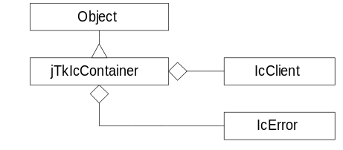
class variables:
packOpt default options (using standard Tk syntax for the pack command) for the layout of the container. Initial value is {-expand y -fill x -side top}.
frameOpt default options (using standard Tk syntax for the frame command) for the border of the frame. Initial value is {}.
instance variables:
root root frame widget, set by the constructor.
frame frame of the container, child of root, set by the constructor.
errorId associated error object (of class IcError), set by the constructor.
icSvId associated client object (of class IcClient), set by the constructor.
wdList list of component widgets (sub-classes of jTkIcWidget), set by the constructor of jTkIcWidget.
constructor:
jTkIcContainer {ROOT HOST PORT}
this method (1) sets the root instance variable to the value provided by ROOT, (2) create a new frame with the options given in the frameOpt class variable, this new frame is a sub-widget of ROOT and is stored in the frame instance variable, (3) creates a new associated error object (stored in the errorId instance variable) and a new associated client object (stored in the icSvId instance variable).
ROOT: root frame widget, no default value.
HOST: name of remote host, used for the creation of the associated client object, no default value.
PORT: port number on the remote host, used for the creation of the associated client object, no default value.
public methods:
focus {JTK_ID} gives the default focus to the widget given by JTK_ID.
JTK_ID: object of class jTkIc*, no default value.
return value: none.
pack {args} uses the packing geometry manager of the Tk toolkit in order to organize the widgets given as arguments inside the frame of the container. Packing options given by the packOpt class variable are used.
args: each argument shall be an object of class jTkIc* to be put inside the container frame, no default value.
return value: none.

IcRuleClass  package: ic.rule  represents a rule. | 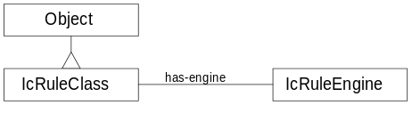
class variables:
refused-us American version of the error string to be displayed when the rule cannot be activated. Initial value is "Corrected dependency error first".
refused-fr French version of the error string to be displayed when the rule cannot be activated. Initial value is "Corriger les erreurs sur les dependances".
depends List of dependencies. Initial value is {}.
phony Indicates if the rule is phony or not, a “phony” rule does not return any information to the client. Initial value is 0.
instance variables:
data-extra list of instance variables to be set by a given action, most of the time, its value is “value status”. Initial value is {}.
data-temp contains a reference to a message to display. Initial value is {}.
status status of the rule, possible values are: “OK” (no error), “FX” (error occurred), “LCK” (rule is locked), “UNK” (rule is unlocked) or Unused. Initial value is Unused.
value value of the rule. Initial value is {}.
previous previous value of the value instance variable. Initial value is {}.
param value of the parameter passed to the valid method. Initial value is {}.
tic contains CPU time as return by the clock clicks Tcl built-in command. Initial value is {-1}.
depends list of dependencies. Initial value is {}.
engine associated engine, shall be an instance of the IcRuleClass class, set by the constructor.
oldStatus saved value of the status instance variable, set by the lock method.
oldValue saved value of the value instance variable, set by the lock method.
locked indicates if the rule is locked or not. If the rule is locked, then contains a message indicate the reason of the locking of the rule, otherwise, if the rule is not locked, this variable does not exist. Set by the lock method.
constructor:
IcRuleClass {ENG_ID}
sets the engine instance variable to the value given by ENG_ID and then searches in the dependency list (given by the depends class variable). Each rule found in that list is created and added to the depends instance variable.
ENG_ID: object representing the associated engine, no default value.
public methods:
valid {PARAM args} sets the data-extra instance variable to “value status”, the value and param instance variables to PARAM, the status instance variable to “OK” and the tip instance variable to the current CPU time.
This is the default validation method, it does nothing special (just report that validation is always OK). For an actual use, the class should be derived and this method overloaded to take into account application-specific code.
PARAM: value for the param instance variable, no default value.
args: unused parameter.
return value: none.
message {TYPE} displays a message corresponding to a type indicated by TYPE, the language of the message is indicated by the lang instance variable of the associated engine object. If the message in the required language cannot be retrieved, then the message in American is displayed as a default. The message is not actually displayed, but stored in the data-temp instance variable instead.
TYPE: type of message to display, no default value.
return value: none.
list {args} displays a message of type “list” using the message method.
args: unused parameter.
return value: none.
tip {args} displays a message of type “tip” using the message method.
args: unused parameter.
return value: none.
default {args} displays a message of type “default” using the message method and sets the data-extra instance variable to “value status”.
args: unused parameter.
return value: none.
help {args} displays a message of type “help” using the message method.
args: unused parameter.
return value: none.
refused {DEP_LST} displays a message of type “refused” using the message method and sets the data-extra instance variable to “status”.
DEP_LST: unused parameter.
return value: none.
decorate {args} this method is typically called once when displaying the widget in order to decorate it with all the strings from the rules.
args: arguments passed to the default method, no default value.
return value: none.
undo {args} reset the value instance variable with the value contained by the previous instance variable.
args: unused parameter.
return value: none.
unlock {args} Unlocks the rule and restores the previous values of the value and status instance variables (or set status to “UNK” if no previous status was set).
args: unused parameter.
return value: none.
lock {PARAM args} locks the rule (set the status instance variable to “LCK”) in order to avoid any changes of the value during validation process. Previous values of the value and status instance variables are saved in the oldValue and oldStatus instance variables.
PARAM: a message/value pair, the message part explains the reason to lock the rule and the value part is the value submitted to validation, no default value.
args: unused parameter.
return value: none.
query {METHOD PARAM}
performs an action (given by METHOD) and check the dependency list before.
METHOD: action to perform, possible values are: decorate, default, valid, list, undo, lock, unlock, tip and help, no default value.
PARAM: parameters for the action, no default value.
return value: none.

IcRuleEngine  package: ic.rule  Generic rule engine, stores all rule objects. | 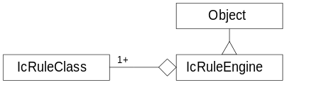
instance variables:
lang language used to display the messages, possible values are fr for French and us for American. To add more languages, new class variables must be added to the IcRuleClass class, the name of the class variables shall be under the form messagetype-langcode. Initial value is {us}.
answer return value for the doIt method, set by the called rules.
owner handler of the class owning the rule engine, set by the constructor.
topRule name of the top rule, set by the constructor.
_rl_* set of rules objects (of type IcRuleClass), the star (*) represents the name of the rule, set by the constructor (for the top rule) and the getHandle method (for the other rules).
constructor:
IcRuleEngine {OWNER {RL_TOP all}}
sets the owner and topRule instance variables using values provided by OWNER and RL_TOP and creates a new rule: the top rule.
OWNER: handle of the owner, no default value.
RL_TOP: name of the top rule, default value is all.
destructor:
free {} destroys all the rules (referred to by the _rl_* instance variables).
return value: none.
public methods:
value {RL_NAME} returns a list consisting of the name of the rule (given by RL_NAME) and its value (given by the value instance variable of the associated rule object).
RL_NAME: shall be a rule object previously defined, no default value.
return value: the pair name/value as described above.
lock {RL_NAMES MSG {VALUE {}}}
calls the lock method with MSG and VALUE as arguments for all rules found in the RL_NAMES list.
RL_NAMES: shall be a list of valid rules, no default value.
MSG: message giving the reason of the locking of the rule, no default value.
VALUE: value submitted for validation, default value is {}.
return value: none.
unlock {RL_NAMES} calls the lock method for all rules found in the RL_NAMES list.
RL_NAMES: shall be a list of valid rules, no default value.
return value: none.
rlDump {RL_NAME} displays the content of the rules (calling their dump method) matched by the glob-style pattern given by RL_NAME.
RL_NAME: glob-style pattern matching one or more rule names associated with the engine, no default value.
return value: “ERROR” if the pattern matches no rule, otherwise none.
getHandle {RL_NAME}
returns the object associated with the rule name given by RL_NAME, if there is no rule with that name, then it is created.
RL_NAME: name of a rule, no default value.
return value: rule object corresponding to RL_NAME.
doIt {METHOD QUERY}
calls the query method of all the rules
METHOD: name of the method to call, as accepted by the query method of the rule class, no default value.
QUERY: list of values, the first value shall be the name of the rule to call, and the remaining values are the parameters to pass to the called rule, no default value.
return value: answer instance variable.

IcPopup  package: ic.popup  Pop-up window object which displays a list box in which the user can select a particular string. | 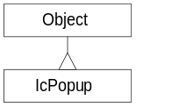
instance variables:
popup pop-up top-level widget, set by the constructor.
w widget associated with the owner object, set by the constructor.
constructor:
IcPopup {OWNER T}
this method (1) sets the w instance variable to the value of the associated widget of OWNER, (2) creates a new frame (which is stored in the popup instance variable), a list box and a scroll bar are inserted in this frame, (3) the strings given in the T list are inserted in the list box.
OWNER: owner object, the object shall belong to a class providing the widget method which returns a widget handle, no default value.
T: list of strings to be inserted in the list box of the pop-up window, no default value.
destructor:
free {} destroys the popup widget.
return value: none.
public methods:
select {OWNER VALUE}
this method is automatically called when the user select (with a click of the mouse or by pressing the <Return> key) a particular string in the list box of the pop-up widget. The select method of the OWNER object is called, passing VALUE as a parameter and the object is destroyed.
OWNER: owner object, the object shall belong to a class providing the select method, no default value.
VALUE: currently selected string in the list box of the pop-up widget, no default value.
return value: none.

IcHelp  package: ic.help  provides the basic mechanism to display a pop-up help window. | 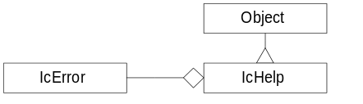
instance variables:
errorId associated error object (of class IcError), set by the constructor of jTkIcWidget.
widget associated widget descriptor.
tip message to be displayed in the help pop-up window.
public methods:
message {} calls the tip method of the associated error object.
return value: none.
popup {} displays the tip help message for the widget widget in a pop-up window. The help pop-up window is automatically destroyed when the mouse pointer will leave the parent widget.
return value: none.

IcDispatch  package: ic.dispatch  dispatches the bound actions of the user to the rule engines. | 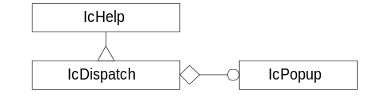
instance variables:
status current status. Initial value is “Unknow” [sic].
value current value. Initial value is “Unknow” [sic].
error error message, set by the ERR method.
public methods:
focus {} gives the default focus to the associated widget (given by the widget instance variable).
return value: none.
TIP {MSG} sets the tip instance variable to the value provided by MSG and then calls the popup method of the superclass in order to display MSG in a pop-up window.
MSG: help message to be displayed in a pop-up window, no default value.
return value: none.
ERR {MSG} sets the error instance variable to the value provided by MSG and then calls the add method of the associated error object in order to add the error message to the list of the currently pending errors displayed by the IcError object.
MSG: error message to be displayed in the IcError object, no default value.
return value: none.
LST {LIST} creates an IcPopup object to display the list of strings given by LIST in a list box. The user will be able to select a particular string.
LIST: list of message strings to be displayed in the IcPopup object, no default value.
return value: none.
MSG {MSG} displays the message given by MSG (with the default colors for a message, as opposed to an error) in the text entry field of the associated error object.
MSG: message to display, no default value.
return value: none.
STS {STATUS} STATUS is stored in the status instance variable. If STATUS values “OK” then the error is removed from the associated error object. The status is then used to paint the widget.
STATUS: value of the status, no default value.
return value: none.
VAL {DATA} displays the text provided by DATA in the associated widget. This method is equivalent to the LBL method.
DATA: message to be displayed inside the associated widget, no default value.
return value: none.
LBL {DATA} displays the text provided by DATA in the associated widget. This method is equivalent to the VAL method.
DATA: message to be displayed inside the associated widget, no default value.
return value: none.
update {FRAME} for each pair {ACTION DATA} given in the FRAME list, performs the action indicated by ACTION, providing DATA as a parameter to the invoked method. Possible methods called are given below:
value of ACTION method called
“status” STS
“list” LST
“message” MSG
“libel” LBL
“refused” no method is called
“error” ERR
“tip” TIP
“value” VAL
FRAME: list of pairs action/data, no default value
return value: none.

IcBinder  package: ic.binder  Default binding for actions on widgets. | 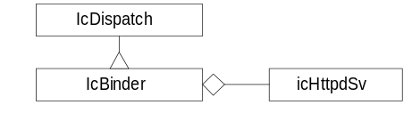
class variables:
delayList delay (in milliseconds) to wait before displaying query list window. Initial value is 300.
delayHelp delay (in milliseconds) to wait before displaying queryTip. Initial value is 3000.
instance variables:
rule rule name.
icSvId associated server object (of class icHttpSv), set by the constructor of jTkIcWidget.
queryTip query tip, as returned by the associated server, set by the queryTip method.
changed indicates that data is been changed in the widget, set by the keyIn method.
public methods:
queryValid {} this method is called each time we want to make sure the data in the widget is valid.
return value: none.
queryList {} displays a query list after a small delay, the delay is specified by the delayList instance variable. The waiting process can be interrupted at any time if the user presses a key, otherwise it sends a list command to the associated server.
return value: none.
select {DATA} this method is automatically called from a list pop-up window, when a selection is made by the user. The selection is stored in DATA. This method displays the selected string on the widget (by a call to the VAL method) and test if the data is valid (by a call to the queryValid method).
DATA: string selected by the user in the list box, no default value.
return value: none.
queryTip {} if the queryTip instance variable is set then it is displayed, otherwise its value is retrieved by sending the tip command to the associated server. For each of these operations, we are waiting a small amount of time (given by the delayHelp instance variable).
return value: none.
queryUndo {} sends an undo command to the associated server.
return value: none.
keyIn {} this method is called each time a key is pressed in order to enter data when the widget has the focus. The changed instance variable is set to 1 to indicate that data is changed and the widget is repainted.
return value: none.
focusIn {} this method is called each time the focus is given to the widget, it binds user events to internal methods. Possible methods called are given below:
event bound method called
<Key> keyIn
<FocusOut> queryValid
return value: none.
bind {} binds user events to internal methods. Possible methods called are given below:
event bound method called
<Double-1> queryValid
<Button-2> queryList
<FocusIn> focusIn
<Button-1> queryList
<Key-Escape> queryUndo
<Enter> queryTip
<Leave> cancels the execution of the watch-dog
<Control-n> moves the focus to the next widget
<Control-p> moves the focus to the previous widget
<return> queryValid and focus to the next widget
After that, the rule given by the rule instance variable is registered to the associated client (given by the icSvId instance variable).
return value: none.

jTkIcWidget  package: ic.jTk  Generic widget class. | 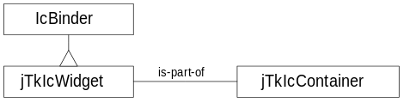
class variables:
frameOpt default options (using standard Tk syntax for the frame command) for the border of the frame. Initial value is {}.
color-LCK default color for “LCK” mode. Initial value is grey.
color-FX default color for “FX” mode. Initial value is red.
color-OK default color for “OK” mode. Initial value is blue.
color-UNK default color for “UNK” mode. Initial value is black.
instance variables:
frame top-level frame of the widget, set by the constructor.
ownerId owner object, shall be of type jTkIcContainer, set by the constructor.
wdPrevious previous widget object (as given by the list of widget in the associated jTkIcContainer object), set by the constructor.
wdNext next widget object (as given by the list of widget in the associated jTkIcContainer object), set by the constructor.
constructor:
jTkIcWidget {OWNER_ID}
This method:
1. sets the current status (status instance variable) to UNK,
2. sets the ownerId instance variable to OWNER_ID,
3. sets the icSvId and errorId instance variables to the values of the associated server and error objects of OWNER_ID,
4. creates a new frame which is a sub frame of the root frame of OWNER_ID (the frame is created using the default options given by the frameOpt class variable and is set in the frame instance variable),
5. sets the wdPrevious and wdNext instance variables from data given by the list of component widgets of the owner and update this list to add the current widget.
OWNER_ID: object of class jTkIcContainer, no default value.
public methods:
focus {} gives the focus to the widget.
return value: none.
paint {COLOR} set the foreground color of the widget to the color specified by the color code given by COLOR. The color code indicates a color referenced by one of the following class variables: color-LCK, color-FX, color-OK or color-UNK.
COLOR: shall be a known color code, possible values are: LCK, FX, OK or UNK, default value is UNK.
return value: none.
queryValid {} calls the queryValid method of the superclass.
return value: none.

jTkIcEntry  package: ic.jTk  Text entry widget. | 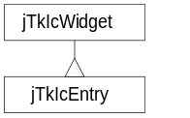
class variables:
entryOpt default options for the text entry field. Initial value is {}.
labelOpt default options for the associated label. Initial value is {-anchor w -width 25}.
packOpt default options for the packing of the text entry field and its associated label in the widget. Initial value is {-side left -expand y -fill x -pady 2m}.
instance variables:
changed boolean value to indicate if data in the text entry field has been changed, set by the constructor.
label associated label widget, set by the constructor.
constructor:
jTkIcEntry {OWNER_ID RULE}
this method (1) sets the changed and rule instance variables to (resp.) 0 and RULE, (2) creates a new frame widget containing a text entry field and an associated label.
OWNER_ID: object of class jTkIcContainer, no default value.
RULE: rule name, no default value.
public methods:
queryValid {} if data has changed (the changed instance variable is set to 1), calls the queryValid method of the superclass and reset the changed instance variable to 0.
return value: none.
LBL {DATA} set DATA as the text of the associated label.
DATA: string to write on the label, no default value.
return value: none.
VAL {DATA} set DATA as the text of the entry field.
DATA: string to write in the entry field, no default value.
return value: none.

jTkIcButton  package: ic.jTk  Button widget. | 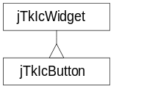
class variables:
packOpt default options for the packing of the button in the widget. Initial value is {-side right -pady 2m}.
constructor:
jTkIcButton {OWNER_ID RULE}
creates a new frame with a button inside it, RULE is used to initialize the rule instance variable and is displayed on the button.
OWNER_ID: object of class jTkIcContainer, no default value.
RULE: rule name, no default value.
public methods:
focusIn {} this method does nothing.
return value: none.
TIP {MSG} sets the TIP instance variable to MSG and call the message method.
MSG: message to display in ‘tipped’ mode, no default value.
return value: none.
VAL {MSG} this method does nothing.
MSG: unused parameter.
return value: none.

