**Do-it-yourself: batch data/file transmission with InfraRed light for Arduino compatible boards**

**by Fulvio Farina Arboccò**

1. **DOWNLOAD THE LIBRARY SOURCE CODE**

Go to the following repository link:

<https://github.com/fulviofarina/InfraRed>

to download my library source code.

1. **BUILDING THE TRANSMITTER**

What you need:

- a Raspberry or Arduino-like development board

- a NPN Transistor (for example, the cheap 2N2222 or 2N3904)

- an InfraRed light-emitting diode (850nm or 950nm wavelength emitter)

- a 1kΩ resistor

- a 27Ω resistor

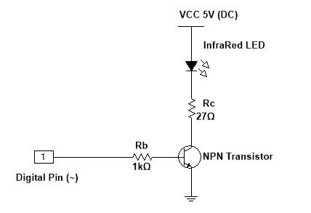

Figure 1. Transmitter schematic

Connection:

- Connect the terminal wire to a digital pin (GPIO) capable of tone-generation, that is, a pulse width modulation (PWM) pin. In Arduino-like boards these pins are labelled with the symbol (~). By default the source code employs the pin D9.

- Connect to the 5V and ground pins.

Code Upload:

- Open the sketch or code file: “**TransmitterCode.ino**” and replace the “**senderPin**” number by the digital pin number you employed when building the transmitter. It looks like this:

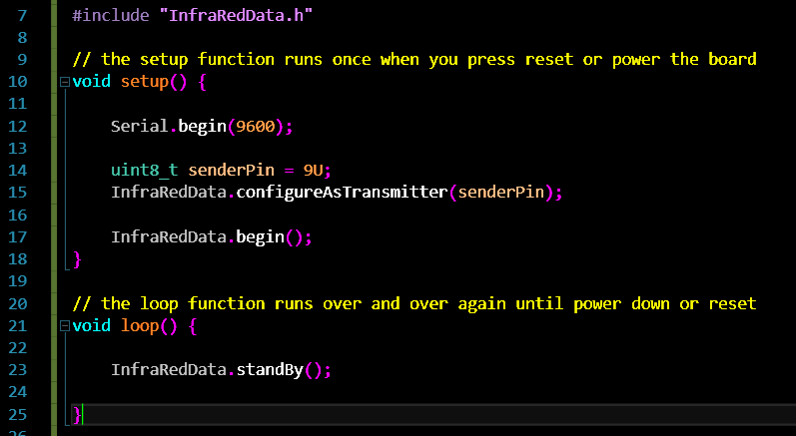

- Upload the code to your board.

1. **BUILDING THE RECEIVER**

What you need:

- a Raspberry or Arduino-like development board

- a NPN Transistor (for example, the cheap 2N2222 or 2N3904)

- an InfraRed phototransistor (850nm or 950nm wavelength receiver)

- a 500Ω resistor

- a Visible LED is optional, as it is employed only for visual feedback.

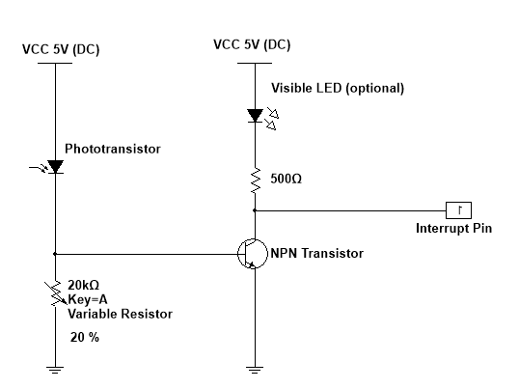

Figure 2. Receiver schematic

Connection:

- Connect the terminal wire to a digital pin capable of Interrupt Service Routines. In Arduino-like boards the standard interrupt pins are D2 or D3. By default the source code emplys the pin D2.

- Connect to the 5V and ground pins.

Code Upload:

- Open the sketch or code file: “**ReceiverCode.ino**” and replace the “**receiverInterruptPin**” number by the digital (interrupt) pin number you employed when building the receiver. It looks like this:

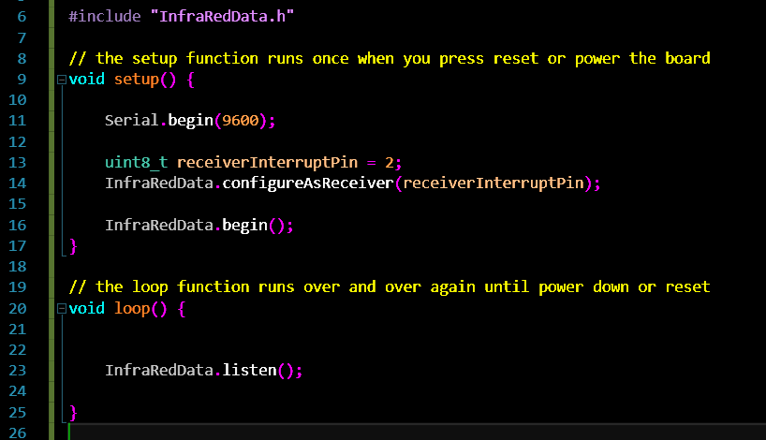

- Upload the code to your board.

1. **ALMOST READY: GET QuickCOM**

Go to the following link:

<https://www.researchgate.net/publication/326979459>

to download and install my Windows program: “**QuickCOM**”.

It is a guided-user-interface for quick data/file transmission between the boards. It is specially suited for this project. It looks like this:

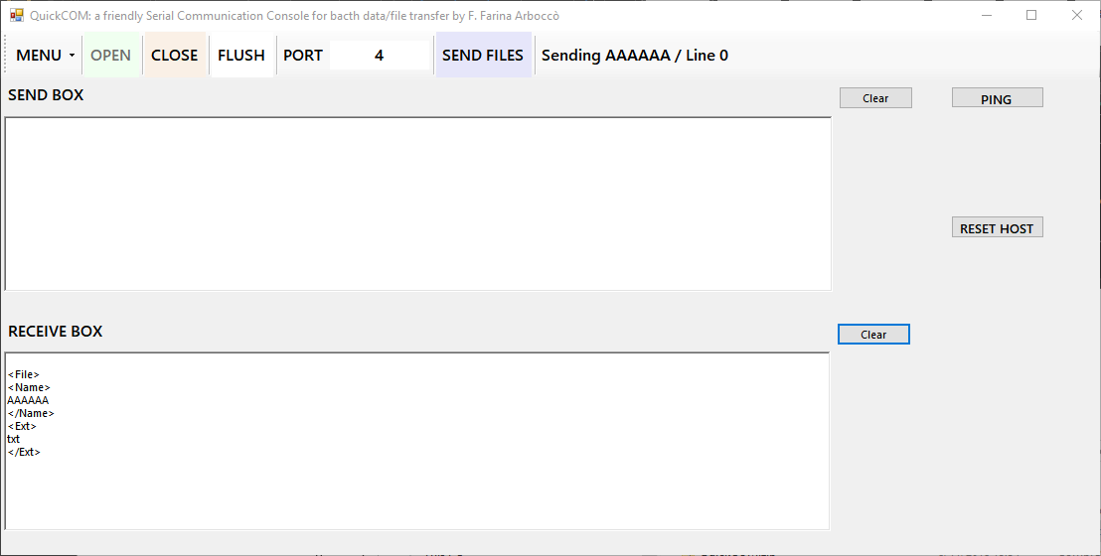

- Open one instance of the program on the computer that is connected (via USB) to the receiver board.

**-** Replace the communication port number by the one employed by your receiver board.

- Open one instance of the program on the computer that is connected (via USB) to the transmitter board.

**-** Replace the communication port number by the one employed by your transmitter board.

1. **READY: Sending data and files**

- You are now set to start the data transmission in the **“Sender Box”**

- By clicking “Ping” on the transmitter computer you should be able to see “Ping” on the receiver computer (in the “**Receiver Box**”). If not, adjust the receiver variable resistor (or potentiometer) to the enviromental day-light intensity until you see some visible feedback. Make sure the InfraRed emitter and receiver are facing each other without obstacles with no more than 2.5 meters distance when employing standard InfraRed cheap-components. The project can be adapted with LASER diodes to achieve greater distances.

- The “Reset” button allows you to reset the receiver board in case it hangs.

- Try the “Send Files” feature first with an ASCII/Unicode (text) file and then with another kind of file. The feature supports multiple file transfer.