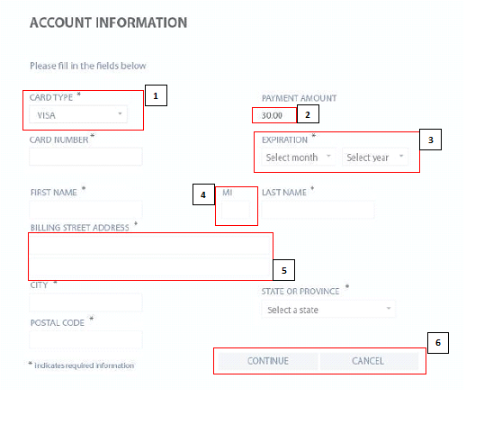

1. CARDTYPE should be written as a CARD TYPE. There shouldn’t be selected default value like VISA.
2. On Payment Amount area there should be written currency near the amount.
3. Expiration label name should be Expiration Date.
4. MI label is not descriptive. Abbreviations should not be used. Label names should be determined in a way that the user can clearly understand and the textbox size should be proportional to the others.
5. The address label should be a single line. If two lines are given to allow more than one address to be entered, each line should have its own descriptive title. Billing Stress Address 1 , Billing Stress Address 2 etc.
6. Continue and Cancel buttons should be in opposite places. Continue button should be on right side. And maybe their colours can be different, continue – green, cancel – red etc.

In addition to these;

The cvv code field of the credit card can be added.

The steps to enter the address can be during the province, city, street address.

The sizes and positions of all textboxes must be compatible with each other.