This is the base_model architecture.

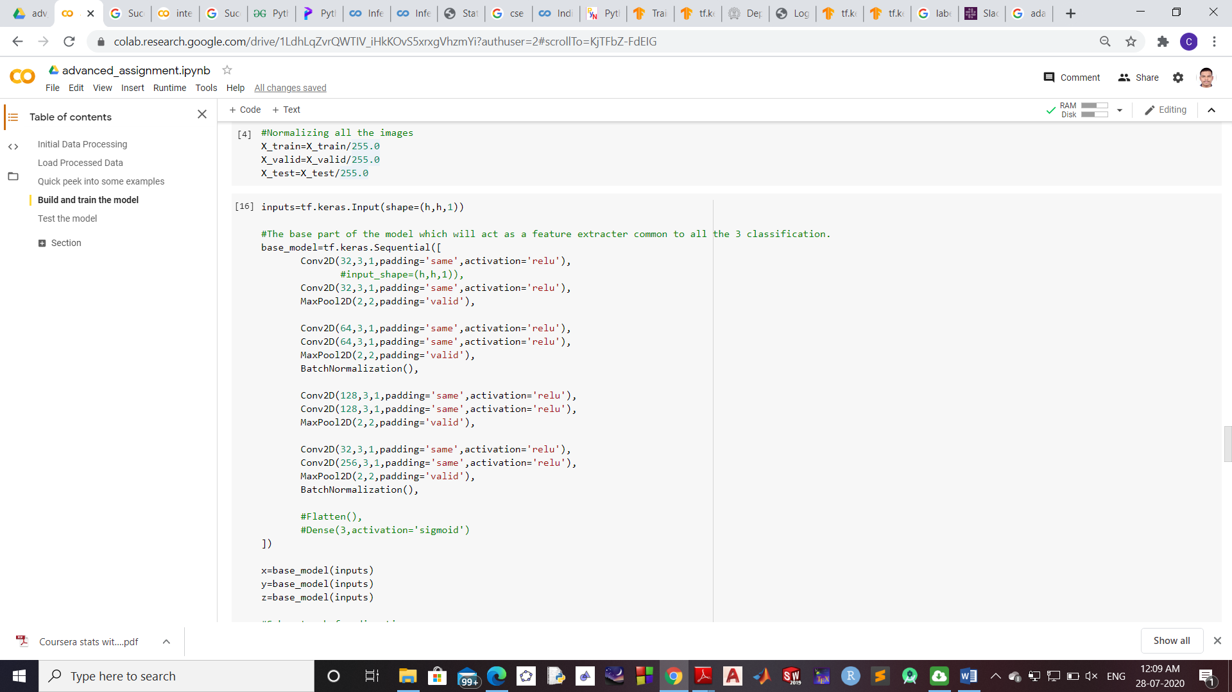

This is the top layer architecture

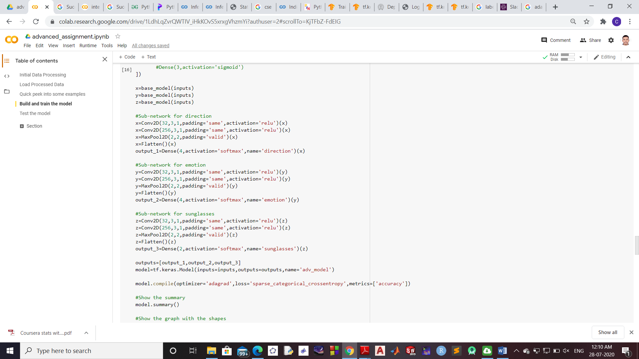

Graphical representation of the complete model

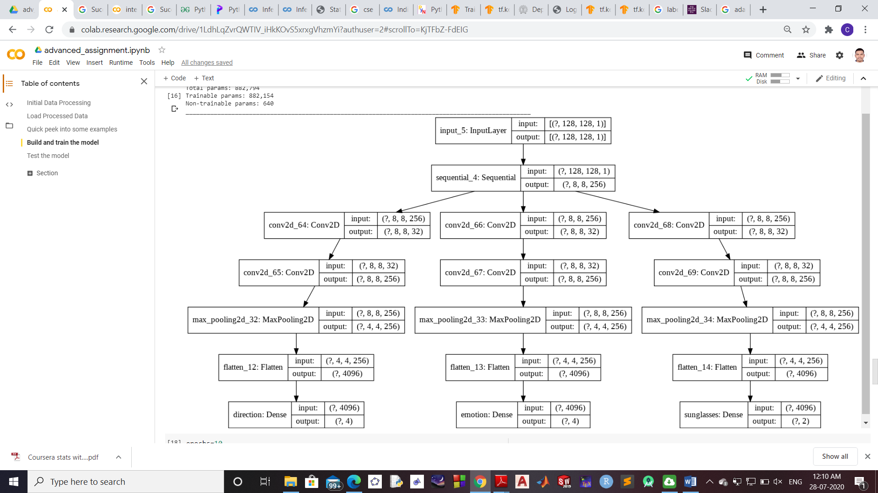

Results after total 20 epochs

Epoch 10/10

235/235 [==============================] - 65s 277ms/step - loss: 0.5920 - direction_loss: 0.0025 - emotion_loss: **0.5880** - sunglasses_loss: 0.0015 - direction_accuracy: 0.9999 - emotion_accuracy: **0.8152** - sunglasses_accuracy: 0.9999 - val_loss: 2.8092 - val_direction_loss: 0.0725 - val_emotion_loss: 2.7347 - val_sunglasses_loss: 0.0020 - val_direction_accuracy: **0.9648** - val_emotion_accuracy: **0.1587** - val_sunglasses_accuracy: **0.9989**

The model performs decently on direction and sunglasses detection. However it just isn’t able to learn to recognize emotions.