Chitchat Protocol

Packet Structure

Every packet has a packet header of two 32-bit signed integers. The first integer is the packet's type, and the second is its total length.

All strings are encoded in UTF-16LE (little endian), meaning that each character is 2 bytes wide.

Note that in the diagrams below, any sections highlighted in gray have a variable length.

**Packet 0x00: Login Packet**

The username and password are separated by 2 null bytes. Credentials length = (characters in username * 2) + (characters in password * 2) + 2.



**Packet 0x01: Logout Packet**

Contains only the packet type and length.



**Packet 0x02: Mesage Packet**

Contains a chat message and the user ID of the user sending it.

**Packet 0x03: WhoIsIn Packet**

If sent as a request, contains only the packet type and length. If sent as a response to a request packet, contains also a list of users. Note: the [Username Length][Username][User Role][User ID] section in the image is repeated [Number of Users] times.



**Packet 0x04: Joined Packet**

Contains the username, role and user ID of a user who joined the chat. The username field may be blank to indicate to the recipient that the packet contains their role and user ID.

**Packet 0x05: Left Packet**

Contains the user ID of a user who left the chat.



**Packet 0x06: GrantAccess Packet**

Contains the user ID for whom to grant access to the chat.

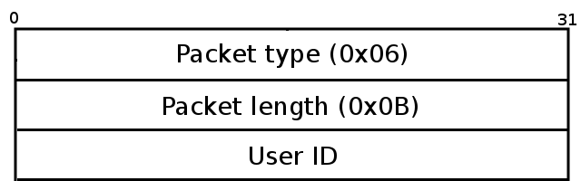

Sequences

User sends login packet

Server responds with whoisin packet and joined packet

Server sends joined packet to all other connected clients

User sends chat packet

Server sends chat packet to all other connected clients

User sends logout packet

Server sends left packet to all other connected clients

User sends grantaccess packet

Server sends grantaccess packet to specified user