Extending DRSEM inspection capacity and application with the

introduction of D2DB technique

Hao Yu1,*, Changlian Yan 1, Rongjia Zhang 1, Yuan Gan1,

Nuo Ding1, Ming Ding1, Zhao Chen1, Xiaojun Luo1,

Junhai Jiang 1, Zongchang Yu 1, ChunYing Han1

1 Dongfang Jingyuan Electron Limited, Beijing, China, 100176;

* [hao.yu01@dfjy-jx.com](mailto:hao.yu01@dfjy-jx.comr)

Abstract (100 words)

With the rapid advance of semiconductor process technologies, defect detection using Defect Review Scanning Electron Microscopy (DRSEM) images has become increasingly challenging. Defects with complicated patterns have been difficult to detect. By introducing design layout information into the defect detection process, we have improved the defect detectability of DRSEM and expanded its applications. With D2DB technology, we can accurately detect systematic defects within patterned regions. Additionally, we can identify various soft defects in the images and defects caused by pattern drift. Moreover, the target recognition capability allows us to monitor CD changes and verify hotspots directly by combining SEM review results with design layout checking.

**Keywords:** DRSEM images, Defect detection, D2DB technology.

Technical Abstract (250~500 words)

Conventional SEM review technique is usually applied after BFI/EBI inspections, which uses die-to-die inspection method to detect defects. However, this method has been limited by its ability to detect systematic defects in design and mask manufacturing. Moreover, at advanced technology nodes, DRSEM faces challenges in detecting defects with complex patterns.

In order to solve these problems described above, we have introduced D2DB technique into the SEM review process. By using this method, these defects include systematic defects, hard defects, soft defects, pattern drift, can be easily detected. Fig. 1. displays an example of defect detection process with D2DB technique. We first extract contours from SEM images shown in Fig.1(b); Then, the contours are aligned with designs for defect detection process shown in Fig.1(c). Based on the alignment results, we can easily report the location of the defects on the SEM images. Besides, the detection results can be fed back to design and mask fabrication, which enable continuous yield enhancement.

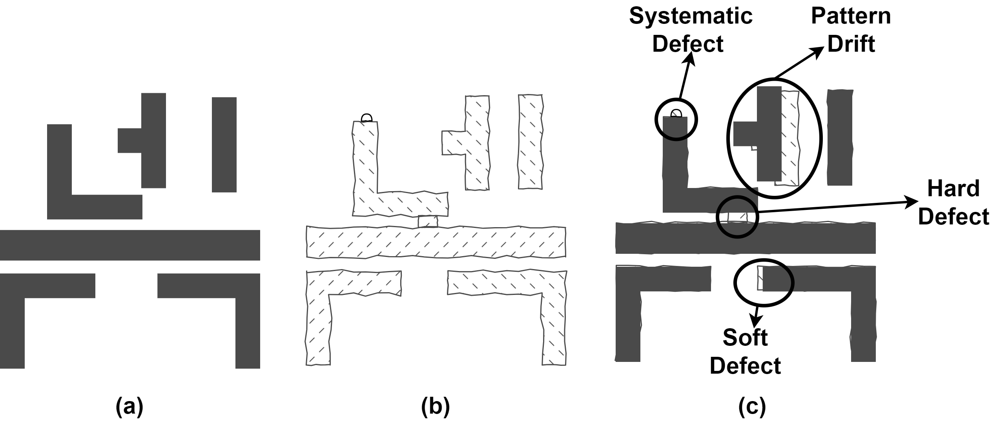

Fig.1. Example of defect detection in DRSEM images using D2DB technology. (a) Design layout, (b) contours extracted from DRSEM image, (c) detected defects using D2DB technology.

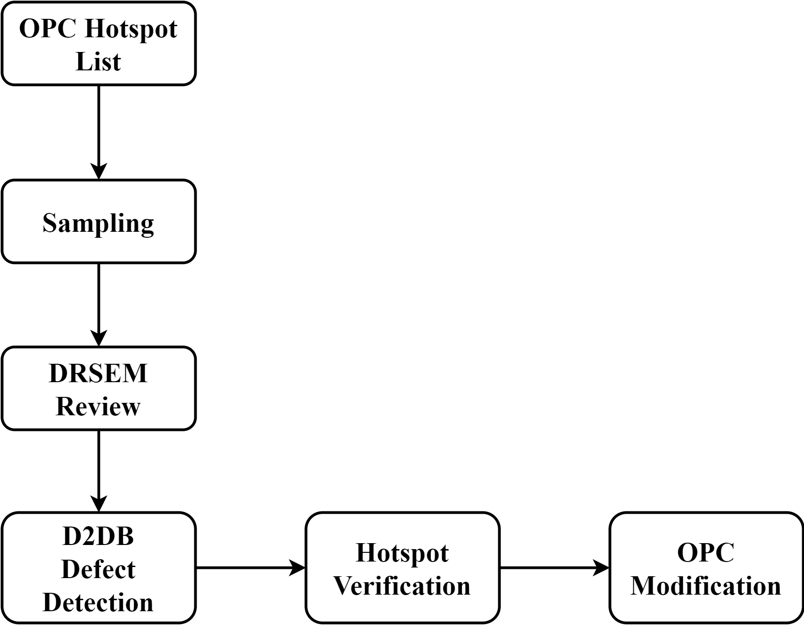In addition, the D2DB technique proposed in this work have provided an efficient way to verify the hotspots by combining with SEM review process. The verification flow is displayed in Fig.2. Through the flow shown in Fig.2, the OPC hotspots can be not only quickly and efficiently checked by defect detection process with DRSEM, but also feedback to OPC model modification.

Fig.2. Accelerated verification flow of OPC hotspots on DRSEM images using D2DB technology.

At last, D2DB metrology makes it possible to measure and monitor CD with DRSEM images shown in Fig.3. The long-term CD changes in the images can be effectively monitored. On the whole, the introduction of D2DB technique have extended DRSEM inspection capacity and application.

Fig.3. CD measurement flow in DRSEM images of different patterns using D2DB technology.