Prince Ikede

CSC 341

I completed the assignment and I don’t have any questions.

Driver:

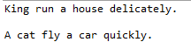

ObserverPattern:

