

**NETWORK SECURITY**

**PROJECT PART 2 – OPTIONAL PART**

**RAHUL DILEEP JADHAV – 010687638**

**IFUNANYA NNOKA - 010754159**

**Result: Bits 37 difficulty 137438953472**

**Nonce: 712104922140203459311248264073**

**nextTx: I, Rahul Dileep Jadhav, give Ifunanya Nnoka 10 BTC-282, on November18, 2016 2:52 am**

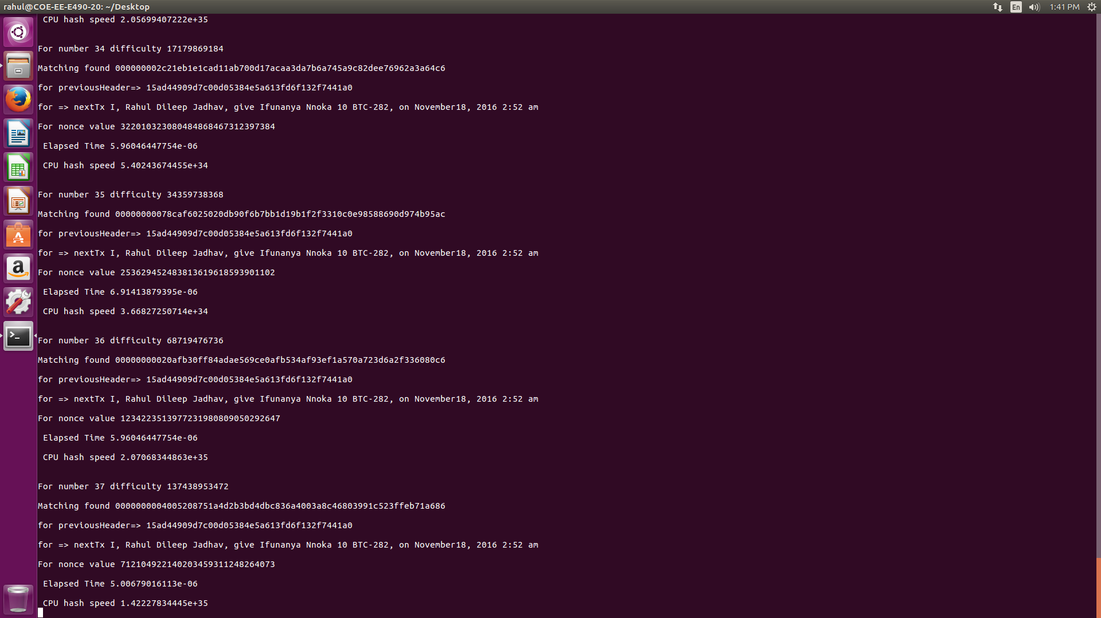

**Python Code:**

