Chapter 14

Monitoring and Metering

Management is that for which there is no algorithm. Where there is

an algorithm, it’s administration.

– ROGER NEEDHAM

The market is not an invention of capitalism. It has existed for

centuries. It is an invention of civilization.

– MIKHAIL GORBACHEV

# Introduction

In addition to the burglar alarms we discussed in the last chapter, your home will likely have a number of other monitoring devices: utility meters, baby monitors, smoke detectors, exercise equipment, health trackers and connected appliances. You may also buy value online for some metering systems, from a prepayment utility meter in your home through prepaid postage labels. An increasing num- ber of systems are concerned with monitoring and metering human activities and indeed the natural environment too. They go back a long way. James Watt, the steam engine pioneer, didn’t just sell engines; he licensed his patents using a sealed counter that measured the number of revolutions an engine had made. His inspectors read these from time to time and billed the customer for royalties.

Electronic systems that use cryptography and tamper-resistance have dis- placed most of the older mechanical systems and opened up all sorts of new applications. Ticketing is huge, from transport tickets through sports events to coupons; my case study for ticketing is the prepayment meters used for gas and electricity. Then I’ll turn to vehicle systems. The most familiar of these may be taxi meters but as these are being replaced by phone apps, I’ll mainly discuss tachographs – devices used in Europe and Australia to record the speed and working hours of truck and coach drivers, and in the USA to record the comings and goings of bank trucks. My third case study is the curfew tags used in the USA to monitor criminal suspects before trial and in the UK for parolees after release. My fourth is the electronic postage meters used to frank letters and

457

packages.

Many of these new applications follow the traditional IT industry mantra of ‘ship it Tuesday and get it right by version 3’. We do have the beginnings of general standards for IoT security, such as the draft ETSI standard EN 303 645 which lays out the usual motherhood-and-apple-pie stu↵ like no default passwords, protecting crypto keys, updateable software, minimising the attack surface and allowing users to delete personal information [640]. But turning basic principles into good engineering takes e↵ort, and we can learn a lot from applications that have already gone through at least one iteration of attack and defence. I hope the case studies in this chapter will give some of the needed contextual insight.

You’ll recall that in order to defeat a burglar alarm it is suﬃcient to make it appear unreliable. Meters add further subtleties.

When we discussed an alarm in a bank vault, we were largely concerned with attacks on communications (though sensor defeats also matter). But many metering systems are much more exposed physically. A taxi driver may want the meter to read more miles or more minutes than were actually worked, so may manipulate it into over-measuring. With tachographs, it’s the reverse: the truck driver usually wants to drive above the speed limit, or work dangerously long hours, so wants the tachograph to ignore some driving. Utility consumers may want their meters to ignore some of the passing electricity or gas. Criminal defendants and parolees may want to evade a curfew order. In such cases, the subject of surveillance may cause the device to make false readings, or simply to fail. There are also underground markets for exploits of various kinds.

Many metering and monitoring systems are also concerned with evidence. An opponent could get an advantage either by manipulating communications (such as by replaying old messages) or by falsely claiming that someone else had done so. With postal franking systems, it’s not suﬃcient for the attacker to cause a failure (as then he can’t post his letters). And we need to understand the real threats. The post oﬃce is mostly concerned with stopping wholesale fraud, such as crooked direct marketers who bribe postal employees to slip a truckload of mail into the system. The system may look like it’s designed to stop external fraud, but its real focus is internal.

# Prepayment Meters

There are many systems where the user pays in one place for a token – whether a magic number, or a cardboard ticket with a magnetic strip, or an app that displays a QR code, or even a rechargeable chip card – and uses the stored value somewhere else. Examples include transport tickets, photocopier cards in libraries, lift passes at ski resorts, and washing-machine tokens in university halls of residence.

The main protection goal is usually to prevent the tokens being forged at scale. Duplicating a single ticket is not too hard, and repeating a magic number is easy. Such scams can be prevented if we make all the tokens unique and all the devices online. But that makes things fragile; if people can’t get on the bus

in a mobile network black spot, or can’t use a ski lift or a washing machine if a data centre is down, that can damage the business and cost real money. So the replay and forgery detection must sometimes be done o✏ine. But if we simply encipher all our tokens using a universal master key, a villain could extract it from a stolen terminal and set up in business selling tokens. What are our options?

In most ticketing systems, procedural fraud is easy. A free rider can jump the barrier at a subway station; an electricity meter can have a bypass switch wired across it. But most people won’t cheat unless someone makes it seem easy and safe by industrialising it. To maximise revenue, petty fraud should be at least slightly inconvenient and – more importantly – there should be mechanisms to prevent anyone forging tickets at scale.

The ﬁrst example I’ll discuss is the prepayment electricity meter. I chose this because I was lucky enough to consult on a project to electrify three million households in South Africa (a central election pledge made by Nelson Mandela when he took power). This work is described in some detail in [93]. By December 2019, the STS speciﬁcation we developed was used in 68 million meters in 98 countries. Most of the lessons learned apply directly to other ticketing systems.

## Utility metering

Householders who can’t get credit buy gas and electricity services using pre- payment meters (Figure 14.1). In the old days they were coin-operated, but the costs of coin collection led vendors to develop token-based meters instead. This technology was driven by less developed countries, and most notably by South Africa, where it became a national priority to electrify the townships; as many of the houses were informally constructed, and the owners did not even have addresses (let alone credit ratings), prepayment was the only way to go. Over 2 million meters were installed during Nelson Mandela’s term of oﬃce as President, and there are now an estimated 10 million in use there. The largest installation is 35 million in Indonesia, and they are common in in Africa, Asia and Latin America, as well as in some developed countries; most meters in Northern Ireland are prepayment. The typical developed country might have

about 10% of households using prepayment meters, because they’re on welfare or have court judgments against them.

The customer goes to a shop and buys a token, which can be a card, a cardboard ticket with a magnetic strip, or a 20-digit magic number. Most of South Africa’s meters use a magic number. This is convenient for the customer, as a ticket can be bought at a supermarket checkout, at an ATM, over the phone or online.

The token is really just one or more instructions, encrypted using a key unique to the meter, and saying something like ‘meter 12345 – dispense 50KWh of electricity!’ The meter interrupts the supply when the credit runs out. Some tokens have engineering functions too. Special tokens may be used to change prices: if the power company charges di↵erent rates for the daytime and evening, the meter may need updates on the relative prices and the times at which the tari↵s change.

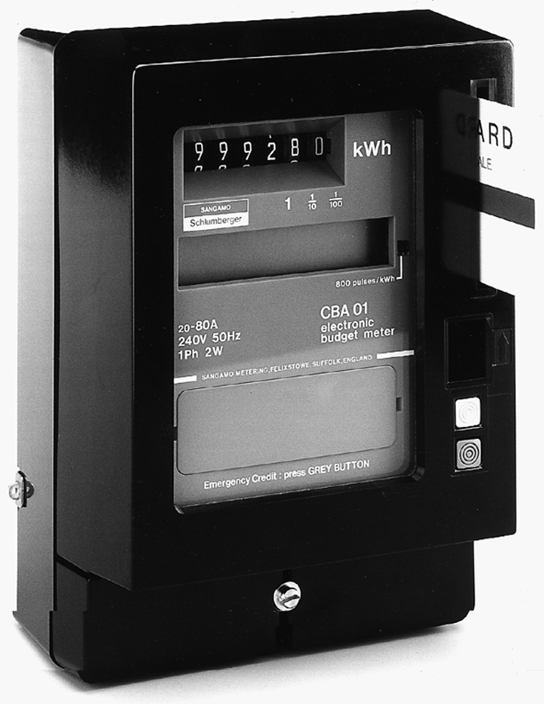Of the UK’s electricity meters, about twice as many use smartcards as mag- netic tickets. The former do not use the STS standard but are able to report consumption patterns, tampering attempts and so on back to the power com- pany. The magnetic-ticket and magic-number meters do not have such a back channel. There is currently a project to replace all the meters in most EU countries with *smart meters* which report readings and other data over a radio link, and which can be set remotely into prepayment mode. Smart meters have already been installed in other countries with mixed results. I’ll return to them later.

Figure 14.1: – a prepayment electricity meter (Courtesy of Schlumberger)

Prepayment was the only way that less developed countries could electrify millions of homes quickly. In the developed world, the main incentive was re- ducing bad debts and other administrative costs. An added beneﬁt is energy saving. In areas where most meters are prepaid, electricity consumption is up to 10% lower, as its cost becomes more salient to the householder.

## How the system works

The security requirements for prepayment meters seem straightforward. Tokens should not be easy to forge, while genuine tokens should not work in the wrong meter, or in the right meter twice. The usual strategy is to tie each token to a unique meter, so that someone can’t use the same magic number in two di↵er- ent meters, and also make each token unique using serial numbers or random numbers, so that the same token can’t be used twice in the same meter. But it took a surprising amount of experience to develop this simple idea into a robust system.

Each meter has a crypto key to authenticate its instructions from the vending

machine. Early systems had one for each neighbourhood, usually in a local store. It had a vend key *KV* which is the master key for a neighborhood, and each meter has a device key *KID* derived by encrypting its meter ID under the vend key:

*KID* = {*ID*}*K*V

This is the same key diversiﬁcation technique described for parking lot ac- cess devices in Chapter 4, and it works ﬁne where all the tokens are bought locally. But real life is usually more complicated. In Britain, deregulation of the electricity industry led to dozens of electricity companies who buy power from

generators and sell it onward to households through a common infrastructure, so meters change ownership between multiple power companies with di↵erent tari↵ structures. In South Africa, many people commute long distances, so they want to buy tickets where they work. So we started with protocols to send a

customer meter key from the vending station that ‘owns’ the meter to another station, and to pass sales data in the opposite direction for balancing and settle- ment, somewhat like in ATM networks. In 2007 we introduced online vending; a central server has a hardware security module with all the vend keys, so a customer can buy a magic number over the Internet or via their mobile phone. This server sells directly to seven million customers and also via about 10,000 online vend points such as ATMs and shops.

Statistical balancing is used to detect *non-technical losses*, that is, theft of power through meter tampering or unauthorized connections to mains cables. We compare the readings on a feeder meter, which might supply 30 houses, with token sales to those houses. But customers hoard tickets and meter readers lie about when they read the meter, so the discrepancy is a noisy signal. You can use it as a source of leads for your investigation team, and as statistical check on your bookkeeping systems, but that’s about it.

There were cases where vending machines were stolen and used to sell to- kens in competition with the utility. Eliminating such a ‘ghost vendor’ generally means changing the keys in all the local meters; there are a few stolen machines still out there, operated by crime syndicates. The countermeasure was to main- tain a credit balance in the vending machine’s security chip that also protects vend keys and foreign meter keys. The balance is decremented with each sale and only credited again when cash is banked; the operating company then sends a magic number that reloads the chip with credit. So we have an accounting system enforced by a value counter at the point of sale, rather than by ledger data kept on servers at the utility. However, the strategic direction was central-

isation, to save the e↵ort and expense of managing resellers, and operators have replaced o✏ine vending machines by online vending points that get their tokens in real time from a central service.

## What goes wrong

As with burglar alarms, environmental robustness is critical. Apart from the huge range of temperatures (as variable in South Africa as in the continental

United States) many areas have severe thunderstorms: the meter can be thought of as a microprocessor with a 3-kilometer lightning conductor attached.

When meters were destroyed by lightning, the customers complained and got credit for the value they said was still unused. So their next step was to poke live mains wires into the meter to try to emulate the e↵ects of the lightning. One make of meter would give unlimited credit if the circuitry under the token slot was destroyed, so service denial attacks worked well enough to become popular.

It was to get worse. Kids in Soweto observed that when there was a brown- out – a fall in voltage from 220 to 180 volts – a particular make of meter went to maximum credit. Soon they were throwing steel chains over the 11KV feeders and crediting all the meters in the neighborhood. This bug wasn’t picked up because brown-out testing hadn’t been speciﬁed. Developed-country environ- mental standards were inadequate for use in Africa. The responsible company almost went bust after 100,000 meters had to be pulled out and re-ROMmed.

There were numerous other bugs. One make of meter didn’t vend a speciﬁed quantity of electricity, but so much worth of electricity at such-and-such a rate. Vending sta↵ discovered that the tari↵ could be set to a minute amount, and the meter would operate almost for ever. Another allowed refunds, but a copy of the refunded token could still be used. Another meter remembered only the last token serial number entered, so by alternately entering duplicates of two tokens it could be charged up indeﬁnitely.

As elsewhere, the real security breaches resulted from bugs and blunders that were discovered by accident and exploited in quite opportunistic ways. Some of the exploits scaled up and cost millions to ﬁx.

Other lessons learned, which we wrote up in [93], were:

* + - * prepayment may be cheap and simple so long as you control the marketing channel, but when you try to sell tokens through third parties such as convenience stores, banks and supermarkets, it can become expensive, complicated and risky;
      * if you don’t get the security infrastructure right ﬁrst time, then changing it can be expensive – as was the case with the need to sell meter tokens at distant shops, to support commuters;
      * recycle technology if you can, as it’s likely to have fewer bugs. Much of what we needed was borrowed from the world of cash machines;
      * use multiple experts. One expert alone can not usually span all the issues, and even the best will miss things;
      * you absolutely need prolonged ﬁeld testing. This is where many errors and impracticalities will ﬁrst make themselves known.

The main lesson learned in the years after the initial deployment was to design out scalable fraud, which meant centralisation. There are still procedural exploits; for example, as any company can become a reseller, buying meters and a vending station on the market, crooked ﬁrms can set up rogue meters in community housing estates and direct the tenants to buy tokens from them

instead. So prepayment does not entirely abolish the need for good old-fashioned audit, energy balancing and inspection – and neither does it entirely solve the problems of local corruption or broader state capture in less developed countries.

What we learned ended up in the STS speciﬁcations that are now used by dozens of manufacturers worldwide. One compromise did come back to bite us, though. The date in the STS meters rolls over in 2024, which was the distant future back in the early 1990s when we were doing the work1. Now that there are 60 million meters in almost 100 countries, it’s going to cost utilities hundreds of millions to give each customer a special key-change ticket to manage the rollover. (The positive side of the key change is that the remaining ghost vending machines will be ﬁnally put out of business.) So, when designing a new system, please think of sustainability not just as ‘Will this system be OK for the next 30 years?’ but ‘Will this be OK for the next 100 years?’ You may just live long enough to be embarrassed!

## Smart meters and smart grids

In the early 2000s, the metering industry started selling the idea of a *smart me- ter* – a meter with real-time communications to a central server so that it could be read remotely. This had been patented as long ago as the 1970s but was de- veloped into a broader concept involving not just billing, and prepayment if need be, but ﬁne-grained pricing, power outage reporting and power quality moni- toring. *Automatic meter reading* (AMR) was superseded by *advanced metering infrastructure* (AMI); the latter has two-way communications, so commands can be send to the meter remotely. Pricing can be complex, including both time-of- day and demand-response tari↵s. The beneﬁts sold to utilities included reduced billing costs and easier debt collection. The case made to governments included reducing peak demand and thus the number of power stations required. Mar- keters talked about ‘smart grids’, talked excitedly of your meter being able to control domestic appliances and to negotiate real-time tari↵s with the market. A more sober claim was that smart meters would pay for themselves by making users more conscious of how much electricity they used, thus saving money. The beneﬁt to the meter vendor was replacing a product that cost $15 and lasted for 50 years with one that cost at least $50 and lasted for maybe 15.

There are many issues with smart metering. Researchers ﬁrst raised general privacy concerns about ﬁne-grained consumption data going to utilities; if the meter is set to monitor consumption by the minute or even by the second, the

utility can work out how many people are in the home, when they eat, when they shower and when they sleep. This leads to direct concerns around predatory marketing, and indirect concerns around third-party access – whether via law- enforcement warrants, abuse of authorised access, or the perhaps inevitable intrusion of the advertising ecosystem. This led to debates about the time granularity of measurement, and how much data should be held in the meter

1We had to ﬁt everything into the 66 bits of a 20-digit token, and although we thought of having an extra bit in the counter to get an extra 31 years, that would have meant a time unit of 2 minutes rather than one, which would have made selling multiple tokens for a meter at the same time tricky. But we did have the foresight to provide for resetting the counter on key change.

versus centrally. Then we noticed that putting a remotely commandable o↵ switch in all of a country’s homes creates a major cyber-war threat; if an enemy can switch o↵ your electricity supply they can quickly close down your economy, or hold you to ransom [105]. This led to a scramble by the national-security agencies. But perhaps the biggest bundle of issues was around the diverging incentives of the various stakeholders. Utilities want to sell lots of energy, while governments want to save it and to reduce peak demand. So who would win?

The pioneer was Italy, where the utility ENEL started installing smart me- ters in 2001. Their main concern was power theft, particularly in southern Italy where enforcement sta↵ sent to disconnect non-paying customers were threat- ened by gangsters. Smart meters enabled defaulters to be switched remotely to a prepayment regime. This was seen as a success, and the lobbyists got to work. The concept of a smart grid became US policy with the Energy Independence and Security Act of 2007 and came forcefully to public attention when Presi- dent Obama allocated $4.5bn to its development as the headline measure of the American Recovery and Reinvestment Act; the European Parliament followed with a 2009 law requiring member states to conduct an economic assessment of smart metering by 2012, and if they found it beneﬁcial, mandate its use by 2022 (with 80% adoption by 2020) [652]. Many countries have now launched national or regional smart meter programmes as have a number of U.S utilities, and we have some experience of the successes (such as Spain) and failures (including the UK and Ontario).

While US utilities tend to be regulated local monopolies, the European model has competitive generation, regulated transmission and distribution monopolies, and competitive retailers. Whether the meters belong to the distribution net- work operator or the retailer is a matter of historical accident. It turned out that where the distributor owned the meter, replacing all the meters with smart meters was straightforward, as a contractor could do a whole street at a time, and the meters could be connected to the utility via power-line communications with the substation. In Spain, the utilities set up a buyers’ cartel and insisted that every supplier’s meter would work with every other supplier’s headend, so they got commodity hardware costing under e50 a meter.

However, in countries where the retailer owns the meter, things were not so simple. There is a serious problem with incentives: if smart meters are to pay for themselves by saving energy, then it makes no sense to put them under the control of the retailer, which maximises its proﬁt by maximising energy sales. Germany did an honest assessment, decided that smart meters would be uneconomic, and abandoned the project. Britain unfortunately plowed ahead. Its Department of Energy and Climate Change had already had economic assessments in 2004, 2007 and 2008 which showed a negative return on the investment. Undeterred, they stretched the assumptions about costs, beneﬁts, electricity prices and interest rates, came up with a positive assessment in 2009, and committed Britain to introducing smart meters not just for electricity but for gas too [883].

Outside Europe, the same problems arose where meters were owned by mul- tiple retailers. New Zealand made smart meters optional, calculating they would be worthwhile only for large houses. In Ontario, as in Britain, the government pressed on, leading to an expensive failure, documented in the 2014 Annual

Report of the Auditor General [1197]. The province dealt with 73 local distri- bution companies by building a central system to collect all the meter readings and making them available to retailers, as well as regulators. The goal of the system, to cut peak demand, was not realised at all; the peak-to-trough price variation that politicians were prepared to tolerate was not enough to change behaviour. The Ontario cost-beneﬁt analysis that had been prepared in 2005 (a year after ministers announced the project) turned out to have overestimated beneﬁts as $600m when they were at most $88m, while costs ballooned to $2bn; the largest retailer spent over $500 per meter on the devices and the systems to support them. Overall, energy planning was so poor that the province ended up selling surplus power to the USA, subsidising utilities in Michigan and in New York State to the tune of billions of dollars.

In Britain, smart metering has evolved into what may be the largest ever civilian project disaster. Successive governments (Labour, coalition and Conser- vative) committed to rolling out smart meters by 2020 as nobody wanted to be accused of not being ‘green’. To my way of thinking, wasting £20 billion without saving any energy, and displacing better projects that could have yielded real savings, was about as un-green as you can get. The project was gold-plated at every level, with each home having up to four devices: smart meters for gas and electricity, a home hub to connect them to a wireless network, and an in-home display so the bill payer could track consumption. (The project started in 2009 just as people started to use smartphones but was too rigid to switch to using apps instead.) Ministers followed the Ontario route of a central meter reading server but nonetheless a UK householder who accepts a smart meter from one

vendor and then moves to a di↵erent supplier to save money usually has to sub-

mit manual readings thereafter. It took years to agree a national standard for a second-generation meter and most of the deployed meter ﬂeet consists of older incompatible models; the vendors fought for years to get their own patents in there and the oﬃcials didn’t have the technical knowledge or political support to bang heads together. Security mechanisms were retroﬁtted in a panic in the mid-2010s once we pointed out that a hostile state could simply turn o↵ British households’ power at a time of tension [105]. Whistleblowers who threatened to expose the project’s failure, and a likely cost increase from £11bn to £23bn, were threatened with prison [919]. The National Audit Oﬃce then reported at the end of 2018 that the project was falling materially short of expectations: the plan had been to replace 80% of UK meters by the end of 2020, but only 12.5m had been done, with 39m yet to do [1391]. What’s more, 70% of the

meters lost functionality when customers switched supplier (as you have to do annually to get decent prices). If government follows its declared strategy of moving everyone to second-generation meters, all these old ones will have to be replaced; according to a report from November 2019, only 2.3m of the meters were the new ones. Cost savings are unlikely as the industry will have to support good old-fashioned meters, several types of obsolete smart meter and the new smart meters through the 2020s. As for energy savings, there’s no sign. (The government could save a lot of energy if it used the meters to move everyone to prepayment, but that’s not on the agenda, and could have been done with much cheaper kit.) Nobody’s using the data for anything but billing. And now

oﬃcials just don’t want to know: in the words of the NAO report, “The Depart- ment currently has no plans to continue engagement with consumers after the

rollout is complete.”

Two ﬁnal remarks on smart grids. While the meter makers were doing their big marketing push in the late 2000s, there was breathless talk of meters helping to stabilise the grid by creating demand response and improving measurement. The scepticism expressed at the time by experienced power engineers has turned out to be justiﬁed. Grids have indeed become more fragile as generation capac- ity has moved from large spinning machines attached to the core transmission network to hundreds of thousands of windmills and solar panels embedded in the wider distribution systems. Recent large outages, such as in South Australia on 28 September 2016 and the UK on 9 August 2019, were cascade failures, caused when a local issue (a storm in Australia, and a lightning strike in England) caused a rate of change of frequency in excess of the safety limit, causing fur- ther loads to be shed, resulting in undervoltage and further load shedding. A complicating factor in each case is that now we have a lot of generation capacity embedded on people’s rooftops, shedding load doesn’t work as well as it used to. The takeaway is not that we need smart meters, even at the substation level, but that we need more inertia in the system – which means buying batteries or synchronous condensers. We also need to make the rest of the infrastructure more tolerant of outages. Much of the political fury in Britain over the 2019

power cut came from London commuters being stuck in trains for hours. This

happened because 60 Siemens Desiro class trains tripped at 49Hz when they should have tripped at 48.5Hz, and half of them would not restart because of a software bug. Getting them going again required a visit from a technician with a laptop2.

Demand response was also supposed to help with peak demand reduction. Nowhere have smart meters helped. Many countries now have capacity mar- kets where grid operators can buy extra megawatts, on timescales of seconds to minutes, but these operate using dedicated systems. For example, data centre operators who have standby diesel generators and have to run them for half an hour a month to make sure they still work, are paid to start them when they’re needed. In warmer countries, some people get discounts on their electricity bills for allowing their air conditioners to be switched o↵ for half an hour during demand peaks. Eventually, the chargers for electric cars will contribute to this too, once there are enough of them. But the equipment to do this is always separate from the main utility meter; no entrepreneur starting a capacity com- pany would want to get entangled with the regulated mess that is metering. As for the smart meter marketing vision of your home hub negotiating energy prices and turning o↵ your cooker or water heater in response to a price surge, that is remote from commercial reality. Firms that sell things like cookers and heaters are indeed putting CPUs and communications in them, but they talk to the ﬁrm’s own servers, not to other devices; and the idea that politicians would

allow retail prices to surge to match those on capacity markets is na¨ıve. All

that smart meters have achieved in Britain is to put a few tens of thousands of meter readers out of work, at a cost to the bill payer of £20 billion. Ontario was the same, but with one less trailing zero.

2UK trains and railway signals are not allowed to do over-the-air software upgrade because of national security rules, as the railways are considered to be critical national infrastructure. This also means that security patches take days to ship. Well done, MI5!

## Ticketing fraud

Transport ticketing is a larger application than utility metering, but I don’t know of any serious and publicly available study of the failure modes of train, bus and subway tickets. In the case of London, deregulation of the railways led to problems with train companies manipulating ticket sales by booking them at stations where they got a larger percentage of the takings; if you’re designing a system that shares revenue between vendors, you should try to design out the incentive for stakeholders to cheat. There was also a scare after the break of Mifare Classic described in section 13.2.5; Transport for London scrambled to add intrusion-detection systems to detect fraud.

One type of ticketing on which we do have some real fraud data is the airline variety. During the 2010s, there emerged an ecosystem of fraudulently obtained air tickets and of channels for reselling them. The tickets are obtained by a variety of methods, ranging from compromised credit cards through dishonest sta↵ at airlines and travel agencies through stolen air miles and hacked book-

ing systems; the marketing channels include spam, aﬃliate marketing, sales to migrant communities and sales to human traﬃckers. This is all documented

by Alice Hutchings [936, 937]. The key factors are that plane tickets, unlike subway tickets, are suﬃciently valuable for such an ecosystem to develop; and that while some of the customers know they’re getting bogus tickets, enough of them are simply suckers, so you can’t just arrest everyone who turns up for a ﬂight with an invalid ticket.

I’ll now look at a class of applications where the attacks are more severe and prolonged than on electricity meters. The threat model includes sensor manipu- lation, service denial, accounting ﬁddles, procedural defeats and the corruption of operating sta↵. This exemplary ﬁeld of study is vehicle monitoring systems.

# Taxi meters, tachographs and truck speed limiters

A number of systems are designed to monitor and control vehicles. The most fa- miliar is probably the odometer in your car. When buying a used car you’ll worry whether the car has been *clocked*, that is, had its indicated mileage reduced. As odometers became digital, clocking became a kind of computer fraud [391]. A related problem is *chipping*, that is, replacing or reprogramming the engine con- troller. This can be done for two basic reasons. First, the engine controller acts as the server for the remote key-entry systems that protect most modern cars from theft, as described in Chapter 4; so if you want to steal a car without steal- ing the key, you might replace the controller in the street, or else tow the car and replace or reprogram the controller later. Second, people reprogram their cars’ engine controllers to make them go faster, and the manufacturers dislike this because of the increased warranty claims from burned-out engines. So they try to make the controllers more tamper resistant, or at least tamper-evident. This arms race is described in [624].

Many vehicles now keep logs that are uploaded to the manufacturer during

servicing. General Motors started equipping some vehicles with black boxes to record crash data in 1990. By the time the logging became public in 1999, some six million vehicles had been instrumented, and the disclosure caused protests from privacy activists [1938]. Indeed, there’s a whole conference, ESCAR, de- voted to electronic security in cars. Vehicle security is becoming a hot topic again in 2019 because of the growing interest in autonomous operation3.

Other vehicle monitoring systems are ﬁtted after manufacture, and the most familiar may be the taxi meter. A taxi driver has an incentive to manipulate the meter to show more miles travelled (or minutes waited) if he can get away with it. There are various other kinds of ‘black box’ used to record the movement of

vehicles from aircraft through ﬁshing vessels to armored bank trucks, and their operators have di↵ering levels of motive for tampering with them. Insurers who sell ‘pay-as-you-drive’ insurance to young and high-risk drivers demand that they ﬁt black boxes with satellite navigation devices that let the insurer charge a couple of pennies a mile for driving along a country road in the afternoon but

a couple of dollars a mile for evening driving in an inner city [1909]. Any young man who wants to impress a lady by driving around town on a Saturday night will have an incentive to beat the black box.

## The tachograph

The case study I’m going to use here is the tachograph. These devices are used to monitor truck drivers’ speed and working hours; in Europe, the traditional analogue devices were replaced by digital ones from 2006, and as a truck lasts about ten years, most of the ﬂeet is now digital. This gives us some interesting data on how such equipment works, and can fail; and it’s an example of how a move to digital technology didn’t make things better. What was actually needed wasn’t whizzy technology but more enforcement.

Vehicle accidents resulting from a driver falling asleep at the wheel cause several times more accidents than drunkenness (20 percent versus 3 percent of accidents in the UK, for example). Accidents involving trucks are more likely to lead to fatal injuries because of the truck’s mass. So most countries regulate truck drivers’ working hours. While these laws are enforced in the USA using weigh stations and drivers’ log books, countries in Europe use tachographs that record a 24-hour history of the vehicle’s speed. Until 2005–6, this was recorded on a circular waxed paper chart (Figure 14.2); since then, digital tachographs

have been introduced and the old system has been largely phased out4.

First let’s look at the old analogue system as our baseline; it’s still in use by old trucks and buses on Europe’s roads.

The analogue system uses a waxed paper chart that is loaded into the tacho- graph, which is part of the vehicle’s speedometer/odometer unit. It turns slowly on a turntable inside the instrument that turns once every 24 hours, and a speed history is inscribed by a ﬁne stylus connected to the speedometer. With some

3Full disclosure: one of my research students is funded by Bosch.

4Vehicles registered since August 2004 in the UK had to have digital systems ﬁtted, driver cards have been issued since June 2005 and the use of digital systems in new vehicles became mandatory in August 2006; the dates vary slightly for other EU countries.

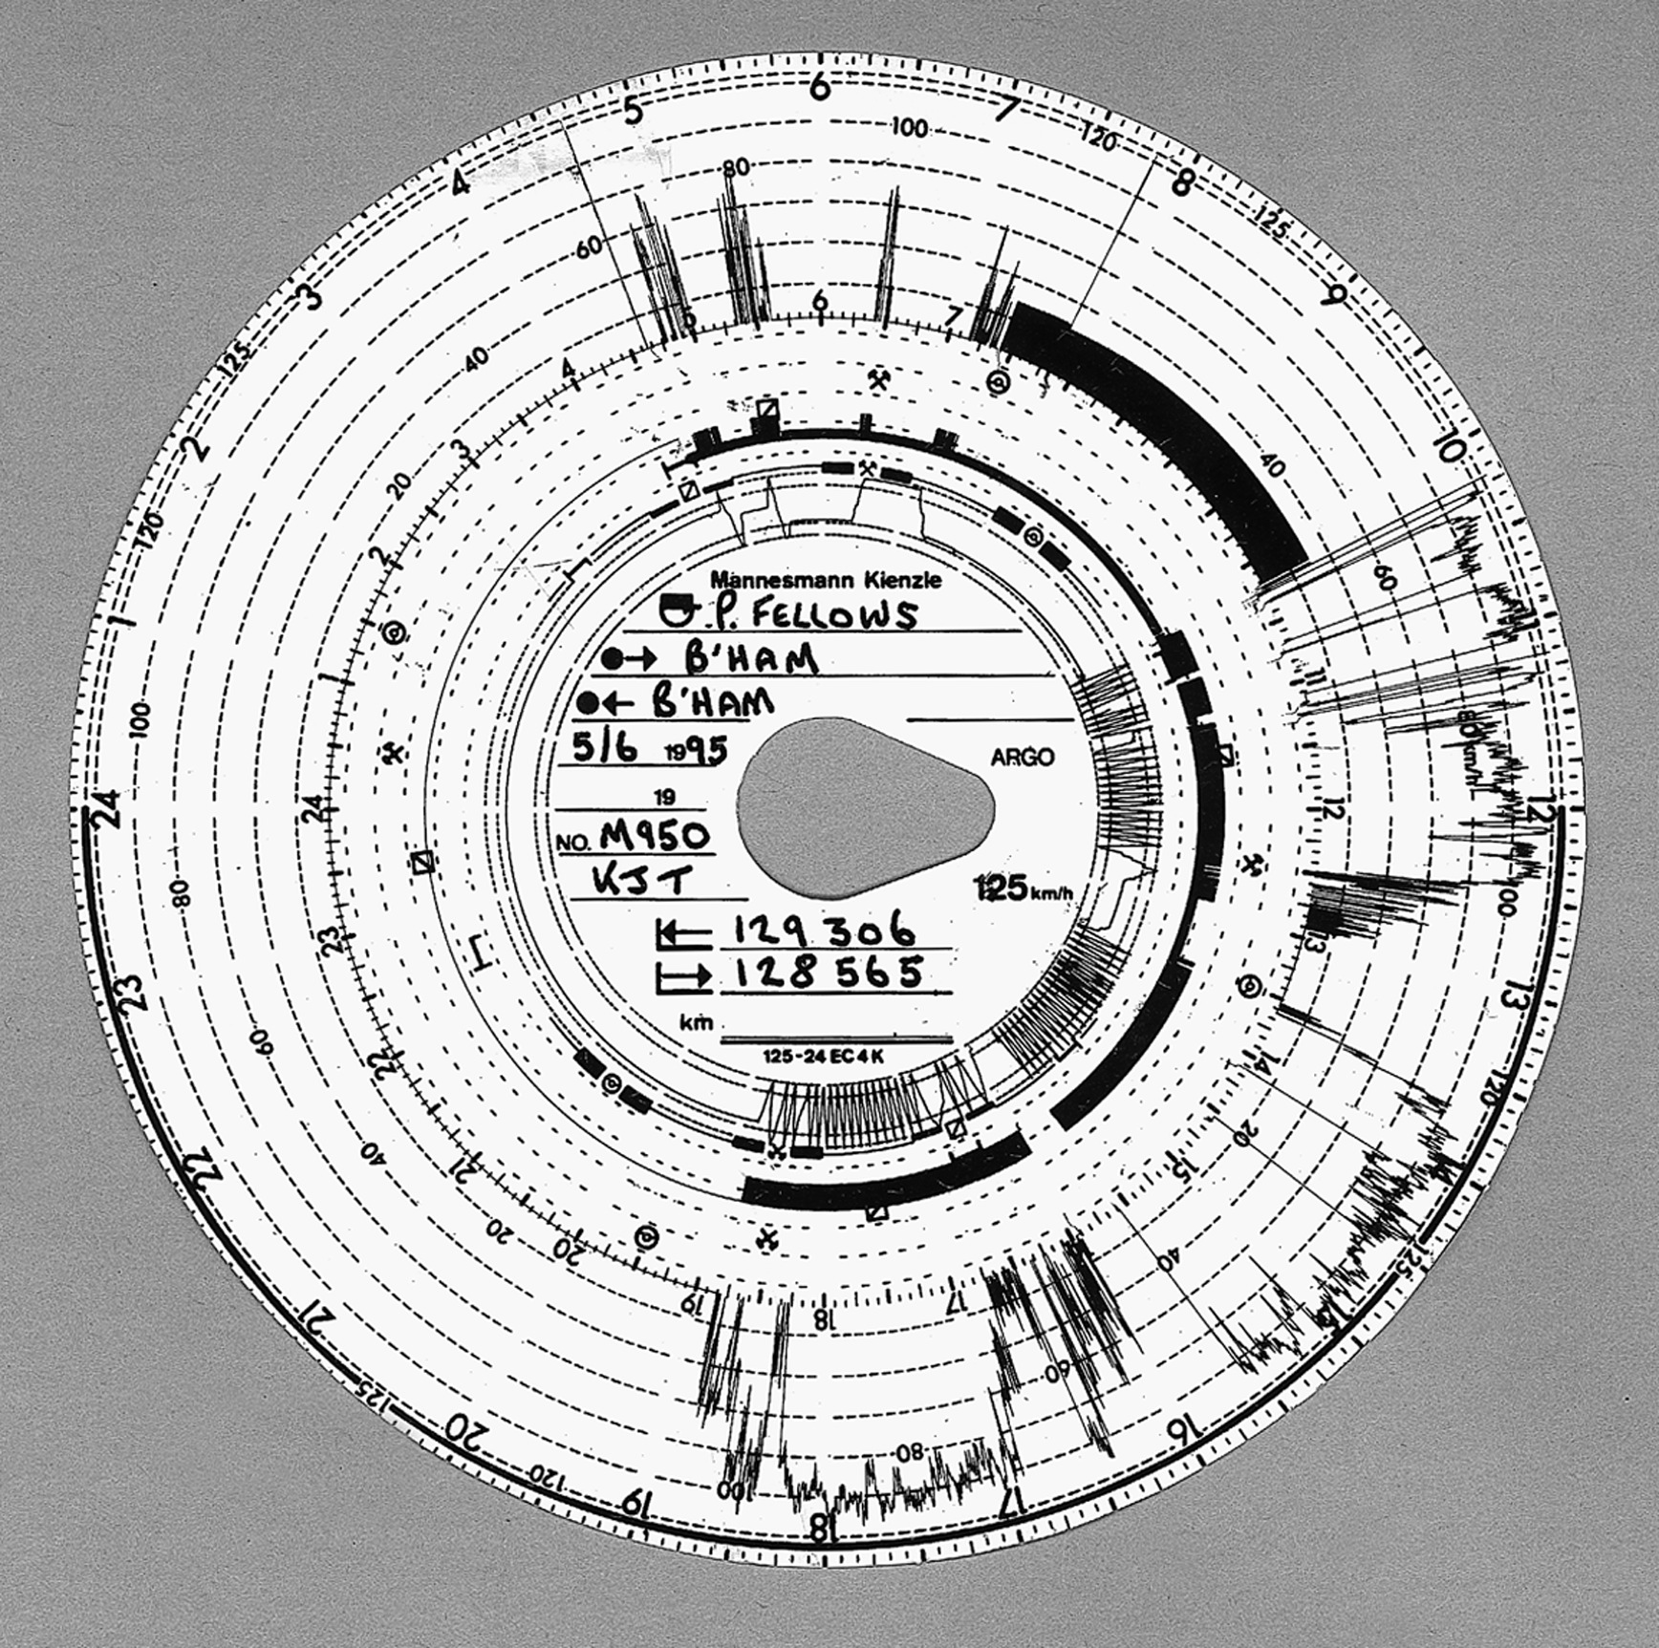

Figure 14.2: – a tachograph chart

exceptions that needn’t concern us, it is an o↵ence to drive a truck in Europe unless you have a tachograph; if it’s analogue you must have a chart installed, and have written on it your starting time and location. You must also keep sev- eral days’ charts with you to establish that you’ve complied with the relevant driving hours regulations (typically 8.5 hours per day with rules for rest breaks per day and rest days per week). If it’s digital you have to have a driver card plugged into it; the card and the vehicle unit both keep records.

European law also restricts trucks to 100 km/h (62 mph) on freeways and less on other roads. This is enforced not just by police speed traps and the tachograph record, but directly by a speed limiter that is also driven by the

tachograph. Tachograph charts are also used to investigate other o↵ences, such as unlicensed waste dumping, and by ﬂeet operators to detect fuel theft. So there are lots of reasons why a truck driver might want to ﬁddle his tacho- graph. Indeed, it’s a general principle in security engineering that one shouldn’t aggregate targets. Forcing a truck driver to defeat his tachograph in order to circumvent his speed limiter, and vice versa, was a design error – but one that’s

now too entrenched to change easily.

Most of what we have to say applies just as well to taxi meters and other monitoring devices. While the truck driver wants his vehicle to appear to have gone less distance, the taxi driver wants the opposite. This has little e↵ect on the actual tampering techniques.

## What goes wrong

According to a survey of 1060 convictions of drivers and operators done before the introduction of the new digital system [64], the o↵ences were distributed as follows.

* + - 1. How most tachograph manipulation is done

About 70% of o↵ences that result in conviction did not involve tampering but exploited procedural weaknesses. For example, a company with premises in Dundee and Southampton should have four drivers in order to operate one vehicle per day in each direction, as the distance is about 500 miles and the journey takes about 10 hours – which is illegal for a single driver to do every day. The standard ﬁddle is to have two drivers who meet at an intermediate point such as Penrith, change trucks, and insert new paper charts into the tachographs. So the driver who had come from Southampton now returns home with the vehicle from Dundee. When stopped and asked for his charts, he shows the current chart from Penrith to Southampton, the previous day’s for Southampton to Penrith, the day before’s for Penrith to Southampton, and so on. In this way he can give the false impression that he spent every other night in Penrith and was thus legal. This practice of swapping vehicles halfway through the working day is called *ghosting*. It’s even harder to detect in mainland Europe, where a driver might be operating out of a depot in France on Monday, in Belgium on Tuesday and in Holland on Wednesday.

Simpler frauds included setting the clock wrongly, pretending that a hitch- hiker is a relief driver, and recording the start point as a village with a very common name – such as ‘Milton’ in England or ‘La Hoya’ in Spain. If stopped, the driver can claim he started from a nearby Milton or La Hoya.

Such tricks often involve collusion between the driver and the operator. When the operator is ordered to produce charts and supporting documents such as pay records, weigh station slips and ferry tickets, his oﬃce may well conveniently burn down. (It’s remarkable how many truck companies operate out of cheap wooden sheds at a safe distance from the trucks in their yard.)

* + - 1. Tampering with the supply

The next largest category of fraud, amounting to about 20% of the total, in- volved tampering with the supply to the tachograph instrument, including in- terference with the power and impulse supply, cables and seals.

The earliest tachographs used a rotating wire cable – as did the speedometers in cars up until the early 1980s – that was hard to ﬁddle with; if you jammed the truck’s odometer it was quite likely that you’d shear o↵ the cable. More recent analogue tachographs are ‘electronic’, in that they use electric cables rather than rotating wire. The input comes from a sensor in the gearbox, which sends electrical impulses as the prop shaft rotates. This has made ﬁddling much easier! A common attack is to unscrew the sensor about a tenth of an inch, which causes the impulses to cease, as if the vehicle were stationary. To prevent this, sensors are ﬁxed in place with a wire and lead seal. Fitters are bribed to wrap the wire anticlockwise rather than clockwise, which causes it to loosen

rather than break when the sensor is unscrewed. The fact that seals are issued to workshops rather than to individual ﬁtters complicates prosecution.

But most of the ﬁddles are much simpler still. Drivers short out the cable or replace the tachograph fuse with a blown one. (One manufacturer tried to

stop this trick by putting the truck’s anti-lock braking system on the same fuse. Many drivers preferred to get home sooner than to drive a safe vehicle.) There’s evidence of power-supply interruption on the chart in Figure 14.2: around 11 A.M., there are several places where the speed indicated in the outside trace goes suddenly from zero to over 100 km/h. These indicate power interruptions, except where there’s also a discontinuity in the distance trace. There, the unit was open.

* + - 1. Tampering with the instrument

The third category of fraud was tampering with the tachograph unit itself. The typical o↵ence in this category is miscalibration, usually done in cahoots with the ﬁtter but sometimes by the driver defeating the seal on the device. This amounted for some 6% of o↵ences, but declined through the 1990s as the introduction of digital communications made it easier to tamper with the cable instead.

* + - 1. High-tech attacks

The state of the tampering art at the time of the survey was the equipment in Figure 14.3. The plastic cylinder on the left of the photo is marked ‘Voltage Regulator — Made in Japan’ but is certainly not a voltage regulator. (It appears to be made in Italy.) It is spliced into the tachograph cable and controlled by the driver using the remote control key fob. A ﬁrst press causes the indicated speed to drop by 10%, a second press causes a drop of 20%, a third press causes it to fall to zero, and a fourth causes the device to return to proper operation.

This kind of device accounted for under 1% of convictions but its use was believed to be much more widespread. It’s extremely hard to ﬁnd as it can be hidden at many di↵erent places in the truck’s cable harness. Police oﬃcers who stop a speeding truck equipped with such a device, and can’t ﬁnd it, have diﬃculty getting a conviction: the sealed and apparently correctly calibrated tachograph contradicts the evidence from their radar or camera.

## Digital Tachographs

The countermeasures taken against tachograph manipulation vary by country. In Britain, trucks are stopped at the roadside for random checks by vehicle inspectors, and suspect trucks may be shadowed across the country. In the Netherlands, inspectors prefer to descend on a trucking company and audit their delivery documents, drivers’ timesheets, fuel records etc. In Italy, data from the toll booths on the freeways are used to prosecute drivers who’ve averaged more than the speed limit (you can often see trucks parked just in front of Italian toll booths). But drivers can arbitrage between the di↵ering control regimes. For example, a truck driver operating between France and Holland can keep his documents at a depot in France where the Dutch vehicle inspectors can’t get at them. The weakness in the UK system was that when a vehicle inspector stopped a truck and found evidence of a violation, this would result in a prosecution some

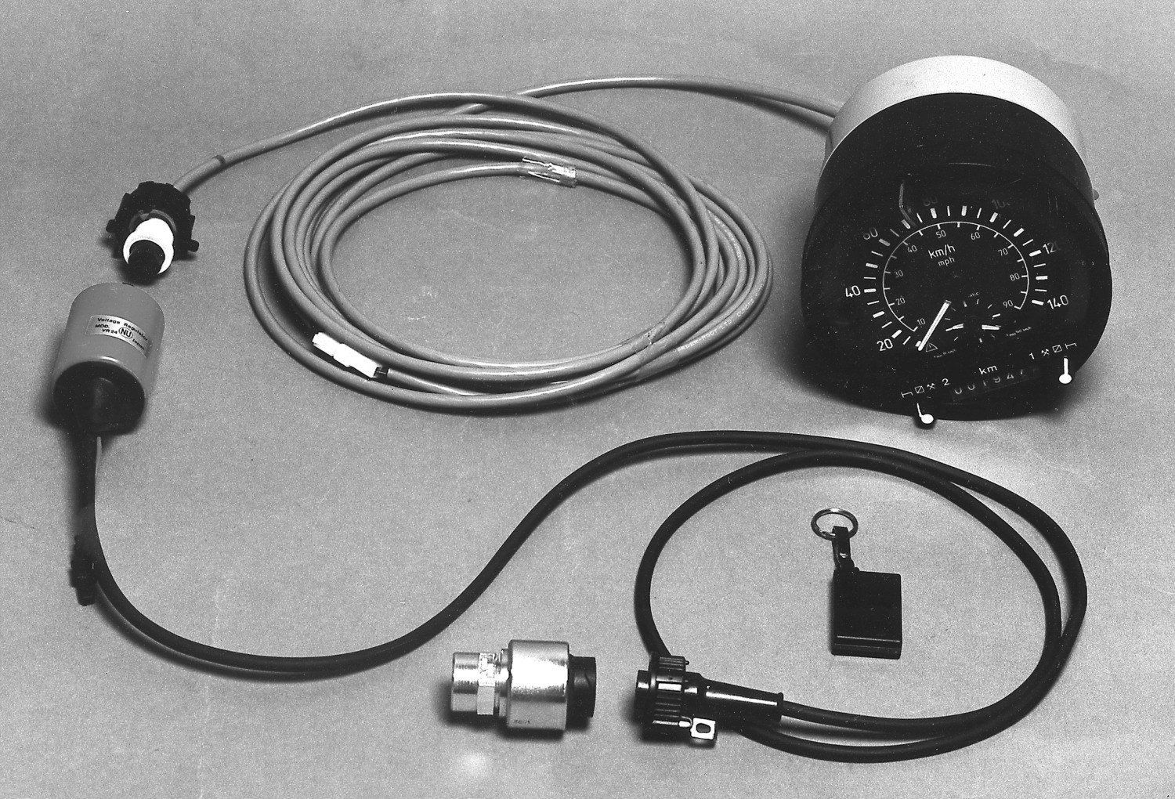

Figure 14.3: – a tachograph with an interruptor controlled by the driver using a radio key fob. (Courtesy of Hampshire Constabulary, England)

months later in the local magistrate’s court. Foreign drivers often just didn’t appear.

So the European Union took the initiative to design a uniﬁed electronic tachograph system to replace the existing paper-based charts with smartcards. Each driver now has a driver card that contains a record of his driving hours over the last 28 days. Every vehicle registered since 2006 has a vehicle unit that can hold a year’s history. There are also workshop cards used by mechanics to calibrate devices, and control cards used by law enforcement oﬃcers to read them out at the roadside. In 1998, I was hired by the UK Department of Trans- port to look at the new scheme and try to ﬁgure out what would go wrong. After talking to a wide range of people from policemen and vehicle inspectors to tachograph vendors and accident investigators, I wrote a report [64]. I revisited the ﬁeld in 2007 when writing the second edition of this book; it was simulta-

neously pleasing and depressing to ﬁnd that I’d mostly predicted the problems

correctly. However a few interesting new twists also emerged. Finally, in 2020, in the third edition, we can take a more mature view.

The main objection raised to the project was that it was not clear how going digital would help combat the procedural frauds that made up 70% of the total. Indeed, our pair of drivers ‘ghosting’ between Dundee and Southampton had their lives made even easier. It took fourteen years – more than the lifetime of a truck – to change over to the new system and meantime a crooked company could run one new digital truck and one old analogue one. Each driver will now have one chart and one card, with ﬁve hours a day on each, rather than two charts which they might accidentally mix up when stopped. This turned out to be well-founded. By 2008, some 20% of the vehicle ﬂeet had digital tachographs

– somewhat more than would be expected – which suggested that operators

may have been installing digital devices before they need to as they’re easier to

ﬁddle. In 2020, drivers have multiple cards.

Another objection was that enforcement would be made harder by the loss of detailed speed and driving hours information. Back in 1998, the Germans had wanted the driver card to be a memory device so it could contain detailed records; the French insisted on a smartcard, thanks to lobbying from their smart- card industry. So the driver card has limited memory, and can only contain a limited number of alarm events.

* + - 1. System-level problems

The response to the loss of ﬁne-grained data varies by country. Germany went for an infrastructure of ﬂeet management systems that accept digital tachograph data, digitized versions of the analog data from the existing paper charts, fuel data, delivery data and even payroll, and reconcile them all to provide not just

management information for the trucking company but surveillance data for the police. Britain has something similar, although it’s up to the police to decide which companies to inspect; unless they do so, data on driving infringements is only available to the employer. There are third-party service ﬁrms who will analyse this for companies who are keen on saving time, or just demonstrating compliance. Germany has also introduced a system of road pricing for heavy goods vehicles that gives further inputs into ﬂeet management.

Britain has a network of automatic number plate reader (ANPR) cameras, initially installed around London to make IRA bombing attacks harder; after the Good Friday agreement in 1997 ended that threat, ANPR was not decom- missioned but extended nationwide. That was justiﬁed on the basis of detecting car tax evaders, but we then saw ANPR data adduced in more and more prose- cutions, for everything from terrorism down to burglary. In the case of drivers’ hours enforcement, the strategy is to verify a sample of logged journeys against the ANPR database; where discrepancies are found, the company’s operations are then scrutinised more closely.

However, disagreements about privacy and about national economic interests hindered EU-wide standardization. It’s up to individual countries whether they require truck companies to download and analyze the data from their trucks. And even among countries that require this, there’s still arbitrage. For example, the German police are much more vigorous at enforcing drivers’ hours regula- tions than their Italian counterparts. So, under the old analogue system, an Italian driver who normally didn’t bother to put a chart in his machine did so while driving over the Alps. Meanwhile, the driver of the German truck going

the other way took his chart out. The net e↵ect was that all drivers in a given

country were subject to the same level of enforcement. But if the driving data got uploaded from the Italian driver’s card and kept on a PC at a truck com- pany in Rome then they were subject to Italian levels of enforcement (or even less if the police in Rome didn’t care about accidents in Germany). The ﬁx was extraterritoriality; an Italian truck driver stopped in Germany can now be prosecuted there if he can’t show satisfactory records of his driving in Italy for the week before he crossed the border.

In the UK, foreign drivers who were stopped and ordered to appear at a magistrates’ court often didn’t turn up. The real ﬁx turned out to be not technological, but legal. In March 2018, Britain changed the law to allow spot ﬁnes at the roadside. Previously, oﬃcers could only issue spot ﬁnes for ongoing o↵ences, rather than for o↵ences visible in the truck or driver records. This change led to a near-tenfold increase in ﬁnes [924].

* + - 1. Other problems

Overall, the move from analogue to digital wasn’t an improvement. While com- parative fraud statistics of digital and analogue devices have not been collected, the view of oﬃcials is that while the initial detection of an unrealistic journey remains much the same, the sophistication of digital defeat devices makes them harder to ﬁnd [1726]. And there are other interesting problems with tachographs becoming digital.

First, digital tachographs were the ﬁrst system that caused digital signatures to turn up in court in large numbers. For years, security researchers have been writing academic papers with punchlines like “the judge then raises X to the power Y, ﬁnds it’s equal to Z, and sends Bob to jail.” The reality is di↵erent. Judges found digital signatures diﬃcult as they were presented as hexadecimal strings on little tickets printed out from vehicle units, with no approved ap- paratus for veriﬁcation. The police solved the problem by applying standard procedures for “securing” evidence. When they raid a dodgy trucking company, they image the PC’s disk drive and take copies on DVDs that are sealed in ev-

idence bags. One gets given to the defence and one kept for appeal. The paper logs documenting the copying are available for Their Worships to inspect, along with the printouts from the vehicle units.

Second, many drivers have more than one driver card. This is an o↵ence everywhere but that doesn’t stop it! Drivers borrow them from friends who use them only occasionally – for example because they usually drive trucks under 3.5 tonnes. And thanks to EU freedom of movement, drivers can easily have more than one address: the Jean Moulin of Toulouse may also be Jean Moulin of Antwerp. A database, Tachonet, was set up to try to catch duplicate applications across European countries but it doesn’t seem to work very well. For example, drivers may forget their middle name in one of their countries of residence. From 2018 it was made mandatory for Member States to share data with it.

Third, there are new kinds of service-denial attacks (as well as the tradi- tional ones on gearbox sensors, fuses and so on). A truck driver can destroy his smartcard by feeding it with mains electricity (even a truck’s 24 volts will do ﬁne). Under the regulations he is allowed to drive for 15 days while waiting for a replacement. As static electricity destroys maybe 1% of cards a year anyway, it’s hard to prosecute drivers for doing this occasionally.

Fourth, I mentioned that the loss of detailed, redundant data on the tacho- graph chart makes enforcement harder. In the old analogue days, experienced vehicle inspectors had a ‘feel’ for when a chart isn’t right, but the analogue trace was replaced by a binary signal saying either that the driver infringed the

regulations or that he didn’t. This spills over into other enforcement tasks; ana- logue charts were often used to collect evidence of illegal toxic waste dumping, for example, as the recorded speed history often gave an inspector a good idea of the truck’s route.

Next, some of the cards in the system (notably the workshop cards used to set up the instruments, and the control cards used by police and vehicle inspectors) are very powerful. They can be used to erase evidence of wrongdoing. For example, if you use a workshop card to wind back the clock in a vehicle unit from 10th July to 8th July, then the entries for July 9th and 10th become unreadable. Some countries have therefore gone to great lengths to minimise the number of workshop cards that fall into bad hands. In the UK, for example, truck mechanics have to pass a criminal records check to get one; yet this isn’t foolproof as it’s often companies that get convicted, and the wealthy owners of

crooked truck-maintenance ﬁrms just set up new ﬁrms. There’s no company licensing scheme, and although wrongdoers can be blacklisted from acting as directors of licensed ﬁrms, crooks just hide behind nominee directors.

* + - 1. The resurrecting duckling, or TOFU

There is one interesting spin-o↵ from the world of tachographs. In the late 1990s, a European Union regulation decreed that, in order to frustrate the use of interruptors of the kind shown in Figure 14.3, all digital tachographs had to encrypt the pulse train from the gearbox sensor to the vehicle unit. As both of these devices contain a microcontroller, and the data rate is fairly low, this shouldn’t in theory have been a problem. But how on earth could we distribute the keys? If we just set up a hotline that garages could call, it is likely to be

abused. There’s a long history of ﬁtters conspiring with truck drivers to defeat the system, and of garage sta↵ abusing helplines to get unlocking data for stolen cars and even PIN codes for stolen car radios.

One solution is given by the *resurrecting duckling* security policy model, more prosaically known as *trust on* ﬁ*rst use*. This is named after the fact that a duckling emerging from its egg will recognize as its mother the ﬁrst moving object it sees that makes a sound: this is called imprinting. Similarly, a ‘newborn’ vehicle unit, just removed from the shrink wrap, can recognize as its owner the ﬁrst gearbox sensor that sends it a secret key. The sensor does this on power-up. As soon as this key is received, the vehicle unit is no longer a newborn and will stay faithful to the gearbox sensor for the rest of its ‘life’. If the sensor fails and has to be replaced, a workshop card can be used to ‘kill’ the vehicle unit’s key store and resurrect it as a newborn, whereupon it can imprint on the new sensor. Each act of resurrection is indelibly logged in the vehicle unit to make abuse harder. (This at least was the theory – the implementation fell somewhat short in that in one unit the error code for sensor rekeying is the same as the error code for a power outage.)

The resurrecting duckling model of key management was originally developed to deal with the secure imprinting of a digital thermometer or other piece of medical equipment to a doctor’s tablet or a bedside monitor [1819]. It is also used in wireless LAN extenders; these devices typically use a protocol suite called Homeplug AV to transmit data at 155Mb/s over the domestic power mains

from a unit plugged into your broadband hub to a remote unit on another ﬂoor. In order to prevent your neighbours being able to use your wiﬁ, each virtual network is encrypted with a key that’s set up the ﬁrst time you plug in an extender [1437]. The idea is that when you plug something in, it should just work; if it mates with the wrong network, you press a button and try again; in extremis you can do the security manually by copying a key o↵ the packaging into any enrolled device that has a keyboard. As more and more devices with constrained interfaces join the Internet of Things, such protocols will become more widespread.

## Sensor defeats and third generation devices

However, even if the protocols can be secured, the sensors can still be attacked directly. Since digital tachographs started shipping, the folks who brought you the interruptor now have a new product: a black box containing electromagnets and electronics to simulate a gearbox. The errant truck driver unscrews his gearbox sensor and places it in this simulator, which comes with its own cable and a sensor that he plugs into his actual gearbox. The system now operates as before; on command it will either relay impulses faithfully, or discard them, or ﬁlter some of them out. The dodgy pulse-train arrives at the tachograph as before, but this time beautifully encrypted using triple-DES. Secure sensing is harder than it looks!

This became such a nuisance that the EU passed a law in 2009 speciﬁcally prohibiting, and requiring Member States to check for, “any device, or devices, intended to destroy, suppress, manipulate or alter any data, or which is intended to interfere with any part of the electronic data exchange between the component parts of recording equipment, or which inhibits or alters the data in such ways prior to encryption” [652]. It also upgraded the regulations to require that vehicles registered from 2012 have the ‘third version tachograph’, which requires an extra motion sensor as a countermeasure to sensor defeats

## The fourth generation – smart tachographs

In 2014 the regulations were updated to introduce the smart tachograph, which is required in vehicles registered for the ﬁrst time as from 15 June 2019, and adds:

* + - * better security mechanisms to make fraud more diﬃcult;
      * a satellite navigation system, which will record the truck’s location at the start and end of each trip, and every three hours if the trip’s longer than that;
      * a radio link for a cop at the roadside to read tachograph data when the vehicle is moving

By now, the reader might feel a certain cynicism about anything called ‘smart’. The regulations are a further move in the direction of pervasive enforce- ment, but stop short of demanding that vehicle units keep detailed GPS history.

Privacy law in some countries would make that diﬃcult; in egregious cases, such as toxic waste dumping, the authorities can always subpoena the driver’s mo- bile phone history5. Meanwhile, vendors o↵er ﬂeet management systems with automatic infringement checking, assuring ﬁrms that this will minimise liability. We will have to wait and see how this all works out.

But what might be the practicalities of requiring constant GPS monitoring?

We can get some insight from our next application.

# Curfew tags: GPS as policeman

My third case study of monitoring and metering is the curfew tags that criminal suspects and paroled o↵enders wear on their ankles in order to constrain and monitor their movements. Introduced in Britain in 1999, they are used to cut the prison population. Most o↵enders are released after serving half their sentence and spend some of their parole period under curfew, which typically means that they must stay at home from 7pm to 7am. They wear a curfew tag on an ankle bracelet which communicates with a home monitoring station. Others receive community sentences instead of prison, with a curfew. Some 20,000 o↵enders may be ‘on tag’ at any one time.

Curfew tags have spread to many other countries too. The more expensive tags contain GPS chips and report the tag wearer’s location constantly to the police. In Britain, these devices are worn by sex o↵enders whose curfews prohibit them from going near schools, by persistent o↵enders in some police areas, and by terrorism suspects. In France, they’re being introduced in domestic violence cases [478]. In the USA, they’re o↵ered to many suspects pre-trial as a condition of bail (of whom the most famous may have been Harvey Weinstein). There, the issue is that while the Federal government pays for its prisoners’ tags, 90%

of cases are raised by states and cities, which mostly force the tag wearer to pay. Monitoring is dominated by two companies which typically charge $10 a day, with $350 up front. (When government pays, they only get $2–3 a day.) So poor defendants get into debt, or get jailed for nonpayment. This is short-sighted, as jail costs about $100 a day. Given that the USA has about a million people awaiting trial in jail at any time, this is a policy issue with real consequences; the number of tag wearers is over 125,000 and has been rising since the First Step Act of 2018. Judges see monitoring orders as cost-free; they issue them defensively, steadily widening the scope; two-thirds of tag wearers are African-American; and unlike with bail, defendants don’t get their money back if acquitted [1074].

In 2013–6, I was involved as an expert witness in a number of curfew-tag cases. The ﬁrst, in 2013, involved a woman convicted of shoplifting who was accused of tampering with her curfew tag as it indicated on several occasions that she’d left home in the evening. Analysis of the logs relating to my de- fendant’s case showed large numbers of false alarms; some of these had good explanations (such as power cuts) but many didn’t. The overall picture was of

5All vehicles under 3.5 tons in Europe are required to have embedded phones for eCall emergency service; this is unfortunately not mandatory for larger vehicles, no doubt because of industry lobbying.

an unreliable technology surrounded by chaotic procedures and conﬂicts of inter- est. The tagging contractor, Serco, not only supplied the tags and the back-end systems, but the call centre and the interface to the court system. What’s more, if you break your curfew, it isn’t the public prosecutor that takes you before the magistrates, but the contractor – relying on expert evidence from one of its subcontractors, who helped design the system. We asked the court for access to the tag in the case, plus a set of tagging equipment for testing, the system speciﬁcations, false alarm statistics and audit reports. The contractor promptly replied that “although we continue to feel that the defendant is in breach of the order, our attention has been drawn to a number of factors that would allow me to properly discontinue proceedings in the public interest” [83].

Several months later, there was a case involving several men subject to ‘ter- rorism prevention and investigation measures’ (TPIM) orders. These were a measure introduced in 2011 that allows the UK government to impose curfews on individuals believed to be a terrorist threat but against whom there is insuﬃ- cient evidence to mount a prosecution; they have been controversial on human- rights grounds. A number of individuals were served with orders restricting their movements and ﬁtted with GPS tags to monitor compliance. These tags tended

to break o↵ after about six months, whereupon the men were prosecuted for tag

tampering and imprisoned. As this was covered by a secrecy order, the pattern only came to light when it was noticed by a London law ﬁrm that represented three of them. Again, the government refused to expose any evidence to expert examination, and the three men were acquitted, causing embarrassment to the then Home Secretary, Theresa May [?]. A few days later, one of them evaded surveillance by donning a niqab in a London mosque and leaving as a woman. This caused outrage in the press [1904]. The following month, it turned out that the two main UK curfew tag contractors – Serco and G4S – had been defrauding the government at scale, by charging tag fees for o↵enders who had been ac- quitted or who were in prison, abroad or dead, and that this had been going on since the contracts started in 2005. They were stripped of their contracts and the matter was referred to the Serious Fraud Oﬃce [1286]. Serco was eventually

ﬁned £19.2m in 2019 and ordered to pay £3.7m costs; its accountants, Deloitte,

were ﬁned £4.2m for audits they conducted of the tagging operation.

The dependability of curfew tags came to trial in 2014 in the case of yet another terrorism suspect who was being held in immigration detention, accused of tag tampering, which he denied. This time the government decided to risk a trial. The suspect’s lawyers instructed me and a colleague at our Materials Science department as experts. We formed the hypothesis that the stress of wearing a heavy tag would lead to a fracture of the strap’s ﬁxing, particularly

for a devout Muslim who prayed ﬁve times a day. The court duly ordered that

the two of us, and a Saudi research student at our lab, be ﬁtted with GPS tags, and we rigged up accelerometers and strain gauges to monitor the test. While the student’s tag survived several days of prayer, my tag broke o↵ when I caught it on a radiator at home, and my colleague’s after he wore it while playing football. The speciﬁcation called for the tag to withstand a 50kg pull, and the operating company (which had taken over the business from G4S but still used the same specialist subcontractors) claimed that the material from which it was made was not liable to fatigue fractures. The government refused however ‘for reasons of commercial conﬁdentiality’ to reveal what this material

was. No matter; a test of a sliver from the broken ﬁxing lug revealed that it was a polycarbonate that does indeed su↵er fatigue fractures. The court ordered us to hand back all our samples ‘to protect the contractor’s intellectual property’ but did not impose a secrecy order on our expert report, which can be found

at [85]. This suspect was also eventually freed by the court.

By 2015–6 GPS tags, from a new supplier, were being used by the Kent police to monitor petty o↵enders. The supplier initially made inaccurate claims about GPS accuracy (salesmen don’t like to admit anything is less than perfect), and there were a couple of trials. This forced us to study the security and reliability of GPS, or more generally GNSS (a term that includes not just the original US service but the European Galileo system plus the Russian and Chinese o↵erings). In such services, a constellation of satellites each broadcasts a very accurate time signal, and a receiver seeing four or more of these can solve for its position and time. In practice it takes more than that. First, the signal’s propagation depends on conditions in the ionosphere, which are variable, leading to error unless this can be calibrated against reference stations – a technique called augmentation, which is used in aircraft navigation and can result in a precision of 2m. The accuracy of consumer equipment is more like 10m on average, but it can be signiﬁcantly worse, for several reasons.

First, if the visible satellites are clustered close together this dilutes the precision, which may happen if only a few satellites are visible. In this case, you can look up the resulting *dilution of precision* and use it to estimate the error. (For the key ﬁxes in our ﬁrst case, only ﬁve satellites were visible and the expected error was 45m; there are websites where you can look this up as a function of location and time.) Second, many consumer devices (such as phones) have *snap-to-*ﬁ*t* software that automatically places the device on the nearest road or path. Third, even larger errors can come from multipath

– typically when a signal reﬂected from a building competes with the direct signal. The combination of multipath and snap-to-ﬁt is what causes your phone

or your navigator to jump from one street to another when driving or walking through a town with tall buildings. Finally, there are various kinds of jamming, ranging from barrage jamming that simply denies service to more sophisticated strategies such as *meaconing* in which a decoy retransmits the radio spectrum observed at another location, causing GPS equipment to believe it is at that location instead. Until recently, GPS jamming was something governments did, but the advent of low-cost software radios is starting to spread the fun. If I were a gangster on tag, I could use meaconing to provide an alibi: it would tell the police I’d been at home while I’d actually gone out and shot someone.

If you’re going to base a business on GPS, whether directly or by relying on an underlying mapping service, it’s a good idea to understand not just the av- erage error but the worst case, and the circumstances in which such outliers can arise6. It’s possible to do better than commodity equipment, whether by using professional equipment or by using clever signal processing. One of my post- docs, Ramsey Faragher, did a startup (Focal Point Positioning) which applies interferometry to successive GPS ﬁxes in order to increase accuracy and detect both multipath and many kinds of jamming, supporting precision of about one

6You should employ at least one engineer who’s read up on the subject (such as via [1017]) and follows the relevant blogs (such as [https://www.insidegnss.com](http://www.insidegnss.com/).

metre7.

At the organisational level, the court cases gave insight into how the tech- nology was working its way into police practice. A signiﬁcant proportion of burglaries are committed by ‘proliﬁc persistent o↵enders’ – typically men with drug and alcohol problems with dozens of convictions for minor o↵ences. (Our ﬁrst case was of a man alleged to have snuck into someone’s kitchen and stolen a bottle of wine from the fridge.) If police ﬁt their ‘frequent ﬂiers’ with curfew

tags, then when a burglary was reported they can simply look up to see if any of them had been within 100 yards, and if so send a car to pick them up. This may help the police drive down the crime statistics by locking up the frequent ﬂiers for ever longer sentences; it might be less optimal socially if it ﬁlls up the jails with men who should be on rehab or receiving psychiatric care – or if it diverts attention from the more capable o↵enders.

# Postage Meters

My fourth case history of metering is the postage meter. Postage stamps were introduced in Britain 1840 by Sir Rowland Hill to simplify charging for post, and developed into a special currency that could be used for certain purposes, from paying for postage to paying certain taxes and topping up the value of postal money orders. Bulk users of the postal system started to ﬁnd stamps unsatisfactory by the late 19th century, and the postage meter was invented in 1889 by Josef Baumann. Its ﬁrst commercial use was in Norway in 1903; in the USA Arthur Pitney and Walter Bowes had a meter approved for use in 1920 and built a large business on it. Early postal meters were analogue, and would print a stamp (known as an indicium) on a letter, or on a tape to stick on a parcel. The indicium had a date so that old indicia couldn’t be peeled o↵ and reused. Each meter had a mechanical value counter, protected by a physical seal; every so often you’d take your meter into the post oﬃce to be read and

reset. Fraud prevention relied on users taking their mail to the local post oﬃce,

which knew them; the clerk could check the date and the meter serial number.

In 1979, Pitney Bowes introduced a ‘reset-by-phone’ service, which enabled ﬁrms to buy an extra $500 worth of credit over the phone; the implementation involved a mechanical one-time pad, with the meter containing a tape with successive recharge codes [477]. In 1981, this was upgraded to a DES-based system that enabled a meter to be recharged with any sum of money. The recharge codes were calculated in part from the value counter – so if the ﬁrm lied about how much postage they’d used, they couldn’t recharge the device. However, these meters still produced inked indicia.

In 1990, Jos´e Pastor of Pitney Bowes suggested replacing stamps and indicia with printed digital signatures [1497]. This caught the attention of the US Postal Service, which started a program to investigate whether cryptography could help produce better postage meters. One concern was whether the availability of color scanners and copiers would make stamps and indicia too easy to forge. A threat analysis done for them by Doug Tygar, Bennett Yee and Nevin Heintze revealed that the big problem was not so much the forging or copying of stamps, or even

7Full disclosure: I invested in the company.

tampering with meters to get extra postage. It was bulk mailers corrupting Postal Service employees so as to insert truckloads of junk mail into the system without paying for them [1912]. As a bulk mailer on the ﬁddle would risk arousing the suspicion of postal sta↵, there was a temptation to cut them in on the deal; and then it was natural to forge a meter plate whose inducting post oﬃce was elsewhere. By 1990 US Postal service losses were in nine ﬁgures, and through the 1990s there were a number of high-proﬁle convictions of bulk mailers who had manipulated their meters, getting away with millions of dollars of free postage [265].

This led to a development programme for a meter using digital signatures, generated by tamper-resistant processors in the postage meters. This was de- veloped into an open standard available to multiple competing manufacturers. The basic idea is that the indicium, which is machine-readable, contains both the sender and recipient postal codes, the meter number, the date, the postage rate, the amount of postage ever sold by the meter and the amount of credit remaining in it, all protected with a digital signature. The private signature key is kept in the meter’s processor while its corresponding public signature

veriﬁcation key is kept in a Postal Service directory, indexed by the meter se- rial number. In this way, postal inspectors can sample mail in bulk at sorting oﬃces, checking that each item is not only franked but on a logical route from its ostensible source to its destination.

The USA introduced the technology in 2000, with traditional suppliers such as Pitney Bowes selling traditional meters while startups such as stamps.com obtained licenses to generate indicia online so that customers could download them and print them on their computers at home. Germany and the UK were next in 2004 and Canada in 2006; other countries followed suit. By 2006, all US postal facilities had the scanners needed to read the new indicia, of which an example is illustrated in Figure 14.4 below.



FIM Mark

Town Circle or Postmark

Licensing Post Office/Mailed From ZIP Code Date of Mailing (as required)

Postage Amount

MERRIFIELDVA 22180

$0.32

FIRST-CLASS

Rate Category

*optional advertising art area*

March 31, 1998

US POSTAGE DEVICE12345678901234

Device ID

Two Dimensional Barcode

•Licensing ZIP Code •Signature Algorithm Fla•gDigital Signature

* Destination ZIP Code •Device ID

•Software ID

•Date of Mailing

•Ascending Register •Postage

•Descending Register

•Rate Category

* Reserve Field
* Version

Figure 14.4: – one of the new formats for US postal meters (courtesy of Symbol Technologies)

Such indicia can be produced by postage meters that are drop-in replace-

ments for the old-fashioned devices; you weigh a letter, frank it, and get billed at the end of the month. You don’t have to take the meter in to be read though, as that can be done over the Internet for a credit meter, while if you buy a prepay- ment meter you replenish it by phoning a call centre and buying a magic number with your credit card. This works in much the same way as the prepayment electricity meters discussed earlier in this chapter.

Indicia can also be bought over the Internet by simply specifying the sender and destination postal codes. This ‘online postage’ is aimed at small ﬁrms and people working from home who don’t send enough mail for it to be worth their while buying a meter. Both metered and online postage are cheaper than stamps to distribute. It has also become possible to manage the system much better, by tracking volumes and proﬁtability of mail down to local level. So, all told, digital post o↵ers more ﬂexibility to both users and postal services. But what about security?

Postage meters are a slight extension of the utility metering model. There’s a tamper-resistant processor, either in the meter itself, or attached to a web server in the case of online postage; this has a value counter and a crypto key. It dispenses value by creating indicia until the value counter is exhausted, then requires replenishment from a control unit higher up in the chain. There are some additional features in each case. Many postage meters include a ‘Clark- Wilson’ feature whereby the value counter actually consists of two counters, an Ascending Register (AR) containing the total value ever dispensed by the meter, and a Descending Register (DR) indicating the remaining credit. The balancing control is AR + DR = TS, the ‘total setting’, that is, the total of all the sales made by or authorised for that device. If the balance fails, the meter locks up and can only be accessed by inspectors.

The full threat model includes stolen postage meters, meters that have been tampered with to provide free postage, genuine meters used by unauthorised people, mail pieces with indicia of insuﬃcient value to cover the weight and service class, and straightforward copies of valid indicia. Various sampling and other tests are used to control these risks. Subtleties include how you deal with features like certiﬁed mail and reply mail. There are also national di↵erences on matters ranging from which authentication algorithms are used to what sort of usage data the meters have to upload back to the postal service.

Once operators got real experience, the industry started to move away from digital signatures to message authentication codes. Signatures appealed because they were elegant; but in real life, signature veriﬁcation is expensive, and has also turned out to be unnecessary. Equipment at major sorting oﬃces must process thousands of mail pieces a minute, and postal services usually verify indicia as an o✏ine batch operation. Forged mail pieces go through initially and are only intercepted once a pattern of abuse emerges. Once veriﬁcation is centralised, MACs make more sense than signatures; the central servers have hardware security modules with master keys that are diversiﬁed to a MAC key in each meter, just as with utility meters. It turns out that two-digit MACs are enough to detect systematic abuse before it becomes signiﬁcant [477].

In many countries, the postal service contracts all the cryptography out to the meter vendors. So indicia are veriﬁed only in the home postal system, as

overseas systems will often use di↵erent vendors. We also see a diversity of architectures. Canada, for example, uses both signatures and MACs on its indicia. (And if you want to bribe a postal employee to let a few tons of junk mail into the system, the place to do it is now at a border crossing.)

How stu↵ actually breaks in real life is – as always – instructive. In the German post oﬃce’s ‘Stampit’ scheme, a user buys ‘smart pdf’ ﬁles that contact the post oﬃce to say they’re being printed, without any interaction with the user or her software. If the paper jams, or the printer is out of toner, then tough. So users arrange to photocopy the stamp, or to copy it to a ﬁle from which it can be printed again if need be. The UK system has learnt from this: although a stamp is grey-listed when a user PC reports that it’s been printed, the grey doesn’t turn to black until the stamp appears at the sorting oﬃce. The di↵erence in syntax is subtle: the German system tried to stop you printing the stamp more than once, while the British system more realistically tries to stop you using it more than once [884].

All told, moving to digital postal meters enabled much better control than was possible in the old days, when postal inspectors had to refer to paper records of mechanical meter readings. It also facilitates business models that extend the service to many more customers and that also improve the post oﬃce’s cash

ﬂow and credit control. Unlike digital tachographs, digital postal meters have brought real beneﬁts.

# Summary

Many security systems are concerned one way or another with monitoring or metering some aspect of the environment. They range from utility meters to taxi meters, tachographs, and postal meters. We’ll come across further metering and payment systems in later chapters, such as the mechanisms used to stop printer cartridges working once they have printed a certain number of pages.

Many monitoring, metering and payment systems have been redesigned as the world moved from analogue to digital technology. Some of the redesigns have been a success, and others less so. Digital prepayment electricity meters have been a success, as they enable utility companies in the developing world to sell power to hundreds of millions of people who don’t even have addresses, let alone credit ratings. Digital tachographs have been less impressive; they just do what the old analogue systems did, but less well. Their slow evolution was perhaps inevitable given the many entrenched stakeholders and the lack of op- portunity for a disruptive process change, as the goal was securing compliance by a mature industry with existing safety law. Our third example, the curfew

tag, extends location monitoring from vehicles to human beings. It has sup- ported some innovation, since technical o↵ender monitoring is a new industry; it also teaches us some of the limits of using GPS in large complex systems. Our fourth example, the postage meter, did allow some competitive innovation and has been a success.

As with burglar alarms, the protection of monitoring systems is tied up with dependability. You have to think long and hard about what sort of service denial

attacks are possible. Key management can be an issue, especially in low-cost widely-distributed systems where you can’t provide a central key management facility or hire enough trustworthy people. Systems may have to deal with numerous mutually suspicious parties, and must often be implemented on the cheapest possible hardware. Many of the monitoring devices are in the hands of opponents. And there are all sorts of application-level subtleties that have to be understood if you want your design to succeed.

# Research Problems

There’s a lot of talk about the ‘Internet of Things’ but few concrete examples for researchers to think about. Case studies such as those described here may help. Although the mechanisms (and products) developed for payment networks can be adapted (and are), much of the design work has to be redone and the end result often has vulnerabilities. Metering applications are particularly useful because of the pervasive mutual mistrust caused not just by competing com- mercial entities but by the presence of dishonest sta↵ at every level, as well as dishonest customers; and the fact that most of the equipment is in the custody of the attackers.

Again, there are questions for security economists and scholars of innovation. Why did some digital transformations of existing metering systems work well (utilities, postage) while others were less impressive (tachographs)? Why were some disruptive, in that new entrants successfully challenged the previous in- cumbent suppliers, while in other cases (such as postage) the existing suppliers managed the transition to better digital systems and survived despite innovative competition from dotcom startups?

# Further Reading

Prepayment electricity meters are described in [93]. Tachographs are written up in [64]; other papers relevant to transport appear in the annual ESCAR conference on electronic security in cars. The early work on postal meters is in [1912] and the US regulations can be found in [1320]. However the most detailed exposition of postage meter security is a book by Gerrit Bleumer of Francotyp-Postalia, which played a leading role in the program [265].