Test Classification
Model Random Forest Classifier
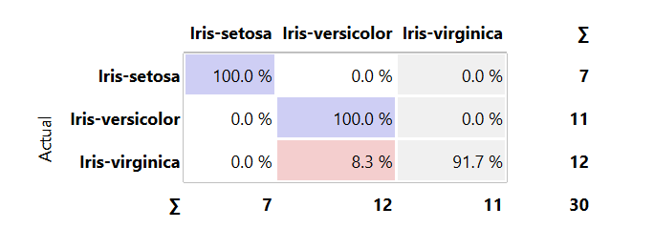

Test Regression
Model Gradient Boosting
