SDEV 153 Final (Hand-On Practical)

For this portion of the final you will need to:

1. Add missing code to the 2 given HTML pages, and the CSS page.
2. Create 2 additional pages using the Listings.html page as a template after completing/correcting the given code.
3. Save and zip your work and submit it in the Module 16 Folder on the Assignments/Assessments page.

This is the correct finished design.

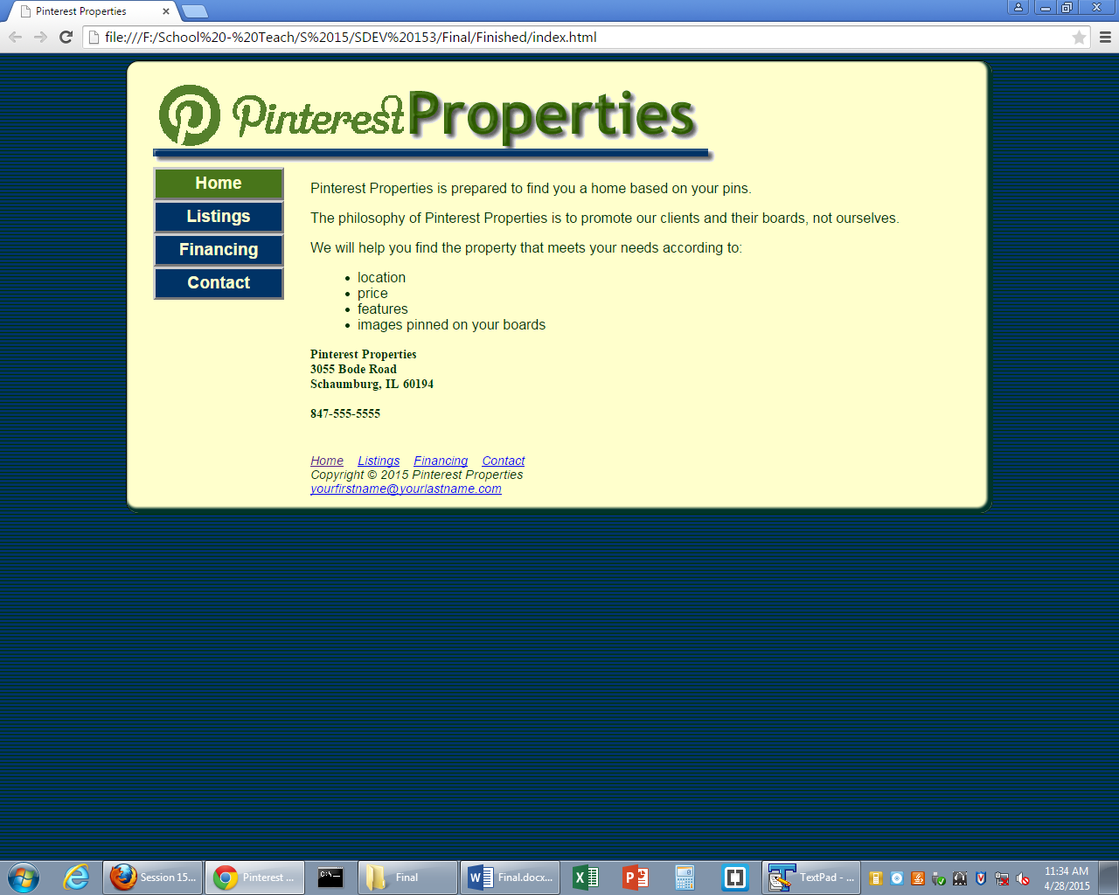

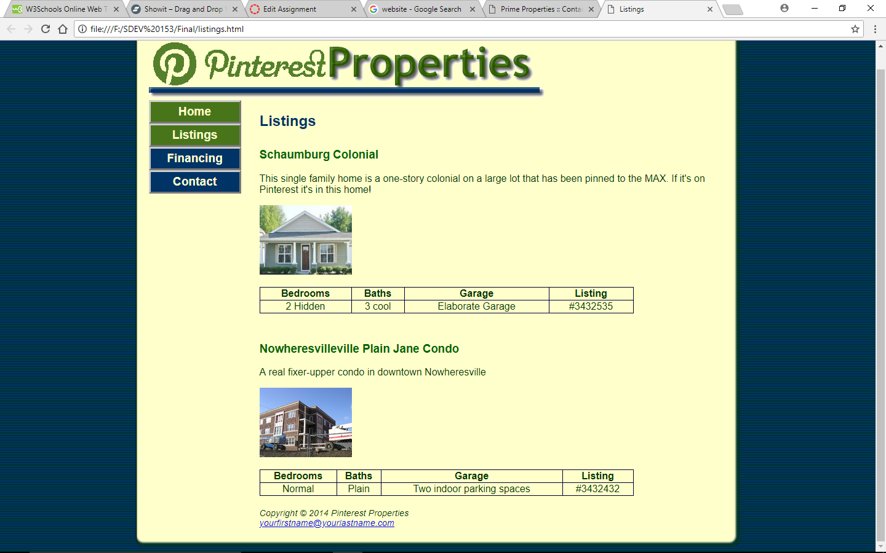

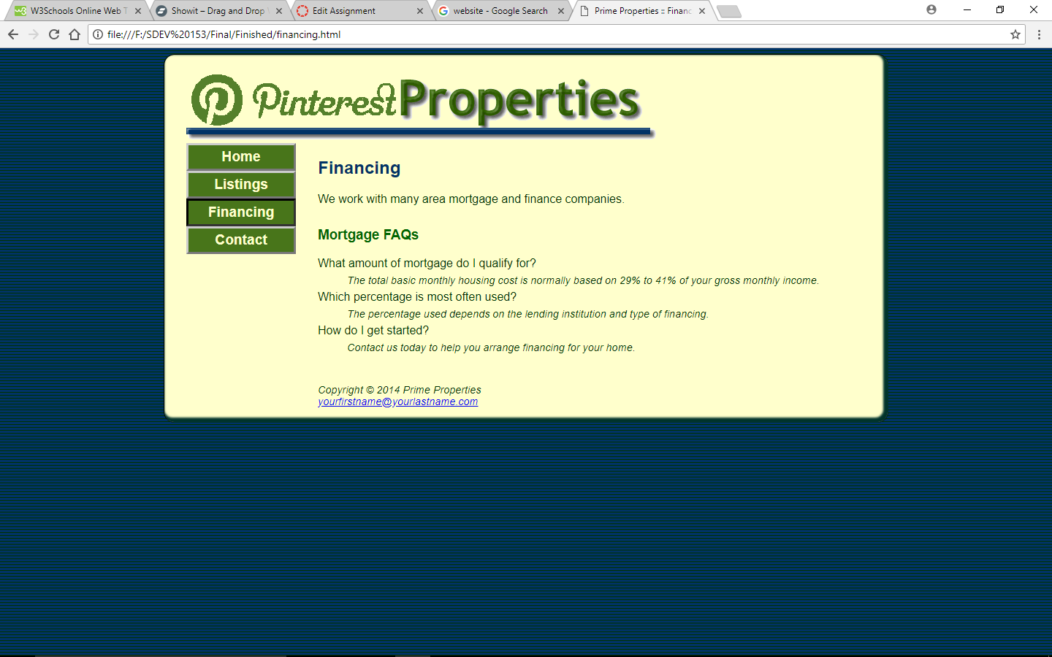

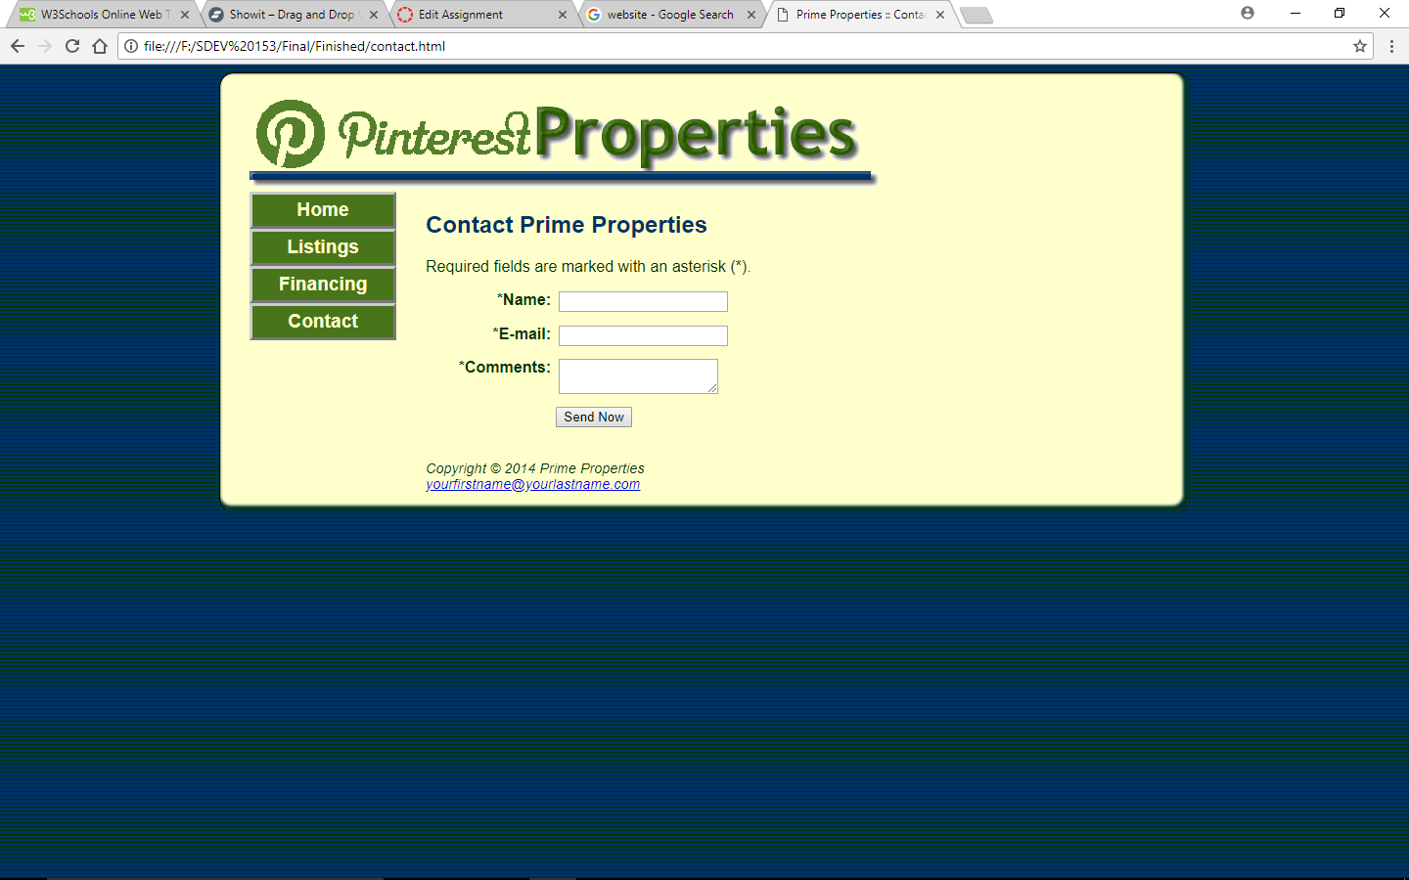

Here are some things to look for/at:

1. Titles
2. Page Description
3. Links
4. Media in a mobile link
5. Any needed id corrections
6. Any needed class corrections
7. Check for correct types of lists
8. Missing or broken links
9. Margins
10. All images are displaying correctly
11. Use of the .ico image
12. The wrapper should be padded with 30px on the left and 20px on the bottom
13. Floating left and right
14. list-style-types
15. text-decorations
16. What is the correct order for the anchor pseudo-code. One of them is missing on purpose

**Your INDEX page HTML CODE:**

<!DOCTYPE html>

<html lang="en">

<head>

<title></title>

<meta charset="utf-8">

<link href="mobile.css" rel="stylesheet" media="_________ screen and (max-device-width: 480px)">

<meta name="viewport" content="width=device-width, initial-scale=1.0" >

<meta name="description" content="Pinterest Properties is _______________">

<!--[if lt IE 9]>

<script src=" http://html5shim.googlecode.com/svn/trunk/html5.js ">

</script>

<![endif]-->

</head>

<body>

<div id="wrapper">

<header>

<h1>Pinterest Properties</h1>

</header>

<nav>

<ul>

<li><a href="index.html">Home</a></li>

<li><a href="listings.html">Listings</a></li>

<li><a href="financing.html">Financing</a></li>

<li><a href="contact.html">Contact</a></li>

</ul>

</nav>

<main>

<p>Pinterest Properties is prepared to find you a home based on your pins as well as market and sell your ugly home.</p>

<p>The philosophy of Pinterest Properties is to promote our clients and their boards, not ourselves. </p>

<p>We will help you find the property that meets your needs according to:</p>

<li>location</li>

<li>price</li>

<li>features</li>

<li>images pinned on your boards</li>

<div class=" ">Pinterest Properties<br>

3055 Bode Road<br>

Schaumburg, IL 60194<br>

<br>

<a id=" " href="847-555-5555">847-555-5555</a>

<span id="desktop">847-555-5555</span><br> <br>

</div>

</main>

<footer>

<div class=" ">

<a href="index.html">Home</a> &nbsp;&nbsp;

<a href=" ">Listings</a>&nbsp;&nbsp;

<a href="financing.html">Financing</a> &nbsp;&nbsp;

<a href="contact.html">Contact</a>

</div>

Copyright &copy; 2015 Pinterest Properties<br>

<a href="mailto:yourfirstname@yourlastname.com"> yourfirstname@yourlastname.com</a>

</footer>

</div>

</body>

</html>

**Your CSS CODE:**

header, nav, main, footer { display: block; }

body{ background-color: #003333;

background-image: url(horizontal.png);

color: #003300;

font-family: Arial, Helvetica, sans-serif;

}

#wrapper{ width: 80%;

min-width: 700px;

max-width: 960px;

margin-left: _________

margin-right: _________

background-color: #FFFFCC;

min-width: 700px;

padding: _________

border: 1px ridge #00332B;

-webkit-box-shadow: inset -3px -3px 3px 3px #00332B;

-moz-box-shadow: inset -3px -3px 3px 3px #00332B;

box-shadow: inset -3px -3px 3px 3px #00332B;

-webkit-border-radius: 15px;

-moz-border-radius: 15px;

border-radius: 15px;

}

header{ color:#48751A;

background-image: url(logo.gif);

background-repeat: no-repeat;

height: 100px;

}

h1{ text-indent: -99999px;

white-space: nowrap;

overflow: hidden;

}

h2{ color:#003366;

}

h3{ color:#006600;

padding-top: 10px;

}

nav{ font-weight: bold;

font-size: 1.2em;

}

nav { font-weight: bold;

font-size: 1.2em;

float: ______

width: 150px;

}

nav a { text-decoration: ______

display: block;

text-align: center;

color: #FFFFCC;

font-weight: bold;

border: 3px outset #CCCCCC;

padding: 5px;

}

nav a:______ { background-color: #003366; }

nav a:______ { background-color: #48751A; }

nav a:______ { border: 3px inset #333333; }

___________________________________

nav ul { list-style-type: _______

margin: 0;

padding-left: 0;

}

main { margin-left: 180px;

padding: 0 20px 20px 0;

}

main ul { list-style-position: inside;

}

dd{ font-style:italic;

font-size:.90em;

line-height:200%;

}

#right{ margin-left: 180px;

padding: 0;

}

.contact{ font-family: "Times New Roman", serif;

font-size: .90em;

font-weight:bold;

}

.floatleft{ float: left;

padding-right: 20px;

padding-bottom: 20px;

}

.clear{_________: left;

}

img{ border-style: none;

}

footer{ font-size: .60em;

font-style: italic;

clear: both;

}

#mobile{ display: none;

}

#desktop{ display: inline;

}

table { width: 80%;

border: 1px solid #000033;

border-collapse: collapse;

}

td, th { border: 1px solid #000033;

}

td { text-align: center;

}

@media only screen and (max-width: 1024px) {

body { margin: 0; padding: 0; background-color:#FFFFCC; background-image: none; }

#wrapper { width: 100%; min-width: 0; margin: 0; padding: 0; box-shadow: none; border-radius: 0; border-style: none; }

header { background-image: url(primemobile.gif); background-repeat: no-repeat; text-shadow: 1px 1px 1px #000033; height: 100%; }

h1 { margin: 0; padding-left: 2em; text-indent: 0; font-size: 3.7em; white-space: normal; }

nav { float: none; width: auto; margin-top: 0.5em; }

nav a { padding: 0.2em; margin-left: 0.3em; float: left; width: 20%; }

main { padding: 2.5em 1em ; margin: 0; font-size: 90%; clear: both; }

}

@media only screen and (max-width: 768px) {

h1 { padding-top: 0.25em; padding-left: 1.5em; font-size: 2.4em;}

nav { width: 98%; }

nav a { padding: 0.5em; width: 40%; float: left; min-width: 5em; margin-left: 0.5em; }

main { padding: 0.6em;}

.floatleft { float: none; padding-right: 0; padding-bottom: 0; }

h3 { padding-top: 0; margin: 0; }

dd { line-height: 100%; }

footer { padding: 0.5em; margin: 0; }

#mobile { display: inline; }

#desktop { display: none; }

}