Exercises-1

Source reference:

https://github.com/function86437/PSP

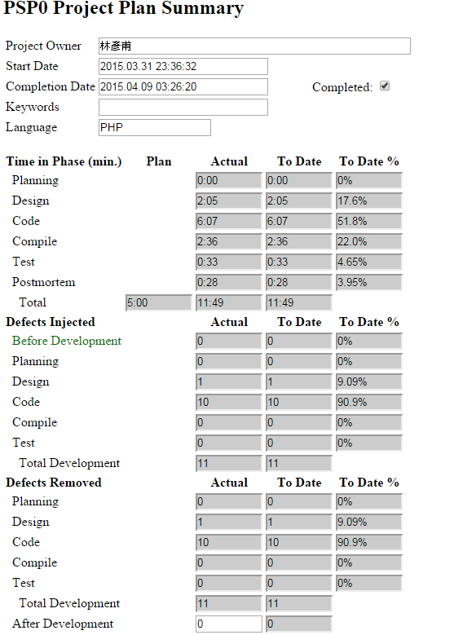

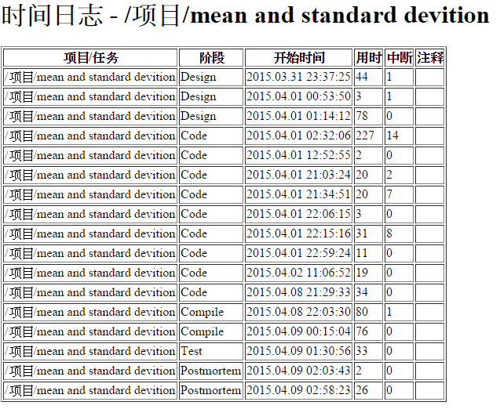

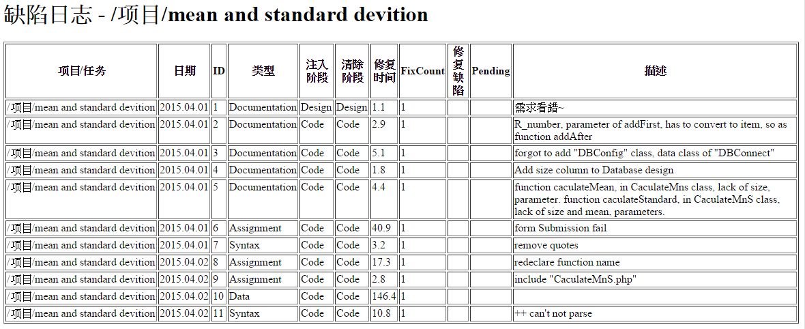

Source program listing

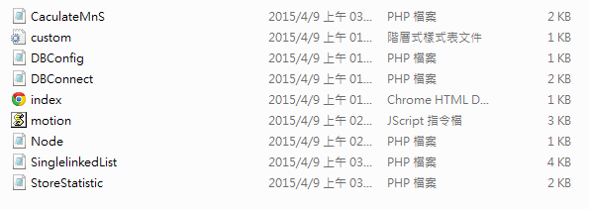

Test Result



C:\Users\Banana\Desktop\PSP\source code\img\test_1_result.PNG



C:\Users\Banana\Desktop\PSP\source code\img\Test_2_result.PNG