InfoVis Parallel

Technical Manual

14 January 2020

# Overview

## Objectives

### Goals

* Rapid design of new parallel-coordinates layouts for multidimensional timeseries.
* Ad-hoc, reconfigurable collaborative visualization environments.

### Principles

* Clean, minimalist abstractions based on category theory.
* Efficient use of bandwidth and memory.
* Firewall friendly.
* Portability across hardware and software platforms.
* Low maintenance.

## Layers

* A visualization language for expressing parallel-coordinates layouts and behaviors.
* Microservices for composing dataflows.
* A protocol buffer specification for embodying visual representations.
* Wire transport via WebSockets and/or Kafka.

# Visualization language

## Elements

* *Dataset:* Multidimensional data in a relational format.
* *Presentation:* The binding of visualizations with variables and animation.
* *Containers:* A grouping a layout.
  + *Singleton:* A single layout.
  + *Array:* A set of layouts.
  + *Collection:* A set of containers.
* *Extent:* The registration in 1D, 2D, or 3D of a container.
* *Grid:* A local unit coordinate system associated with axes, their labels, and their styling.
  + *LineGrid:* A 1D coordinate line.
  + *RectangleGrid:* A 2D plot.
  + *BoxGrid:* A 3D plot.
* *Axis:* Coordinate axes in 1D, 2D, or 3D associated with variables.
* *Link:* Parallel-coordinate linkages between axes.
  + *Point:* Data rendered as points and invisibly linked across a set of grids.
  + *Polyline:* Data rendered as polylines linked across an ordered set of grids.
* *Styling:* The colors for normal data, selected data, highlighted data, and the thickness of lines.

## Semantics

* Each data record has an unique ID.
  + That record is rendered on each axis of each grid, according to the values of variables for the record.
* Selection and highlighting operate on all renderings of the record for the specified IDs, across all of the grids and axes.
* The type of linkages between grids determine how the record is rendered as points and/or polylines.
* A single variable can be flagged for use in animation.

## Serialization

* The visualization language is defined as Haskell algebraic datatypes (ADTs).
* The visualization language is serialized as YAML or JSON, or in Haskell syntax.
* A compiler is available to transform datasets according to the language specification into a stream of protocol buffer messages.

## Coordinates

* Each *variable* is scaled to [0,1] according to the *dataset* metadata.
* Each *grid* has a local [0,1] coordinate system for each of its axes.
* The *extents* of the grid define an affine transformations from the local coordinate system into the coordinate system of its *container*.
* *Containers* have their [0,1] coordinate systems and their own *extents*.
* Thus, the scene graph is a hierarchy of nested unit coordinate systems related by affine transformations.

## 

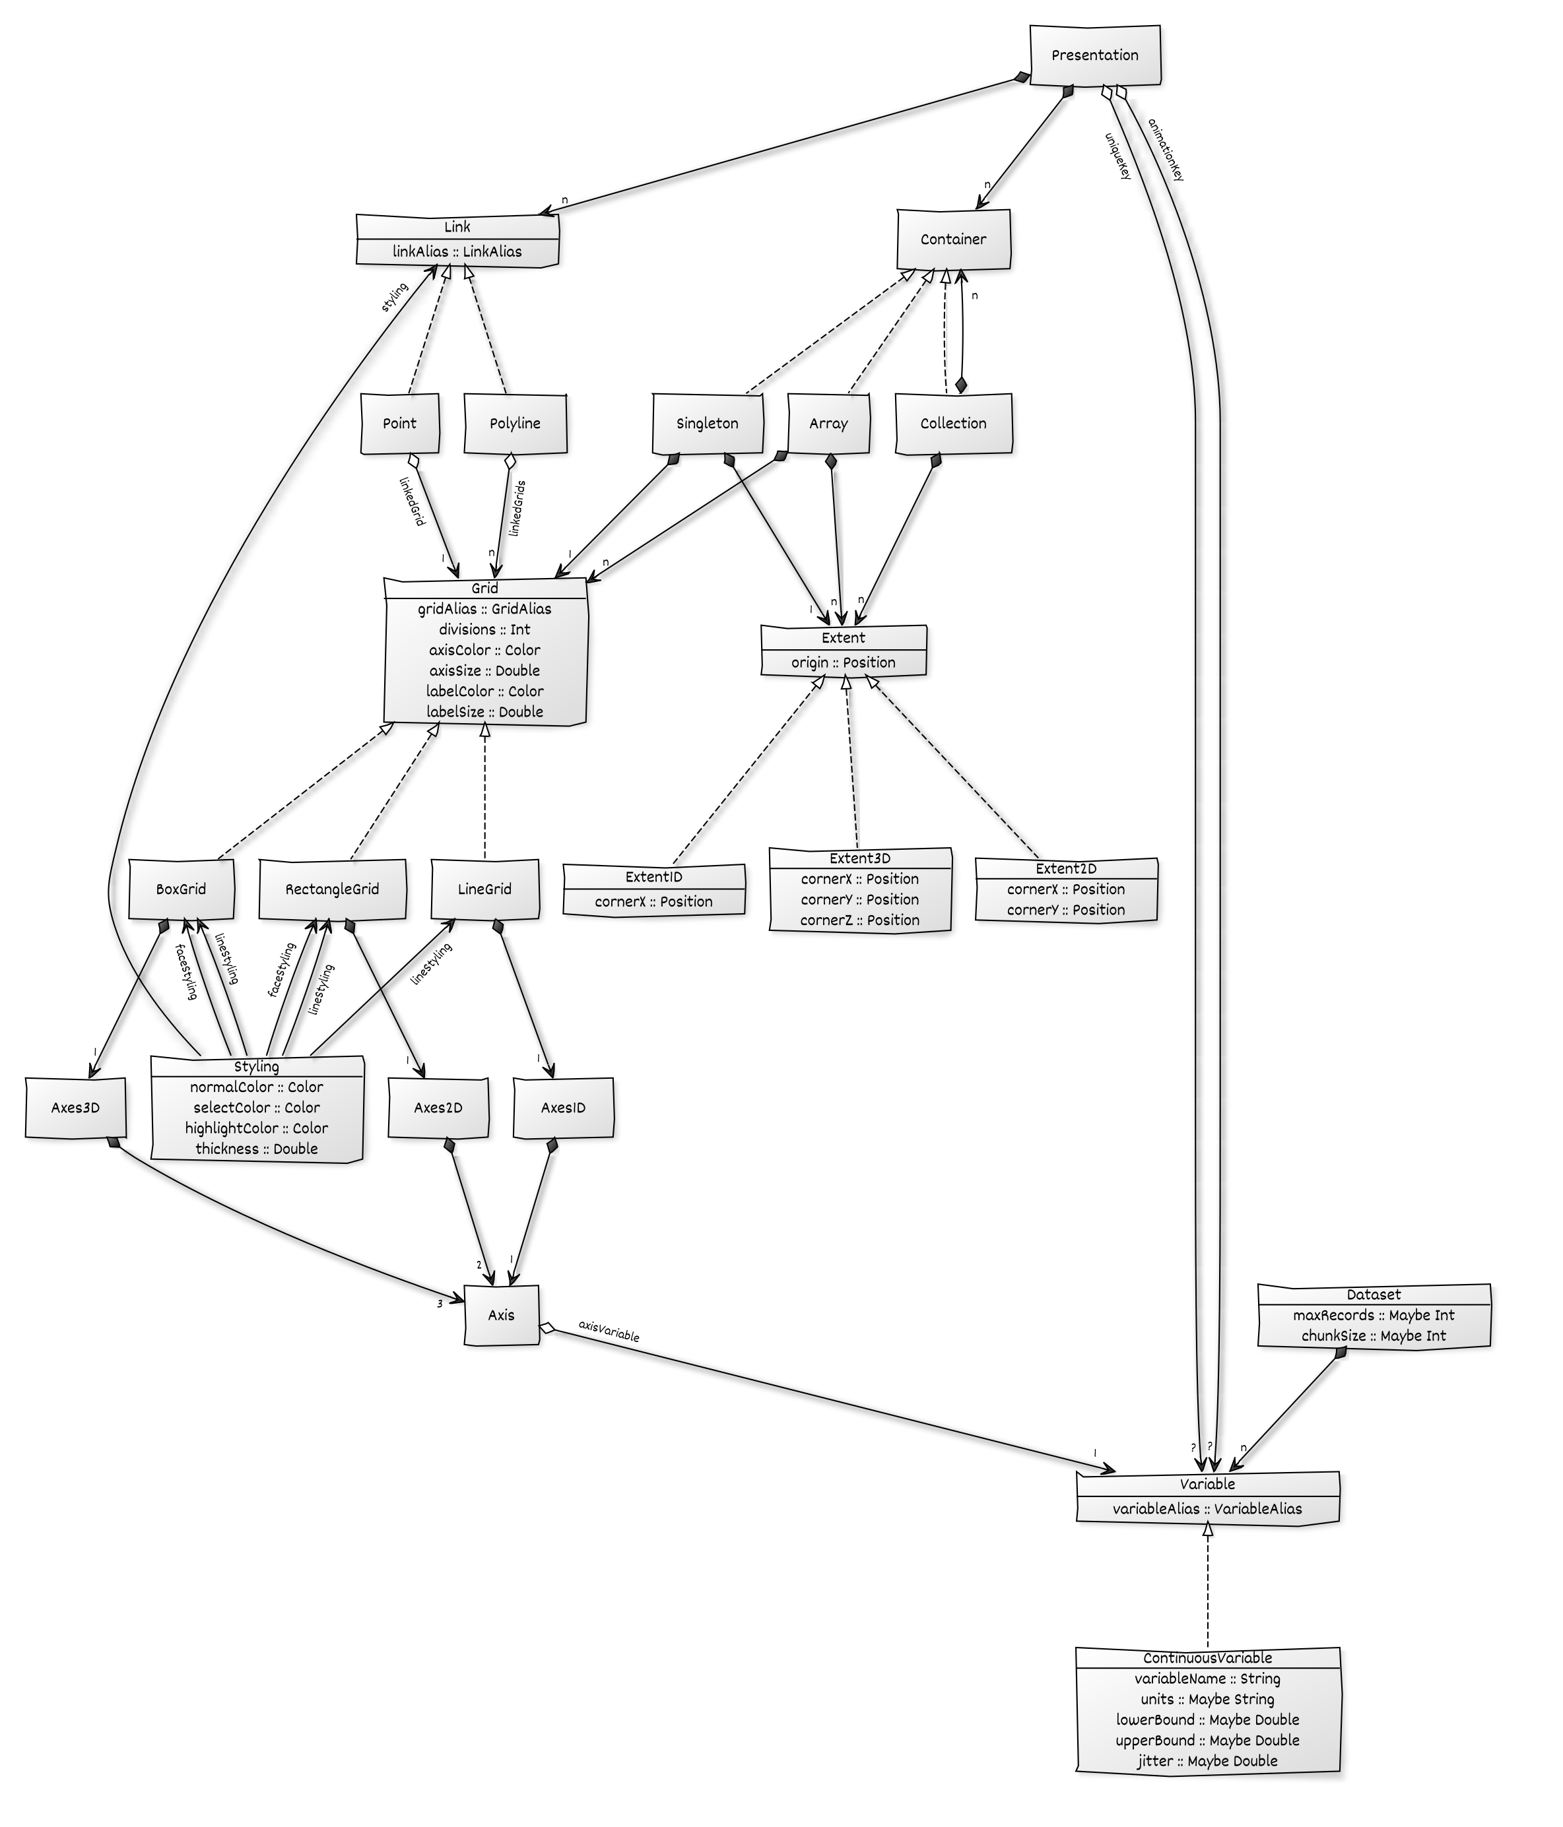

Class diagram for visualization language.

## Example Dataset

dataset :  
 datasetIdentifier: datasets/ENB2012.tsv  
 variables :  
 - variableAlias : Relative Compactness  
 variableName : Relative Compactness  
 lowerBound : 0.60  
 upperBound : 1.00  
 - variableAlias : Surface Area  
 variableName : Surface Area  
 units : m²  
 lowerBound : 500  
 upperBound : 825  
 - variableAlias : Wall Area  
 variableName : Wall Area  
 units : m²  
 lowerBound : 225  
 upperBound : 425  
 - variableAlias : Roof Area  
 variableName : Roof Area  
 units : m²  
 lowerBound : 100  
 upperBound : 225  
 - variableAlias : Overall Height  
 variableName : Overall Height  
 units : m  
 lowerBound : 3.25  
 upperBound : 7.25  
 - variableAlias : Orientation  
 variableName : Orientation  
 units : 2=N,3=E,4=S,5=W  
 lowerBound : 1.9  
 upperBound : 5.1  
 - variableAlias : Glazing Area  
 variableName : Glazing Area  
 lowerBound : -0.01  
 upperBound : 0.41  
 - variableAlias : Glazing Area Distribution  
 variableName : Glazing Area Distribution  
 units : 0=unknown,1=uniform,2=N,3=E,4=W,5=W  
 lowerBound : -0.01  
 upperBound : 5.01  
 - variableAlias : Heating Load  
 variableName : Heating Load  
 units : kWh/m²  
 lowerBound : 5  
 upperBound : 50  
 - variableAlias : Cooling Load  
 variableName : Cooling Load  
 units : kWh/m²  
 lowerBound : 5  
 upperBound : 50

## Simple Example: 3D scatterplot

presentation :  
 uniqueKey : Glazing Area Distribution  
 containers :  
 - tag : Singleton  
 extent :  
 tag : Extent3D  
 origin : [0, 0, 1]  
 cornerX : [1, 0, 1]  
 cornerY : [0, 0, 0]  
 cornerZ : [0, 1, 1]  
 grid :  
 tag : BoxGrid  
 gridAlias : heatingBox  
 axes3D :  
 - axisVariable : Wall Area  
 - axisVariable : Roof Area  
 - axisVariable : Heating Load  
 divisions : 5  
 lineStyling :  
 normalColor : 0x33333380  
 selectColor : 0x666600CC  
 highlightColor : 0x660000CC  
 thickness : 0.010  
 faceStyling :  
 normalColor : 0x33333300  
 selectColor : 0x666600CC  
 highlightColor : 0x660000CC  
 thickness : 0.010  
 axisColor : 0x1A993340  
 axisSize : 0.015  
 labelColor : 0x1A9933FF  
 labelSize : 0.050  
 links :  
 - tag : Point  
 linkAlias : heatingScatterplot  
 linkedGrid : heatingBox  
 styling :  
 normalColor : 0x0000FFCC  
 selectColor : 0xCCCCCCFF  
 highlightColor : 0xFF0000FF  
 thickness : 0.005

## Complex Example: two 3D scatterplots, parallel planes, and parallel forest with animation

presentation :  
 animationKey : Orientation  
 uniqueKey : Glazing Area Distribution  
 containers :  
 - tag : Collection  
 extents :  
 - tag : Extent3D  
 origin : [0.05, 0.55, 0.05]  
 cornerX : [0.45, 0.55, 0.05]  
 cornerY : [0.05, 0.95, 0.05]  
 cornerZ : [0.05, 0.55, 0.95]  
 - tag : Extent3D  
 origin : [0.55, 0.55, 0.05]  
 cornerX : [0.95, 0.55, 0.05]  
 cornerY : [0.55, 0.95, 0.05]  
 cornerZ : [0.55, 0.55, 0.95]  
 containeds :  
 - tag : Singleton  
 extent :  
 tag : Extent3D  
 origin : [0, 0, 0]  
 cornerX : [1, 0, 0]  
 cornerY : [0, 1, 0]  
 cornerZ : [0, 0, 1]  
 grid :  
 tag : BoxGrid  
 gridAlias : heatingBox  
 axes3D :  
 - axisVariable : Wall Area  
 - axisVariable : Roof Area  
 - axisVariable : Heating Load  
 divisions : 10  
 lineStyling :  
 normalColor : 0x333333FF  
 selectColor : 0x666600CC  
 highlightColor : 0x660000CC  
 thickness : 0.005  
 faceStyling :  
 normalColor : 0x33333300  
 selectColor : 0x666600CC  
 highlightColor : 0x660000CC  
 thickness : 0.005  
 axisColor : 0x1A993340  
 axisSize : 0.010  
 labelColor : 0x1A9933FF  
 labelSize : 0.01  
 - tag : Singleton  
 extent :  
 tag : Extent3D  
 origin : [0, 0, 0]  
 cornerX : [1, 0, 0]  
 cornerY : [0, 1, 0]  
 cornerZ : [0, 0, 1]  
 grid :  
 tag : BoxGrid  
 gridAlias : coolingBox  
 axes3D :  
 - axisVariable : Wall Area  
 - axisVariable : Roof Area  
 - axisVariable : Cooling Load  
 divisions : 0  
 lineStyling :  
 normalColor : 0x666666CC  
 selectColor : 0x666600CC  
 highlightColor : 0x660000CC  
 thickness : 0.005  
 faceStyling :  
 normalColor : 0x33333300  
 selectColor : 0x666600CC  
 highlightColor : 0x660000CC  
 thickness : 0.005  
 axisColor : 0x1A993340  
 axisSize : 0.010  
 labelColor : 0x1A9933FF  
 labelSize : 0.01  
 - tag : Array  
 extents :  
 - tag : Extent2D  
 origin : [0.1, 0.1, 0.1]  
 cornerX : [0.1, 0.1, 0.9]  
 cornerY : [0.1, 0.4, 0.1]  
 - tag : Extent2D  
 origin : [0.2, 0.1, 0.1]  
 cornerX : [0.2, 0.1, 0.9]  
 cornerY : [0.2, 0.4, 0.1]  
 - tag : Extent2D  
 origin : [0.3, 0.1, 0.1]  
 cornerX : [0.3, 0.1, 0.9]  
 cornerY : [0.3, 0.4, 0.1]  
 - tag : Extent2D  
 origin : [0.4, 0.1, 0.1]  
 cornerX : [0.4, 0.1, 0.9]  
 cornerY : [0.4, 0.4, 0.1]  
 - tag : Extent2D  
 origin : [0.5, 0.1, 0.1]  
 cornerX : [0.5, 0.1, 0.9]  
 cornerY : [0.5, 0.4, 0.1]  
 grids :  
 - tag : RectangleGrid  
 gridAlias : plane1  
 axes2D :  
 - axisVariable : Relative Compactness  
 - axisVariable : Surface Area  
 divisions : 5  
 lineStyling :  
 normalColor : 0x666666CC  
 selectColor : 0x666600CC  
 highlightColor : 0x660000CC  
 thickness : 0.005  
 faceStyling :  
 normalColor : 0x33333399  
 selectColor : 0x666600CC  
 highlightColor : 0x660000CC  
 thickness : 0.005  
 axisColor : 0x1A993340  
 axisSize : 0.010  
 labelColor : 0x1A9933FF  
 labelSize : 0.01  
 - tag : RectangleGrid  
 gridAlias : plane2  
 axes2D :  
 - axisVariable : Wall Area  
 - axisVariable : Roof Area  
 divisions : 5  
 lineStyling :  
 normalColor : 0x666666CC  
 selectColor : 0x666600CC  
 highlightColor : 0x660000CC  
 thickness : 0.005  
 faceStyling :  
 normalColor : 0x33333399  
 selectColor : 0x666600CC  
 highlightColor : 0x660000CC  
 thickness : 0.005  
 axisColor : 0x1A993340  
 axisSize : 0.010  
 labelColor : 0x1A9933FF  
 labelSize : 0.01  
 - tag : RectangleGrid  
 gridAlias : plane3  
 axes2D :  
 - axisVariable : Overall Height  
 - axisVariable : Orientation  
 divisions : 5  
 lineStyling :  
 normalColor : 0x666666CC  
 selectColor : 0x666600CC  
 highlightColor : 0x660000CC  
 thickness : 0.005  
 faceStyling :  
 normalColor : 0x33333399  
 selectColor : 0x666600CC  
 highlightColor : 0x660000CC  
 thickness : 0.005  
 axisColor : 0x1A993340  
 axisSize : 0.010  
 labelColor : 0x1A9933FF  
 labelSize : 0.01  
 - tag : RectangleGrid  
 gridAlias : plane4  
 axes2D :  
 - axisVariable : Glazing Area  
 - axisVariable : Glazing Area Distribution  
 divisions : 5  
 lineStyling :  
 normalColor : 0x666666CC  
 selectColor : 0x666600CC  
 highlightColor : 0x660000CC  
 thickness : 0.005  
 faceStyling :  
 normalColor : 0x33333399  
 selectColor : 0x666600CC  
 highlightColor : 0x660000CC  
 thickness : 0.005  
 axisColor : 0x1A993340  
 axisSize : 0.010  
 labelColor : 0x1A9933FF  
 labelSize : 0.01  
 - tag : RectangleGrid  
 gridAlias : plane5  
 axes2D :  
 - axisVariable : Heating Load  
 - axisVariable : Cooling Load  
 divisions : 5  
 lineStyling :  
 normalColor : 0x666666CC  
 selectColor : 0x666600CC  
 highlightColor : 0x660000CC  
 thickness : 0.005  
 faceStyling :  
 normalColor : 0x33333399  
 selectColor : 0x666600CC  
 highlightColor : 0x660000CC  
 thickness : 0.005  
 axisColor : 0x1A993340  
 axisSize : 0.010  
 labelColor : 0x1A9933FF  
 labelSize : 0.01  
 - tag : Array  
 extents :  
 - tag : Extent1D  
 origin : [0.7, 0.1, 0.2]  
 cornerX : [0.7, 0.4, 0.2]  
 - tag : Extent1D  
 origin : [0.7, 0.1, 0.4]  
 cornerX : [0.7, 0.4, 0.4]  
 - tag : Extent1D  
 origin : [0.7, 0.1, 0.6]  
 cornerX : [0.7, 0.4, 0.6]  
 - tag : Extent1D  
 origin : [0.7, 0.1, 0.8]  
 cornerX : [0.7, 0.4, 0.8]  
 - tag : Extent1D  
 origin : [0.9, 0.1, 0.2]  
 cornerX : [0.9, 0.4, 0.2]  
 - tag : Extent1D  
 origin : [0.9, 0.1, 0.4]  
 cornerX : [0.9, 0.4, 0.4]  
 - tag : Extent1D  
 origin : [0.9, 0.1, 0.6]  
 cornerX : [0.9, 0.4, 0.6]  
 - tag : Extent1D  
 origin : [0.9, 0.1, 0.8]  
 cornerX : [0.9, 0.4, 0.8]  
 - tag : Extent1D  
 origin : [0.8, 0.1, 0.4]  
 cornerX : [0.8, 0.4, 0.4]  
 - tag : Extent1D  
 origin : [0.8, 0.1, 0.6]  
 cornerX : [0.8, 0.4, 0.6]  
 grids :  
 - tag : LineGrid  
 gridAlias : line1  
 axes1D :  
 axisVariable : Relative Compactness  
 divisions : 10  
 lineStyling :  
 normalColor : 0x666666CC  
 selectColor : 0x666600CC  
 highlightColor : 0x660000CC  
 thickness : 0.005  
 axisColor : 0x1A993340  
 axisSize : 0.010  
 labelColor : 0x1A9933FF  
 labelSize : 0.01  
 - tag : LineGrid  
 gridAlias : line2  
 axes1D :  
 axisVariable : Surface Area  
 divisions : 10  
 lineStyling :  
 normalColor : 0x666666CC  
 selectColor : 0x666600CC  
 highlightColor : 0x660000CC  
 thickness : 0.005  
 axisColor : 0x1A993340  
 axisSize : 0.010  
 labelColor : 0x1A9933FF  
 labelSize : 0.01  
 - tag : LineGrid  
 gridAlias : line3  
 axes1D :  
 axisVariable : Wall Area  
 divisions : 10  
 lineStyling :  
 normalColor : 0x666666CC  
 selectColor : 0x666600CC  
 highlightColor : 0x660000CC  
 thickness : 0.005  
 axisColor : 0x1A993340  
 axisSize : 0.010  
 labelColor : 0x1A9933FF  
 labelSize : 0.01  
 - tag : LineGrid  
 gridAlias : line4  
 axes1D :  
 axisVariable : Roof Area  
 divisions : 10  
 lineStyling :  
 normalColor : 0x666666CC  
 selectColor : 0x666600CC  
 highlightColor : 0x660000CC  
 thickness : 0.005  
 axisColor : 0x1A993340  
 axisSize : 0.010  
 labelColor : 0x1A9933FF  
 labelSize : 0.01  
 - tag : LineGrid  
 gridAlias : line5  
 axes1D :  
 axisVariable : Overall Height  
 divisions : 10  
 lineStyling :  
 normalColor : 0x666666CC  
 selectColor : 0x666600CC  
 highlightColor : 0x660000CC  
 thickness : 0.005  
 axisColor : 0x1A993340  
 axisSize : 0.010  
 labelColor : 0x1A9933FF  
 labelSize : 0.01  
 - tag : LineGrid  
 gridAlias : line6  
 axes1D :  
 axisVariable : Orientation  
 divisions : 10  
 lineStyling :  
 normalColor : 0x666666CC  
 selectColor : 0x666600CC  
 highlightColor : 0x660000CC  
 thickness : 0.005  
 axisColor : 0x1A993340  
 axisSize : 0.010  
 labelColor : 0x1A9933FF  
 labelSize : 0.01  
 - tag : LineGrid  
 gridAlias : line7  
 axes1D :  
 axisVariable : Glazing Area  
 divisions : 10  
 lineStyling :  
 normalColor : 0x666666CC  
 selectColor : 0x666600CC  
 highlightColor : 0x660000CC  
 thickness : 0.005  
 axisColor : 0x1A993340  
 axisSize : 0.010  
 labelColor : 0x1A9933FF  
 labelSize : 0.01  
 - tag : LineGrid  
 gridAlias : line8  
 axes1D :  
 axisVariable : Glazing Area Distribution  
 divisions : 10  
 lineStyling :  
 normalColor : 0x666666CC  
 selectColor : 0x666600CC  
 highlightColor : 0x660000CC  
 thickness : 0.005  
 axisColor : 0x1A993340  
 axisSize : 0.010  
 labelColor : 0x1A9933FF  
 labelSize : 0.01  
 - tag : LineGrid  
 gridAlias : line9  
 axes1D :  
 axisVariable : Heating Load  
 divisions : 10  
 lineStyling :  
 normalColor : 0x666666CC  
 selectColor : 0x666600CC  
 highlightColor : 0x660000CC  
 thickness : 0.005  
 axisColor : 0x1A993340  
 axisSize : 0.010  
 labelColor : 0x1A9933FF  
 labelSize : 0.01  
 - tag : LineGrid  
 gridAlias : line10  
 axes1D :  
 axisVariable : Cooling Load  
 divisions : 10  
 lineStyling :  
 normalColor : 0x666666CC  
 selectColor : 0x666600CC  
 highlightColor : 0x660000CC  
 thickness : 0.005  
 axisColor : 0x1A993340  
 axisSize : 0.010  
 labelColor : 0x1A9933FF  
 labelSize : 0.01  
 links :  
 - tag : Point  
 linkAlias : heatingScatterplot  
 linkedGrid : heatingBox  
 styling :  
 normalColor : 0x0000FFCC  
 selectColor : 0xCCCCCCFF  
 highlightColor : 0xFF0000FF  
 thickness : 0.005  
 - tag : Point  
 linkAlias : coolingScatterplot  
 linkedGrid : coolingBox  
 styling :  
 normalColor : 0x0000FFCC  
 selectColor : 0xCCCCCCFF  
 highlightColor : 0xFF0000FF  
 thickness : 0.005  
 - tag : Polyline  
 linkAlias : parallelPlanes  
 linkedGrids : [plane1,plane2,plane3,plane4,plane5]  
 styling :  
 normalColor : 0x0000FF33  
 selectColor : 0xCCCCCCFF  
 highlightColor : 0xFF0000FF  
 thickness : 0.005  
 - tag : Polyline  
 linkAlias : parallelForest1  
 linkedGrids : [line1,line9]  
 styling :  
 normalColor : 0x0000FF33  
 selectColor : 0xCCCCCCFF  
 highlightColor : 0xFF0000FF  
 thickness : 0.005  
 - tag : Polyline  
 linkAlias : parallelForest2  
 linkedGrids : [line2,line9]  
 styling :  
 normalColor : 0x0000FF33  
 selectColor : 0xCCCCCCFF  
 highlightColor : 0xFF0000FF  
 thickness : 0.005  
 - tag : Polyline  
 linkAlias : parallelForest3  
 linkedGrids : [line3,line9]  
 styling :  
 normalColor : 0x0000FF33  
 selectColor : 0xCCCCCCFF  
 highlightColor : 0xFF0000FF  
 thickness : 0.005  
 - tag : Polyline  
 linkAlias : parallelForest4  
 linkedGrids : [line4,line9]  
 styling :  
 normalColor : 0x0000FF33  
 selectColor : 0xCCCCCCFF  
 highlightColor : 0xFF0000FF  
 thickness : 0.005  
 - tag : Polyline  
 linkAlias : parallelForest5  
 linkedGrids : [line5,line10]  
 styling :  
 normalColor : 0x0000FF33  
 selectColor : 0xCCCCCCFF  
 highlightColor : 0xFF0000FF  
 thickness : 0.005  
 - tag : Polyline  
 linkAlias : parallelForest6  
 linkedGrids : [line6,line10]  
 styling :  
 normalColor : 0x0000FF33  
 selectColor : 0xCCCCCCFF  
 highlightColor : 0xFF0000FF  
 thickness : 0.005  
 - tag : Polyline  
 linkAlias : parallelForest7  
 linkedGrids : [line7,line10]  
 styling :  
 normalColor : 0x0000FF33  
 selectColor : 0xCCCCCCFF  
 highlightColor : 0xFF0000FF  
 thickness : 0.005  
 - tag : Polyline  
 linkAlias : parallelForest8  
 linkedGrids : [line8,line10]  
 styling :  
 normalColor : 0x0000FF33  
 selectColor : 0xCCCCCCFF  
 highlightColor : 0xFF0000FF  
 thickness : 0.005  
 - tag : Polyline  
 linkAlias : parallelForest9  
 linkedGrids : [line9,line10]  
 styling :  
 normalColor : 0x0000FF33  
 selectColor : 0xCCCCCCFF  
 highlightColor : 0xFF0000FF  
 thickness : 0.005

# Microservices

## Existing Microservices

* Rendering on a variety of VR, AR, and 2D devices:
  + WebGL/WebVR/WebXR client in JavaScript, using WebSockets.
  + OpenGL quadbuffer stereo client in Haskell, using Kafka or WebSockets.
* Visualization language:
  + Compiler in Haskell, using Kafka or WebSockets.
* Input devices in Go and Haskell, using Kafka or WebSockets.
* Patchboard in Go, using Kafka or WebSockets.
  + Connect streams.
  + Filter streams.
  + Multiplex streams.
  + Push pre-compiled data.
  + Record streams.

## Wire Transport

* WebSockets
  + Two-way communication.
  + Widely supported, especially in web clients.
  + Firewall friendly.
  + Secure.
* Kakfa
  + Producer/consumer model.
  + Persistence and replay.
  + Redundancy, federation, and grouping of streams.
  + Firewall unfriendly.
  + Secure.

## 

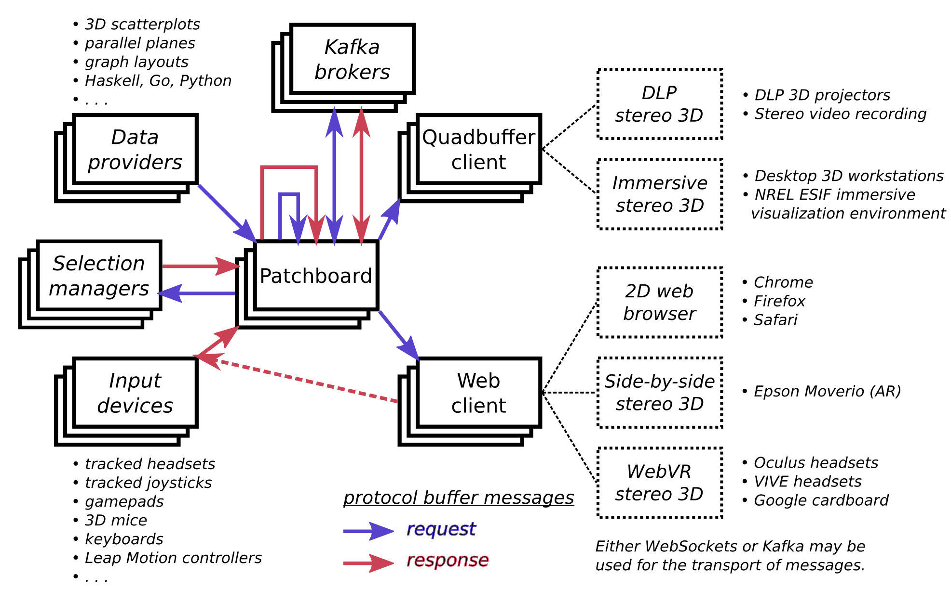

Architecture of microservices.

## Patchboard Application

* The patchboard allows the wiring, multiplexing, and filtering of sources and sinks.
* WebSockets and Kafka streams may be mixed.
* Pre-compiled messages may be injected.
* Command-line application.
* The patchboard may be scripted or used interactively.

## Patchboard Commands

sources  
sinks  
relays  
delete [source|sink|relay]...  
  
relay 'relay'  
add-sink 'relay' [sink]...  
add-source 'relay' [source]...  
remove-sink 'relay' [sink]...  
remove-source 'relay' [source]...  
filter 'relay' [show] [message] [reset] [upsert] [delete] [view] [tool] [offset]  
converter 'relay' [show] [view] [tool] [offset]  
  
files 'source' [filename]...  
append 'source' [filename]...  
reset [source]...  
absorber 'sink'  
printer 'sink' (Request|Response)  
  
websocket 'path'  
serve 'address' 'path'  
kafka 'address' [true|false] 'topic'  
  
script [file]...  
wait 'seconds'  
silent  
verbose  
help  
exit

# Protocol Buffers

## Messaging

* Simple request/response pattern on typed channels.
* Only *differences* in state are transmitted (i.e., monoidal).
* The messaging specification is more expressive than the visualization language.
* Implemented in Protocol Buffers 3.
  + Near-universal language support.
  + Compact and efficient.
* Semantics:
  + Multiple frames.
  + Multiple objects in each frame.
  + Mixtures of primitives.
  + One viewpoint.
  + One tool.
  + One global offset.
  + One (perhaps composite) device with buttons and analog outputs.

## Request Message

Any combination of the following:

* Set the visible frame to a particular number.
* Show a text message on the display.
* Clear the display.
* Insert and/or update geomtric objects.
* Delete geometric objects, using their unique IDs.
* Set the viewpoint.
* Set the location of the tool.
* Set the offset of the display relative to the global coordinate system.

## Request Message

message Request {  
 int32 show = 1; // 0 = no change  
 string message = 2; // "" = no change  
 bool reset = 3;  
 repeated Geometry upsert = 4;  
 repeated int64 delete = 5;  
 Location viewloc = 6;  
 Location toolloc = 7;  
 Location offsetloc = 8;  
}

## Response Message

Any combination of the following:

* A specific frame was shown.
* A specific text message was displayed.
* The tool is starting to hover over the specified IDs.
* The tool is stoping to hover over the specified IDs.
* The specified IDs have been selected.
* The specified IDs have been deselected.
* THe viewpoint is at the specified location.
* The tool is at the specified location.
* The scene is offset relative to the global coordinate system.
* The specified buttons are depressed.
* The specified buttons are pressed.
* The specified buttons are released.
* The analog device has the specified values.

## Response Message

message Response {  
 int32 shown = 1;  
 string message = 2;  
 repeated int64 hover = 3;  
 repeated int64 unhover = 4;  
 repeated int64 select = 5;  
 repeated int64 deselect = 6;  
 Location viewloc = 7;  
 Location toolloc = 8;  
 Location offsetloc = 9;  
 fixed32 depressed = 10;  
 fixed32 pressed = 11;  
 fixed32 released = 12;  
 repeated double analog = 13;  
}

## Geometry Message

* Primitives: sets of points, sets of polylines, sets of rectangles, a text label, an axis (line with arrow).
* Each object has an ID, but different primitive may share the same ID.
* Each object has a frame number specifying on when it will be visible.
* Objects have position, size, and color; points have glyphs.
* Messages specify *changes* in state, not absolute state.
* A message may simultaneously modify the objects in multiple frames.
* A message may simultaneously modify all of the primitive types.

## Geometry Message

message Geometry {  
 int32 fram = 1; // 0 = all  
 int64 iden = 2;  
 int32 type = 3; // 0 = all, 1 = points, 2 = polylines,  
 // 3 = rectangles, 4 = label, 5 = axis  
 int32 mask = 4;  
 repeated int32 cnts = 5;  
 repeated double posx = 6; // mask = 00001b = 1  
 repeated double posy = 7; // mask = 00001b = 1  
 repeated double posz = 8; // mask = 00001b = 1  
 double size = 9; // mask = 00010b = 2  
 fixed32 colr = 10; // mask = 00100b = 4  
 string text = 11; // mask = 01000b = 8  
 int32 glyp = 12; // mask = 10000b = 16;  
 // 0 = cubes/boxes for points/polylines,  
 // 1 = spheres/cylinders  
}

## Location Message

Location is simply a vector and a quaternion.

message Location {  
 double posx = 1;  
 double posy = 2;  
 double posz = 3;  
 double rotw = 4;  
 double rotx = 5;  
 double roty = 6;  
 double rotz = 7;  
}

# Conclusion

## Next Steps

* Better management of selections.
* Web-based patchboard, sharable among distributed users.
* Migrate most input devices to Go and WebSockets.
* Revise semantics to address minor design flaws.
* Data provider for graph/network drawing.
* Complete Python support.
* R support.
* More documentation and examples.