Name:Adtiya Funde
PRN:125BI E078
Div:E , Batch: El
Code:
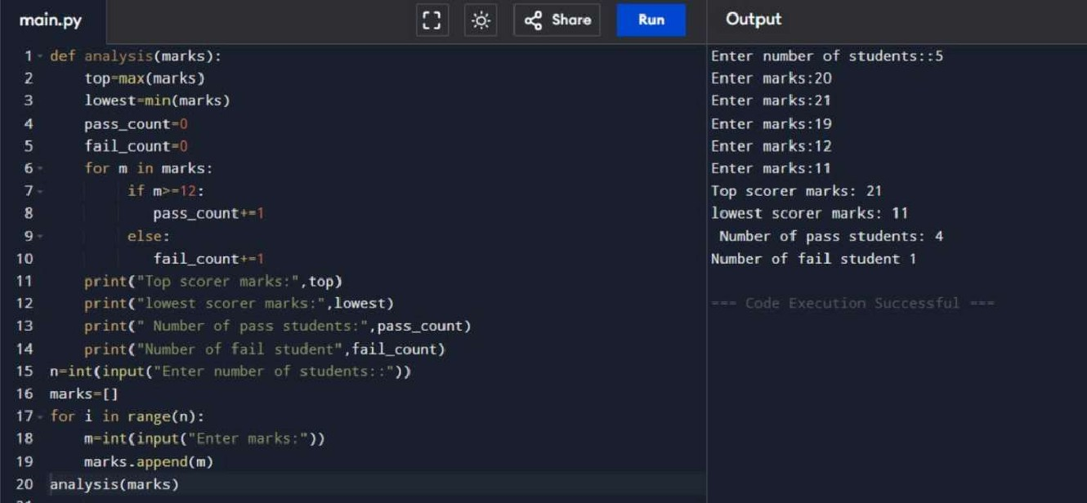
Questions:
main.py Share Run Output
def firi _top_scorer(marks) : Enter number of students: 3
- return max(marks) Enter marks of student I . 20
- Enter marks of student 2: 20
- def find lowest scorer(marks): Enter marks of student 3: 20
- return min(marks) Top scorer marks: 20
- Lowest marks: 20
- def find_passed_students(marks) : Passed students marks: [20, 20, 20] 8 passed — [ ]
- for m in marks : Code Execution Successful
- if m 12
- passed. append(m)
- return passed
13
14
- # Example data (you can change it)
- marks = [ ]
- 18 n int(input("Enter number of students: '
19
20 for i in range(n):

21 m = int(input(f"Enter marks of student {i+l}
22 marks . append(m)
23
- print("Top scorer marks: " , find top_scorer(marks))
- print("Lowest marks: " , find lowest_scorer (marks))
- prinCd"Passed students marks : " , find_passed_students(marks )
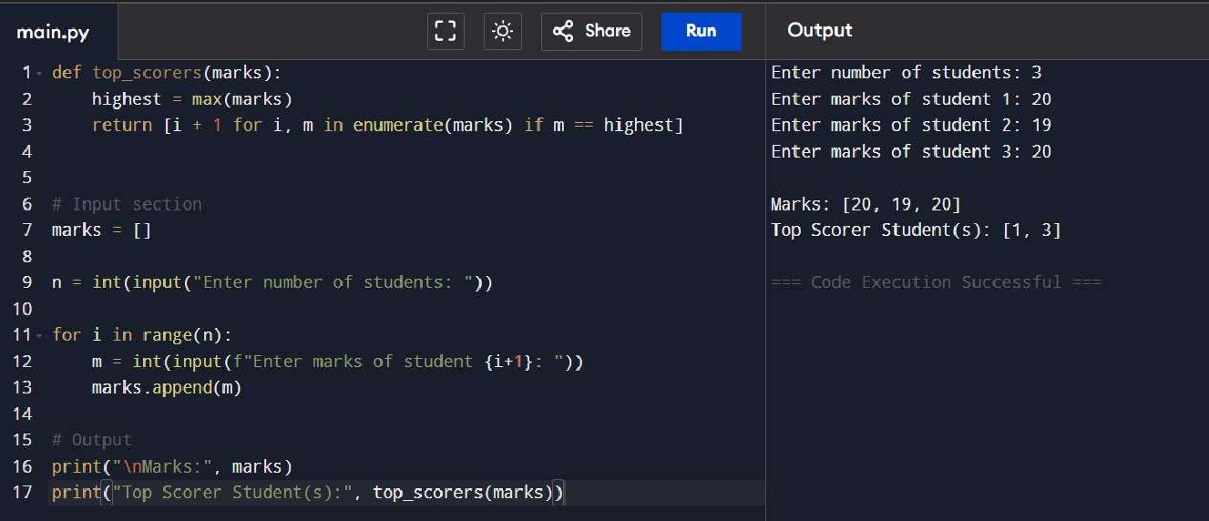
main.py Share Output
def calculate_percentages(marks): Enter number of students: 4
2 | return [ (m / 25) * 100 for m In marks] |  |  | Enter marks of student 1 | (out of 25): | 14
3 |  |  |  | Enter marks of student 2 | (out of 25): | 16
4 |  |  |  | Enter marks of student 3 | (out of 25): | 19
5  6 | def :  highest = max(percentages) |  |  | Enter marks of student 4 | (out of 25): | 23
7 | return [i ± 1 for in enumerate(percentages) | if p | - highest] | Marks : [14, 16, 19, 23]
- # Input Percentages : [56.0, 64.0, 76.0, 92.0]
- marks Top Scorer Student(s): [4]

10 n int(input("Enter number of students: '
11 Code Execution Successful 12 for i in range(n):
- m = int(input(f"Enter marks of student {i+l} (out of 25):
- marks. append(m)
- # processing
- percentages 17 # Output
- marks)
- print( "Percentages : ' [round(p , 2) for p in percentages])
- print("Top Scorer Student(s):' top_scorers(percentages))

main.py Share Run
- students
- n int(input("Enter number of students: '
- subjects = number of subjects:
- for i in range(n):
- print(f"\nEnter marks for Student marks
- for j in range(subjects):
- while True 10 try :
1 1 m = int(input(f"Subject
- if 0 m 25
- marks. append (m) 14 break 15 else:
- print("lnvalid! Enter marks between 0 and 25.
- except ValueError:
- print("lnvalid input! Enter a number. "
- students . append (marks)
- totals [sum(s) for s in students]
- percentages [ (t / (subjects * 25)) * 100 for t in totals]
- def top_scorers (totals) :
- highest = max(totals)
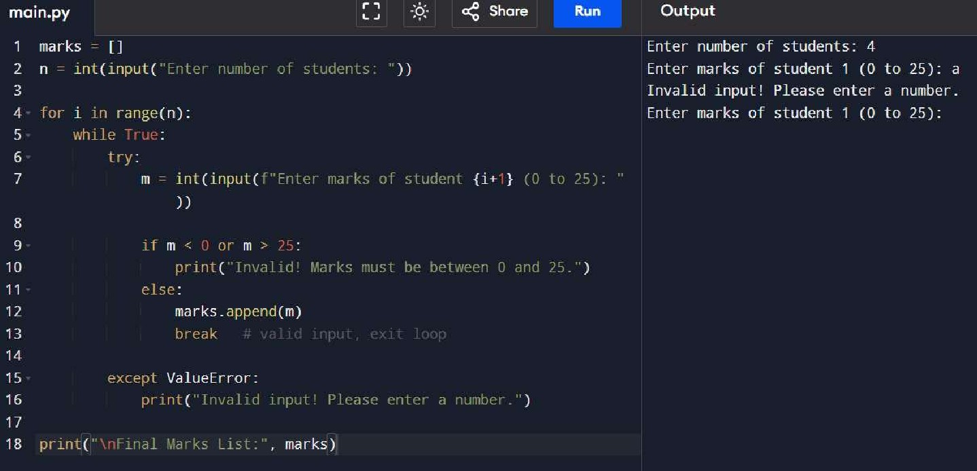
- return [i + 1 for i, t in enumerate(totals) if t highest] Output
Enter number of students: 3 Enter number of subjects: 2
Enter marks for Student 1 :
Subject I : 14
Subject 2: 16
Enter marks for Student 2:
Subject 1 •. 19
Subject 2: 20
Enter marks for Student 3:
Subject 1 : 21
Subject 2: 13
RESULT
Marks of Students: [ [14, 16] , [19, 20] , [21 , 13]]
Total Marks: [30, 39, 34]
Percentages: [60.0, 78.0, 68.0] Top Scorer Student(s): [2]
Lowest Scorer Student(s): None
Code Execution Successful

25, def lowest scorers(totals):
26 lowest = min(totals)
