The Connect Four Dataset
The first classification that will be looked at is the classification of several states of a popular strategy game, Connect Four. For the purpose of this analysis paper, it is assumed that the reader is familiar with the game. The data contains 67557 instances with all 42 grid-space features (seven by six) which represent each space in the grid of the game. Each feature contains one of three discrete values that represent the state of the space in the game. A space can either be taken by player 1, labeled in the data as 'x', taken by player 2, 'o', or is taken by neither player and is blank, 'b'. The last feature is the classification which is one of three possible classes: 'win' – player one wins the game from this state, 'lose' – player 1 loses the game from this state. 'draw' – neither player wins the game from this state. There is no missing information from the data. It is unclear how the games were played. It seems that the data was produced by iterative play of several games, but it remains unclear how the players are defined. Are they human, machines, monkeys? Despite this, the data and classification problem still remains interesting as all possible definitions of a player are bound to make mistakes.

Based on the instances of the data, the problem is to find a learning method to classify the final result from a current state of a game. It is important to note that the 67,557 instances within the data only represent a small fraction to the astronomical number of possible states that the game could take, 4,531,985,219,092. For a given turn, there are usually 7 possible moves, and once a legal winning move is made there will be no need to continue the game.

In spite of the large amount of possible states a single game can hold, a game can be iteratively played over and over resulting in same states with a different classification. Intuitively, the earlier states of the game will be more susceptible to this and be harder to classify, and as a game continues on the states will converge toward a particular classification based on the layout of the grid at that instance and be easier to classify. Therefore, a particular module must learn how to deal with these earlier or 'noisier' instances of the dataset. In actuality, a player could likely make a mistake resulting in instances that will be difficult to classify, and this will force a successful module to be much more more sophisticated in its way of represent this.

The Forest Coverage Dataset
The second classification problem will look at a dataset of features from terrain in 30 by 30 meter areas that classify the forest coverage type for the areas. The study area includes four wilderness areas located in the Roosevelt National Forest of northern Colorado. The dataset contains 15,121 instances, 12 measures, but 54 columns of data (10 quantitative variables: elevation in meters, aspect in degrees azimuth, slope in degrees, horizontal distance in meters to nearest surface water, vertical distance in meters to nearest surface water features, horizontal distance in meters to nearest roadway, hillshade index at 9am, Noon, and 3 pm ( index from 0 to 255), horizontal distance in meters to nearest wildfire ignition points. 4 binary wilderness areas and 40 binary soil type variables). Note that each instance will contain only a single soil type and a single wilderness area with value 1 and the rest are 0. There are seven possible classification labels for the different forest coverages. They are represented with as following: Forest Cover Type Classes: 1 – Spruce/Fir, 2 -- Lodgepole Pine, 3 -- Ponderosa Pine, 4 – Cottonwood/Willow, 5 – Aspen, 6 – Douglas-fir, 7 -- Krummholz.

Given 7 possible classifications for the data, it will be interesting to see how different learning methods fit the data properly. In the notes given with the data from UCI it stated that originally two particular algorithms were used to classify this problem, “Two predictive models were examined in this study, a feedforward neural network model and a more traditional statistical model based on discriminant analysis. ... The final neural network model had a higher absolute classification accuracy (70.58%) than the final corresponding linear discriminant analysis model(58.38%) “
This seems rather low for a proper learning algorithm and perhaps can be improved greatly taking different learning algorithms like the five that will be used in this analysis. An interesting aspect of this particular problem is that the features that must be fitted by the module encapsulates both discrete and continuous data.

Introduction to the Implementation of the Algorithms
As stated, both classification problems stated above will be analyzed using the following five machine learning algorithms: Decision Trees, Neural Networks, Boosting, Support Vector Machines, and k - Nearest Neighbors, All algorithms are run through python related libraries that help implement and represent the algorithms and results from the analytical tests. The main libraries used to create the algorithms include NumPy, Pandas, SciPy, Sklearn, and for the neural network portion PyBrain was implemented. The training and testing data for both problems on all algorithms are created by splitting the datasets in half equally. Only the instances of the training set is reduced when analysis is done.

The Decision Tree Approach
In the two classification problems the Sklearn DecisionTreeClassification class which implements the CART algorithm. The decision tree algorithm uses the fitted data to produce a binary tree of nodes and leaves. Depending on the values of the features, the tree will classify instances by running through the tree's nodes and once the instance hit a leaf of the tree, it will be given the appropriate classification. For both classification problems, the GINI impurity value is used to compute the best feature for a node when the algorithm creates the tree. The feature that gives the minimum GINI impurity is selected to represent the next node of a tree. The training and testing data for both problems are created by splitting the datasets in half equally. Pruning on the max depth of both datasets' tree was performed by iterating over fraction of the total features and setting the fraction as the max depth of a tree while the training set that gave minimum test error was reused. This was done because python's implementation did not have any other feature to use as a pruning method. Cross validation was not exactly performed since the actual testing data was used to find the best fit for the module.

The Decision Tree Approach on the Connect 4 Problem
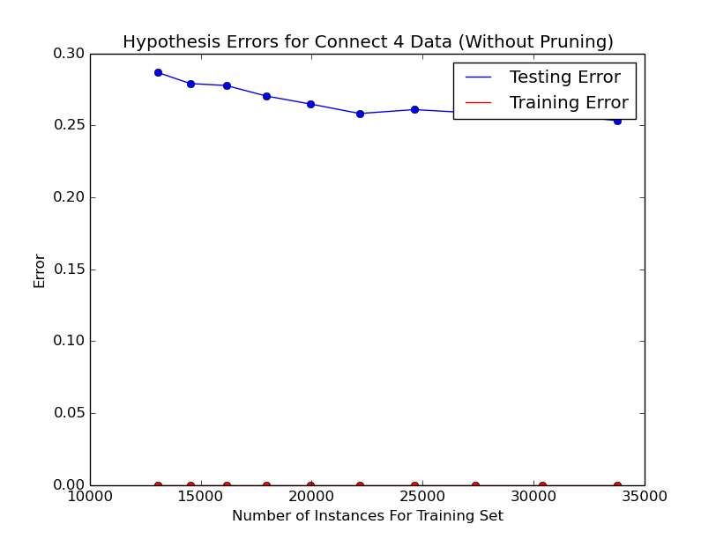

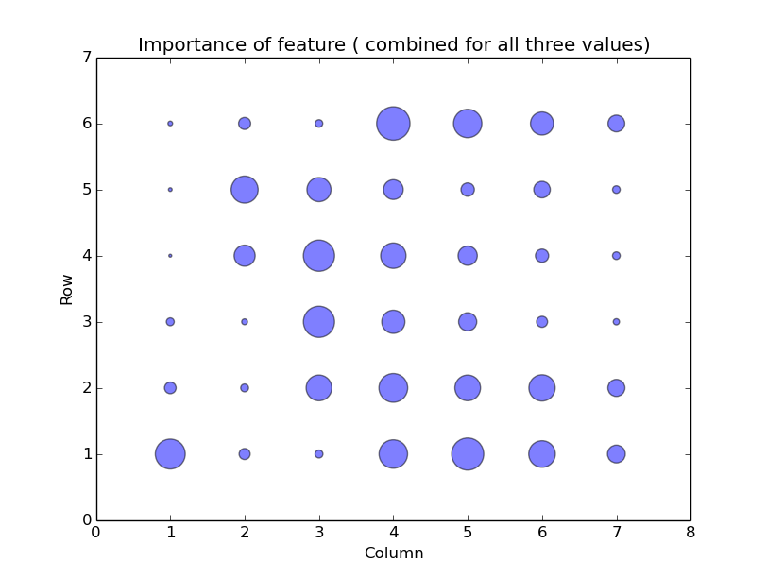
Since the data can hold three values that don't represent anything in a linear order (the state of a given space), each feature was transformed into three binary features that give a 1 if the grid space holds that value and a 0 if it does not. Therefore, a total of 126 features are given with 42 of them being 1 and the rest as 0. The training sets without pruning completely fits all iterations of the tree propagation. The test error seems to have a negative correlation to the size of the training data. Although this particular algorithm performs rather poorly on the test set with a minimum error of .25267 and a minimum testing error with a tree depth of 18 at .2504, it can be concluded that the module overfits the testing data and is difficult to fix. Therefore, a conclusion to be made is that if the tree module was given more instances that have not been seen yet, the algorithm would perform better overall because the testing error seems to be going down as more instances are given for the training module. Another conclusion can be made once the tree that gave the lowest test error is completed and the importance of each feature is found by taking the GINI importance( this is not to be confused with the GINI impurity) of each feature. The GINI importance is the sum of the difference of decreases of GINI impurity of a particular feature. What is apparent by the graph, is that the features in the middle of the grid show bigger importance. It seems intuitive that the middle column would have more importance than the outer columns. Despite this, the outer columns do not express a better distribution of the importance as one would expect which seems to show that the module expresses a bit of noise.
The Decision Tree Approach on the Forest Coverage Problem

The forest problem appears to have a similar fitting issue that the Connect 4 problem faced with when no pruning was done. That is, the module fits all instances of the training module, but returns a minimum error of 0.2374 on the training set with the most instances which seems to insist that the module has overfitted the training data. Very little gain is achieved when pruning takes place at a minimum when the max depth of the tree is at 18: 0.2287. When other types of pruning methods were taken, nothing seemed to lower the error rate. Rather, in one case of setting the amount of maximum nodes that a tree could hold, the results gave 100% error rates for all iterations. (up to 275 nodes was checked) This is probably due to the fact that there are 7 possible classes and the module needs to properly be able to fit all 7 of them. When the GINI importance ratios were found, the 'aspect' feature had a very high rate .413018015. Where the second rate was the hillside shade at 9 AM at .0898442188. Since these GINI importances are normalized, these two features give half of the importance. Many soil binary features gave 0 importance. To conclude on this algorithm for this problem, the pruning feature did not help fix the overfitting problem, but perhaps by manipulating the high importance values and creating new values from them, it would help solve the problem.

The Neural Network Approach
The neural network algorithm was implemented using the PyBrain library. The Back Propagation method is used for training in which an instance pushes forward on a neural network and once it reaches the classification label, if the label disagrees with the true label of the instance, it back propagates the delta(change) of the weights, then updates the weights based on its learning constant and delta. For both problems a single hidden layer is used, 5-node and a 15- node hidden layer will be ran on for both problems. The algorithm trains over 10 epochs. A cross validation set is used to find the best fit epoch. The algorithm runs better if the labels are transformed into binary classifications that represent whether an instance is a class or not. So for the output nodes in the Connect 4 problem 3 nodes are outputted and 7 for the forest coverage problem.

The Neural Network Approach on the Connect 4 Problem
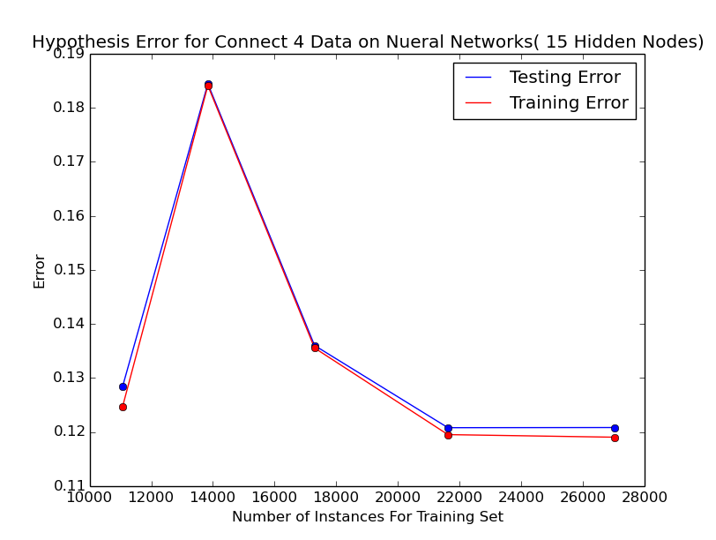
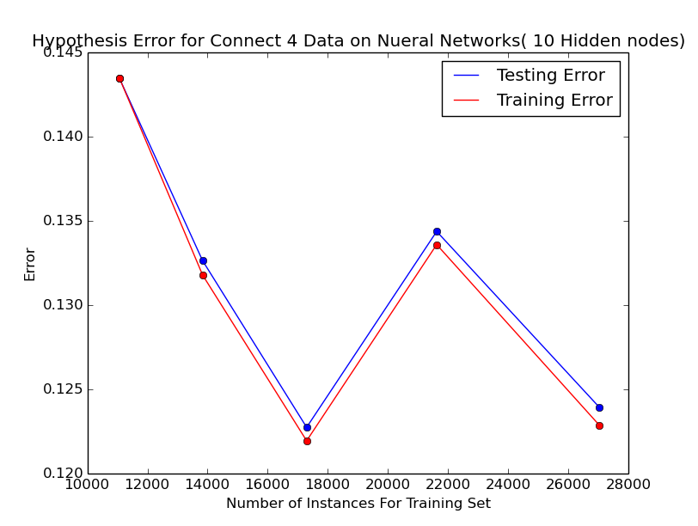

The Boosting Approach
The boosting algorithms for both sets used the AdaBoostClassifier class in the sklearn library. This enacted the Ana Boost algorithm on the same decision tree algorithm used previously. The boosting algorithm requires to set the size of the forest for the algorithm to train on. This is set to 200 for the two problem. In practice the algorithm will train on the decision tree and guarantee that its error rate is at least a little better than a half, if it does not find one, or fits the training set perfectly, it will stop learning on the forest. Pruning was also performed on both problems by changing the max_depth of the tree that the boosting algorithm will train on.

For quick instructions and an addictive online version of the game please see http://www.knowledgeadventure.com/games/connect-four/
http://oeis.org/A212693 gives a brief description of an algorithm that computes this number
This label is changed to 0 for the neural network portion of the analysis due to the nature of the algorithms implemented.

