Utilization of VAT for Hot-start of TSP solutions
Scott Phillips and Kelly Cohen PhD
¹University of Cincinnati, Cincinnati, Ohio 45221
cohenky@uc.edu
sphillips@nexigen.com
Abstract. Utilizing Visualization Assessment for Tendency (VAT) for hot-start of Ant Colony Optimization (ACO) TSP solutions. VAT provides an excellent hot-start for further refinement by local swarms, in addition to supporting recursive local cluster optimization.
Keywords: VAT, TSP, ACO
- VAT Background
Visual Assessment for Tendency (VAT) is a cluster identification technique pioneered by Bezdek,. It converts an Nx2 matrix of observations into a NxN dissimilarity matrix D. While there are multiple dissimilarity measures that can be used, one of the most common is the Euclidean distance, or L2-norm. If the L2-norm is used, then the dissimilarity matrix becomes a symmetric distance matrix, and the observations become points, or “cities” on the 2D plane.
The VAT then uses a Minimum Spanning Tree (MST) approach to finding the optimal ordering of the columns of D to minimize differences from one row r_{i} to the next row r_{i+1}. It then generates the Reordered Dissimilarity Image (RDI), with the minimum distances aligned along the diagonal. When this D matrix is viewed as an image, “dark blocks” will appear that signify both cluster existence and cluster size.
The algorithm as proposed by Bezdek et al is very similar to Prim’s algorithm, which is used to identify the optimal tree routing through a collection of nodes, respecting which nodes and edges are connected.
- ACO Background
Ant Colony Optimization (ACO) is a form of swarm optimization, wherein “ants” explore the possible search space, balancing the local optimal choice against the previously explored choices as expressed by a “pheromone trail”. The "pheromone trail” evaporates over time, and the most recent ants keep refreshing it. The strength of a given pheromone is inversely proportional to the cost function, so more optimal solutions have stronger pheromone trails.
While there are continuous and mixed-domain ACO techniques, one of the very common problems is a discrete choice problem, the Traveling Salesman Problem (TSP). The pheromone trail ends up being a 2D matrix P of the same shape as the Distance matrix D. As each ant traverses the cities, it picks a random city from those not visited, with the probability of each city being related to the immediate distance and the number of ants which made that choice before “pheromone trail”. When an ant has visited all cities and returned to the start, its pheromone trail is inversely related to the total distance it has traveled.
Because ACO is a stochastic optimization method, it does not require a cost function to be continuous or differentiable, only comparable. This relaxes a lot of common optimization constraints, but makes the problem susceptible to initialization issues. While ACO will not get stuck in (automatically find) the nearest local optima (unlike gradient-descent methods), it is not guaranteed to find an optima at all. As a result, most ACO problems are solved in finite time, a finite number of generations, and the optimal solution found is returned. As a result, it is helpful to have a reasonable initial guess of a solution, a so called “hot start” to the ACO.
- The Connection
If the dissimilarity matrix D is taken to be the distance matrix where the city numbers match the row/column numbers of the matrix (because it is symmetric when using the L2-norm), the VAT matrix D` is a permutation of the rows and columns that minimize the distances on the primary diagonals. A distance matrix will have 0 in the primary diagonal, since the Euclidean distance between a point p and itself is, by definition, zero.
That being said, the off-diagonal entries (p,q) represent the distance from a city p to city q. The total distance of the tour T is the sum of the distances from each city to the next, and then back to the start (if necessary). Because the graph is connected, closed, and symmetric, the total distance for a tour T does not change based upon the choice of starting city, only on the order of the cities in the tour. An intuitive tour would be the off-1 diagonal of D`, representing visiting each of the reordered cities sequentially. The return to start is the entry D`_{1,N}, representing the distance from city 1 to city N. Since the VAT algorithm identifies the reordering, it is possible to identify the actual tour order T in the original city order, not just in the D` order.
This combination of distance and ordering provides a solution to the MST, as well as the corresponding TSP. In addition, because the TSP is, in the worst case, visiting every entry in the MST twice, the MST tour provides an upper bound on the best possible tour:
$Cost\left(tour_{best}\right)≤ 2*Cost(MST)$ (1)
  - Examples
The sample case used was designed to have obvious clusters as well as an overall structure. This structure is a half-circle or a full circle with small, regular N-gons uniformly distributed around the primary circle (which itself is approximated as an N-gon). The variables in question are N_clusters and N_cities_per_cluster. By utilizing this structure, an accurate approximation to the optimal tour could be computed analytically by the following formula:
$T_{optimal}= P_{polygon}+N_{cities}*P_{city_{polygon}} – N_{cities}*D_{city_{polygon}}$ (2)
By keeping D_polygon > D_city_polygon, the optimal tour will encompass each small cluster in sequence around the perimeter. A random tour will crisscross the center, leading to a much longer (and therefore worse) tour.
Fig. 1. City Paths and VAT/IVAT comparison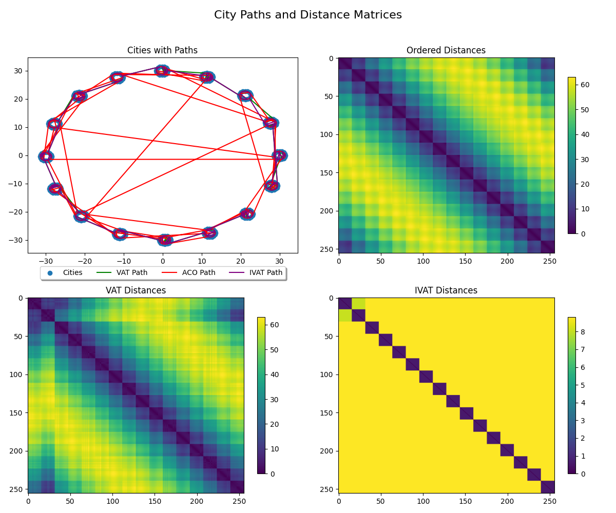

- The (other) Connection
A natural follow-up question to “can the VAT hot-start a TSP?” is “can a TSP solution help identify the VAT?” To explore this case, we took a “random” permutation of cities based upon the example design of 3.1. This provides confidence that the optimal VAT clustering is very distinct and structured, while appearing random on first glance. The only constraint applied to the permutation was that city-1 (the start) remained at column-1, thereby ensuring the ACO started on a consistent city in every run. All rows and columns were permuted the same way, thereby keeping the permuted distance matrix DP symmetric.
At first, a naïve ACO TSP solver from 2 was used. It was found that the ACO solution did not converge quickly relative to the size of DP. Since the final outcome should always be the optimal one, a random permutation system was applied. For this method, the initial cities were assumed to be in order co={1,…N}, and random pairs of cities were swapped to produce order cp. The tour length was then computed directly (an O(N) operation). If the Tour(cp) < Tour(co), then the permuted order is assigned to co. Otherwise, the permutation is undone and another pair of random cities is permuted. This operation is repeated for a predefined number of times N_permutations. The final permuted order is then returned, and the approximate VAT matrix aD is visualized using the normal VAT techniques.
  - Examples
Fig. 2. TSP Approximation of VAT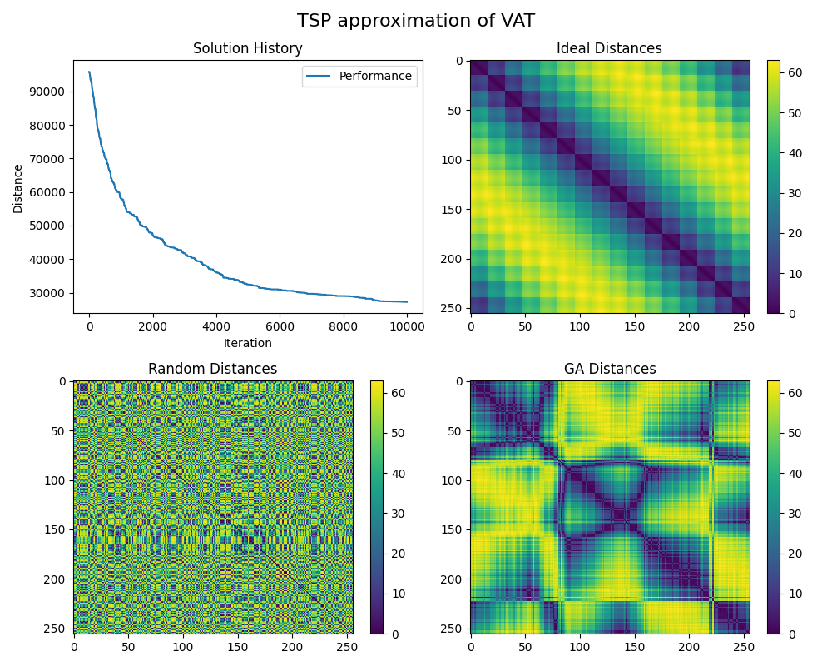

For citations of references, we prefer the use of square brackets and consecutive numbers. Citations using labels or the author/year convention are also acceptable. The following bibliography provides a sample reference list with entries for journal articles [1], an LNCS chapter [2], a book [3], proceedings without editors [4], as well as a URL [5].

References
- Author, F.: Article title. Journal 2(5), 99–110 (2016).
- Author, F., Author, S.: Title of a proceedings paper. In: Editor, F., Editor, S. (eds.) CONFERENCE 2016, LNCS, vol. 9999, pp. 1–13. Springer, Heidelberg (2016).
- Author, F., Author, S., Author, T.: Book title. 2nd edn. Publisher, Location (1999).
- Author, F.: Contribution title. In: 9th International Proceedings on Proceedings, pp. 1–2. Publisher, Location (2010).
- LNCS Homepage, http://www.springer.com/lncs, last accessed 2016/11/21.

Wang, L., Nguyen, U.T.V., Bezdek, J.C., Leckie, C.A., Ramamohanarao, K. (2010). iVAT and aVAT: Enhanced Visual Analysis for Cluster Tendency Assessment. In: Zaki, M.J., Yu, J.X., Ravindran, B., Pudi, V. (eds) Advances in Knowledge Discovery and Data Mining. PAKDD 2010. Lecture Notes in Computer Science(), vol 6118. Springer, Berlin, Heidelberg. https://doi.org/10.1007/978-3-642-13657-3_5
https://arxiv.org/pdf/2008.09570v1
Havens, Timothy & Bezdek, James. (2012). An Efficient Formulation of the Improved Visual Assessment of Cluster Tendency (iVAT) Algorithm. Knowledge and Data Engineering, IEEE Transactions on. 24. 1 - 1. 10.1109/TKDE.2011.33.
https://realcyh.github.io/yuhang-chen/tsp/

