Cloud and Containers
Evidence Template
  - CEN4025 | Assignment 9
Student: Marcus Ridley
Prepared: November 8 2026
Test dates: [record actual dates]
Repository: [Assignment 9 GitHub URL]
Cloud URL: [actual deployed HTTPS endpoint]
This document collects deliverables 2 through 5 for the Java reservation service: local container execution, two container investigations, cloud deployment and an evidence-based comparison. Project resources are submitted separately as deliverable 1.

How to use this template
Add screenshots as each step finishes. Replace bracketed prompts with actual commands, settings and observations. Captions identify what the image demonstrates; the results paragraph explains its significance. Keep full output in evidence/logs and original images in evidence/screenshots. Remove unused prompts before submission.
Current status: Local container build, startup, HTTP verification and Investigation 1 on port publication are complete. Investigation 2 on storage and cloud deployment remain pending.
Report order: 2 Application and Containerization Evidence; 3 Container Configuration Investigation Evidence; 4 Cloud Deployment Evidence; 5 Local and Cloud Comparison. Figure numbers run continuously from 1 through 13.

2 Application and Containerization Evidence

2.1 Application and runtime requirements
Selected application: Java reservation service reused from Assignment 8. Its HTTP API lists available appointment slots, creates reservations, retrieves a booking by ID and cancels reservations. Verify at least two distinct operations in both local and cloud environments.
Application dependencies: Java 21, Maven, Spring Boot 4.1.1, web MVC, validation and Jackson dependencies from pom.xml. CSV persistence uses data/reservations.csv relative to the application working directory. No external database is planned.
Host and engine: Mac with Apple Silicon. Docker Desktop 4.98.0 and Docker Engine 29.9.2 were checked on November 8 2026; client darwin/arm64 and server linux/arm64. [Record current macOS version and actual allocated Docker resources.]

2.2 Container definition and decisions
Prepared configuration: a Maven and Java 21 build stage runs mvn -B package; a Java 21 runtime stage receives the JAR. The process runs as app, uses /app as its working directory and writes to /app/data. PORT defaults to 8080 and can be supplied by the cloud platform. HTTP binds to 0.0.0.0.
Record exact configuration: [Paste the Dockerfile or selected excerpts. Record image tags and actual image digest or ID after building. Explain build versus runtime stages, unprivileged execution, writable directory permissions, Java memory setting and .dockerignore.]
Network requirements: HTTP requires a published host port for local access and an exposed service endpoint in the cloud. The existing TCP listener on 9090 is outside this assignment’s HTTP tests and is not planned for publication.

2.3 Deployment planning
Selected provider: Render using the existing student account. Proposed service: Free Docker web service. Proposed service model: PaaS. Confirm the selected plan, account requirements, resources, PORT binding and supported image architecture before deployment. Record the date and links used for verification.
Provider verification: [Actual Free plan availability, signup requirements, runtime support and limitations. Confirm no paid resource or payment method is required.]

2.4 Image build and local startup
Build evidence: Capture the completed docker build output, image tag or ID and Maven test summary. Keep the full build log; a command entered without its completed output is insufficient.

Figure 1. Successful container image construction. Mac Terminal shows Maven BUILD SUCCESS, copying the packaged JAR into /app/application.jar, completed image export and the tag cen4025-reservation:a9. The terminal prompt returns after the build finishes.
Results and explanation: The multi-stage image build completed successfully. The build stage packaged the Java application, and the runtime stage received the executable JAR. The retained local-build.log records 13 tests with zero failures, errors or skipped tests. The resulting image is ready for local startup; this evidence does not yet establish that a container is running or that host HTTP requests succeed.
Runtime evidence: Capture docker ps with the container name, image, state and published ports, plus application startup logs. Record the exact docker run command and working directory.

Figure 2. Local container startup and published port. Mac Terminal shows docker run starting cen4025-a9 from cen4025-reservation:a9 and docker ps reporting container e23a1e19f2d1 as Up with 127.0.0.1:8080 mapped to container port 8080. The logs report Java 21.0.13, Spring Boot 4.1.1, Tomcat started on port 8080 and successful application startup.
Results and explanation: The Java application starts inside the container as user app from /app/application.jar. Publishing the HTTP port on host loopback provides a localhost endpoint for the Mac while limiting publication to this host. JAVA_TOOL_OPTIONS applies MaxRAMPercentage=60.0. The application also logs a TCP listener on 9090, which is not published. Container startup and port publication are verified; actual host HTTP accessibility and reservation operations require the next test.

2.5 Local application functionality
Record requests: Use the Mac host, outside the container. Keep HTTP status lines and returned IDs. Test slot listing plus reservation creation and retrieval or cancellation. Label each command and its response.

Figure 3. Successful local API verification from macOS. The host verifier requests http://localhost:8080 and records appointment listing with HTTP 200, reservation creation with HTTP 201, retrieval of the same ID with HTTP 200, cancellation with HTTP 204 and a final appointment listing with HTTP 200. The output ends with ALL HTTP CHECKS PASSED.
Results and explanation: Requests from outside the container reach the application through the published port. Booking 2dbcc03c-a450-44a0-bd29-74cdf5904a7d refers to SLOT-001 and is retrieved with matching data before cancellation. The verifier checks that SLOT-001 returns to availability afterward. This establishes meaningful application functionality and host accessibility, beyond successful container startup. Complete output is retained in evidence/logs/local-http.log.

2.6 Local verification summary
Image construction: PASS. Maven BUILD SUCCESS and completed Docker export are recorded in Figure 1 and evidence/logs/local-build.log. The image is tagged cen4025-reservation:a9.
Startup and accessibility: PASS. Figure 2 verifies startup and loopback port publication; Figure 3 verifies actual requests from the Mac host.
Functional checks: PASS. Appointment listing, reservation creation, retrieval and cancellation succeeded; the verifier also confirmed restored slot availability. See Figure 3 and evidence/logs/local-http.log.
Problems and fixes: [Record any build, permission, port or runtime failures and the corrective actions actually performed.]

3 Container Configuration Investigation Evidence

3.1 Investigation 1 Container port publication
Question: How does publishing a container port affect access from the Mac when the application binding and image remain unchanged? This investigates Docker network exposure rather than repeating the VM binding-address experiment.
Baseline configuration: Figures 2 and 3 show cen4025-a9 using cen4025-reservation:a9 with -p 127.0.0.1:8080:8080 and successful host HTTP access. For the test, that container is stopped and the same image starts as cen4025-a9-unpublished without -p. The app still listens on container port 8080.
Modification: Remove host port publication while keeping the image and application listener unchanged. The exact command is docker run -d --name cen4025-a9-unpublished cen4025-reservation:a9. The original published container is retained for the restoration test.

Figure 4. Host connection fails without container port publication. The published container cen4025-a9 is stopped and cen4025-a9-unpublished starts from the same cen4025-reservation:a9 image without a -p option. Startup logs report Tomcat on port 8080. docker ps reports the new container as Up and shows only 8080/tcp, without a host mapping. The Mac request to localhost:8080/api/appointments fails with curl error 7.
Results and explanation: The application starts successfully, but its HTTP port is not published on the Mac. The displayed 8080/tcp describes the exposed container port and does not create a host listener. Comparing this result with successful host requests in Figure 3 isolates port publication as the changed condition; the application image and its binding configuration are unchanged. The Docker Desktop supporting screenshot also shows the original container stopped and the unpublished container running without a published port. Figure 5 records restoration and the successful host retest.

Figure 5. Published endpoint restored and verified from macOS. The terminal records stopping cen4025-a9-unpublished and restarting cen4025-a9. docker ps shows the original container e23a1e19f2d1 running with 127.0.0.1:8080 mapped to container port 8080. A request from the Mac to localhost:8080/api/appointments returns HTTP/1.1 200 with four appointment records.
Results and explanation: Restoring the container with the published port restores host HTTP access. Figure 4 shows successful application startup without publication and a failed host request; Figure 5 shows a working host request after returning to the published container. The image and HTTP listener settings are unchanged. EXPOSE 8080 describes the container port, while -p creates the host mapping needed here. This completes the baseline, modification, observation and restoration for Investigation 1. The supporting Docker Desktop image corroborates the running and stopped states; the terminal response establishes actual accessibility.

3.2 Investigation 2 Container replacement and storage
Question: Does a reservation survive removal and recreation of the container, and how does a named volume change the result? Use the same image and CSV storage configuration. Compare replacement, not only restart of the same container.

3.2.1 Baseline without external storage
Without a volume: cen4025-a9 uses the image cen4025-reservation:a9 and publishes 127.0.0.1:8080 to container port 8080. The baseline booking is 68d7dc73-418e-436d-a04c-de98789f9ac1, and the CSV path is /app/data/reservations.csv. Figure 6 records successful retrieval and no external mounts.

Figure 6. Reservation and CSV data before container replacement. A POST request creates reservation 68d7dc73-418e-436d-a04c-de98789f9ac1 for SLOT-001. Retrieval of that ID returns HTTP/1.1 200. docker inspect reports an empty Mounts array, and docker exec displays the same booking in /app/data/reservations.csv.
Results and explanation: The booking exists in the running application and in a CSV file inside the container. No volume or bind mount is attached, so this establishes the baseline for testing data lifetime in the container writable layer. It does not yet show what happens after replacement. The booking ID is saved on the Mac in evidence/logs/storage-no-volume-booking.json so the same record can be requested after recreation.

3.2.2 Replacement without a volume

Figure 7. Reservation data is lost after replacement without a volume. The original container is stopped and removed, then recreated from cen4025-reservation:a9 with the same host port mapping. The new container ID begins 17f151952e5c. Retrieval of the original reservation returns HTTP 400 with Reservation not found; appointment listing returns HTTP 200 including SLOT-001, and ls -l /app/data reports total 0.
Results and explanation: Figure 6 established that reservation 68d7dc73-418e-436d-a04c-de98789f9ac1 existed in both the application and its CSV file. Removing that container discarded its writable layer. The replacement uses the same image and published port, but the booking and CSV file are absent. The HTTP 400 is this application’s response for a missing reservation, not a network failure; the HTTP 200 appointment response demonstrates continued accessibility. The next test mounts a named volume at /app/data to compare data lifetime across replacement.

3.2.3 Replacement with a named volume
With a named volume: I mounted cen4025-a9-data at /app/data and created a reservation before testing container replacement.

Figure 8. Reservation stored in a named volume before replacement. The booking response and HTTP 200 lookup identify reservation 74f125aa-4ce8-410c-96a3-88c9f2636047. Docker inspection shows cen4025-a9-data mounted read-write at /app/data; the CSV file contains the matching reservation.
Results and explanation: The application can write and retrieve reservation data through the mounted volume as its configured service user. This establishes the baseline for the replacement test in Figure 9.

3.2.4 Reservation retained after container replacement
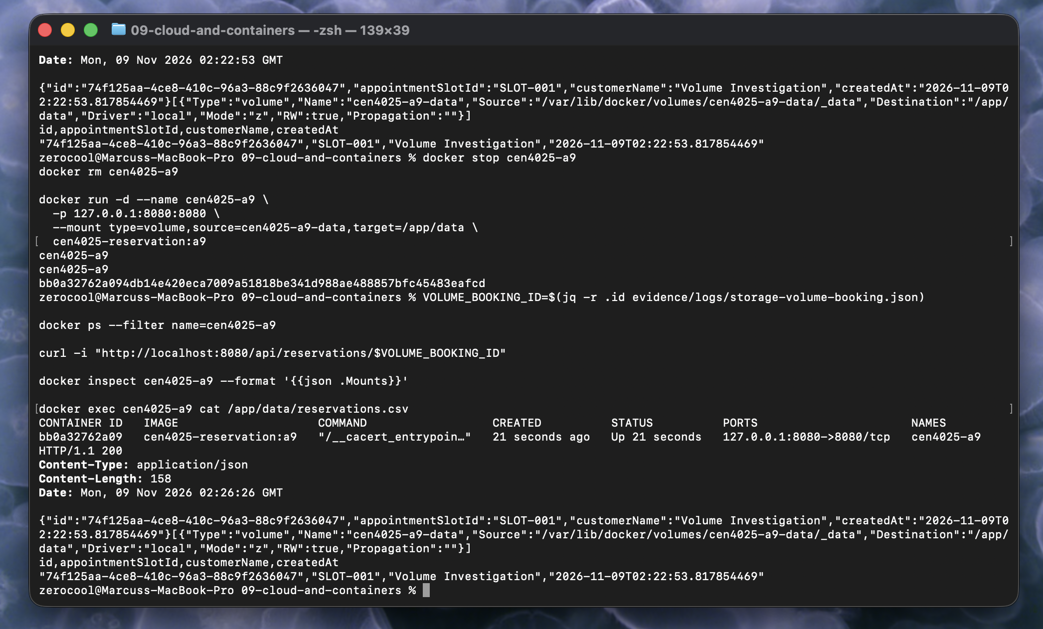
Figure 9. Named volume preserves the reservation after container replacement. After stopping and removing the prior container, a replacement with ID bb0a32762a09 mounts cen4025-a9-data at /app/data. Retrieval of reservation 74f125aa-4ce8-410c-96a3-88c9f2636047 returns HTTP 200, and the CSV retains the same record and creation time.
Results and explanation: The reservation survived removal and recreation because its CSV file resides in a named volume whose lifetime is independent of the container writable layer. Without a volume, the same replacement procedure lost the booking in Figure 7. Mounting the existing volume restores access to the original file; this is persistence across replacement, rather than merely restarting the same container. Deleting the volume would still remove its data.

4 Cloud Deployment Evidence

4.1 Provider service model and configuration
Provider and service: Render; [actual service name, region, Free plan, resource allocation, branch and commit].
Deployment source: [Repository URL and commit or image reference. Record Dockerfile path and build context.]
Runtime and network: [Actual PORT, server binding, environment variables, health check path and public HTTPS URL. Exclude credentials.]
Responsibilities: [Explain what Render manages and what you configure, deploy and maintain. Identify this approach’s cloud service model.]
[Insert screenshot or actual command output here]
Figure 10. Cloud service deployment settings. [Complete after capture: Show the selected plan and relevant runtime and network settings. This configuration screenshot does not by itself demonstrate a working application.]
Results and explanation: [Pending. State the observed result, how the evidence supports it, and why it matters. Include failures or limitations where applicable.]

4.2 Cloud build and startup
[Insert screenshot or actual command output here]
Figure 11. Cloud image build and application startup. [Complete after capture: Show completed build and startup output for the deployed revision. Record deployment date, revision and actual listening port.]
Results and explanation: [Pending. State the observed result, how the evidence supports it, and why it matters. Include failures or limitations where applicable.]

4.3 Cloud application verification
Run requests against the actual public cloud URL. Demonstrate at least two distinct operations and retain their HTTP statuses and responses. A cloud dashboard showing a running service is not enough.
[Insert screenshot or actual command output here]
Figure 12. Appointment listing through the public cloud endpoint. [Complete after capture: Show the exact HTTPS endpoint and returned appointment data. Record status, date and relevant startup delay if observed.]
Results and explanation: [Pending. State the observed result, how the evidence supports it, and why it matters. Include failures or limitations where applicable.]
[Insert screenshot or actual command output here]
Figure 13. Reservation operations through the public cloud endpoint. [Complete after capture: Show reservation creation and retrieval or cancellation, including status codes and matching IDs. Verify restored availability where applicable.]
Results and explanation: [Pending. State the observed result, how the evidence supports it, and why it matters. Include failures or limitations where applicable.]

4.4 Deployment issues and limitations
Problems and resolutions: [Actual symptom, diagnosis, changes and retest; write none observed only if accurate.]
Data lifetime and resources: [Record actual free-service restrictions and whether filesystem data survives restart or redeploy. Separate documented limits from behavior you tested.]

5 Local and Cloud Comparison

5.1 Observed functionality and configuration
Complete each row using actual values and evidence references from the local and cloud runs. Explain what each difference changes for application execution or portability.
Aspect | Local container | Cloud service
Operations and responses | [Actual value and evidence] | [Actual value and evidence]
Image revision and architecture | [Actual value and evidence] | [Actual value and evidence]
Port and network exposure | [Actual value and evidence] | [Actual value and evidence]
Environment and memory settings | [Actual value and evidence] | [Actual value and evidence]
CSV data lifetime | [Actual value and evidence] | [Actual value and evidence]
Infrastructure responsibility | [Actual value and evidence] | [Actual value and evidence]

5.2 Changes required for cloud execution
Application code changes: [List actual changes or explain that none were required, supported by the final source.]
Container configuration changes: [Base image, build architecture, startup command, working directory, permissions or memory settings actually changed.]
Deployment settings: [Actual provider PORT, health check, plan, endpoint and other service settings.]

5.3 Evaluation
[Explain observed portability, environment assumptions, persistence limitations and division of responsibilities. Support conclusions with the actual tests above. Do not substitute a general cloud description for your results.]

5.4 Supporting evidence and submission review
[Insert screenshot or actual command output here]
Figure 14. Supporting comparison evidence. [Complete after capture: Optional: show a direct local versus cloud comparison or a tested cloud restart result. If unused, remove this figure and update the figure count.]
Results and explanation: [Pending. State the observed result, how the evidence supports it, and why it matters. Include failures or limitations where applicable.]
Project resources: [Confirm source, Dockerfile, configuration and local/cloud instructions are included; exclude build output, images, caches and credentials.]
Evidence review: [Confirm all pending prompts are completed, figures are numbered, captions match images, both investigations are explained, and local and cloud operations have actual request/response evidence.]
Submission: [Deliverables 2–5 in this single Word document or a final PDF; project resources separately through Canvas or the repository link.]

