**Transposed context**

**LATEST SUBMISSION GRADE**

100%

**1.Question 1**

**Let (G, M, I)(*G*,*M*,*I*) be a formal context. Suppose that |G| = 1000∣*G*∣=1000 and |M| = 10∣*M*∣=10 and consider the "transposed" context (M, G, J)(*M*,*G*,*J*) such that mJg*mJg* if and only if gIm*gIm* for all g*g* from G*G* and m*m* from M*M*. Which context has more concepts?**

(G, M, I)(*G*,*M*,*I*)

(M, G, J)(*M*,*G*,*J*)

(G, M, I)(*G*,*M*,*I*) and (M, G, J)(*M*,*G*,*J*) have the same number of concepts.

**Correct**

**1 / 1 point**

**2.Question 2**

**Recall the naive algorithm computing all the concepts of (G, M, I)(*G*,*M*,*I*).**

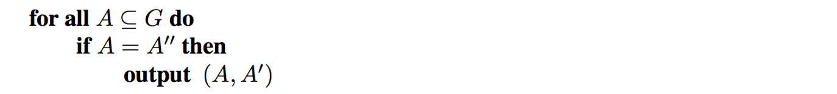

**Suppose that |G| = 1000∣*G*∣=1000 and |M| = 10∣*M*∣=10 and consider the "transposed" context (M, G, J)(*M*,*G*,*J*) such that mJg*mJg* if and only if gIm*gIm* for all g*g* from G*G* and m*m* from M*M*. On which of the two contexts will this algorithm spend more time?**

(G, M, I)(*G*,*M*,*I*)

(M, G, J)(*M*,*G*,*J*)

It will spend roughly the same time on (G, M, I)(*G*,*M*,*I*) and (M, G, J)(*M*,*G*,*J*).

**Correct**

For (G, M, I)(*G*,*M*,*I*), the algorithm iterates over 2^{1000}21000 subsets of G*G*, while, for (M, G, I)(*M*,*G*,*I*), there are only 2^{10}210 iterations over the subsets of M*M*. In both cases, each iteration takes time O(|G||M|)*O*(∣*G*∣∣*M*∣).