两台服务器安装lvs和keepalived
ip地址：192.168.1.244 【mac地址：00:16:3E:98:07:E8】
ip地址：192.168.1.233 【mac地址：00:16:3E:3B:60:AA】

虚拟IP：192.168.1.231

对244服务器操作

(二) 安装keepalived (D1,D2服务器都要安装keepalived)
cd /data/software/
rz 上传文件keepalived-1.2.13.tar.gz
[root@vm_web1 software]# tar -zvxf keepalived-1.2.13.tar.gz
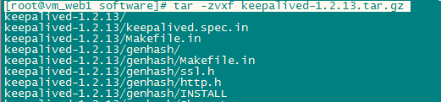

cd keepalived-1.2.13
./configure --sysconf=/data/conf/ --prefix=/data/apps/keepalived/
# 如果出现!!!
OpenSSL is not properly installed on your system. !!!
则执行yum -y install openssl-devel
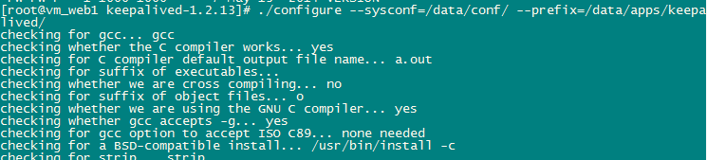

make
make install
ln -s /data/apps/keepalived/sbin/keepalived /sbin/keepalived
cp /home/data/conf/rc.d/init.d/keepalived /etc/rc.d/init.d/
cp /home/data/conf/sysconfig/keepalived /etc/sysconfig/
mkdir /etc/keepalived
cp /home/data/conf/keepalived/keepalived.conf /data/conf/
ln -s /data/conf/keepalived.conf /etc/keepalived/keepalived.conf
rm -rf /data/conf/keepalived /data/conf/rc.d /data/conf/sysconfig
echo "1" >/proc/sys/net/ipv4/ip_forward # 开启路由功能

(三) 安装ipvs管理软件(D1,D2服务器都要安装)
1： 检查kernel是否已经支持LVS的IPVS模块
modprobe -l | grep ipvs
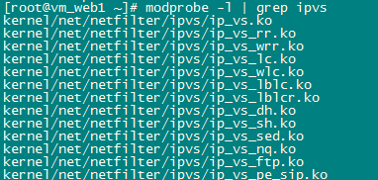
如果有类似上面的输出则说明内核已经支持
2： 安装ipvs
yum -y install ipvsadm
ipvsadm --help (看到参数信息则说明安装成功)
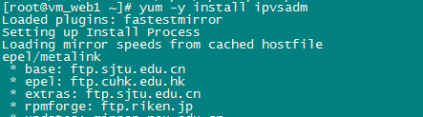

(四) 添加防火墙规则
iptables -F -t mangle # 清空mangle中的规则
iptables -t mangle -I PREROUTING -d 192.168.1.231 -p tcp -m tcp --dport 80 -m mac ! --mac-source 00:16:3E:3B:60:AA -j MARK --set-mark 1 【192.168.1.244服务器配置】
iptables -t mangle -I PREROUTING -d 192.168.1.231 -p tcp -m tcp --dport 80 -m mac ! --mac-source 00:16:3E:98:07:E8 -j MARK --set-mark 1 【192.168.1.233服务器配置】

# 目标ip地址是192.168.1.231并且目标端口为80的数据标记为1（排除另外一台lvs调度器 所以是排除另外一台调度器的mac地址 两台lvs的set-mark 值不同 并且规则中都排除对端的mac地址）
service iptables save
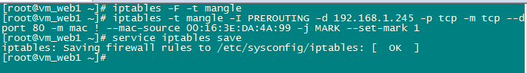

(五) 配置keepalived
vi /etc/keepalived/keepalived.conf
修改配置信息参考：
192.168.1.244和233配置.txt
【D2上配值和D1基本相同只是state MASTER改成state BACKUP,priority 100 改成 priority 80】
vi /data/conf/shell/chk_ipvsadm.sh
插入配置信息
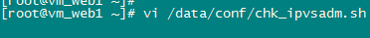
#!/bin/bash
#
# author: linmaogan
# description:
# 定时查看ipvsadm是否存在，如果不存在则启动ipvsadm，
# 如果启动失败，则停止keepalived
#

status=$(ps aux|grep ipvsadm | grep -v grep | grep -v bash | wc -l)
if [ "${status}" = "0" ]; then
service ipvsadm start
status2=$(ps aux|grep ipvsadm | grep -v grep | grep -v bash |wc -l)
if [ "${status2}" = "0" ]; then
/etc/init.d/keepalived stop
fi
fi
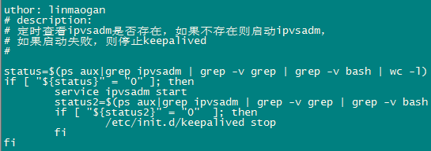

(六) Real_Server上的配置 (D1,D2上执行相同的操作)
# 在LVS的DR模式下，用户的访问请求到达Real Server 后，是直接返回给用户的，不再经过前端的Director Server,因此，需要在每个Real server节点上增加虚拟的VIP地址，这样数据才能直接返回给用户
chmod 777 /etc/rc.d/init.d/functions
vi /etc/init.d/lvsrs

#!/bin/bash
#把以下内容保存成:lvsrs
#并放置在/etc/init.d目录下
#如果想启动LVS Server执行:/etc/init.d/lvsrs start
#如果想停止LVS Server执行:/etc/init.d/lvsrs stop
VIP=192.168.1.231 #虚拟IP，视具体情况而变

. /etc/rc.d/init.d/functions # 如果提示权限不够，那么先在命令行执行: chmod 777 /etc/rc.d/init.d/functions

case "$1" in
start)
ifconfig lo:0 $VIP netmask 255.255.255.255 broadcast $VIP
/sbin/route add -host $VIP dev lo:0
echo "1" >/proc/sys/net/ipv4/conf/lo/arp_ignore
echo "2" >/proc/sys/net/ipv4/conf/lo/arp_announce
echo "1" >/proc/sys/net/ipv4/conf/all/arp_ignore
echo "2" >/proc/sys/net/ipv4/conf/all/arp_announce
sysctl -p >/dev/null 2>&1
echo "RealServer Start OK"
;;
stop)
ifconfig lo:0 down
route del $VIP >/dev/null 2>&1
echo "0" >/proc/sys/net/ipv4/conf/lo/arp_ignore
echo "0" >/proc/sys/net/ipv4/conf/lo/arp_announce
echo "0" >/proc/sys/net/ipv4/conf/all/arp_ignore
echo "0" >/proc/sys/net/ipv4/conf/all/arp_announce
echo "RealServer Stoped"
;;
*)
echo "Usage: $0 {start|stop}"
exit 1
esac
exit 0

chmod 755 /etc/init.d/lvsrs
service lvsrs start
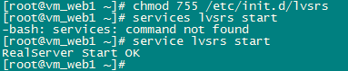

(七) 管理lvs (以下D1,D2上都执行)
1）启动lvs调度器
service keepalived start # 开启路由功能
echo "1" >/proc/sys/net/ipv4/ip_forward

2） 关闭lvs调度器
service keepalived stop
echo "0" >/proc/sys/net/ipv4/ip_forward
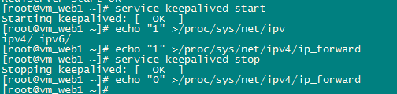

(八) 添加开机启动
chkconfig --add keepalived
chkconfig keepalived on

vi /etc/rc.d/rc.local
/etc/init.d/lvsrs start # 添加这一行到末尾

ip a 查询
