座號：08 姓名：方宜馨

階段性作業六

商品管理綜合應用(後台登入功能)

* 請製作「商品管理」之後台管理介面登入功能，使管理透過此介面登入後可以進入管理頁面，操作商品的上下架，須達到下列要求：
  1. 建立管理者登入功能，包含資料庫端所需資料表，及登入畫面。
  2. 請於資料庫中建立至少三筆管理者資料。
  3. 管理者登入須進行相關驗證，若為管理者，則進入管理頁面，若非管理者，則出現錯誤訊息。
  4. 須有防止使用者直接由網址列輸入管理介面url，繞過登入檢查的機制。
  5. 前端必須驗證下列項目：
     + 帳號與密碼為必要欄位，若有未填欄位則不得送出資料。
     + 帳號規則為第一碼為英文字母開頭的3-20碼字串。
     + 密碼規則為3-20確任一字元所組成的字串。
  6. 須配合MasterPage控制項製作主版頁面。
  7. 各項參考畫面如下三圖所示。

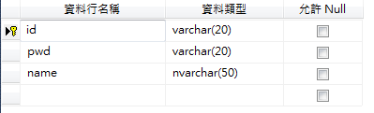

管理者資料表參考圖

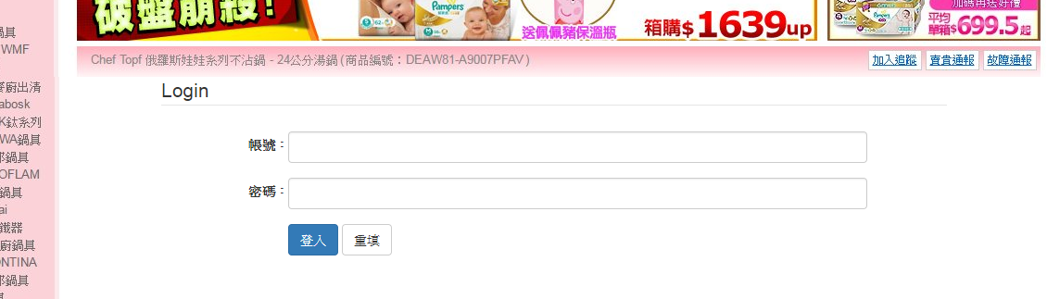

登入畫面參考圖

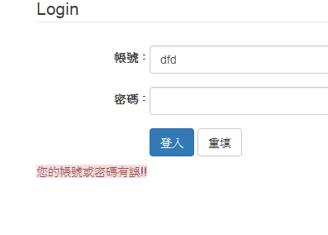

登入檢查錯誤參考圖

**繳交作業時，請以FTP上傳程式原始檔與本文件檔各一份，原始程式碼請另放置在一個資料夾內。**

※以上各項均須完成始得通過※

結果畫面截圖(含資料庫端畫面至少四個圖)：

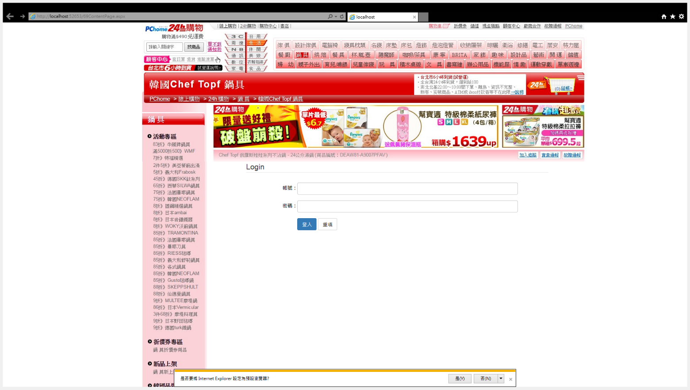

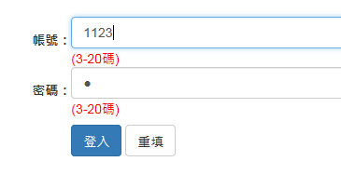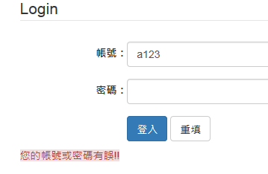

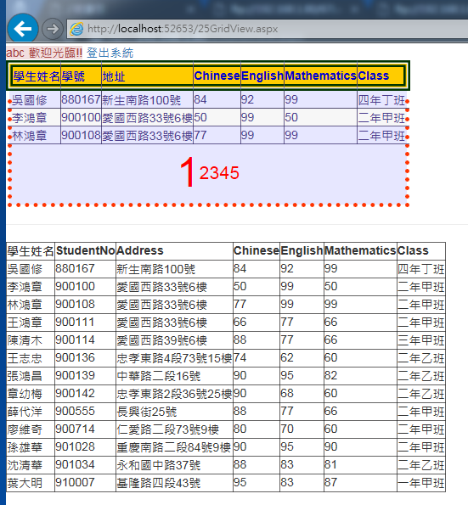

程式碼(所有相關的程式碼均須貼上)：

69ContentPage.aspx

<%@ Page Title="" Language="C#" MasterPageFile="~/MasterPage.master" AutoEventWireup="true" CodeFile="69ContentPage.aspx.cs" Inherits="_69ContentPage" %>

<asp:Content ID="Content1" ContentPlaceHolderID="head" Runat="Server">

<style>

tr{

height:50px;

}

</style>

</asp:Content>

<asp:Content ID="Content2" ContentPlaceHolderID="ContentPlaceHolder1" Runat="Server">

<fieldset>

<legend>

Login

</legend>

<table style="width:90%">

<tr>

<td class="text-right"><label for="txtAccount">帳號：</label></td>

<td>

<asp:TextBox ID="txtAccount" runat="server" CssClass="form-control"></asp:TextBox>

<asp:RequiredFieldValidator ControlToValidate="txtAccount" ID="RequiredFieldValidator1" runat="server" ErrorMessage="(必填)" ForeColor="Red" Display="Dynamic"></asp:RequiredFieldValidator>

<asp:RegularExpressionValidator ControlToValidate="txtAccount" ID="RegularExpressionValidator1" runat="server" ErrorMessage="(3-20碼)" ValidationExpression="[A-Za-z]\w{2,20}" ForeColor="Red" Display="Dynamic"></asp:RegularExpressionValidator>

</td>

</tr>

<tr>

<td class="text-right"><label for="txtPwd">密碼：</label></td>

<td>

<asp:TextBox ID="txtPwd" runat="server" CssClass="form-control" TextMode="Password"></asp:TextBox>

<asp:RequiredFieldValidator ControlToValidate="txtPwd" ID="RequiredFieldValidator2" runat="server" ErrorMessage="(必填)" ForeColor="Red" Display="Dynamic"></asp:RequiredFieldValidator>

<asp:RegularExpressionValidator ControlToValidate="txtPwd" ID="RegularExpressionValidator2" runat="server" ValidationExpression=".{3,20}" ErrorMessage="(3-20碼)" ForeColor="Red" Display="Dynamic"></asp:RegularExpressionValidator>

</td>

</tr>

<tr>

<td>

</td>

<td>

<asp:Button ID="Button1" runat="server" Text="登入" CssClass="btn btn-primary" OnClick="Button1_Click" />

<input id="Reset1" type="reset" value="重填" class="btn btn-default" />

</td>

</tr>

</table>

<asp:Label ID="lblInfo" runat="server" CssClass="alert-danger"></asp:Label>

</fieldset>

</asp:Content>

using System;

using System.Collections.Generic;

using System.Linq;

using System.Web;

using System.Web.UI;

using System.Web.UI.WebControls;

using System.Data;

using System.Data.SqlClient;

using System.Configuration;

public partial class _69ContentPage : System.Web.UI.Page

{

protected void Page_Load(object sender, EventArgs e)

{

}

protected void Button1_Click(object sender, EventArgs e)

{

SqlConnection conn = new SqlConnection(ConfigurationManager.ConnectionStrings["ScoresConnectionString"].ConnectionString);

SqlCommand cmd = new SqlCommand("select * from userdata where id=@id and pwd=@pwd", conn);

//SqlCommand cmd = new SqlCommand("select * from userdata where id='"+ txtAccount.Text + "' and pwd='"+ txtPwd.Text+"'", conn);

cmd.Parameters.AddWithValue("@id", txtAccount.Text);

cmd.Parameters.AddWithValue("@pwd", txtPwd.Text);

//Response.Write(cmd.CommandText);

SqlDataReader dr;

conn.Open();

dr = cmd.ExecuteReader();

if (dr.Read())

{

//ViewState["aa"] = 1;

Session["id"] = dr["id"].ToString();

Session["name"] = dr["name"].ToString();

Response.Redirect("25GridView.aspx");

}

else

{

lblInfo.Text = "您的帳號或密碼有誤!!";

}

conn.Close();

}

}

<?xml version="1.0" encoding="utf-8" ?>

<siteMap xmlns="http://schemas.microsoft.com/AspNet/SiteMap-File-1.0" >

<siteMapNode url="" title="我的資訊系統" description="">

<siteMapNode url="" title="商品管理" description="">

<siteMapNode url="" title="商品編輯" description="">

<siteMapNode url="NewProduct.aspx" title="商品新增" description="" />

<siteMapNode url="EditProduct.aspx" title="商品修改" description="" />

<siteMapNode url="OnProduct.aspx" title="商品上下架" description="" />

</siteMapNode>

<siteMapNode url="SearchProduct.aspx" title="商品查詢" description="" />

</siteMapNode>

<siteMapNode url="" title="會員管理" description="">

<siteMapNode url="NewMember.aspx" title="會員新增作業" description="" />

<siteMapNode url="EditMember.aspx" title="會員修改作業" description="" />

<siteMapNode url="SearchMember.aspx" title="會員查詢作業" description="" />

</siteMapNode>

<siteMapNode url="" title="訂單管理" description="">

<siteMapNode url="EditOrder.aspx" title="訂單修改作業" description="" />

<siteMapNode url="SearchOrder.aspx" title="訂單查詢作業" description="" />

</siteMapNode>

<siteMapNode url="CusCenter.aspx" title="客服中心" description="" />

</siteMapNode>

</siteMap>

<%@ Master Language="C#" AutoEventWireup="true" CodeFile="MasterPage.master.cs" Inherits="MasterPage" %>

<!DOCTYPE html>

<html xmlns="http://www.w3.org/1999/xhtml">

<head runat="server">

<meta http-equiv="Content-Type" content="text/html; charset=utf-8"/>

<title></title>

<asp:ContentPlaceHolder id="head" runat="server">

</asp:ContentPlaceHolder>

<link href="Content/bootstrap.min.css" rel="stylesheet" />

</head>

<body>

<form id="form1" runat="server">

<div class="container">

<div class="row">

<div class="col-xs-12">

<img src="images/TOP.jpg" />

</div>

</div>

<div class="row">

<div class="col-xs-3">

<img src="images/LEFT.jpg" />

</div>

<div class="col-xs-9">

<asp:ContentPlaceHolder id="ContentPlaceHolder1" runat="server">

</asp:ContentPlaceHolder>

</div>

</div>

<div class="row">

<div class="col-xs-12">

<img src="images/BOTTOM.jpg" />

</div>

</div>

</div>

</form>

</body>

</html>

25GridView

<%@ Page Language="C#" AutoEventWireup="true" CodeFile="25GridView.aspx.cs" Inherits="_25GridView" %>

<!DOCTYPE html>

<html xmlns="http://www.w3.org/1999/xhtml">

<head runat="server">

<meta http-equiv="Content-Type" content="text/html; charset=utf-8"/>

<title></title>

<style>

#GridView1 span{

font-size:36pt;

}

#GridView1 tr:last-child a:hover{

font-size:24pt;

}

</style>

<link href="Content/bootstrap.css" rel="stylesheet" />

</head>

<body>

<form id="form1" runat="server">

<div>

<asp:Label ID="Label1" runat="server" CssClass="alert-danger"></asp:Label>

<asp:LinkButton ID="LinkButton1" runat="server" OnClick="LinkButton1_Click">登出系統</asp:LinkButton>

<asp:GridView ID="GridView1" runat="server" AutoGenerateColumns="False" AllowPaging="true" AllowSorting="true"

BackColor="White" BorderColor="#ff3300" BorderStyle="Dotted" BorderWidth="5px" CellPadding="3"

DataKeyNames="StudentNo" DataSourceID="SqlDataSource1" GridLines="Both" PageSize="3">

<Columns>

<asp:BoundField DataField="Name" HeaderText="學生姓名" SortExpression="Name" />

<asp:BoundField DataField="StudentNo" HeaderText="學號" ReadOnly="True" SortExpression="StudentNo" />

<asp:BoundField DataField="Address" HeaderText="地址" SortExpression="Address" />

<asp:BoundField DataField="Chinese" HeaderText="Chinese" SortExpression="Chinese" />

<asp:BoundField DataField="English" HeaderText="English" SortExpression="English" />

<asp:BoundField DataField="Mathematics" HeaderText="Mathematics" SortExpression="Mathematics" />

<asp:BoundField DataField="Class" HeaderText="Class" SortExpression="Class" />

</Columns>

<FooterStyle BackColor="#B5C7DE" ForeColor="#4A3C8C" />

<HeaderStyle BackColor="#ffcc00" Font-Bold="True" ForeColor="#0000cc" BorderStyle="Double" BorderWidth="8px" BorderColor="#003300" />

<PagerStyle BackColor="#E7E7FF" ForeColor="#ff0000" HorizontalAlign="Center" Font-Size="16pt" />

<RowStyle BackColor="#E7E7FF" ForeColor="#4A3C8C" />

<AlternatingRowStyle BackColor="#F7F7F7" />

<SelectedRowStyle BackColor="#738A9C" Font-Bold="True" ForeColor="#F7F7F7" />

<SortedAscendingCellStyle BackColor="#9900cc" ForeColor="White" />

<SortedAscendingHeaderStyle BackColor="#5A4C9D" />

<SortedDescendingCellStyle BackColor="#D8D8F0" BorderColor="Green" BorderStyle="Dotted" BorderWidth="5px" />

<SortedDescendingHeaderStyle BackColor="#3E3277" />

</asp:GridView>

<asp:SqlDataSource ID="SqlDataSource1" runat="server"

ConnectionString="<%$ ConnectionStrings:ScoresConnectionString %>"

SelectCommand="SELECT * FROM [StudentScores]"></asp:SqlDataSource>

<hr />

<asp:GridView ID="GridView2" runat="server"

DataSourceID="SqlDataSource1" OnRowDataBound="GridView2_RowDataBound"></asp:GridView>

</div>

</form>

</body>

</html>

using System;

using System.Collections.Generic;

using System.Linq;

using System.Web;

using System.Web.UI;

using System.Web.UI.WebControls;

public partial class _25GridView : System.Web.UI.Page

{

protected void Page_Load(object sender, EventArgs e)

{

if (Session["id"] == null)

Response.Redirect("69ContentPage.aspx");

Label1.Text = Session["name"].ToString() + "歡迎光臨!!";

}

protected void GridView2_RowDataBound(object sender, GridViewRowEventArgs e)

{

if (e.Row.RowIndex < 0)

e.Row.Cells[0].Text = "學生姓名";

}

protected void LinkButton1_Click(object sender, EventArgs e)

{

Session["id"] = null;

Session["name"] = null;

Response.Redirect("69ContentPage.aspx");

}

}