座號：08 姓名：方宜馨

階段性作業五

綜合應用-選單製作

**請利用HTML、CSS與jQuery撰寫如下選單功能：**

1. 下拉式選單(請參考下圖)

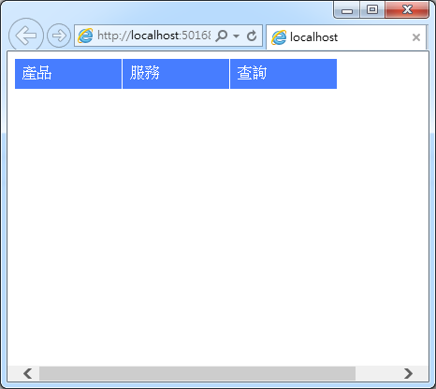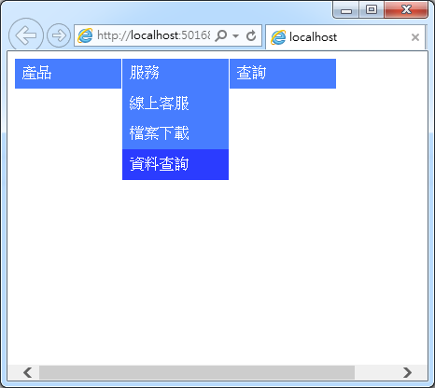

原始碼請貼於框線內：

|  |
| --- |
| <!DOCTYPE html>  <html>  <head>  <meta http-equiv="Content-Type" content="text/html; charset=utf-8" />  <title></title>  <meta charset="utf-8" />  <style>  #container {  width: 500px;  position: relative;  }  #menu {  /*border:2px solid red;*/  position: absolute;  top: 0;  left: 0;  height: 50px;  }  #menu, .submenu {  list-style: none;  margin: 0;  padding: 0;  }  #menu li {  background-color:#fb89d9;  float: left;  border-right: 1px solid white;  }  #menu a {  color: white;  text-decoration: none;  padding: 10px;  width: 120px;  display: block;  }  #menu li ul {  width: 120px;  }  #menu a:hover {  background-color: #fb178e;  }  </style>  </head>  <body>  <div id="container">  <ul id="menu">  <li>  <a href="#">產品</a>  <ul class="submenu">  <li><a href="#">ASP.net</a></li>  <li><a href="#">jQuery</a></li>  <li><a href="#">JavaScript</a></li>  </ul>  </li>  <li>  <a href="#">服務</a>  <ul class="submenu">  <li><a href="#">線上客服</a></li>  <li><a href="#">檔案下載</a></li>  <li><a href="#">資料查詢</a></li>  </ul>  </li>  <li>  <a href="#">查詢</a>  <ul class="submenu">  <li><a href="#">訂單查詢</a></li>  <li><a href="#">歷史訂單</a></li>  </ul>  </li>  </ul>  </div>  <script src="../../Scripts/jquery-3.2.1.min.js"></script>  <script>  $('.submenu').hide();  $('#menu li').hover(function () {  $(this).find('ul').slideDown(300);  }, function () {  $(this).find('ul').slideUp(300);  });  </script>  </body>  </html> |

畫面截圖請貼在下方：

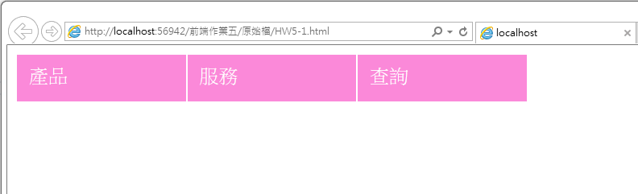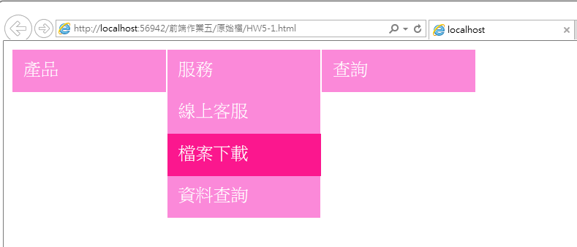

1. 摺疊式選單(請參考下圖)

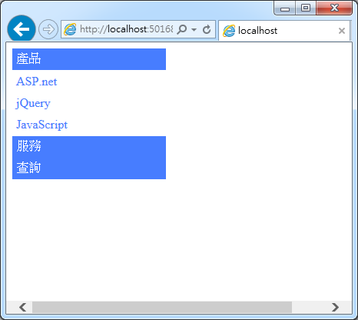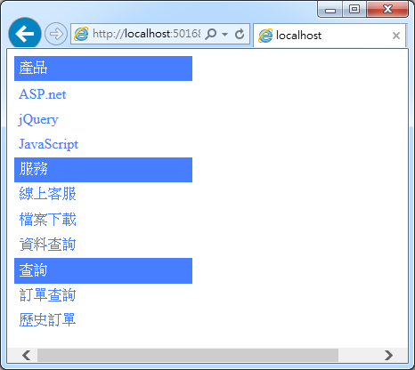

原始碼請貼於框線內：

|  |
| --- |
| <!DOCTYPE html>  <html>  <head>  <meta http-equiv="Content-Type" content="text/html; charset=utf-8" />  <title></title>  <meta charset="utf-8" />  <style>  #container {  /*border:2px solid;*/  width: 500px;  position: relative;  }  #menu {  /*border:2px solid red;*/  position: absolute;  top: 0;  left: 0;  height: 50px;  width: 200px;  }  #menu, .submenu {  list-style: none;  margin: 0;  padding: 0;  }  #menu li {  background-color: #fb178e;  /*float:left;*/  /*border-right:1px solid white;*/  }  #menu a {  color: white;  text-decoration: none;  padding: 5px;  width: 200px;  display: block;  }  #menu li ul {  width: 200px;  }  #menu > li > ul > li {  background-color: white;  }  #menu > li > ul > li > a {  color: #fb178e;  }  </style>  </head>  <body>  <div id="container">  <ul id="menu">  <li>  <a href="#">產品</a>  <ul class="submenu">  <li><a href="#">ASP.net</a></li>  <li><a href="#">jQuery</a></li>  <li><a href="#">JavaScript</a></li>  </ul>  </li>  <li>  <a href="#">服務</a>  <ul class="submenu">  <li><a href="#">線上客服</a></li>  <li><a href="#">檔案下載</a></li>  <li><a href="#">資料查詢</a></li>  </ul>  </li>  <li>  <a href="#">查詢</a>  <ul class="submenu">  <li><a href="#">訂單查詢</a></li>  <li><a href="#">歷史訂單</a></li>  </ul>  </li>  </ul>  </div>  <script src="../../Scripts/jquery-3.2.1.min.js"></script>  <script>  $('.submenu').hide();  $('#menu li').click(function () {  $(this).find('ul').slideToggle(300);  });  </script>  </body>  </html> |

畫面截圖請貼在下方：

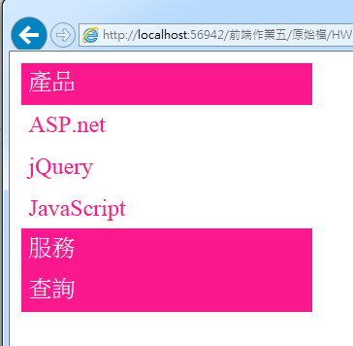 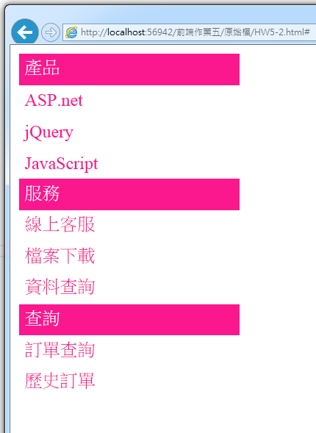

1. 手風琴選單(請參考下圖)

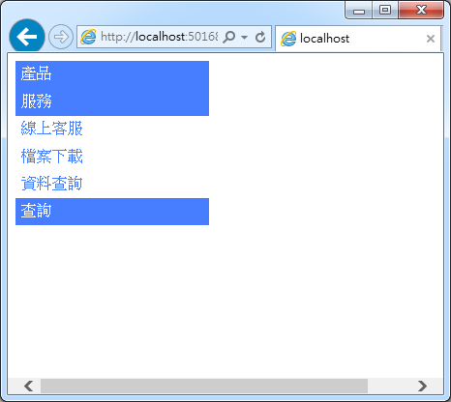

原始碼請貼於框線內：

|  |
| --- |
| <!DOCTYPE html>  <html>  <head>  <meta http-equiv="Content-Type" content="text/html; charset=utf-8" />  <title></title>  <meta charset="utf-8" />  <style>  #container {  /*border:2px solid;*/  width: 500px;  position: relative;  }  #menu {  /*border:2px solid red;*/  position: absolute;  top: 0;  left: 0;  height: 50px;  width: 200px;  }  #menu, .submenu {  list-style: none;  margin: 0;  padding: 0;  }  #menu li {  background-color: #fb178e;  /*float:left;*/  /*border-right:1px solid white;*/  }  #menu a {  color: white;  text-decoration: none;  padding: 5px;  width: 200px;  display: block;  }  #menu li ul {  width: 200px;  }  #menu > li > ul > li {  background-color: white;  }  #menu > li > ul > li > a {  color: #fb178e;  }  </style>  </head>  <body>  <div id="container">  <ul id="menu">  <li>  <a href="#">產品</a>  <ul class="submenu">  <li><a href="#">ASP.net</a></li>  <li><a href="#">jQuery</a></li>  <li><a href="#">JavaScript</a></li>  </ul>  </li>  <li>  <a href="#">服務</a>  <ul class="submenu">  <li><a href="#">線上客服</a></li>  <li><a href="#">檔案下載</a></li>  <li><a href="#">資料查詢</a></li>  </ul>  </li>  <li>  <a href="#">查詢</a>  <ul class="submenu">  <li><a href="#">訂單查詢</a></li>  <li><a href="#">歷史訂單</a></li>  </ul>  </li>  </ul>  </div>  <script src="../../Scripts/jquery-3.2.1.min.js"></script>  <script>  $('.submenu').hide();  $('#menu li').click(function () {  $('#menu>li>ul').slideUp(300);  $(this).find('ul').slideDown(300);  });  </script>  </body>  </html> |

畫面截圖請貼在下方：

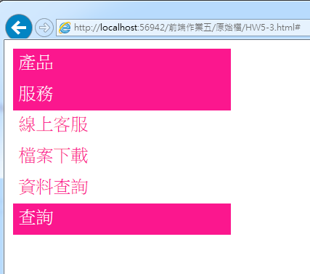

**繳交作業時，請以FTP上傳程式原始檔與本文件檔各一份，原始程式碼請另放置在一個資料夾內。**

※以上各項要求皆須完成始得通過※