座號：08　姓名：方宜馨

階段性作業六

預存程序(Stored Procedure)與自訂函數(Function)應用

1. 請利用ASP.net Web Form建立一介面，讓使用者可以對【教務系統】資料庫的【課程】資料表新增課程資料，並依下列要求進行：
   1. 請於資料庫端撰寫自訂函數，用以判斷《課程編號》是否重複，若重複則回傳某值告知應用程式端該編號不可使用。
   2. 請於資料庫端撰寫預存程序，用以新增課程資料。
   3. 應用程式端須以上述(1)之函數檢查Primary key是否重複，並以上述(2)之預存程序新增課程資料。
   4. 應用程式端與資料庫端之程式寫法不限，亦不限函數及預存程序的數量。

程式碼：

課程編號檢查函數程式碼：

create function fnCheckCourseID

(@id char(5))

returns char(1)

as

begin

declare @a char(5)

select @a=課程編號 from 課程

where 課程編號=@id

if @@ROWCOUNT=0

return '1'

return '0'

end

課程資料新增預存程序程式碼：

create proc addCourse

@id char(5),

@name varchar(30),

@c int

as

alter proc addCourse

@id char(5),

@name varchar(30),

@c int

as

begin

if dbo.fnCheckCourseID(@id)='1'

insert into 課程 values(@id,@name,@c)

end

應用程式端所有程式碼：

<%@ Page Language="C#" AutoEventWireup="true" CodeFile="57DB_HW6.aspx.cs" Inherits="_57DB_HW6" %>

<!DOCTYPE html>

<html xmlns="http://www.w3.org/1999/xhtml">

<head runat="server">

<meta http-equiv="Content-Type" content="text/html; charset=utf-8" />

<title></title>

</head>

<body>

<form id="form1" runat="server">

<asp:ScriptManager ID="ScriptManager1" runat="server"></asp:ScriptManager>

<div>

<asp:SqlDataSource ID="SqlDataSource1" runat="server" ConnectionString="<%$ ConnectionStrings:教務系統ConnectionString %>"

InsertCommand="addCourse" InsertCommandType="StoredProcedure">

<InsertParameters>

<asp:ControlParameter Name="id" ControlID="txtID" Type="String" />

<asp:ControlParameter Name="name" ControlID="txtName" Type="String" />

<asp:ControlParameter Name="c" ControlID="txtCredit" Type="Int16" />

</InsertParameters>

</asp:SqlDataSource>

<table style="width:400px;">

<tr>

<td>課程編號:</td>

<td>

<asp:UpdatePanel ID="UpdatePanel1" runat="server">

<ContentTemplate>

<asp:TextBox ID="txtID" runat="server" AutoPostBack="true" OnTextChanged="txtID_TextChanged"></asp:TextBox>

<asp:RequiredFieldValidator ID="RequiredFieldValidator1" ControlToValidate="txtID" runat="server" ForeColor="Red" ErrorMessage="必填項目" Display="Dynamic"></asp:RequiredFieldValidator>

<asp:RegularExpressionValidator ID="RegularExpressionValidator1" ControlToValidate="txtID" ValidationExpression="CS[0-9]{3}" runat="server" ErrorMessage="必為CS_ _ _ 開頭" ForeColor="Red" Display="Dynamic"></asp:RegularExpressionValidator>

<asp:Label ID="Label1" runat="server"></asp:Label>

</ContentTemplate>

</asp:UpdatePanel>

</td>

</tr>

<tr>

<td>課程名稱:</td>

<td>

<asp:TextBox ID="txtName" runat="server"></asp:TextBox>

<asp:RequiredFieldValidator ID="RequiredFieldValidator2" ControlToValidate="txtName" runat="server" ForeColor="Red" ErrorMessage="必填項目" Display="Dynamic"></asp:RequiredFieldValidator>

</td>

</tr>

<tr>

<td>課程學分:</td>

<td>

<asp:TextBox ID="txtCredit" runat="server"></asp:TextBox>

<asp:RequiredFieldValidator ID="RequiredFieldValidator3" ControlToValidate="txtCredit" runat="server" ForeColor="Red" ErrorMessage="必填項目" Display="Dynamic"></asp:RequiredFieldValidator>

<asp:RangeValidator ID="RangeValidator1" ControlToValidate="txtCredit" runat="server" MinimumValue="0" MaximumValue="10" Type="Integer" ErrorMessage="需為0-10之間" ForeColor="Red" Display="Dynamic"></asp:RangeValidator>

</td>

</tr>

<tr>

<td colspan="2">

<asp:Button ID="Button1" runat="server" Text="新增課程資料" OnClick="Button1_Click" />

</td>

</tr>

</table>

</div>

</form>

</body>

</html>

using System;

using System.Collections.Generic;

using System.Linq;

using System.Web;

using System.Web.UI;

using System.Web.UI.WebControls;

using System.Data;

using System.Data.SqlClient;

using System.Configuration;

public partial class _57DB_HW6 : System.Web.UI.Page

{

protected void Page_Load(object sender, EventArgs e)

{

}

protected void txtID_TextChanged(object sender, EventArgs e)

{

//強制先完成RegularExpression驗證

RegularExpressionValidator1.Validate();

//判斷IsValid的值

if (RegularExpressionValidator1.IsValid)

{

SqlConnection conn = new SqlConnection(ConfigurationManager.ConnectionStrings["教務系統ConnectionString"].ConnectionString);

SqlCommand cmd = new SqlCommand("select dbo.fnCheckCourseID('" + txtID.Text + "')", conn);

SqlDataReader dr;

conn.Open();

dr = cmd.ExecuteReader();

dr.Read();

if (dr[0].ToString() == "1")

{

Label1.Text = "編號可用";

Label1.ForeColor = System.Drawing.Color.Green;

}

else

{

Label1.Text = "編號重複";

Label1.ForeColor = System.Drawing.Color.Red;

}

conn.Close();

}

else

Label1.Text = "";

}

protected void Button1_Click(object sender, EventArgs e)

{

SqlDataSource1.Insert();

}

}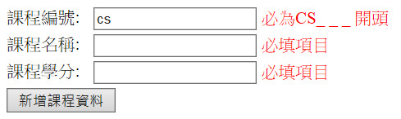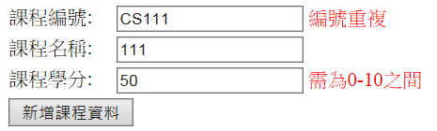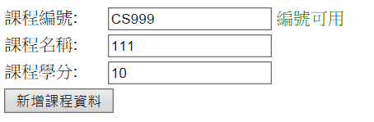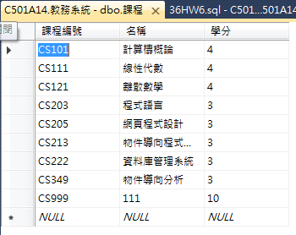

執行畫面截圖：

**繳交作業時，請以FTP上傳程式原始檔與本文件檔各一份，原始程式碼請另放置在一個資料夾內。**

**※功能須完全完成始得通過※**