座號：08 姓名：方宜馨

階段性作業四

資料庫設計與塑模軟體應用

請將如下ER-Diragram利用TDM(Toad Data Modeler)資料庫塑模工具軟體，轉換為視覺化的關聯圖，並利用該軟體產生對應的SQL DDL Script，並利用此Script在資料庫上建置資料庫。

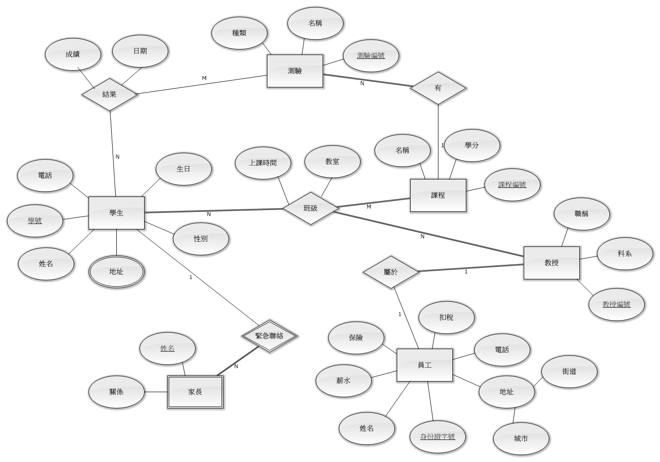

M

M

**繳交作業時，請以FTP上傳完成之文件檔一份。**

※本作業須全部完成始得通過※

視覺化的關聯圖：

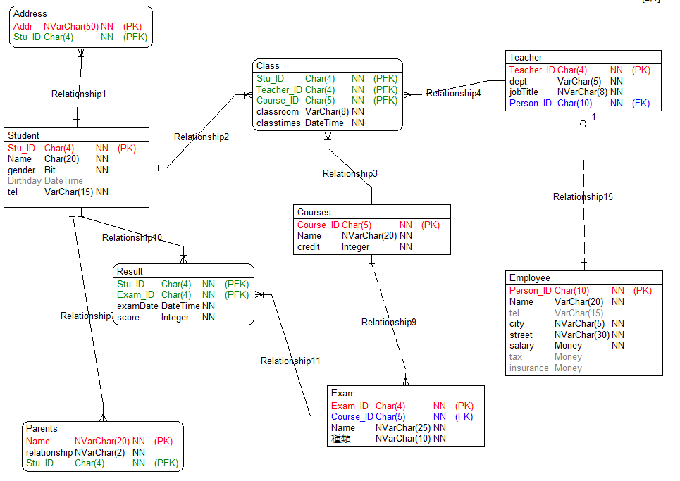

SQL DDL Script：

create database HW

go

use HW

go

Create table [Student]

(

[Stu_ID] Char(4) NOT NULL,

[Name] Char(20) NOT NULL,

[gender] Bit NOT NULL,

[Birthday] Datetime NULL,

[tel] Varchar(15) NOT NULL,

Primary Key ([Stu_ID])

)

go

Create table [Address]

(

[Addr] Nvarchar(50) NOT NULL,

[Stu_ID] Char(4) NOT NULL,

Primary Key ([Addr],[Stu_ID])

)

go

Create table [Courses]

(

[Course_ID] Char(5) NOT NULL,

[Name] Nvarchar(20) NOT NULL,

[credit] Integer Default 3 NOT NULL,

Primary Key ([Course_ID])

)

go

Create table [Class]

(

[Stu_ID] Char(4) NOT NULL,

[Teacher_ID] Char(4) NOT NULL,

[Course_ID] Char(5) NOT NULL,

[classroom] Varchar(8) NOT NULL,

[classtimes] Datetime NOT NULL,

Primary Key ([Stu_ID],[Teacher_ID],[Course_ID])

)

go

Create table [Teacher]

(

[Teacher_ID] Char(4) NOT NULL,

[dept] Varchar(5) NOT NULL,

[jobTitle] Nvarchar(8) NOT NULL,

[Person_ID] Char(10) NOT NULL,

Primary Key ([Teacher_ID])

)

go

Create table [Employee]

(

[Person_ID] Char(10) NOT NULL,

[Name] Varchar(20) NOT NULL,

[tel] Varchar(15) NULL,

[city] Nvarchar(5) NOT NULL,

[street] Nvarchar(30) NOT NULL,

[salary] Money NOT NULL,

[tax] Money NULL,

[insurance] Money NULL,

Primary Key ([Person_ID])

)

go

Create table [Parents]

(

[Name] Nvarchar(20) NOT NULL,

[relationship] Nvarchar(2) NOT NULL,

[Stu_ID] Char(4) NOT NULL,

Primary Key ([Name],[Stu_ID])

)

go

Create table [Exam]

(

[Exam_ID] Char(4) NOT NULL,

[Course_ID] Char(5) NOT NULL,

[Name] Nvarchar(25) NOT NULL,

[種類] Nvarchar(10) NOT NULL,

Primary Key ([Exam_ID])

)

go

Create table [Result]

(

[Stu_ID] Char(4) NOT NULL,

[Exam_ID] Char(4) NOT NULL,

[examDate] Datetime NOT NULL,

[score] Integer NOT NULL,

Primary Key ([Stu_ID],[Exam_ID])

)

go

Alter table [Address] add foreign key([Stu_ID]) references [Student] ([Stu_ID]) on update no action on delete no action

go

Alter table [Class] add foreign key([Stu_ID]) references [Student] ([Stu_ID]) on update no action on delete no action

go

Alter table [Parents] add foreign key([Stu_ID]) references [Student] ([Stu_ID]) on update no action on delete no action

go

Alter table [Result] add foreign key([Stu_ID]) references [Student] ([Stu_ID]) on update no action on delete no action

go

Alter table [Class] add foreign key([Course_ID]) references [Courses] ([Course_ID]) on update no action on delete no action

go

Alter table [Exam] add foreign key([Course_ID]) references [Courses] ([Course_ID]) on update no action on delete no action

go

Alter table [Class] add foreign key([Teacher_ID]) references [Teacher] ([Teacher_ID]) on update no action on delete no action

go

Alter table [Teacher] add foreign key([Person_ID]) references [Employee] ([Person_ID]) on update no action on delete no action

go

Alter table [Result] add foreign key([Exam_ID]) references [Exam] ([Exam_ID]) on update no action on delete no action

go

Set quoted_identifier on

go

Set quoted_identifier off

go

SQL Server資料庫圖表

