Exercise 1

What command would you use to extract just the counts of girls baptized?

>arbuthnot$girls

Try:

>?plot

e.g.

> ?plot.decomposed.ts

> require(graphics)

> m <- decompose(co2)

> m$figure

[1] -0.05359649 0.61055921 1.37564693 2.51682018 3.00028509 2.32921053 0.81293860

[8] -1.25052632 -3.05458333 -3.25194079 -2.06969298 -0.96512061

> plot(m)

Exercise 2

Is there an apparent trend in the number of girls baptized over the years?  
How would you describe it?

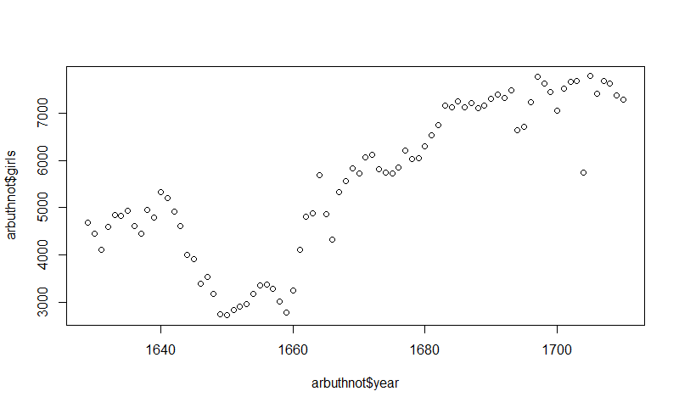

After 1660 year, it is definitely increasing continuously for the number of girls, the increasing trend is from 3000 to more than 7000 persons.

Trying the code of totals:

> arbuthnot$boys + arbuthnot$girls

[1] 9901 9315 8524 9584 9997 9855 10034 9522 9160 10311 10150 10850 10670 10370 9410

[16] 8104 7966 7163 7332 6544 5825 5612 6071 6128 6155 6620 7004 7050 6685 6170

[31] 5990 6971 8855 10019 10292 11722 9972 8997 10938 11633 12335 11997 12510 12563 11895

[46] 11851 11775 12399 12626 12601 12288 12847 13355 13653 14735 14702 14730 14694 14951 14588

[61] 14771 15211 15054 14918 15159 13632 13976 14861 15829 16052 15363 14639 15616 15687 15448

[76] 11851 16145 15369 16066 15862 15220 14928

Exercise 3

Now, make a plot of the proportion of boys over time. What do you see? Tip: If you use the up and down arrow keys, you can scroll through your previous commands, your so-called command history. You can also access it by clicking on the history tab in the upper right panel. This will save you a lot of typing in the future.

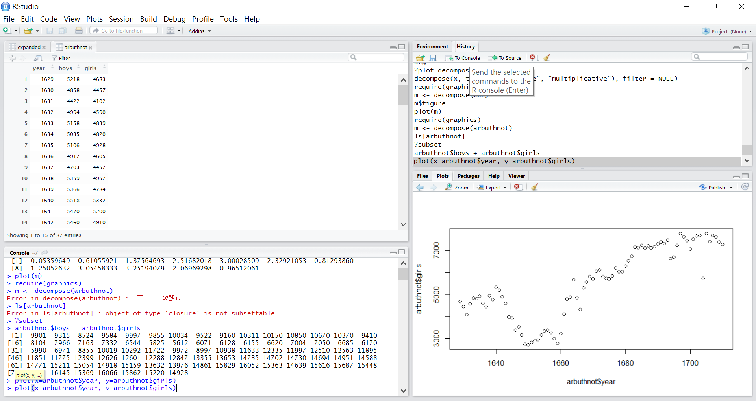

> plot(x=arbuthnot$year, y=arbuthnot$boys)

The trend of boys:

