PLAYGROUND

Technology Architecture
and Evolution Plan
From a teaching-friendly pygame-ce wrapper to a multi-renderer creative-coding framework
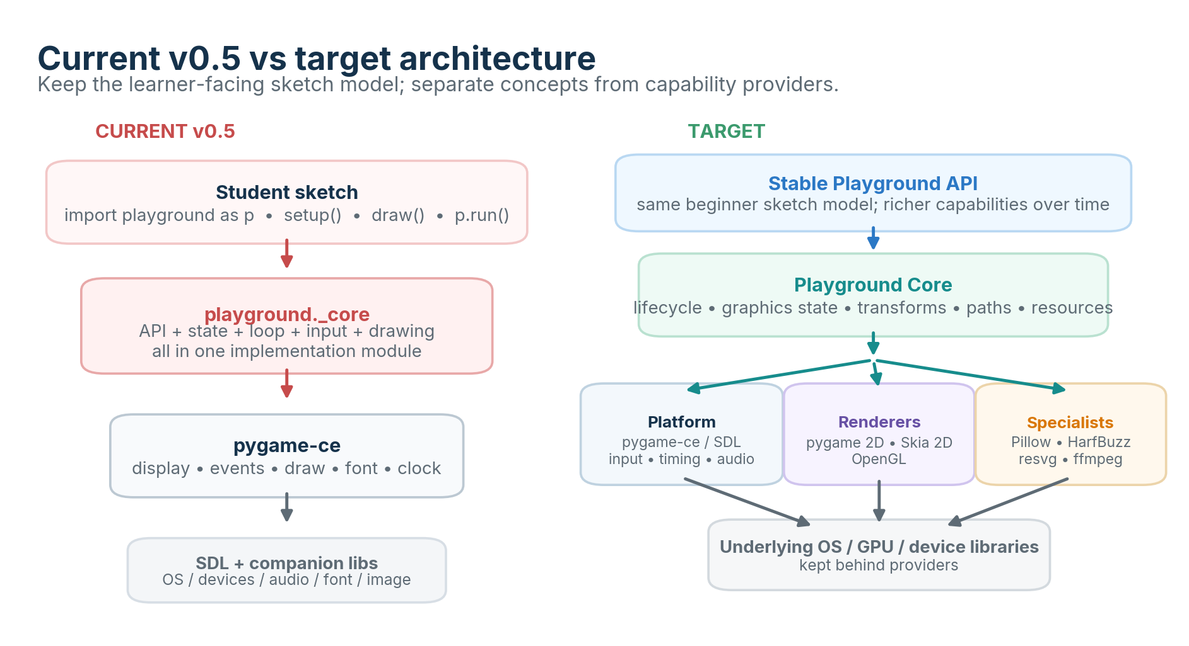
Figure 1. Architectural direction: preserve the sketch experience while separating Playground concepts from capability providers.
Status | Proposed architecture
Baseline | Playground v0.5.0
Primary audience | Maintainers, contributors and instructors
Date | 24 September 2026
Core architecture statement: Playground owns concepts and public semantics; underlying libraries provide replaceable capabilities.

Contents
- 1. Executive summary
- 2. Problem statement and context
- 3. Current state: Playground v0.5
- 4. Goals, non-goals and principles
- 5. Proposed architecture
- 6. Capability-provider strategy
- 7. Runtime and rendering models
- 8. Technology choices
- 9. Packaging and compatibility
- 10. Quality strategy
- 11. Risks and trade-offs
- 12. High-level roadmap
- 13. Immediate next steps
- Appendix A. v0.5 API baseline
- References

1. Executive summary
Playground began as a deliberately small teaching wrapper over pygame-ce. Version 0.5 already succeeds at its original goal: a learner can write a short Python sketch using setup(), draw() and p.run(), draw basic primitives, read live mouse/keyboard state, and animate values without first learning pygame’s display/event-loop ceremony.
The desired evolution is broader: retain that beginner experience while adding the qualities associated with p5/Processing and DrawBot—better paths, transforms, graphics state, typography, images, export, document/frame concepts, audio and input, and eventually shaders/3D. Trying to add all of that directly inside the existing pygame-bound _core.py would turn a teaching wrapper into a tightly coupled monolith.
Recommendation Evolve Playground into a small public API and core model sitting above multiple capability providers. Keep pygame-ce as the default platform/runtime provider; add a Pygame 2D renderer for compatibility, a Skia 2D renderer for high-quality vector/design work, and an optional OpenGL renderer for GPU effects and 3D. Add specialist libraries only where they materially outperform or extend those providers.

The architecture should be introduced incrementally. The first refactor should change internals, not learner code. Existing Session 1 sketches must remain the regression suite for every phase.

2. Problem statement and context

2.1 Problem statement
Playground needs to grow from a single-backend teaching wrapper into a versatile creative-coding framework without losing the simplicity that made the wrapper useful in the first place. The tension is architectural: richer graphics and media capabilities come from different libraries, but exposing those libraries directly would fragment the learner experience and lock public code to implementation choices.
- The current API, sketch lifecycle, state, event handling and rendering are all implemented together in one pygame-oriented core module.
- pygame-ce is excellent at cross-platform windowing, events, input, timing, audio and simple 2D, but it is not intended to be a complete high-end vector/typography/document renderer.
- Skia provides a mature cross-platform 2D graphics engine with paths, transforms, antialiasing, filters, shaders and multiple device backends, but it is not an event/audio/game-loop framework. [5]
- DrawBot demonstrates valuable creative-coding concepts—graphics-state save/restore, reusable Bezier paths, pages/frames and strong export—but its original implementation is tightly tied to macOS. drawbot-skia demonstrates that a useful subset can be reimplemented cross-platform on Skia. [7][8]
- p5 demonstrates the enduring value of a simple setup()/draw() lifecycle for creative coding. [11][12]

2.2 Architectural question
Question Which concepts should Playground own, and which capabilities should be delegated to pygame-ce or other libraries?

The answer proposed here is capability-by-capability rather than library-by-library: do not “replace pygame with Skia.” Keep pygame-ce where its abstraction is already strong; use Skia, Pillow, HarfBuzz, resvg, OpenGL or ffmpeg only for capabilities where they are the better fit.

2.3 Influences, not compatibility targets
Influence | What to borrow | What not to inherit
p5 / Processing | Simple sketch lifecycle; immediate-mode drawing vocabulary; progressive creative coding | Brand/API compatibility as a hard requirement; browser-specific assumptions
DrawBot | Graphics-state stack; reusable paths; pages/frames; export-first thinking; typography quality | macOS/CoreText/AppKit coupling; document-only execution model
pygame-ce | Cross-platform platform services; event loop mechanisms; timing; audio; controllers; approachable 2D | Treating pygame Surface/types as the permanent public data model
Skia | High-quality 2D rendering, paths, transforms, filters, PDF/SVG-capable rendering | Using Skia as a replacement for input/audio/window/runtime concepts

3. Current state: Playground v0.5
The following baseline is taken from the v0.5.0 package currently used for Session 1.
Area | Current v0.5 behavior
Public import | import playground as p
Lifecycle | p.run() discovers optional setup() and required draw() in the caller; draw() repeats until stop/close.
Window | p.size(width, height, title=..., fps=...) uses pygame.display.set_mode().
Drawing | background, circle, ellipse, rect, line, point call pygame Surface/draw APIs directly.
Style | fill/no_fill, stroke/no_stroke, stroke_width, text_size stored in one module-level style object.
Text | pygame.font.Font(None, size) rendered directly to the active Surface.
Input | mouse state sampled each frame; key_down() reads pygame key state; Escape stops the sketch.
Timing | pygame.time.Clock controls FPS; frame_count and delta_time are exposed as live module values.
Utilities | random, constrain, distance.
Module organization | __init__.py exports public functions/live names; _core.py contains state, runtime, input and renderer implementation.

Several aspects are worth preserving: the explicit import alias, the no-argument p.run(), standardized setup/draw callbacks, simple live values such as p.width, and the fact that beginner code contains ordinary Python variables and functions. The main limitation is internal coupling, not the learner-facing syntax.
Figure 2. Current v0.5 coupling compared with the target separation.

4. Goals, non-goals and architectural principles

4.1 Goals
- Preserve the beginner-friendly sketch experience and backwards compatibility for the v0.5 teaching subset.
- Allow multiple renderers without making learner code choose backend-native objects.
- Keep pygame-ce as a strong default provider for platform/runtime services rather than reimplementing SDL bindings.
- Add high-quality 2D paths, transforms, clipping, gradients, typography and export through a Skia-based design renderer.
- Allow specialist providers for raster processing, SVG import, advanced text shaping and video export.
- Leave a clean optional path to GPU effects, shaders and 3D.
- Keep installation progressive: the beginner install should remain small and reliable.

4.2 Non-goals
- Full p5.py, p5.js or DrawBot API compatibility.
- Reimplementing SDL, a text shaping engine, SVG parser, video codec stack or 3D engine inside Playground.
- Forcing every renderer to support every feature; capability detection is preferable to a lowest-common-denominator API.
- Introducing advanced dependencies into the Session 1 install before the corresponding feature is used.
- Committing now to a separate update() callback; v0.5 semantics remain the compatibility baseline.

4.3 Principles
1. Beginner first: advanced capability must not make the first sketch harder.
2. Playground owns concepts; libraries provide capabilities.
3. One public semantic model: state, paths, resources and lifecycle are defined by Playground, not by backend types.
4. Capability interfaces, not backend leakage: pygame.Surface, skia.Path and OpenGL handles stay internal by default.
5. Progressive enhancement: optional providers are lazy-loaded and declared through install extras.
6. Prefer existing integrations when sufficient: use pygame’s SDL abstractions rather than bypassing them without a concrete need.
7. Build architecture before breadth: refactor and test before adding many features.
8. Feature parity is explicit, not assumed: unsupported features fail clearly or use documented fallbacks.

5. Proposed architecture
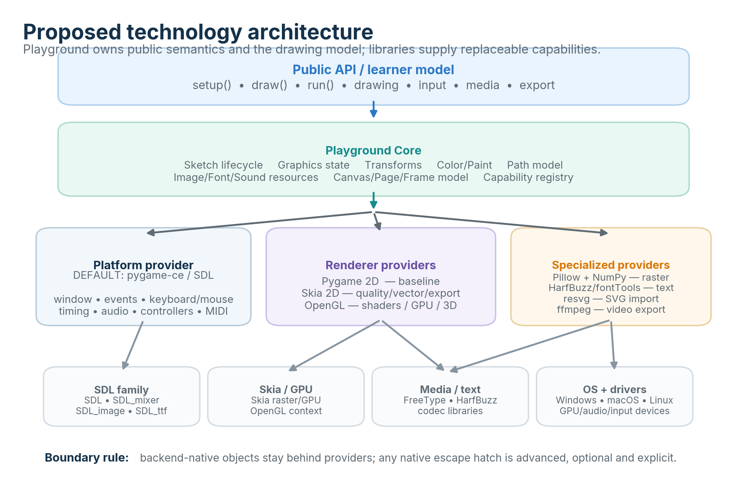
Figure 3. Target architecture: public API and core above platform, renderer and specialist providers.

5.1 Public API / learner model
The stable public surface remains small and Pythonic. A beginner should continue to write code like:
import playground as p
x = 50
def setup():
p.size(640, 400)
def draw():
global x
p.background("white")
p.circle(x, p.height / 2, 40)
x += 2
p.run()

Advanced features should extend the same namespace rather than switch the user into a second framework. Examples: p.translate(), p.path(), p.load_image(), p.save(), p.sound(), and eventually p.shader() or p.box().

5.2 Playground Core
Core concept | Responsibility
Sketch lifecycle | Discover callbacks, initialize providers, own run/stop semantics, dispatch events and frame work.
GraphicsState | Fill/stroke/paint, stroke width, text style, clipping and a state stack/context manager.
Transform | Backend-neutral affine transform stack for translate/rotate/scale and path/image/text placement.
Path / Geometry | Reusable vector path representation independent of pygame or Skia object types.
Resources | Playground-native Image, Font, Sound and later Shader/Mesh handles with provider adapters.
Canvas / Page / Frame | Unifies live drawing, off-screen buffers, document pages and animation frames.
Capability registry | Describes which provider can satisfy VECTOR_PATHS, PDF_EXPORT, SHADERS, AUDIO, etc.
Errors / diagnostics | Clear learner-facing errors when a capability or optional extra is missing.

5.3 Provider boundaries
Internally, interfaces can initially be lightweight Python Protocols or abstract base classes; a dynamic plugin framework is unnecessary until there are multiple third-party providers. The important boundary is conceptual.
class Platform(Protocol):
def create_window(self, width, height, title): ...
def poll_events(self) -> list[Event]: ...
def input_state(self) -> InputState: ...
def tick(self, fps: int) -> float: ...
class Renderer(Protocol):
capabilities: frozenset[Capability]
def begin_frame(self, canvas, state): ...
def draw_path(self, path, state): ...
def draw_image(self, image, transform, state): ...
def draw_text(self, text, position, style): ...
def end_frame(self): ...

6. Capability-provider strategy
Provider selection should be made per capability. pygame-ce remains the default platform provider because it already abstracts SDL and related libraries for many services; adding Skia does not create a reason to duplicate that work. pygame-ce itself depends on SDL plus SDL_ttf/FreeType, SDL_mixer and SDL_image for relevant modules. [1]
Capability | Playground concept owner | Recommended provider | Rationale / notes
Window / OS events | Playground runtime | pygame-ce / SDL | Mature cross-platform abstraction; avoid direct SDL binding unless a real gap appears.
Keyboard / mouse / touch | Input model | pygame-ce | Event queue and device state already integrate with SDL. [2]
Clock / frame pacing | Runtime | pygame-ce Clock | Simple, proven FPS control and delta timing. [3]
Audio / music | Sound API | pygame-ce mixer / SDL_mixer | Keep current integration; expose a simpler Playground Sound API. [4]
Game controllers | Controller API | pygame-ce / SDL | Joystick/gamepad support and events already exist. [15]
MIDI | MIDI API | pygame.midi / PortMidi initially | Useful creative-coding input; isolate behind optional API. [16]
Basic 2D raster | Drawing API | PygameRenderer | Fast startup, minimal dependency, ideal default teaching renderer.
High-quality 2D vector | Path/Paint/Canvas | SkiaRenderer | Paths, transforms, antialiasing, filters and multiple backends. [5][6]
Typography / shaping | Text model | Skia + uharfbuzz + fontTools | Keep shaping/layout above renderer; drawbot-skia demonstrates the approach. [7][17][18]
Raster image processing | Image model | Pillow + NumPy | Well-supported cross-platform processing; keep optional until used. [19][20]
SVG import | Image/Path resource | resvg | Portable static SVG renderer; do not implement SVG parsing. [14]
PDF/SVG export | Document/Exporter | Skia first | Skia supports PDF/SVG-oriented device backends; validate semantics per feature. [5]
Video export | Frame sequence / exporter | ffmpeg subprocess or binding | Encoding is a separate specialist concern; do not embed codec logic.
GPU / shaders / 3D | Shader/Mesh/Camera | OpenGL provider | Use pygame OPENGL context; provider may be PyOpenGL or ModernGL depending packaging. [13][21][22]
Camera / CV | Camera API | pygame camera baseline; OpenCV optional | pygame camera is experimental; use OpenCV for serious CV workloads. [23]

Provider-selection rule If pygame-ce already exposes a stable, sufficient abstraction, keep it. Use an integrated dependency directly only when Playground needs capabilities that pygame does not expose, needs materially better quality/performance, or needs a non-interactive/export-oriented model.

7. Runtime and rendering models

7.1 Interactive runtime lifecycle
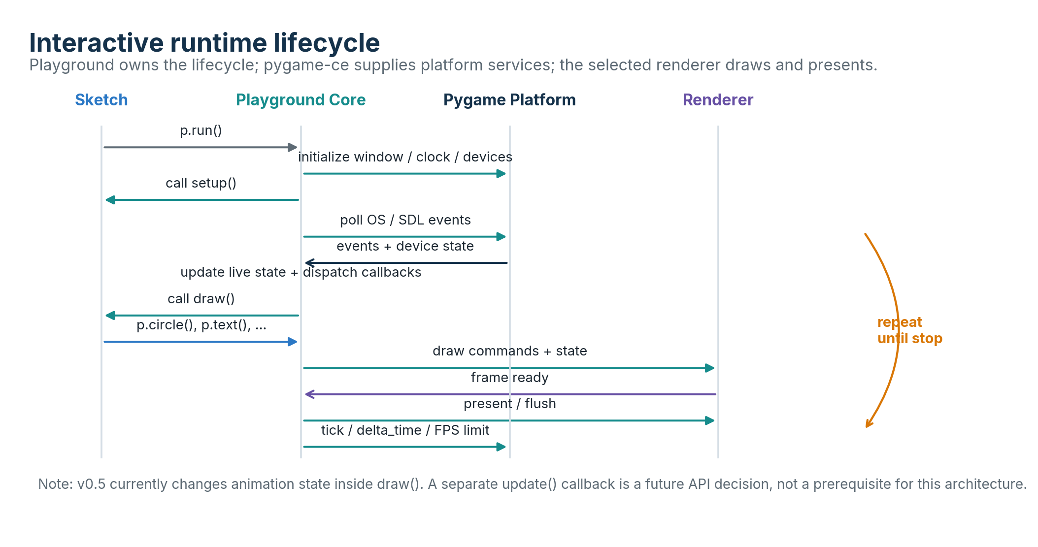
Figure 4. Recommended ownership of the interactive frame lifecycle.
The loop is a Playground concept. pygame-ce supplies event pumping, timing and OS/device integration; a renderer supplies drawing/presentation. This keeps the public lifecycle stable even if the rendering backend changes.
The existing v0.5 convention—state changes can occur in draw() and draw() is required—is retained. A future update() callback may be useful for separating simulation from rendering, but it should be introduced only if teaching and animation use cases justify the extra concept.

7.2 Unified drawing model
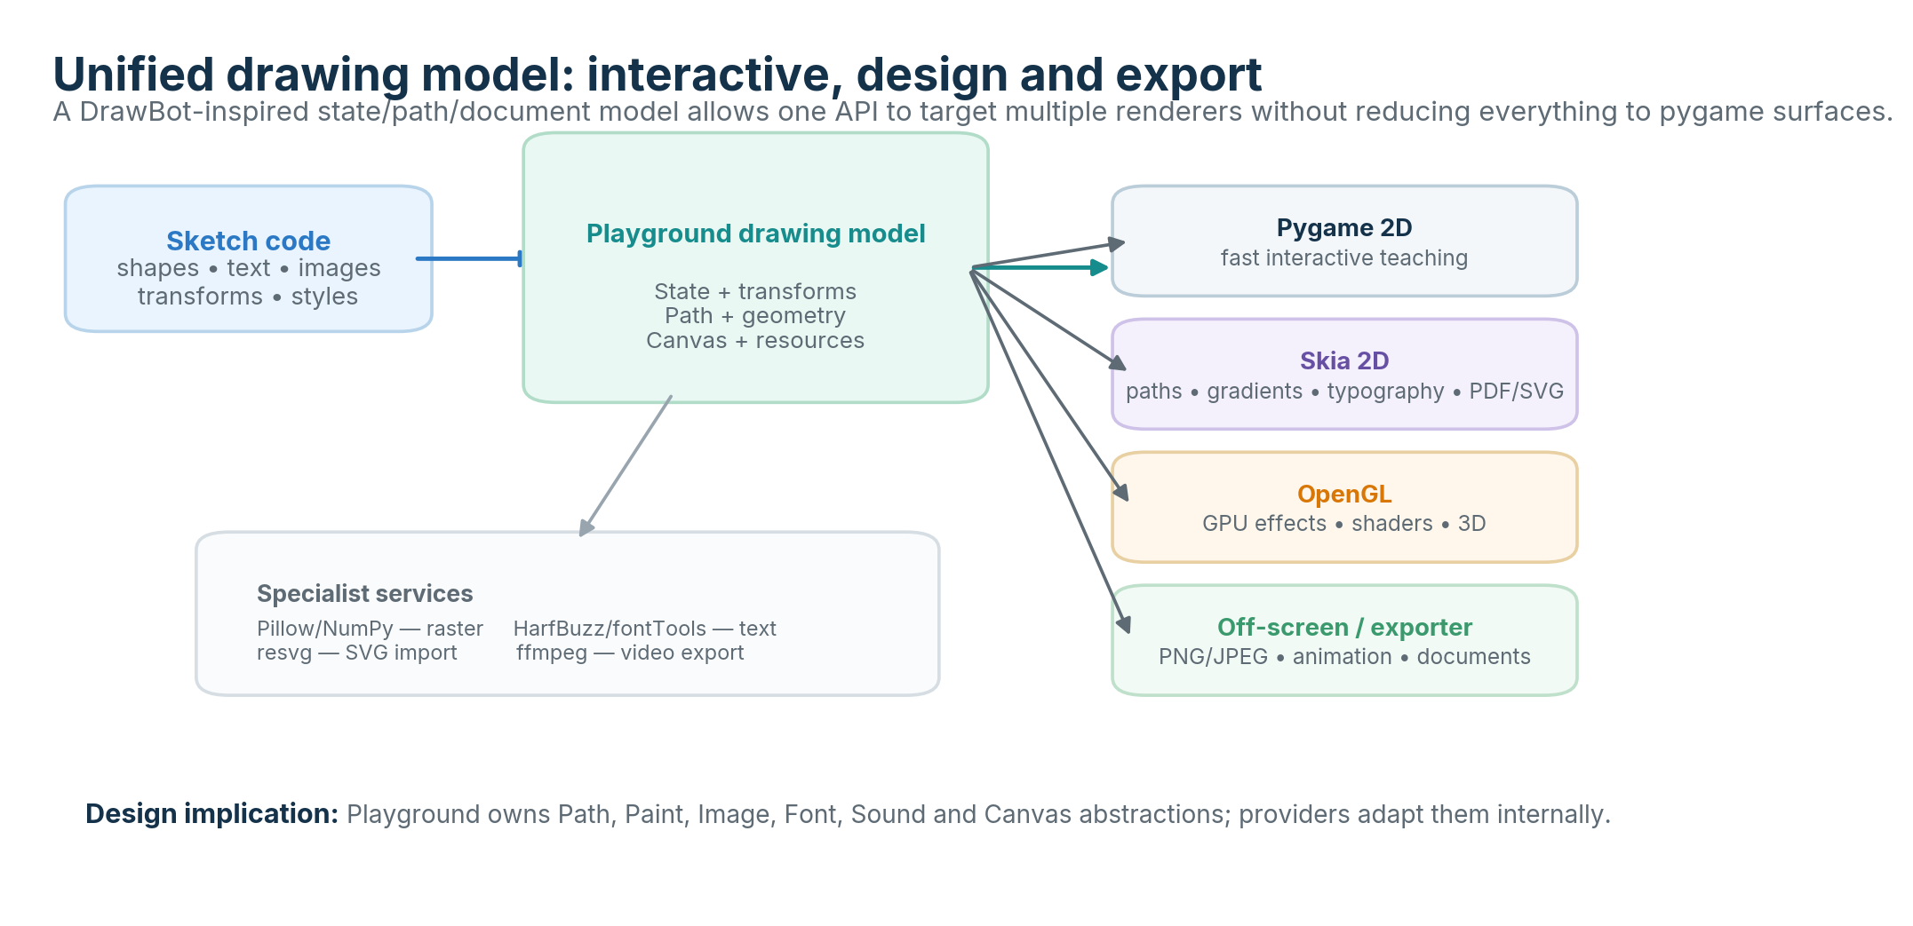
Figure 5. A shared drawing model can feed interactive, high-quality vector, GPU and off-screen/export targets.
The most important long-term abstraction is not a specific renderer; it is a backend-neutral drawing model. DrawBot’s reusable BezierPath and graphics-state save/restore are strong precedents for this model. DrawBot also treats pages as frames/documents and emphasizes export as a first-class use case. [8][9][10]
A Pythonic state context manager is recommended in addition to push/pop functions:
with p.state():
p.fill("tomato")
p.translate(200, 100)
p.rotate(30)
p.rect(0, 0, 120, 50)

8. Technology choices and rationale

8.1 pygame-ce / SDL: retain as default platform runtime
pygame-ce explicitly positions itself as a cross-platform multimedia library built on SDL, and its dependencies already include SDL_ttf/FreeType for fonts, SDL_mixer for audio and SDL_image for image loading. [1] Replacing pygame with direct SDL bindings would move binary packaging, platform differences, device/event translation and lifecycle concerns into Playground without providing a clear learner-facing benefit.
Recommendation: do not expose pygame types in new public abstractions, but continue to use pygame-ce heavily behind PygamePlatform and PygameRenderer.

8.2 Skia: add as the design-quality 2D renderer
Skia describes itself as a cross-platform 2D graphics library used in Chrome, Android, Flutter and other products. Its documented capabilities include text, geometry, matrices, antialiasing, transparency, filters, shaders, path effects and raster/OpenGL/PDF/SVG-style backends. [5]
As of September 2026, skia-python publishes CPython 3.14 wheels for Windows x86-64 and other major platforms, so it is practical for the same Windows/Python environment currently being used for Playground. [6]
drawbot-skia is useful architectural evidence rather than a required dependency: it independently implements a cross-platform subset of DrawBot using Skia and demonstrates paths, transforms, HarfBuzz shaping, variable fonts and multiple export formats. [7] Playground should normally use skia-python directly so its own API and data model remain under its control.

8.3 OpenGL: optional GPU/3D capability
pygame-ce can create an OpenGL display context via pygame.OPENGL, which allows the same platform/runtime layer to support a future GPU renderer. [13] ModernGL can attach to an existing OpenGL context and offers a concise GPU-oriented API, but the current stable ModernGL 5.12.0 PyPI wheels stop at CPython 3.13. [21][22]
Because the current teaching environment is Python 3.14, the architecture should not hard-wire ModernGL as a required dependency. Keep the OpenGL provider interface independent. PyOpenGL currently publishes a generic Python 3 wheel and is a viable compatibility option; ModernGL can be reconsidered when wheel support aligns with the supported Python versions. [24]

8.4 Specialist libraries
Library | Role | Architectural stance
Pillow | Raster image loading/processing/filters | Optional image provider; adapt into Playground Image.
NumPy | Pixel/audio/numeric buffers | Optional shared array representation for advanced operations.
uharfbuzz | Unicode/OpenType shaping | Internal text-layout service when advanced typography is enabled.
fontTools | Font metadata, outlines, variable-font support | Internal font service; useful for path conversion and font inspection.
resvg | Static SVG import/rendering | Use as specialist parser/renderer rather than implementing SVG.
ffmpeg | Video/audio encoding | External encoding provider; keep process boundary explicit.

9. Packaging, dependencies and compatibility
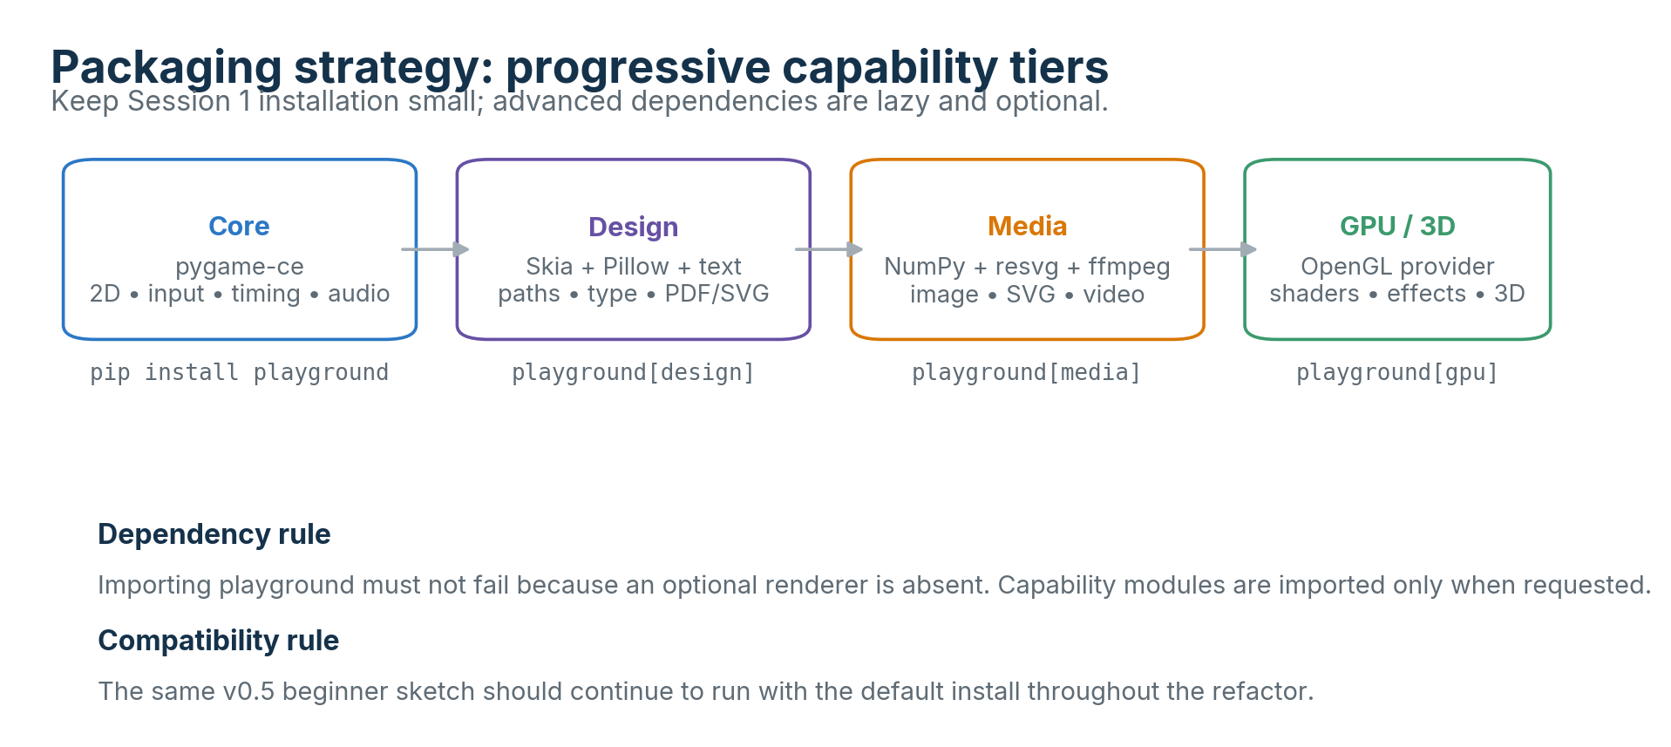
Figure 6. Proposed optional-install tiers.

9.1 Dependency policy
- Base install remains suitable for teaching and includes only required runtime dependencies, initially pygame-ce.
- Optional renderers and specialist capabilities use extras and lazy imports; missing extras produce a targeted message rather than breaking import playground.
- Do not expose third-party classes as the normal public resource types. Use adapters/wrappers with explicit conversion only where needed.
- Pin minimum versions based on tested capabilities, not merely latest releases. Maintain a supported-Python matrix in CI.
- Advanced extras should be independently installable so a user can choose design without GPU, GPU without typography, etc.

9.2 Backwards compatibility
The v0.5 Session 1 API should be treated as an executable compatibility contract. The initial refactor should preserve import playground as p, p.size(), drawing primitives, style functions, live values, input helpers and p.run() behavior. New semantics should be additive unless a clear defect requires a change.
Compatibility gate A v0.5 sample suite should run unchanged on every release during the architecture transition. The first architectural release should demonstrate internal separation with no meaningful learner-visible migration.

9.3 Suggested internal package layout
playground/
__init__.py # curated public API
api.py # user-facing function facade
runtime.py # setup/draw lifecycle, loop, callbacks
state.py # graphics + live sketch state
geometry.py # Path, transforms, geometry
resources.py # Image, Font, Sound, Canvas handles
capabilities.py # capability identifiers / selection
platform/
base.py
pygame_platform.py
renderers/
base.py
pygame2d.py
skia2d.py
opengl.py # optional
media/ # optional specialist adapters
export/ # document/image/video exporters
This is a responsibility map, not a mandate to create many files immediately. Start with the smallest separation that makes testing and replacement possible.

10. Quality and test strategy
Test layer | Purpose | Examples
Public API contract | Prevent learner-visible regression | v0.5 example programs, import/export names, error messages
Core model tests | Validate backend-neutral semantics | transform composition, graphics-state stack, path geometry, color parsing
Provider contract tests | All providers obey required interfaces | create/present frame, supported capability flags, resource lifecycle
Golden image tests | Catch rendering regressions | small deterministic drawings compared within tolerance
Cross-renderer conformance | Compare semantic equivalence where feasible | primitive positions, transforms, clipping, color conversion
Integration tests | Exercise platform + renderer together | window loop, input event dispatch, off-screen render/export
Packaging CI | Prevent install surprises | Windows/macOS/Linux; supported Python versions; base/design/gpu extras

Golden rendering must allow backend-specific antialiasing differences; the goal is semantic correctness, not pixel identity across fundamentally different renderers. For export features, add file-structure checks and a small set of rendered regression samples.

11. Risks, trade-offs and mitigations
Risk / trade-off | Why it matters | Mitigation
Framework becomes too broad | “Swiss army knife” can become incoherent or hard to maintain. | Keep beginner core small; gate advanced features behind capability modules and extras.
Lowest-common-denominator renderer API | Trying to make all backends identical can suppress Skia/OpenGL strengths. | Use capability flags and explicit optional features; define shared semantics only where meaningful.
Backend leakage | Users start depending on pygame/skia native objects. | Provide Playground resource types; make native access an advanced explicit escape hatch.
Dependency/install fragility | Graphics stacks can be difficult on new Python/platform versions. | Base install stays pygame-only; CI optional extras; choose wheels-first dependencies.
Text layout complexity | High-quality shaping/wrapping is more than “draw a string.” | Treat shaping/layout as a separate service; use HarfBuzz/fontTools; phase multiline layout.
OpenGL provider churn | ModernGL/PyOpenGL packaging and driver support differ. | Keep provider interface independent; make GPU extra optional and version-gated.
API expansion harms teaching | Too many functions can distract beginners. | Progressive documentation, curated quick reference, “core” and “advanced” namespaces in docs—not necessarily separate imports.
Licensing obligations | Provider licenses differ. | Maintain a dependency/license inventory; preserve notices and review redistribution obligations before packaging.

12. High-level roadmap
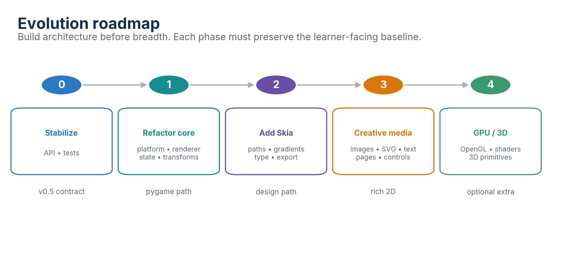
Figure 7. Phased evolution: architecture first, capability breadth later.
Phase | Primary work | Exit criteria
0 — Stabilize v0.5 | Freeze API baseline; examples; unit tests; explicit public API inventory; package/install cleanup. | Session 1 sketches and reference guide match tested behavior.
1 — Refactor core | Split runtime/platform/renderer concerns; introduce Playground state/transform/path abstractions; PygamePlatform + PygameRenderer. | Existing learner code unchanged; no direct pygame draw/display calls outside providers.
2 — Skia design renderer | Add SkiaRenderer, Path, transform/state stack, gradients/clipping, off-screen canvas, basic PDF/SVG/PNG export. | A representative 2D sketch renders through pygame and Skia; export examples are stable.
3 — Creative media | Images/filters, text shaping, fonts, SVG import, document/page/frame model, controls, stronger audio/media API. | Useful DrawBot-like design/document workflows without affecting beginner core.
4 — Optional GPU/3D | OpenGL renderer, shaders, textures, mesh/camera/light model, 3D primitives. | GPU extra is isolated; 2D/base install remains unaffected.

13. Immediate next steps
1. Create a small architecture branch from v0.5 and freeze the current public API in tests.
2. Refactor _core.py into three responsibilities without adding features: runtime, PygamePlatform and PygameRenderer.
3. Introduce a Playground-owned GraphicsState and affine Transform implementation; adapt current primitives through the renderer.
4. Define a minimal Path model and capability enum. Add triangle/quad/polygon only after the path abstraction exists.
5. Prototype SkiaRenderer in a separate optional extra and render the same deterministic examples through both renderers.
6. Add off-screen rendering/export before broadening the public API; this validates the architecture early.
7. After the Skia prototype, decide the first “design” feature slice: state context manager + paths + transforms + PNG/PDF export is a strong candidate.
8. Defer OpenGL implementation until the 2D provider boundary is proven; keep a small context-creation spike as a feasibility test only.
Suggested v0.6 scope Internal architecture refactor, regression tests, GraphicsState/Transform foundations and renderer/platform interfaces. Avoid turning v0.6 into a feature release.

Appendix A — Playground v0.5 API baseline
This list comes from the v0.5.0 package inspected for this architecture document. It is the recommended compatibility baseline for Phase 0/1.
Category | Public names / conventions
Import | import playground as p
Lifecycle | setup() optional; draw() required; p.run(fps=None); p.stop()
Window | p.size(width, height, title="playground", fps=60)
Drawing | p.background, p.circle, p.ellipse, p.rect, p.line, p.point
Style | p.fill, p.no_fill, p.stroke, p.no_stroke, p.stroke_width
Text | p.text, p.text_size
Input | p.key_down; p.mouse_x; p.mouse_y; p.mouse_pressed
Live values | p.width; p.height; p.frame_count; p.delta_time
Utilities | p.random; p.constrain; p.distance
Not present in v0.5 | update(), transform stack, Path, images, sound API, export/document model, multiple renderers

Appendix B — Architecture decision summary
Decision | Recommendation
Keep pygame-ce? | Yes. Retain as default platform/runtime provider and baseline 2D renderer.
Use SDL directly? | No, not initially. pygame-ce already absorbs SDL/platform complexity.
Add Skia? | Yes, as optional high-quality 2D/design renderer using skia-python.
Depend on drawbot-skia? | Study as precedent; normally implement Playground’s own Skia adapter directly.
Use backend-native public types? | No by default. Define Playground Image/Path/Font/Sound/Canvas abstractions.
Require one renderer to implement everything? | No. Use capability flags and clear unsupported-capability errors/fallbacks.
Add OpenGL now? | Design for it; implement after 2D provider boundary is proven.
Add update() now? | No architectural requirement. Keep v0.5 lifecycle; evaluate later as an additive callback.
Base installation | Keep small and reliable; advanced capabilities through extras/lazy imports.

References
[1] pygame-ce project and dependency overview — https://github.com/pygame-community/pygame-ce
[2] pygame-ce event queue documentation — https://pyga.me/docs/ref/event.html
[3] pygame-ce time / Clock documentation — https://pyga.me/docs/ref/time.html
[4] pygame-ce mixer documentation — https://pyga.me/docs/ref/mixer.html
[5] Skia official overview and user documentation — https://skia.org/about/ ; https://skia.org/docs/user/
[6] skia-python PyPI — current platform/Python wheel support — https://pypi.org/project/skia-python/
[7] drawbot-skia — cross-platform DrawBot subset on Skia — https://github.com/justvanrossum/drawbot-skia
[8] DrawBot graphics state / transformations — https://www.drawbot.com/content/canvas/state.html
[9] DrawBot BezierPath — https://www.drawbot.com/content/shapes/bezierPath.html
[10] DrawBot pages / frame model — https://www.drawbot.com/content/canvas/pages.html
[11] p5.js setup() lifecycle reference — https://p5js.org/reference/p5/setup/
[12] p5.js draw() lifecycle reference — https://p5js.org/reference/p5/draw/
[13] pygame-ce OpenGL display/context support — https://pyga.me/docs/ref/display.html
[14] resvg project — static SVG rendering — https://github.com/linebender/resvg/blob/main/README.md
[15] pygame-ce joystick/controller documentation — https://pyga.me/docs/ref/joystick.html
[16] pygame-ce MIDI / PortMidi documentation — https://pyga.me/docs/ref/midi.html
[17] uharfbuzz PyPI — https://pypi.org/project/uharfbuzz/
[18] fontTools PyPI — https://pypi.org/project/fonttools/
[19] Pillow PyPI — https://pypi.org/project/pillow/
[20] NumPy PyPI — https://pypi.org/project/numpy/
[21] ModernGL PyPI — https://pypi.org/project/moderngl/
[22] ModernGL existing-context documentation — https://moderngl.readthedocs.io/en/5.6.4/reference/context.html
[23] pygame-ce camera documentation — https://pyga.me/docs/ref/camera.html
[24] PyOpenGL PyPI — https://pypi.org/project/PyOpenGL/
Research checked 24 September 2026. Technology/version observations in this document are time-sensitive and should be revalidated before locking dependency versions.

