Bulk Order Types

The bulk order types listed below will use the format detailed in the following sections:

1. Daily Filing Update/Replacement (Subscription)
2. Daily Filing Update/Replacement (One-time Request)
3. Weekly Filing Update/Replacement (Subscription)
4. Weekly Filing Update/Replacement (One-time Request)
5. New Master Unload
6. Previous Master Unload
7. New Master Unload by Entity Description
- Previous Master Unload by Entity Description
- File Layout For Daily Filing Update/Replacement
- File Layout for Weekly Filing Update/Replacement
- File Layout for Master Unload

Types 1 through 8, and 10 through 12 have the same format.

Bulk Order file generation and file formats

A file is generated based on the bulk order type that is selected. Files are put in a specified directory on the server and are made available to clients with active subscriptions. The name formats for bulk order is as follows:

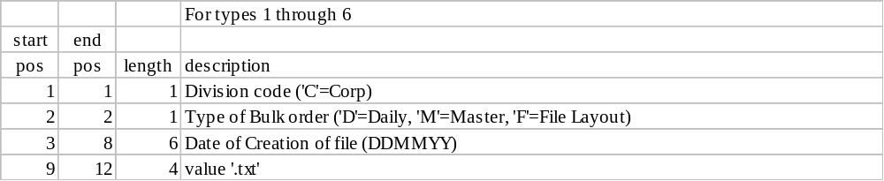

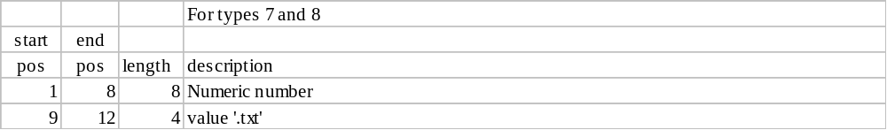

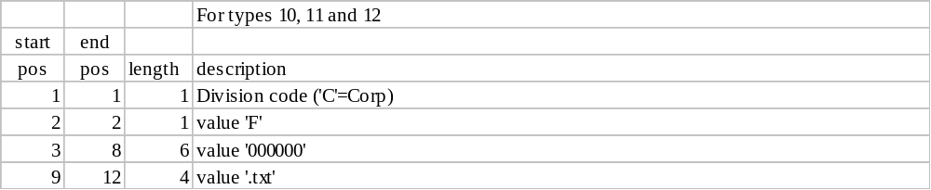
The files generated are text files and contain record codes at the start position to indicate the type of record. These record codes are:

Record layout code 01 Delete All Command Record
Record layout code 02 Master Record
Record layout code 03 Master Address Record
Record layout code 04 Reserved
Record layout code 05 Registered Agent Record - Business Name
Record layout code 06 Registered Agent Record - Personal Name
Record layout code 07 Charter Officer - Business Name
Record layout code 08 Charter Officer - Personal Name
Record layout code 09 Charter Names Record
Record layout code 10 Associated Entity Record
Record layout code 11 Filing History Record
Record layout code 12 Corp Audit Log Record
Record layout code 99 Totals Record

Each record has a length of 560 characters and all the fields contained within are fixed-width strings. Data Type ‘N’ (Numeric) is right justified zero filled on the left. Data Type ‘C’ (Character) is left justified and space filled on the right, even if the value happens to be a number.

For each filing/charter number there will be a complete replacement of ALL its data. ALL of the records associated with the filing/charter number will be on the download file. The following tables describe the record formats:

Record layout code 01 (Delete All Command Record)

Record code 01 indicates that a record has been removed from the database. Delete all data for this FILING_NUMBER.

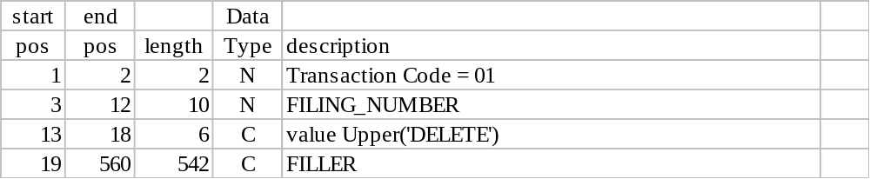
Record layout code 02 (Master Record)

Record code 02 contains the Business Entity Master Record information. Delete all data associated for the filing number and replace it with new data provided.

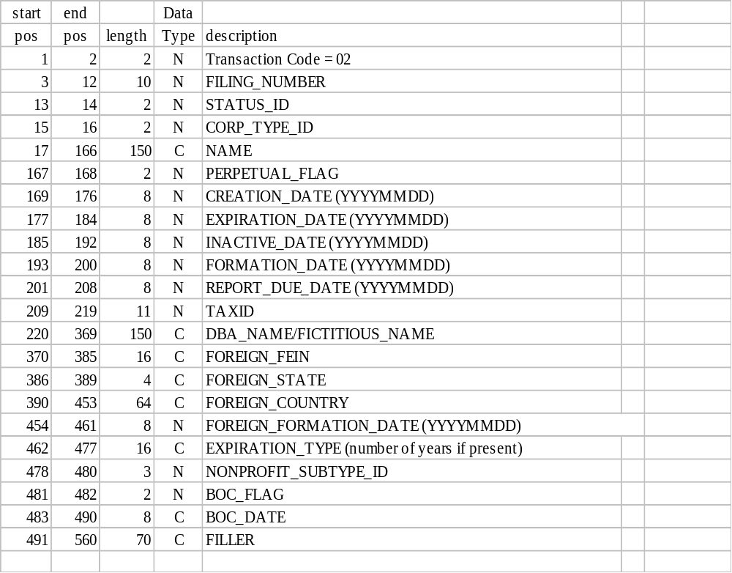

STATUS_ID | STATUS_DESCRIPTION
1 | In existence
2 | Report due
3 | RA notice sent
4 | Forfeited rights
5 | Delinquent
6 | Forfeited existence
7 | Voluntarily dissolved
8 | Involuntarily dissolved
9 | Judicially dissolved
10 | Revoked
11 | Expired
12 | Withdrawn
13 | Merged
14 | Converted
15 | Consolidated
16 | Cancelled
17 | Terminated
18 | Law repealed
19 | Stricken
20 | Deleted
21 | Pending Review
23 | Withdrawn on Conversion

CORP_TYPE_ID | CORP_TYPE
1 | Domestic For-Profit Corporation
2 | Foreign For-Profit Corporation
3 | Domestic Professional Corporation
4 | Foreign Professional Corporation
5 | Professional Association
6 | Domestic Limited Liability Company (LLC)
7 | Foreign Limited Liability Company (LLC)
8 | Domestic Nonprofit Corporation
9 | Foreign Nonprofit Corporation
10 | Domestic Limited Partnership (LP)
11 | Foreign Limited Partnership (LP)
12 | Domestic Limited Liability Partnership (LLP)
13 | Foreign Limited Liability Partnership (LLP)
14 | Unincorporated Nonprofit Association
15 | Defense-Base Development Authority
16 | Texas State Financial Institution
17 | Foreign Corporate Fiduciary
18 | General Partnership Merged with other Entity
19 | Non-existent Limited Partnership Disclaimer
20 | Pre-1999 Foreign or Out-of-State Bank or foreign financial Institution
21 | Trust Corporation
22 | Assumed Name Entity
23 | Foreign Financial Institution
24 | Foreign Business Trust
25 | Foreign Real Estate Investment Trust
26 | Other Foreign Entity
27 | Foreign Professional Association
28 | Application for Name Reservation
29 | Railroad Company
30 | Other Foreign Limited Partnership
99 | Other Entity/Organization

PERPETUAL_FLAG | DESCRIPTION
1 | Perpetual
0 | Non-perpetual

NONPROFIT_SUBTYPE_ID | CORP_TYPE_ID | DESCRIPTION
1 | 8 | Agricultural and Livestock Pool
2 | 8 | Agricultural Finance Corporation
3 | 8 | Business Development Corporation
4 | 8 | Cemetery Corporation
5 | 8 | Cooperative Association
6 | 8 | Cooperative Credit Association
7 | 8 | Cooperative Marketing Association
8 | 8 | Cultural Education Facilities Corporation
9 | 8 | Electric Cooperative
10 | 8 | Farmers Cooperative Society
11 | 8 | Group Hospital Service Corporation
12 | 8 | Health Facilities Development Corporation
13 | 8 | Health Related Institution Cooperative Association
14 | 8 | Hospital Laundry Cooperative Association
15 | 8 | Housing Finance Corporation
16 | 8 | Industrial Development Corporation
17 | 8 | Lodge
18 | 8 | Mutual Loan Corporation
19 | 8 | Non-Profit Legal Services Corporation
20 | 8 | Private Purchasing Cooperative
21 | 8 | Public Facility Corporation
22 | 8 | Telephone Cooperative
23 | 8 | Transportation Corporation
24 | 8 | Water Supply Corporation
25 | 9 | Agricultural and Livestock Pool
26 | 9 | Agricultural Finance Corporation
27 | 9 | Business Development Corporation
28 | 9 | Cemetery Corporation
29 | 9 | Cooperative Association
30 | 9 | Cooperative Credit Association
31 | 9 | Cooperative Marketing Association
32 | 9 | Cultural Education Facilities Corporation
33 | 9 | Electric Cooperative
34 | 9 | Farmers Cooperative Society
35 | 9 | Group Hospital Service Corporation
36 | 9 | Health Facilities Development Corporation
37 | 9 | Health Related Institution Cooperative Association
38 | 9 | Hospital Laundry Cooperative Association
39 | 9 | Housing Finance Corporation
40 | 9 | Industrial Development Corporation
41 | 9 | Lodge
42 | 9 | Mutual Loan Corporation
43 | 9 | Non-Profit Legal Services Corporation
44 | 9 | Private Purchasing Cooperative
45 | 9 | Public Facility Corporation
46 | 9 | Telephone Cooperative
47 | 9 | Transportation Corporation
48 | 9 | Water Supply Corporation
49 | 23 | Bank
50 | 23 | Federal Bank
51 | 23 | Savings Bank
52 | 23 | Federal Savings Bank
53 | 23 | Savings & Loan Assn.
54 | 23 | Federal Savings & Loan Assn.
55 | 23 | Credit Union
56 | 23 | Federal Credit Union
57 | 23 | Trust Company
58 | 8 | Local Government Corporation

EXPIRATION_TYPE | DESCRIPTION
NULL | If Perpetual
Any positive numeric number | Non-perpetual, expiration duration. (The duration in years.)

Record layout code 03 (Master Address Record)

Record code 03 contains the address for the business entity.

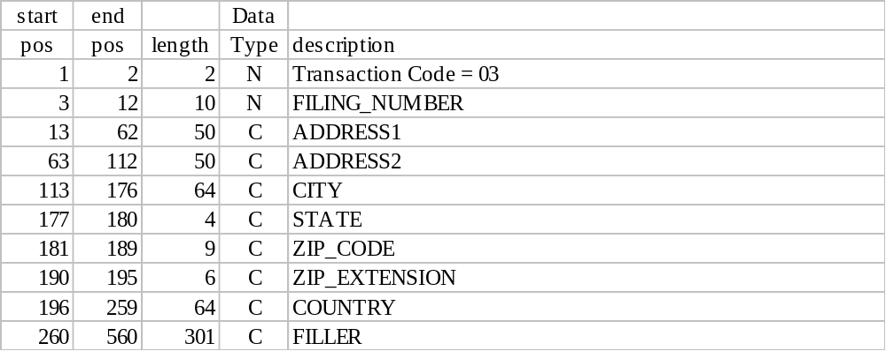

Record layout code 05 (Registered Agent Record - Business Name)

Record code 05 contains the Registered Agent when it is a Business Entity Name.

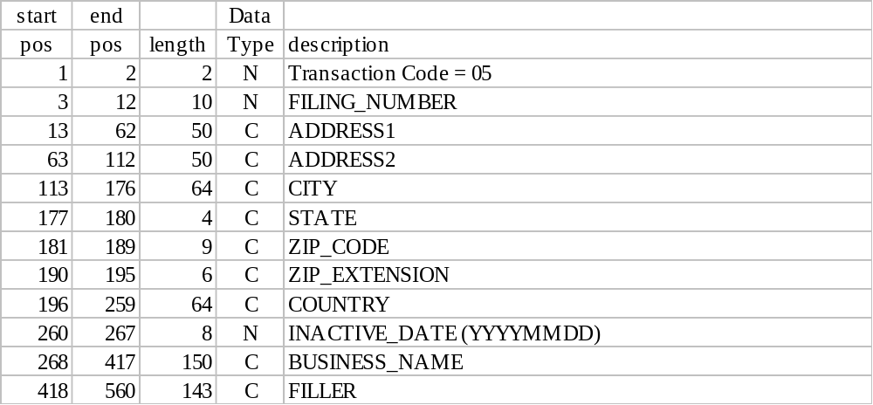

Record layout code 06 (Registered Agent Record - Personal Name)

Record code 06 contains Registered Agent information where the Registered Agent is a Person.

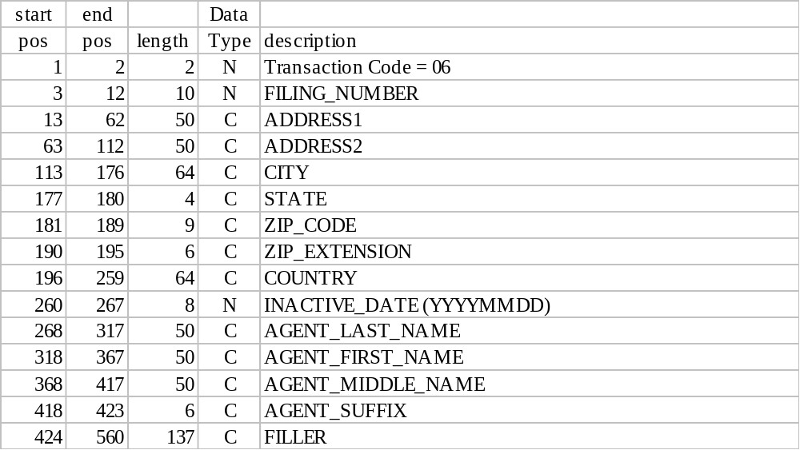

Record layout code 07 (Charter Officer - Business Name)

Record code 07 contains Officer Information where the Officer is a Business Entity.

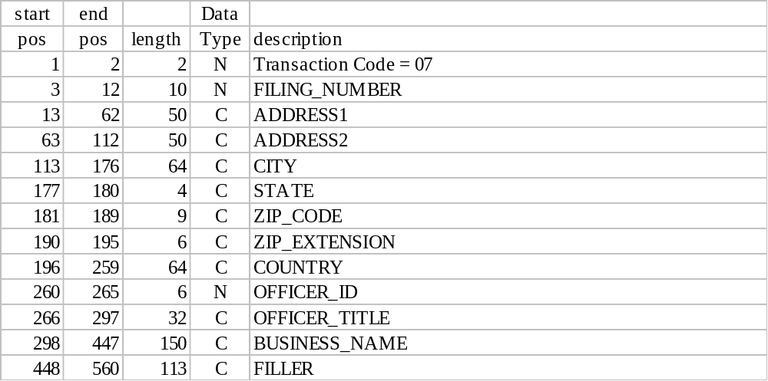
Record layout code 08 (Charter Officer - Personal Name)

Record code 08 contains Officer Information where the Officer is a Person.

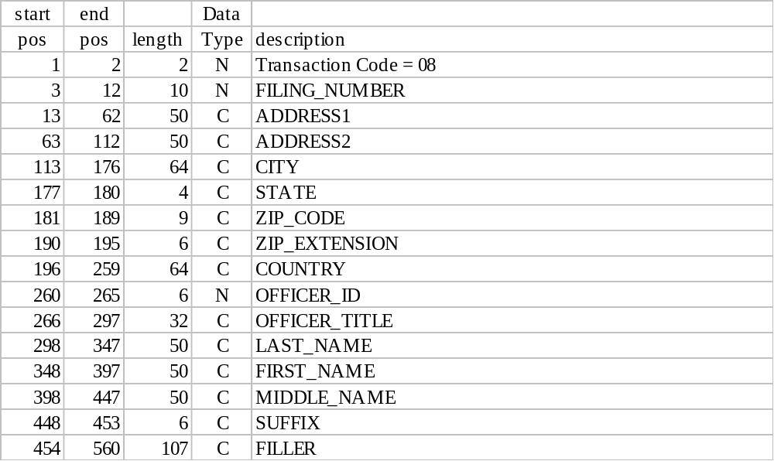

Record layout code 09 (Charter Names Record)

Record code 09 contains Names associated with the Business Entity including types listed below.

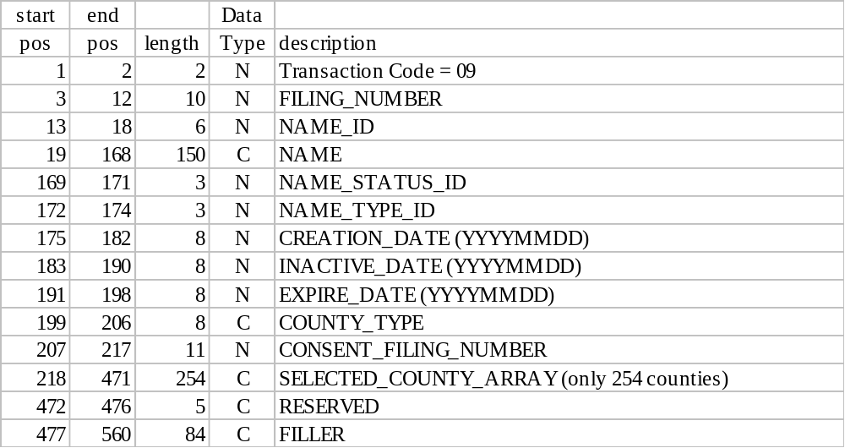

NAME_STATUS_ID | STATUS
1 | In use
2 | Prior
3 | Inactive
4 | Reserved
5 | Registered
6 | Expired
7 | Withdrawn
8 | Terminated
9 | Revoked
10 | Used
11 | Active
12 | Expired
13 | Abandoned
14 | Entity Inactive
15 | Entity Deleted
16 | Striken
17 | Pend. for Review
18 | Locked

NAME_TYPE_ID | NAME_DESCRIPTION
1 | Legal
2 | Fictitious
3 | Assumed

COUNTY_TYPE | DESCRIPTION
Space or NULL | Name is NOT Assumed
LIST | Assumed name for listed counties
ALL | Assumed name for all Texas counties

SELECTED_COUNTY_ARRAY: The SELECTED_COUNTY_ARRAY is 254 bytes corresponding with the 254 counties in Texas. A ‘1’ (numeric 1) is used to include a county in the list. The COUNTY_ID in the County table in APPENDIX C is used as an index into the array. For example if the 1st character has an ‘1’ then Anderson would be selected. If the last character number 254 has an ‘1’ then Zavala would be selected. If the character number 227 has an ‘1’ then Travis would be selected, etc. The default value will be ‘0’ (zero) for non selected counties.
Record layout code 10 (Associated Entity Record)

Record code 10 has associated entity information of the types listed below.

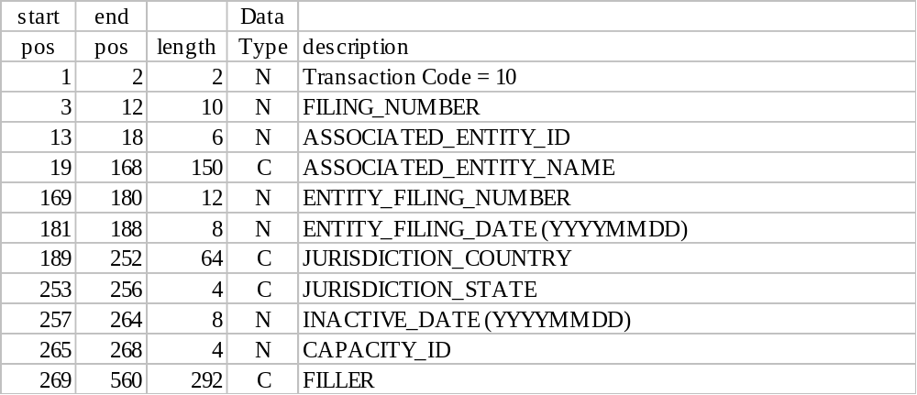

CAPACITY_ID | CORP_TYPE_ID DESCRIPTION
1 | Survivor
2 | Non-Survivor
3 | Resulting Entity
4 | Converting
5 | Converted
6 | Acquiring
7 | Acquired
8 | Consolidated
9 | Consolidating
11 | Predecessor
12 | Underlying Partnership
13 | LLP Registration

Record layout code 11 (Filing History Record)

Record code 11 contains filing history information.

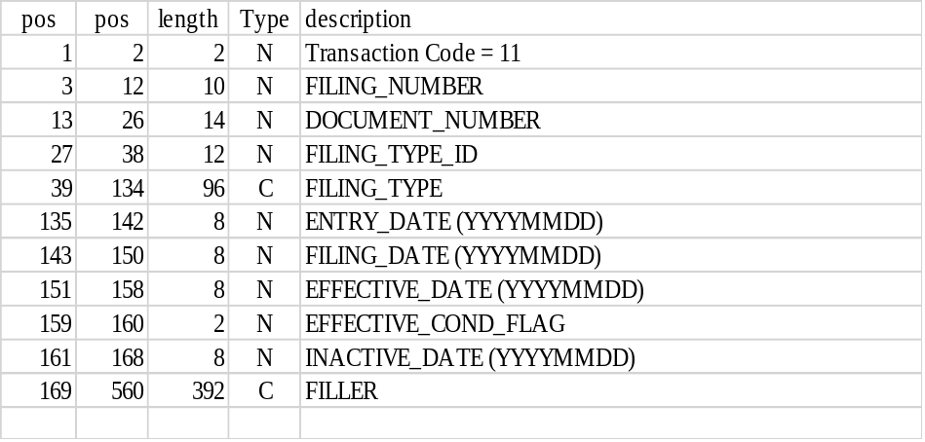
Record layout code 12 (Audit Log Record)

Record code 12 contains audit log information.

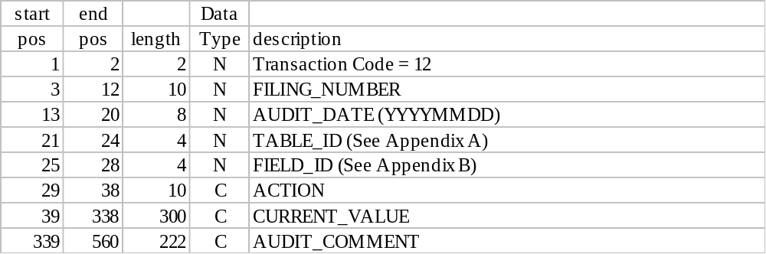

ACTION | DESCRIPTION
ADD | Field was added
UPDATE | Field was updated
DELETE | Field was deleted

TABLE_ID: When this field is edited and the database updated the system logs the name of the table in which that field is found in the Corp_Audit_Log table. This field "Table_ID" points to the table being updated and is taken from the System Table Description summary table. See Appendix A for Table_ID values.

FIELD_ID: The System_Field_Description summary table has stored in it the names of all the fields across all the tables. When a field is edited and updated in the database, the system logs the name of that field in the Corp_Audit_Log table beside the name of the updated table. See Appendix B for Field_ID values.

Record layout code 99 (Totals Record)

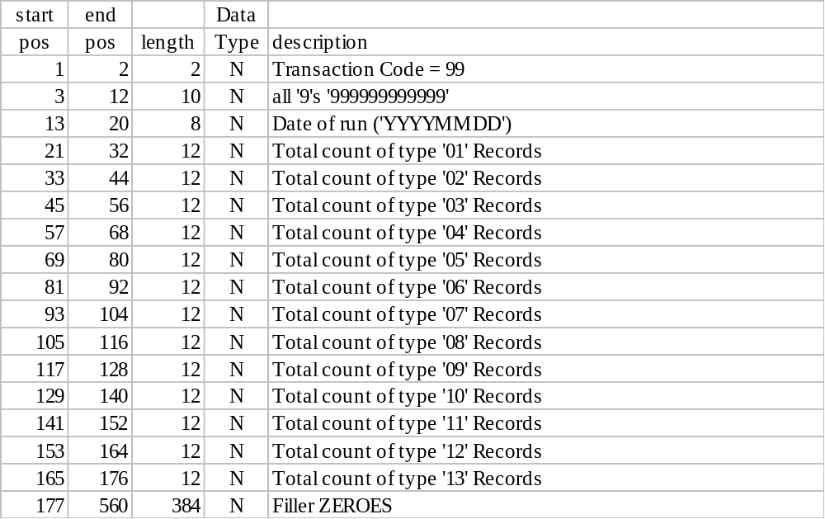

APPENDIX A: Table Description Summary Tables

DATA TABLES

TABLE_ID | TABLE NAME | DESCRIPTION
14 | Corp_Address | Corp Address
16 | Corp_Agent | Corp Agent
17 | Corp_Agent_Data | Corp Agent Data
18 | Corp_Associated_Entity_Data | Corp Associated Entity Data
19 | Corp_Audit_Log | Corp Audit Log
28 | Corp_Data | Corp Data
33 | Corp_Filing | Corp Filing
42 | Corp_Names_Data | Corp Names Data
46 | Corp_Officer_Data | Corp Officer Data

LOOK-UP TABLES

TABLE_ID | TABLE NAME | DESCRIPTION
26 | Corp_Capacity | Corp Capacity
40 | Corp_Name_Status | Corp Name Status
41 | Corp_Name_Type | Corp Name Type
45 | Corp_Nonprofit_Subtype | Corp Nonprofit Subtype
60 | Corp_Status | Corp Status
61 | Corp_Type | Corp Type
64 | County | County

APPENDIX B: System Field Description Summary Tables

DATA TABLES
FIELD_ID | TABLE_ID | FIELD_NAME
67 | 14 | ADDRESS_ID
68 | 14 | ADDRESS1
69 | 14 | ADDRESS2
70 | 14 | CITY
71 | 14 | STATE
72 | 14 | ZIP_CODE
73 | 14 | ZIP_EXTENSION
74 | 14 | COUNTRY
81 | 16 | AGENT_ID
82 | 16 | ADDRESS_ID
83 | 16 | BUSINESS_NAME
84 | 16 | AGENT_LAST_NAME
85 | 16 | AGENT_FIRST_NAME
86 | 16 | AGENT_MIDDLE_NAME
87 | 16 | AGENT_SUFFIX_ID
88 | 17 | FILING_NUMBER
89 | 17 | ADDRESS_ID
90 | 17 | BUSINESS_NAME
91 | 17 | CREATION_DATE
92 | 17 | INACTIVE_DATE
93 | 17 | AGENT_LAST_NAME
94 | 17 | AGENT_FIRST_NAME
95 | 17 | AGENT_MIDDLE_NAME
96 | 17 | AGENT_SUFFIX_ID
97 | 17 | NORMALIZED_NAME
98 | 18 | FILING_NUMBER
99 | 18 | ASSOCIATED_ENTITY_ID
100 | 18 | ASSOCIATED_ENTITY_CORP_TYPE_ID
101 | 18 | CAPACITY_ID
102 | 18 | ASSOCIATED_ENTITY_NAME
103 | 18 | ENTITY_FILING_NUMBER
104 | 18 | ENTITY_FILING_DATE
105 | 18 | INACTIVE_DATE
106 | 18 | JURISDICTION_STATE
107 | 18 | JURISDICTION_COUNTRY
108 | 19 | AUDIT_DATE
109 | 19 | CURRENT_USER_ID
110 | 19 | PREVIOUS_USER_ID
111 | 19 | MODULE_ID
112 | 19 | REFERENCE_TYPE_ID
113 | 19 | DOCUMENT_NUMBER
114 | 19 | REFERENCE_NUMBER
115 | 19 | TABLE_ID
116 | 19 | FIELD_ID
117 | 19 | PREVIOUS_VALUE
118 | 19 | CURRENT_VALUE
119 | 19 | ACTION
120 | 19 | AUDIT_COMMENT
179 | 28 | FILING_NUMBER
180 | 28 | STATUS_ID
181 | 28 | ADDRESS_ID
182 | 28 | CORP_TYPE_ID
183 | 28 | NONPROFIT_SUBTYPE_ID
184 | 28 | NAME
185 | 28 | PERPETUAL_FLAG
186 | 28 | CREATION_DATE
187 | 28 | EXPIRATION_DATE
188 | 28 | INACTIVE_DATE
189 | 28 | FORMATION_DATE
190 | 28 | REPORT_DUE_DATE
191 | 28 | TAXID
192 | 28 | FICTITIOUS_NAME
193 | 28 | FOREIGN_FEIN
194 | 28 | FOREIGN_STATE
195 | 28 | FOREIGN_COUNTRY
196 | 28 | FOREIGN_FORMATION_DATE
197 | 28 | EXPIRATION_TYPE
208 | 33 | DOCUMENT_NUMBER
209 | 33 | FILING_NUMBER
210 | 33 | FILING_TYPE_ID
211 | 33 | FILING_TYPE
212 | 33 | ENTRY_DATE
213 | 33 | FILING_DATE
214 | 33 | EFFECTIVE_DATE
215 | 33 | ENTRY_USER_ID
216 | 33 | LAST_MODIFIED_DATE
217 | 33 | LAST_MODIFIED_USER_ID
218 | 33 | PAGE_COUNT
219 | 33 | IMAGED
220 | 33 | EFFECTIVE_COND_FLAG
221 | 33 | INACTIVE_DATE
222 | 33 | VERIFIED_FLAG
265 | 42 | FILING_NUMBER
266 | 42 | NAME_ID
267 | 42 | NAME_STATUS_ID
268 | 42 | NAME_TYPE_ID
269 | 42 | NAME
270 | 42 | CREATION_DATE
271 | 42 | INACTIVE_DATE
272 | 42 | EXPIRE_DATE
273 | 42 | ALL_COUNTIES_FLAG
274 | 42 | CONSENT_FILING_NUMBER
275 | 42 | SEARCH_ID
285 | 46 | FILING_NUMBER
286 | 46 | OFFICER_ID
287 | 46 | ADDRESS_ID
288 | 46 | OFFICER_TITLE
289 | 46 | BUSINESS_NAME
290 | 46 | CREATION_DATE
291 | 46 | INACTIVE_DATE
292 | 46 | LAST_NAME
293 | 46 | FIRST_NAME
294 | 46 | MIDDLE_NAME
295 | 46 | SUFFIX_ID
296 | 46 | LAST_MODIFIED_DATE
297 | 46 | NORMALIZED_NAME
1631 | 18 | Document_Number
1638 | 28 | Last_Report_Filed_Date
1681 | 16 | Deactivate_Flag
1697 | 28 | BOC_DATE
1698 | 28 | BOC_FLAG
1699 | 28 | TX_DOB
1700 | 28 | TEMPTAXID

LOOK-UP TABLES

FIELD_ID | TABLE_ID | FIELD_NAME
184 | 26 | Capacity_ID
185 | 26 | Description
186 | 26 | Merger
260 | 40 | Name_Status_ID
261 | 40 | Status
262 | 40 | Assumed_Name_Flag
263 | 40 | Availability_Flag
264 | 40 | Description
265 | 41 | Name_Type_ID
266 | 41 | Name_Description
281 | 45 | Nonprofit_Subtype_ID
282 | 45 | Description
283 | 45 | Addtional_Certificate_Flag
284 | 45 | Periodic_Report_Required_Flag
358 | 60 | Status_ID
359 | 60 | Status_Description
360 | 60 | Category
361 | 60 | Description
362 | 61 | Corp_Type_ID
377 | 64 | County_ID
378 | 64 | County_State_ID
379 | 64 | County_Usps_Approved_Flag
380 | 64 | County_Name
1281 | 61 | Corp_Type
1282 | 61 | Subtype_Flag
1283 | 61 | Domestic_Flag
1284 | 61 | Merger_Resulting_Entity_Flag
1285 | 61 | Reinstatement_Period
1286 | 61 | Name_Availability_Flag

APPENDIX C: County Table

COUNTY_ID | COUNTY_NAME
1 | ANDERSON
2 | ANDREWS
3 | ANGELINA
4 | ARANSAS
5 | ARCHER
6 | ARMSTRONG
7 | ATASCOSA
8 | AUSTIN
9 | BAILEY
10 | BANDERA
11 | BASTROP
12 | BAYLOR
13 | BEE
14 | BELL
15 | BEXAR
16 | BLANCO
17 | BORDEN
18 | BOSQUE
19 | BOWIE
20 | BRAZORIA
21 | BRAZOS
22 | BREWSTER
23 | BRISCOE
24 | BROOKS
25 | BROWN
26 | BURLESON
27 | BURNET
28 | CALDWELL
29 | CALHOUN
30 | CALLAHAN
31 | CAMERON
32 | CAMP
33 | CARSON
34 | CASS
35 | CASTRO
36 | CHAMBERS
37 | CHEROKEE
38 | CHILDRESS
39 | CLAY
40 | COCHRAN
41 | COKE
42 | COLEMAN
43 | COLLIN
44 | COLLINGSWORTH
45 | COLORADO
46 | COMAL
47 | COMANCHE
48 | CONCHO
49 | COOKE
50 | CORYELL
51 | COTTLE
52 | CRANE
53 | CROCKETT
54 | CROSBY
55 | CULBERSON
56 | DALLAM
57 | DALLAS
58 | DAWSON
59 | DEAF SMITH
60 | DELTA
61 | DENTON
62 | DEWITT
63 | DICKENS
64 | DIMMIT
65 | DONLEY
66 | DUVAL
67 | EASTLAND
68 | ECTOR
69 | EDWARDS
70 | ELLIS
71 | EL PASO
72 | ERATH
73 | FALLS
74 | FANNIN
75 | FAYETTE
76 | FISHER
77 | FLOYD
78 | FOARD
79 | FORT BEND
80 | FRANKLIN
81 | FREESTONE
82 | FRIO
83 | GAINES
84 | GALVESTON
85 | GARZA
86 | GILLESPIE
87 | GLASSCOCK
88 | GOLIAD
89 | GONZALES
90 | GRAY
91 | GRAYSON
92 | GREGG
93 | GRIMES
94 | GUADALUPE
95 | HALE
96 | HALL
97 | HAMILTON
98 | HANSFORD
99 | HARDEMAN
100 | HARDIN
101 | HARRIS
102 | HARRISON
103 | HARTLEY
104 | HASKELL
105 | HAYS
106 | HEMPHILL
107 | HENDERSON
108 | HIDALGO
109 | HILL
110 | HOCKLEY
111 | HOOD
112 | HOPKINS
113 | HOUSTON
114 | HOWARD
115 | HUDSPETH
116 | HUNT
117 | HUTCHINSON
118 | IRION
119 | JACK
120 | JACKSON
121 | JASPER
122 | JEFF DAVIS
123 | JEFFERSON
124 | JIM HOGG
125 | JIM WELLS
126 | JOHNSON
127 | JONES
128 | KARNES
129 | KAUFMAN
130 | KENDALL
131 | KENEDY
132 | KENT
133 | KERR
134 | KIMBLE
135 | KING
136 | KINNEY
137 | KLEBERG
138 | KNOX
139 | LAMAR
140 | LAMB
141 | LAMPASAS
142 | LASALLE
143 | LAVACA
144 | LEE
145 | LEON
146 | LIBERTY
147 | LIMESTONE
148 | LIPSCOMB
149 | LIVE OAK
150 | LLANO
151 | LOVING
152 | LUBBOCK
153 | LYNN
154 | MADISON
155 | MARION
156 | MARTIN
157 | MASON
158 | MATAGORDA
159 | MAVERICK
160 | MCCULLOCH
161 | MCLENNAN
162 | MCMULLEN
163 | MEDINA
164 | MENARD
165 | MIDLAND
166 | MILAM
167 | MILLS
168 | MITCHELL
169 | MONTAGUE
170 | MONTGOMERY
171 | MOORE
172 | MORRIS
173 | MOTLEY
174 | NACOGDOCHES
175 | NAVARRO
176 | NEWTON
177 | NOLAN
178 | NUECES
179 | OCHILTREE
180 | OLDHAM
181 | ORANGE
182 | PALO PINTO
183 | PANOLA
184 | PARKER
185 | PARMER
186 | PECOS
187 | POLK
188 | POTTER
189 | PRESIDIO
190 | RAINS
191 | RANDALL
192 | REAGAN
193 | REAL
194 | RED RIVER
195 | REEVES
196 | REFUGIO
197 | ROBERTS
198 | ROBERTSON
199 | ROCKWALL
200 | RUNNELS
201 | RUSK
202 | SABINE
203 | SAN AUGUSTINE
204 | SAN JACINTO
205 | SAN PATRICIO
206 | SAN SABA
207 | SCHLEICHER
208 | SCURRY
209 | SHACKELFORD
210 | SHELBY
211 | SHERMAN
212 | SMITH
213 | SOMERVELL
214 | STARR
215 | STEPHENS
216 | STERLING
217 | STONEWALL
218 | SUTTON
219 | SWISHER
220 | TARRANT
221 | TAYLOR
222 | TERRELL
223 | TERRY
224 | THROCKMORTON
225 | TITUS
226 | TOM GREEN
227 | TRAVIS
228 | TRINITY
229 | TYLER
230 | UPSHUR
231 | UPTON
232 | UVALDE
233 | VAL VERDE
234 | VAN ZANDT
235 | VICTORIA
236 | WALKER
237 | WALLER
238 | WARD
239 | WASHINGTON
240 | WEBB
241 | WHARTON
242 | WHEELER
243 | WICHITA
244 | WILBARGER
245 | WILLACY
246 | WILLIAMSON
247 | WILSON
248 | WINKLER
249 | WISE
250 | WOOD
251 | YOAKUM
252 | YOUNG
253 | ZAPATA
254 | ZAVALA
255 | VENDOR

APPENDIX D: General Information

- One and only one Delete All Record (record layout 01) may exist for the same file/charter number. All records with this charter number have been deleted.
- One and only one Master Record (record layout 02) for the same file/charter number. This is a total replacement. Delete all records with this charter number and add this and the following data.
- One and only one Master Address Record (record layout 03) may exist for the same file/charter number.
- One and only one Registered Agent Record. Either a business name (record layout 05) or an individual name (record layout 06) may exist for a file/charter number. The Registered Agent Record will never contain a record with both a business and individual for the same file/charter number.
- Any number of the Charter Officer or Director Record(s) (record layout 07 and/or 08) may exist for the same file/charter number. The Charter Office Record(s) will never contain a record with both a business and individual for a particular officer or director. These records will have either a business name or an individual name for officer or director and may have any number of officers or directors for a file/charter number. These are the old PIR records.
- Any number of the Charter Names Record(s) (record layout 09) may exist for the same file/charter number. These are Assumed or Prior name record(s).
- Any number of the Associated Entity Record(s) (record layout 10) may exist for the same file/charter number. These are Survivor name(s) record(s).
- Any number of the Filing History Record(s) (record layout 11) may exist for the same file/charter number. These are filing or transaction record(s).
- Any number of the Audit Log Record(s) (record layout 12) may exist for the same file/charter number. These are audit or transaction record(s).
- One and only one Totals Record (record layout 99) may exist on the file.
- There may be any combination of record(s) types (01 or 02 through 12) for each charter number whether the file is a master unload or daily filing file. All records for a charter number are included on the file. In the case of daily files; most of the records may be included because this is a total replacement and they are included regardless of what type of transaction or modification has been made to the charter records on the SOS database. For example: any change (either batch or online) to any field in the SOS database will generate a set of total replacement or delete record(s).
- Master unload file will have all the data for all the charter numbers.
- Daily filing file will have all the data for selected charter numbers. These charter numbers will be selected if they had any change (either batch or online) (filing or maintenance) to any field in the SOS database.
- Both the files will contain a set of total replacement record(s) or delete record for each charter number.

