Funmi clothing website is accessible and easy to read and understand. it has some color design to beautify the structure of the webpage and a form for users to fill in when making enquiry. Users can go to different pages by clicking the link shown at the bottom of the logo on the webpage. There is a video to watch. Users can pause, play, minimize and maximize screen.

I made this website accessible by adding alt attribute to images and links. Users that are blind or partially impaired can access the website easily. There is figure caption tag that describe image. I used block quote to highlight some specific word in quotation mark to tell the user what funmi clothing specializes on. I added navigation tag and skip link to skip to the main content. Footer tag shows the end of the webpage with a copyright symbol and the title of the page. There is paragraph that describe what the webpage is about, it’s p tag in html.

The html code is indented accordingly, this can help developers to easily understand the code. For instance, meta, title and link tags are indented inside the head tag. List item tag is indented inside the unordered list tag. Figure caption and image tag are indented inside the figure tag.

I used CSS for styling the webpage. there are borders in yellow and padding around it. The background color is in light pink to make the page colorful and attractive to users.

I tested the webpage with validator to make sure they are validated. The result are shown below.

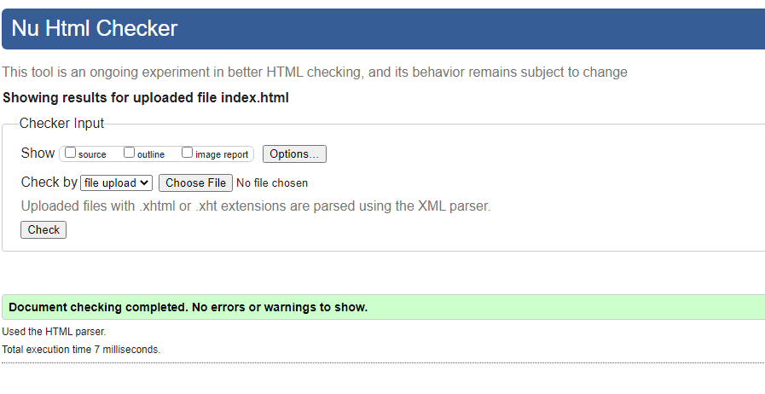

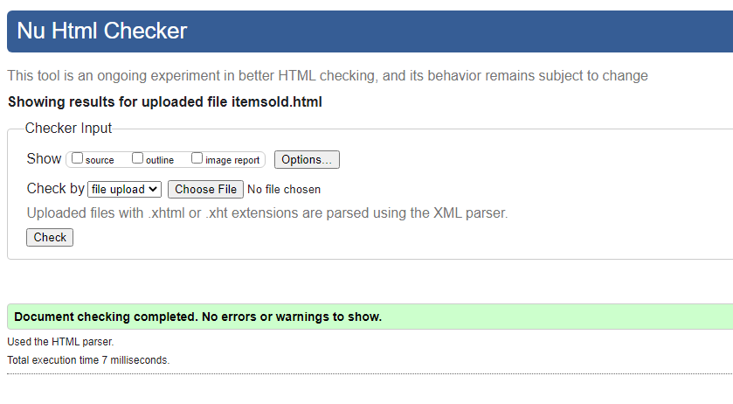

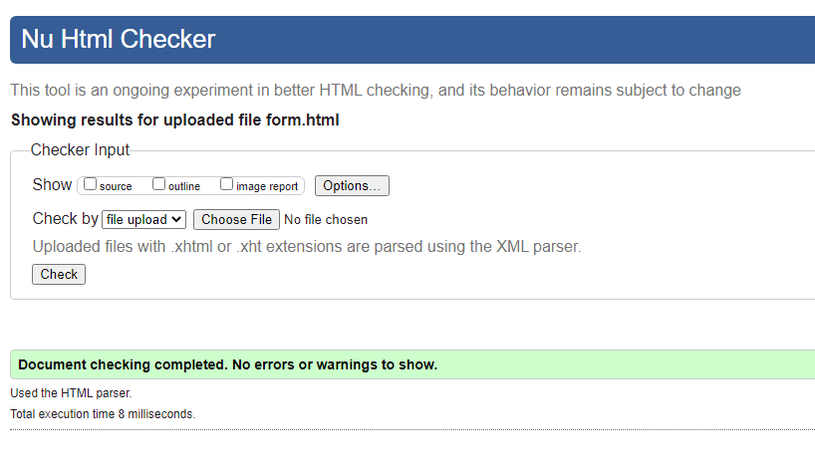

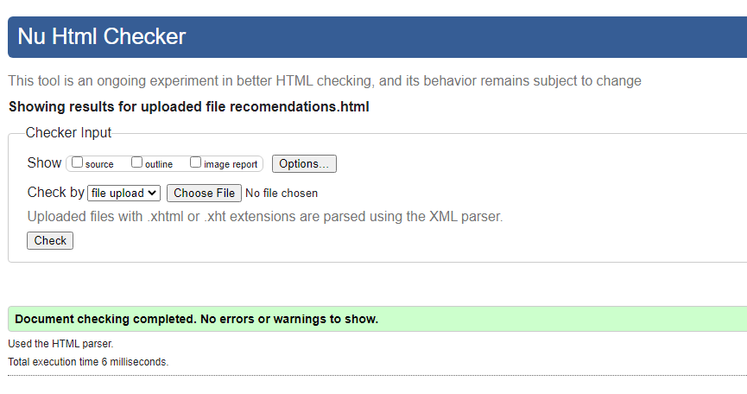

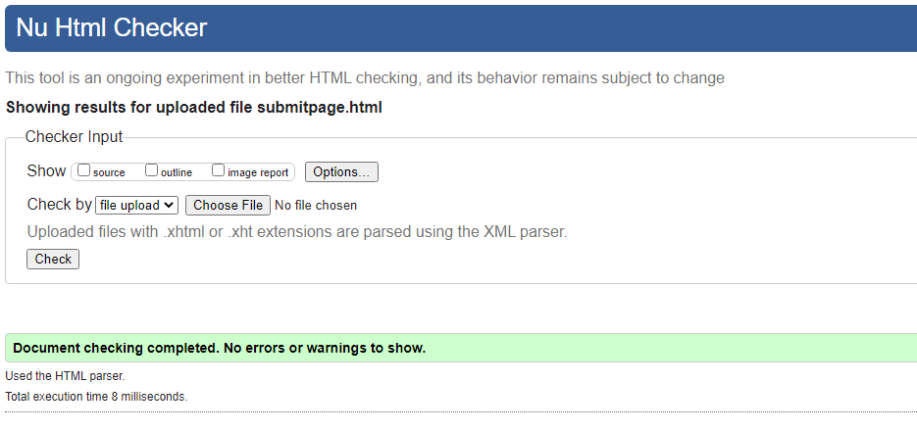

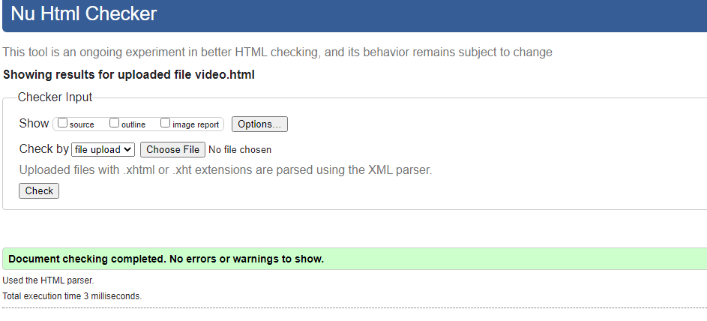

The images are accessible, but I think making the background image to be the same color as the main background could be improved. For example, if the main background color is green, the image background color could also be green.